

Réalisé par le stagiaire Anass Tantane
Dirigé par la formatrice Mouna Lguelsa
Travaux pratiques

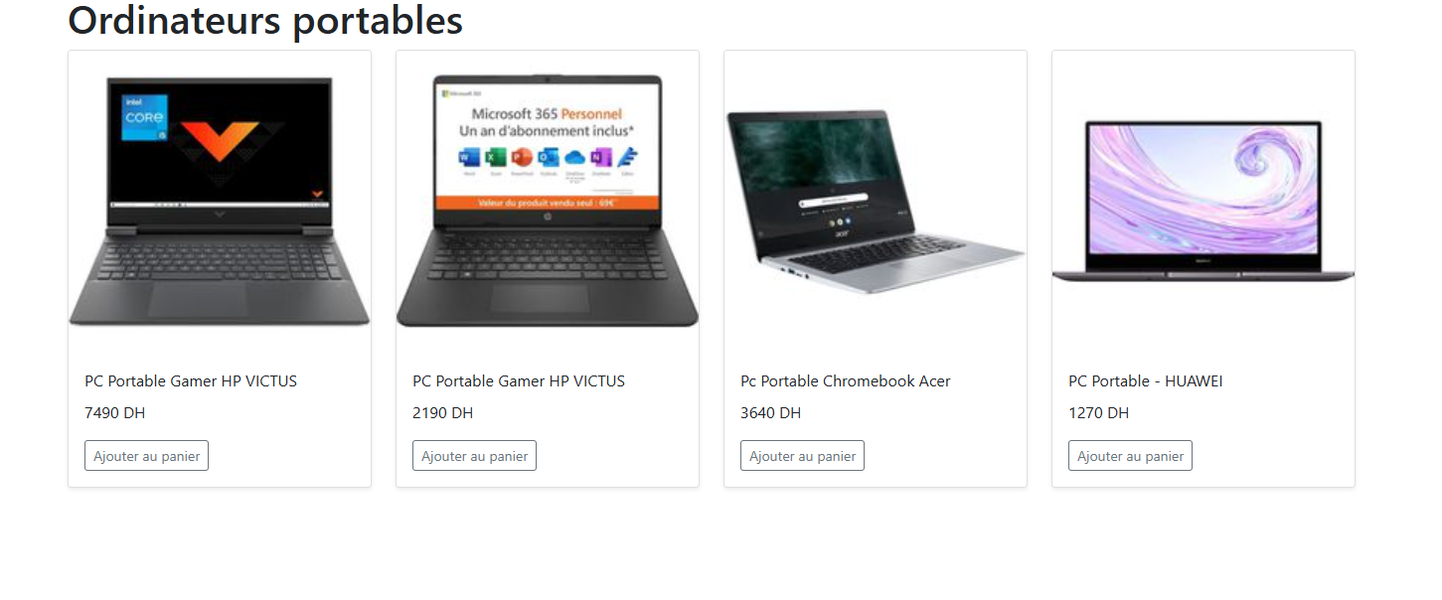

Solution:
<html>
<head>
<title>PC Portable</title>
<link href="https://cdn.jsdelivr.net/npm/bootstrap@5.0.2/dist/css/bootstrap.min.css" rel="stylesheet" crossorigin="anonymous">
<script src="https://cdn.jsdelivr.net/npm/bootstrap@5.0.2/dist/js/bootstrap.bundle.min.js" crossorigin="anonymous"></script>
<script src="https://unpkg.com/react@16/umd/react.development.js" crossorigin></script>
<script src="https://unpkg.com/react-dom@16/umd/react-dom.development.js" crossorigin></script>
<script src="https://unpkg.com/@babel/standalone/babel.min.js"></script>
</head>
<body>
<div id="app"></div>
</body>
<script type="text/babel">
const products = [
{
id: 1,
title: 'PC Portable Gamer HP VICTUS',
price: '7490 DH',
thumbnail : 'HP16D0195NF.jpg'
},
{
id: 2,
title: 'PC Portable Gamer HP VICTUS',
price: '2190 DH',
thumbnail : 'HP14424U3EA.jpg'
},
{
id: 3,
title: 'Pc Portable Chromebook Acer',
price: '3640 DH',
thumbnail: 'NXATHEF002.jpg'
},
{
id: 4,
title: 'PC Portable - HUAWEI',
price: '1270 DH',
thumbnail: 'HUA6901443442959.jpg'
},
];
function Product(props) {
const { title, price, thumbnail } = props;
let thumbnailsrc = "pictures/"+thumbnail;
return (
<div className="col">
<div className="card shadow-sm">
<img className="bd-placeholder-img card-img-top" src={thumbnailsrc} alt="" />
<div className="card-body">
<p className="card-title">{title}</p>
<p className="card-text">{price}</p>
<div className="d-flex justify-content-between align-items-center">
<div className="btn-group">
<button type="button" className="btn btn-sm btn-outline-secondary">Ajouter au panier</button>
</div>
</div>
</div>
</div>
</div>
);
}
function Products(props) {
return (
<main className="container">
<h1>Ordinateurs portables</h1>
<div className="row mb-2">
{products.map((product) => (
<Product key={product.id} title={product.title} price={product.price} thumbnail={product.thumbnail} />
))}
</div>
</main>
)
}
ReactDOM.render(<Products/>, document.getElementById("app"));
</script>
</html>

