**Experiment-14**

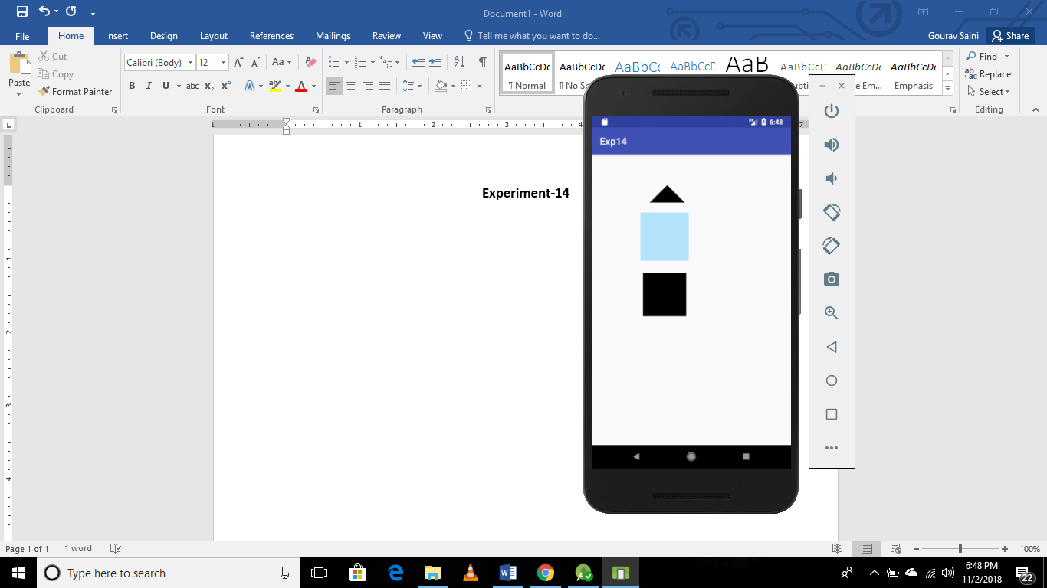

***Activity.xml***

*<?***xml version="1.0" encoding="utf-8"***?>*<**RelativeLayout xmlns:android="http://schemas.android.com/apk/res/android"  
 xmlns:app="http://schemas.android.com/apk/res-auto"  
 xmlns:tools="http://schemas.android.com/tools"  
 android:layout_width="match_parent"  
 android:layout_height="match_parent"  
 tools:context=".MainActivity"**>  
<**RelativeLayout  
 android:id="@+id/triangle"  
 android:layout_width="100dp"  
 android:layout_height="100dp"  
 android:background="@drawable/triangle"  
 android:layout_marginLeft="100dp"** >  
</**RelativeLayout**>  
  
 <**RelativeLayout  
 android:id="@+id/rectangle"  
 android:layout_width="100dp"  
 android:layout_height="100dp"  
 android:layout_below="@+id/triangle"  
 android:layout_marginLeft="100dp"  
 android:layout_marginTop="20dp"  
 android:background="@drawable/rectangle"**>  
  
 </**RelativeLayout**>  
  
  
 <**RelativeLayout  
 android:layout_width="100dp"  
 android:layout_height="100dp"  
 android:layout_below="@+id/rectangle"  
 android:layout_marginLeft="100dp"  
 android:layout_marginTop="20dp"  
 android:background="@drawable/squar"**>  
  
 </**RelativeLayout**>  
  
  
  
</**RelativeLayout**>

**Triangle.xml**

*<?***xml version="1.0" encoding="utf-8"***?>*<**layer-list xmlns:android="http://schemas.android.com/apk/res/android"** >  
 <**item** >  
 <**rotate  
 android:fromDegrees="45"  
 android:toDegrees="45"  
 android:pivotX="-40%"  
 android:pivotY="95%"** >  
 <**shape  
 android:shape="rectangle"** >  
 <**stroke  
 android:color="@android:color/transparent"  
 android:width="10dp"**/>  
 <**solid  
 android:color="#000000"** />  
 </**shape**>  
 </**rotate**>  
 </**item**>  
</**layer-list**>

**Rectangle.xml**

*<?***xml version="1.0" encoding="utf-8"***?>*<**layer-list xmlns:android="http://schemas.android.com/apk/res/android"** >  
 <**item**>  
 <**shape android:shape="rectangle"**>  
 <**solid android:color="#B2E3FA"** />  
 </**shape**>  
 </**item**>  
</**layer-list**>

**Square.xml**

*<?***xml version="1.0" encoding="utf-8"***?>*<**layer-list xmlns:android="http://schemas.android.com/apk/res/android"** >  
 <**item** >  
 <**rotate  
 android:fromDegrees="0"  
 android:toDegrees="12"  
 android:pivotX="-40%"  
 android:pivotY="50%"** >  
 <**shape  
 android:shape="rectangle"** >  
 <**stroke  
 android:color="@android:color/transparent"  
 android:width="10dp"**/>  
 <**solid  
 android:color="#000000"** />  
 </**shape**>  
 </**rotate**>  
 </**item**>  
</**layer-list**>