**Experiment-3**

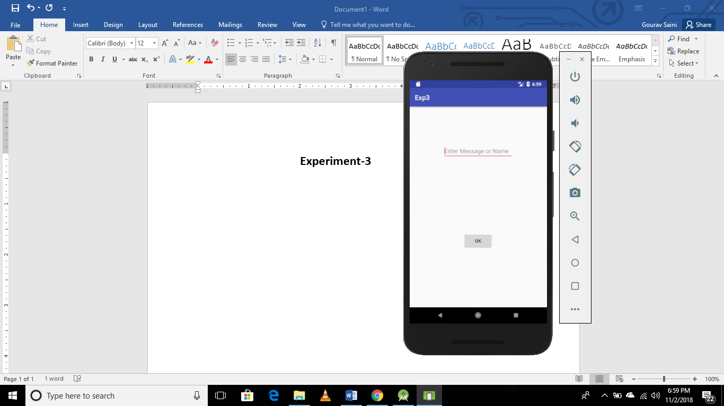 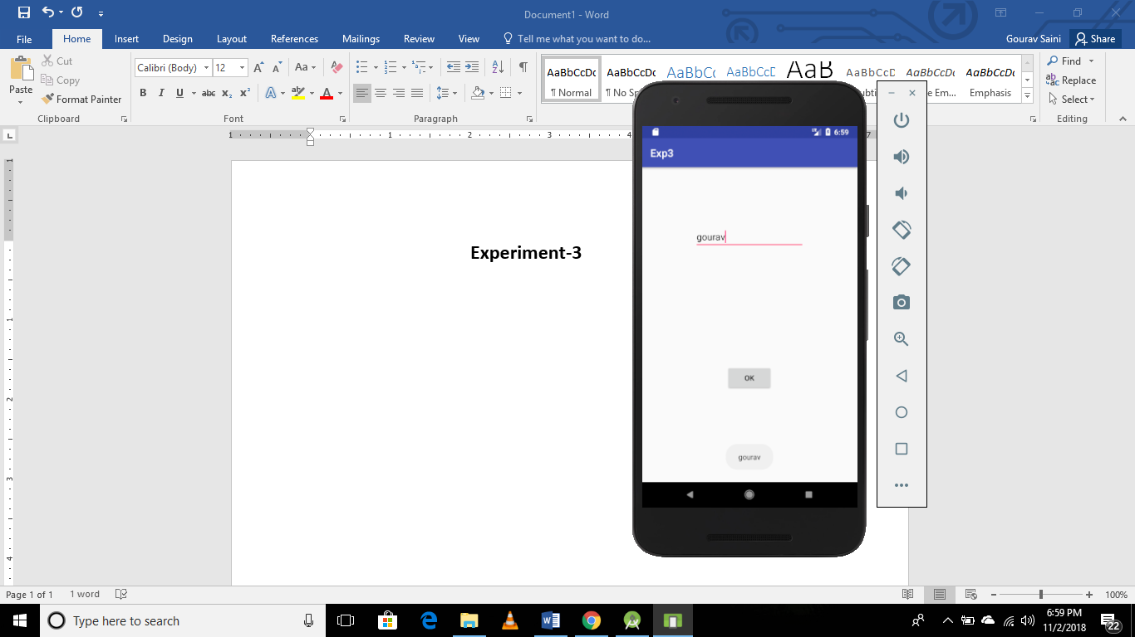

**MainActivity.java**

**public class** MainActivity **extends** AppCompatActivity {  
EditText **edt**;  
String **str**;  
 @Override  
 **protected void** onCreate(Bundle savedInstanceState) {  
 **super**.onCreate(savedInstanceState);  
 setContentView(R.layout.***activity_main***);  
 **edt**=(EditText)findViewById(R.id.***editText***);  
  
 }  
  
 **public void** ok(View view) {  
 **str**=**edt**.getText().toString();  
 Toast.*makeText*(getApplicationContext(),**str**,Toast.***LENGTH_SHORT***).show();  
 }  
}