**Experiment-4**

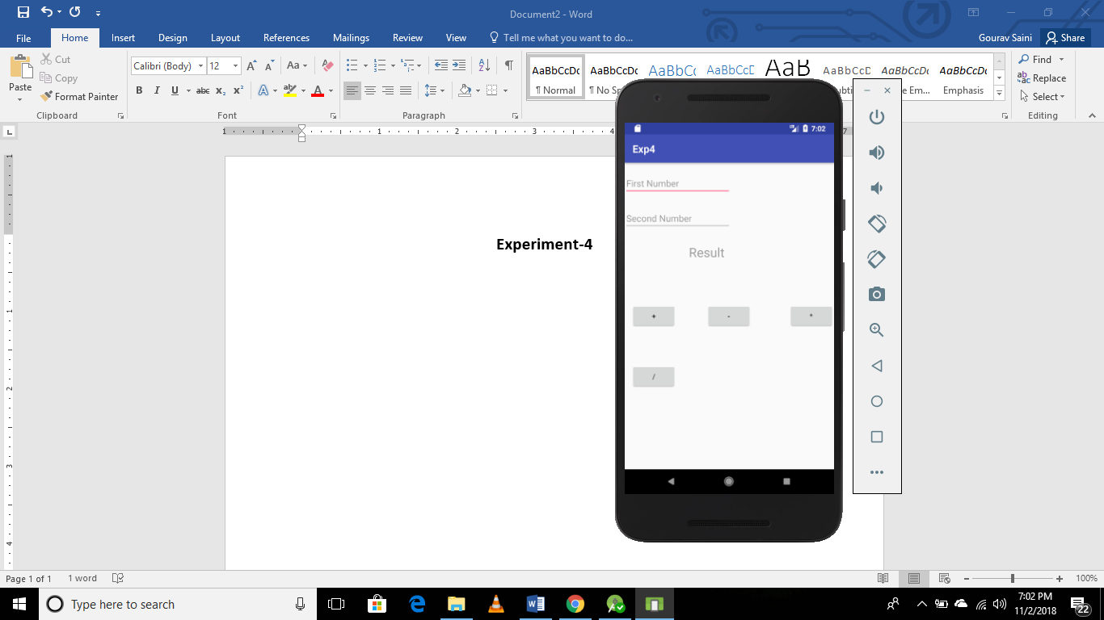 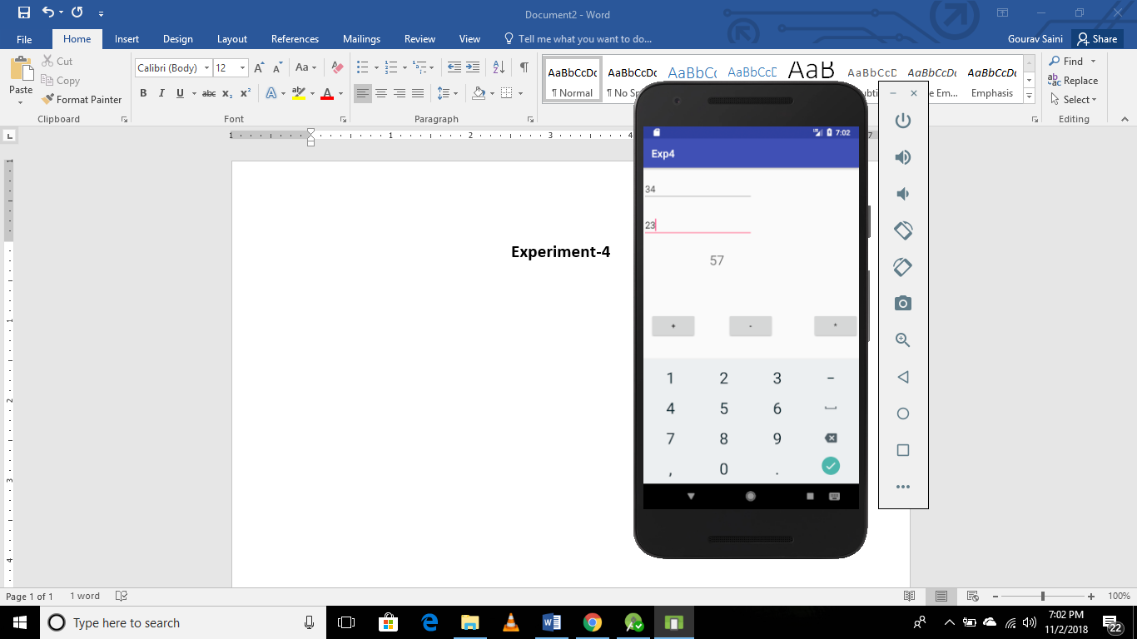

**MainActivity.xml**

**public class** MainActivity **extends** AppCompatActivity {  
  
 EditText **e1**,**e2**;  
 TextView **t1**;  
 **int n1**,**n2**,**result**;  
 @Override  
 **protected void** onCreate(Bundle savedInstanceState) {  
 **super**.onCreate(savedInstanceState);  
 setContentView(R.layout.***activity_main***);  
 **e1**=(EditText) findViewById(R.id.***first***);  
 **e2**=(EditText)findViewById(R.id.***second***);  
 **t1**=(TextView)findViewById(R.id.***result***);  
  
 }  
  
 **public void** Plus(View view) {  
 **n1**=Integer.*parseInt*(**e1**.getText().toString());  
 **n2**=Integer.*parseInt*(**e2**.getText().toString());  
**result**=**n1**+**n2**;  
**t1**.setText(**""**+**result**);  
 }  
  
 **public void** Minus(View view) {  
 **n1**=Integer.*parseInt*(**e1**.getText().toString());  
 **n2**=Integer.*parseInt*(**e2**.getText().toString());  
 **result**=**n1**-**n2**;  
 **t1**.setText(**""**+**result**);  
 }  
  
 **public void** Multi(View view) {  
 **n1**=Integer.*parseInt*(**e1**.getText().toString());  
 **n2**=Integer.*parseInt*(**e2**.getText().toString());  
 **result**=**n1**\***n2**;  
 **t1**.setText(**""**+**result**);  
 }  
  
 **public void** Div(View view) {  
 **n1**=Integer.*parseInt*(**e1**.getText().toString());  
 **n2**=Integer.*parseInt*(**e2**.getText().toString());  
 **double** resul=(**double**) **n1**/**n2**;  
 **t1**.setText(**""**+resul);  
 }  
}