**Experiment-5**

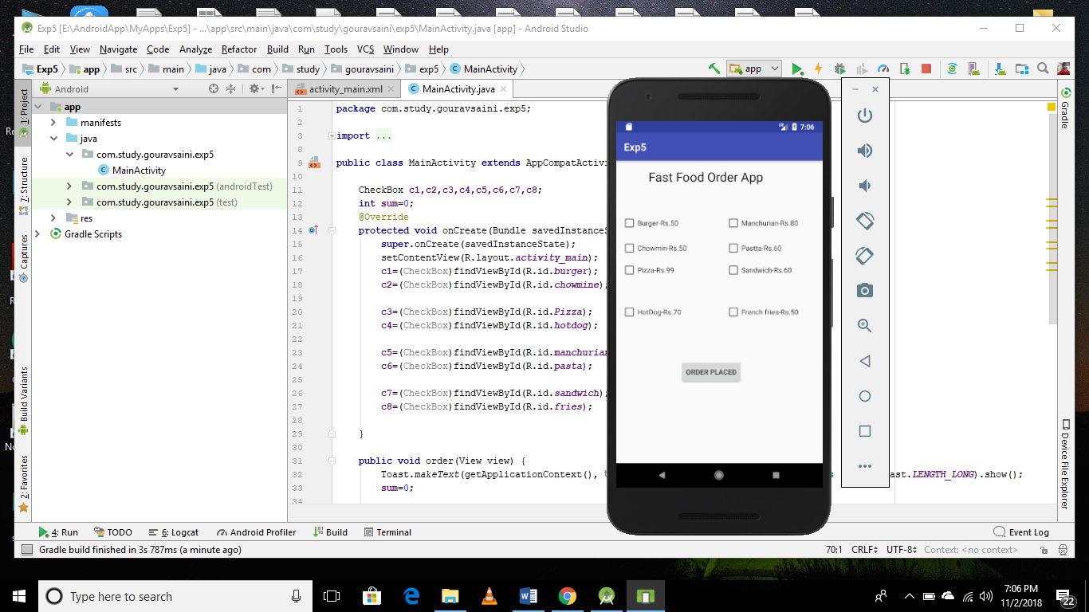 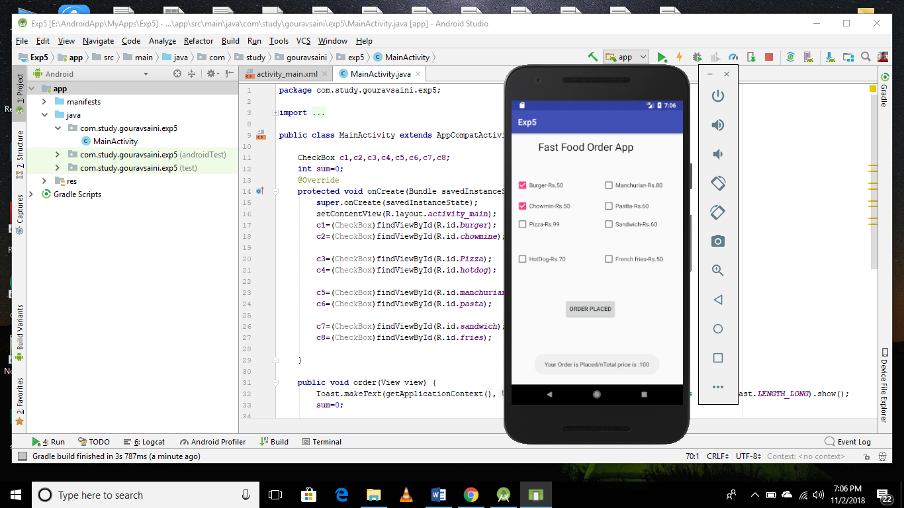

**MainActivity.java**

CheckBox **c1**,**c2**,**c3**,**c4**,**c5**,**c6**,**c7**,**c8**;  
 **int sum**=0;  
 @Override  
 **protected void** onCreate(Bundle savedInstanceState) {  
 **super**.onCreate(savedInstanceState);  
 setContentView(R.layout.***activity_main***);  
 **c1**=(CheckBox)findViewById(R.id.***burger***);  
 **c2**=(CheckBox)findViewById(R.id.***chowmine***);  
  
 **c3**=(CheckBox)findViewById(R.id.***Pizza***);  
 **c4**=(CheckBox)findViewById(R.id.***hotdog***);  
  
 **c5**=(CheckBox)findViewById(R.id.***manchurian***);  
 **c6**=(CheckBox)findViewById(R.id.***pasta***);  
  
 **c7**=(CheckBox)findViewById(R.id.***sandwich***);  
 **c8**=(CheckBox)findViewById(R.id.***fries***);  
  
 }  
  
 **public void** order(View view) {  
 Toast.*makeText*(getApplicationContext(),**"Your Order is Placed/nTotal price is :"**+**sum**,Toast.***LENGTH_LONG***).show();  
 **sum**=0;  
  
 }  
  
 **public void** burger(View view) {  
 **sum**=**sum**+50;  
 }  
  
 **public void** chowmin(View view) {  
 **sum**=**sum**+50;  
 }  
  
 **public void** pizza(View view) {  
 **sum**=**sum**+99;  
 }  
  
 **public void** hotdog(View view) {  
 **sum**=**sum**+70;  
 }  
  
  
 **public void** man(View view) {  
 **sum**=**sum**+80;  
 }  
  
 **public void** pasta(View view) {  
 **sum**=**sum**+60;  
 }  
  
 **public void** sand(View view) {  
 **sum**=**sum**+60;  
 }  
  
 **public void** fries(View view) {  
 **sum**=**sum**+50;  
 }  
}