ANOVA TEST

p = anova1(y) performs one-way ANOVA for the sample data y and returns the p-value. anova1 treats each column of y as a separate group. The function tests the hypothesis that the samples in the columns of y are drawn from populations with the same mean against the alternative hypothesis that the population means are not all the same. The function also displays the box plot for each group in y and the standard ANOVA table (tbl).

p = 5.8025e-08

table =

{'Source'} {'SS' } {'df' } {'MS' } {'F' } {'Prob>F' }

{'Groups'} {[0.1037]} {[ 4]} {[ 0.0259]} {[ 11.1770]} {[5.8025e-08]}

{'Error' } {[0.3478]} {[150]} {[ 0.0023]} {0×0 double} {0×0 double }

{'Total' } {[0.4514]} {[154]} {0×0 double} {0×0 double} {0×0 double }

stats =

gnames: {5×1 cell}

n: [36 37 34 27 21]

source: 'anova1'

means: [0.0439 0.0446 0.0709 0.0878 0.1176]

df: 150

s: 0.0482

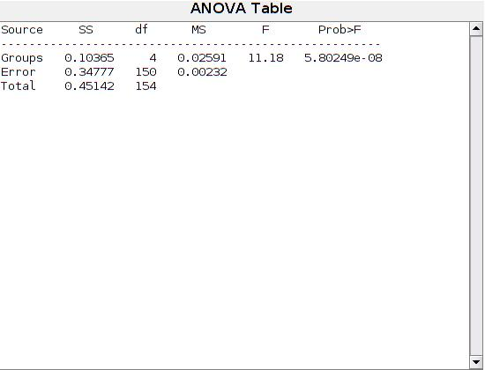

The ANOVA table shows the between-groups variation (Columns) and within-groups variation (Error). SS is the sum of squares, and df is the degrees of freedom. The total degrees of freedom is total number of observations minus one, which is 25 - 1 = 24. The between-groups degrees of freedom is number of groups minus one, which is 5 - 1 = 4. The within-groups degrees of freedom is total degrees of freedom minus the between groups degrees of freedom, which is 24 - 4 = 20.

MS is the mean squared error, which is SS/df for each source of variation. The F-statistic is the ratio of the mean squared errors (13.4309/2.2204). The p-value is the probability that the test statistic can take a value greater than the value of the computed test statistic, i.e., P(F > 6.05). The small p-value of 0.0023 indicates that differences between column means are significant.

**p-value** for the F-test is the probability that the F-statistic can take a value larger than the computed test-statistic value. anova1 tests the null hypothesis that all group means are equal to each other against the alternative hypothesis that at least one group mean is different from the others. The function derives the p-value from the cdf of the F-distribution.

A p-value that is smaller than the significance level indicates that at least one of the sample means is significantly different from the others. Common significance levels are 0.05 or 0.01.

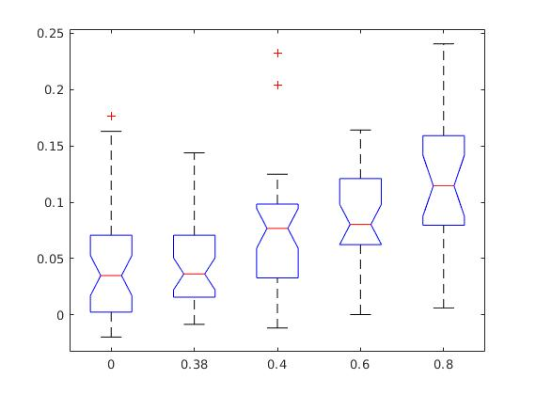anova1 returns a box plot of the observations for each group in [y](https://nl.mathworks.com/help/stats/anova1.html?searchHighlight=anova1&s_tid=srchtitle" \l "bulav5i-y). Box plots provide a visual comparison of the group location parameters.

On each box, the central mark is the median (2nd quantile, q2) and the edges of the box are the 25th and 75th percentiles (1st and 3rd quantiles, q1 and q3, respectively). The whiskers extend to the most extreme data points that are not considered outliers. The outliers are plotted individually using the '+' symbol. The extremes of the whiskers correspond to q3 + 1.5 × (q3 – q1) and q1 – 1.5 × (q3 – q1).

Box plots include notches for the comparison of the median values. Two medians are significantly different at the 5% significance level if their intervals, represented by notches, do not overlap. This test is different from the F-test that ANOVA performs; however, large differences in the center lines of the boxes correspond to a large F-statistic value and correspondingly a small p-value. The extremes of the notches correspond to q2 – 1.57(q3 – q1)/sqrt(n) and q2 + 1.57(q3 – q1)/sqrt(n), where n is the number of observations without any NaN values.

*notch significa muesca

MULT COMPARE

(critical value to use for the multiple comparison: 'tukey-kramer')

c = [‘group1’ ‘group2’ ‘difference of means’ ‘lower limit’ ‘upper limit’ ‘pvalue’]

1.0000 2.0000 -0.0314 -0.0007 0.0301 1.0000

1.0000 3.0000 -0.0584 -0.0270 0.0044 0.1310

1.0000 4.0000 -0.0773 -0.0439 -0.0104 0.0032

1.0000 5.0000 -0.1097 -0.0737 -0.0376 0.0000

2.0000 3.0000 -0.0575 -0.0263 0.0049 0.1443

2.0000 4.0000 -0.0765 -0.0432 -0.0100 0.0036

2.0000 5.0000 -0.1089 -0.0730 -0.0371 0.0000

3.0000 4.0000 -0.0507 -0.0169 0.0170 0.6532

3.0000 5.0000 -0.0831 -0.0467 -0.0102 0.0044

4.0000 5.0000 -0.0680 -0.0298 0.0084 0.2087

m =

*Matrix of the estimates. The first column of m contains the estimated values of the means (or whatever statistics are being compared) for each group, and the second column contains their standard errors.*

0.0439 0.0080

0.0446 0.0079

0.0709 0.0083

0.0878 0.0093

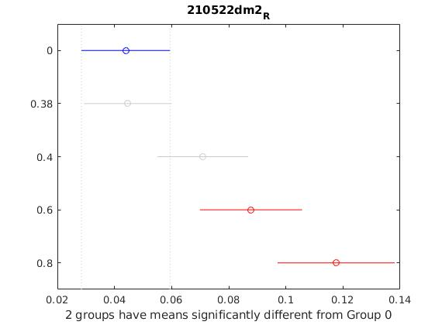 0.1176 0.0105