For the first series of tests, we simulated 20 independent time series based off of the same quadratic function of the form, for 10 time points equally spaced, as follows:  
  
y = ax^2 +bx + c + sigma

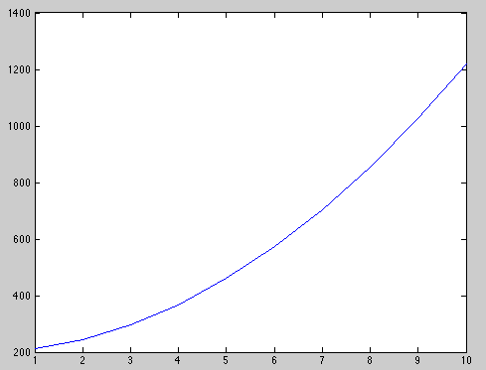

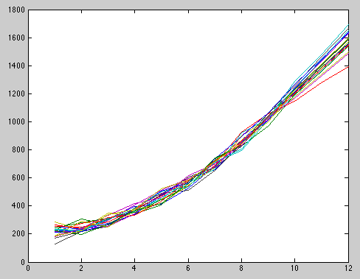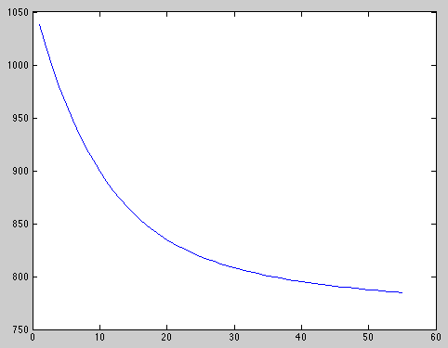So first we ran our algorithm optimizing only on theta using a gradient descent procedure with unit box projection (to ensure alpha and beta values are valid parameters between 0 and 1). As we found, this procedure was sensitive to the initial guess of theta. Below, we have results for when theta is initialized at 0.5 in both columns.

However, these are the results for a different initial guess of theta with values of 0.2 in both columns:

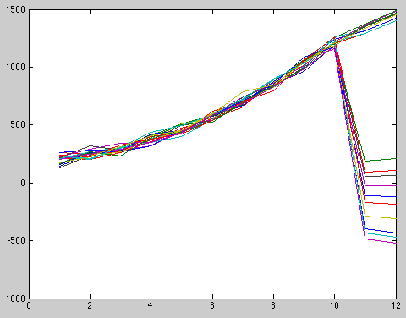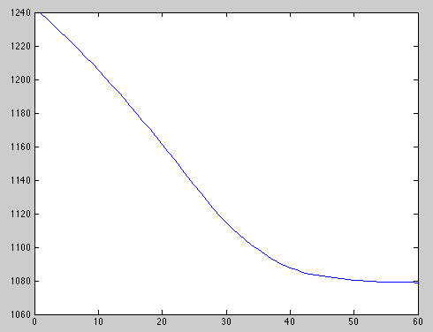

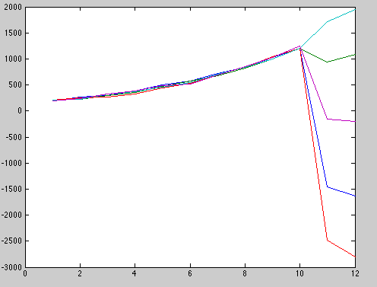So now, we repeat these results by incorporating the omega optimization. In theory, since these time series are independent and do not influence each other, the omega optimization should result in a trivial result with the diagonal being all ones and the rest of the matrix being zeros. What we found is essentially that our procedure of first optimizing with respect to theta then omega and so failed to converge and hence gave nonsensical answers. Here are the plots below:  
  
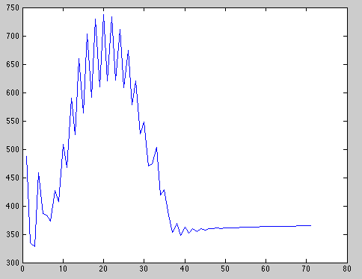

Obviously, these results weren’t good. So we change the algorithm a bit so as to reset the theta value after each iteration. These were the results from that:  
  
