**Channel Characterization (Outfall 002)**

**Data Collection**

The channel located at Outfall 002 was divided into 20 cross sections (polygon). For each cross section the following measurements were taken:

1. Distance from the previous polygon or cross section. The reference point was the bridge located at the beginning of the channel and the first cross section was located at 13 ft. 4 in from the bridge (160 in).
2. Channel width and geometry (Positions). Four measurements were taken: Lout (starting point at the left side of the channel), Lin, Rout (total width of the channel), Rin. See Figure 1.
3. Sediment grain size and depth
4. Vegetation description and other observations

**Data entry**

The excel file ChannelDescription.xlsx contains all the data gathered during the channel characterization. Each column has one measurement:

1. Section: Refers to each cross section (1,2…20)
2. Position: Refers to the four geometry measurements (Lout, Lin, Rout, Rin)
3. Column X: Is the X coordinate for each position and it represents the distance from the previous polygon (inches).
4. Column Y: Is the Y coordinate for each position and it represents the distance of the channel with respect to point Lout (inches).
5. Column Z: Is the Z coordinate for each position and it represents the depth (cm).

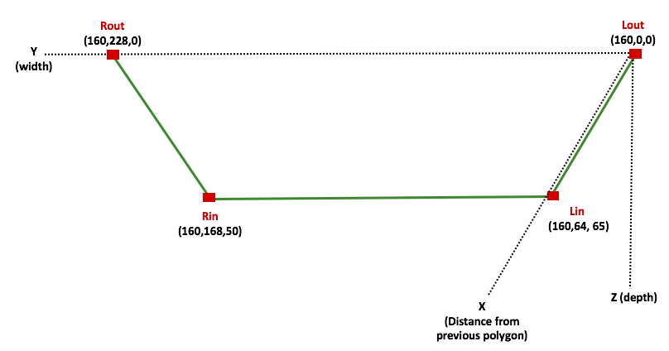

**Figure 1.** Cross section 1 (rough representation). Each position (Rout, Rin, Lout, Rin) has X, Y and Z coordinates. X, Y (inches) Z (cm).[1] All positions from each cross section has the same X coordinate because they are located at the same distance from the previous cross section.

**Channel Geometry: Calculating area and perimeter**

*Area of a trapezoid*

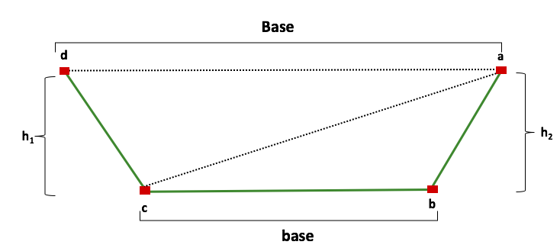

**Figure 2.** Notations used to calculate the area of each cross section.

*rd*

*Perimeter of a trapezoid*

The distances between each point is calculated by:

P= L1 + L2 + L3 + L4

**Model’s Calculations**

**Discharge (Q):** The *volume of water per unit time* that passes a specified point on a stream. Discharge is conventionally measured in cubic feet per second (ft3/s) or cubic meters per second (m3/sec or cms).

Q = WdV

Where,

w = water width

d = mean water depth

v = mean water velocity

Re-writing this equation,

**Manning’s Equation**

Q= AV

Where,

Q = Flow Rate, (ft3/s)

v = Velocity, (ft/s)

A = Flow Area, (ft2)

n = Manning’s Roughness Coefficient

R = Hydraulic Radius, (ft)

S = Channel Slope, (ft/ft)

1. In the R code all X, Y and Z values are converted to cm.