**CPEG 585 – Assignment #4**

Part (a). Develop a matrix equation for minimizing the cost in image registration (without shear) when the correspondences between the points in two images I1 and I2 are known. Summation indicates the sum over all points in a shape.

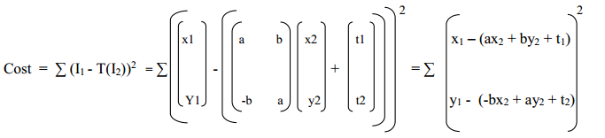



Solution:

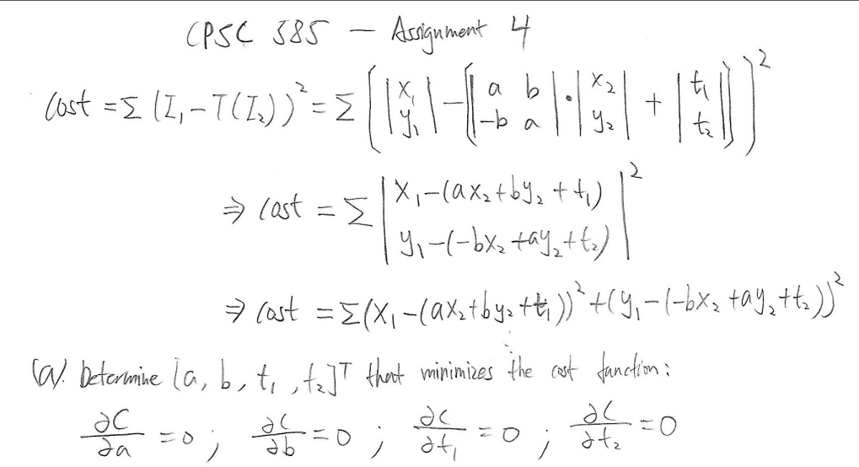

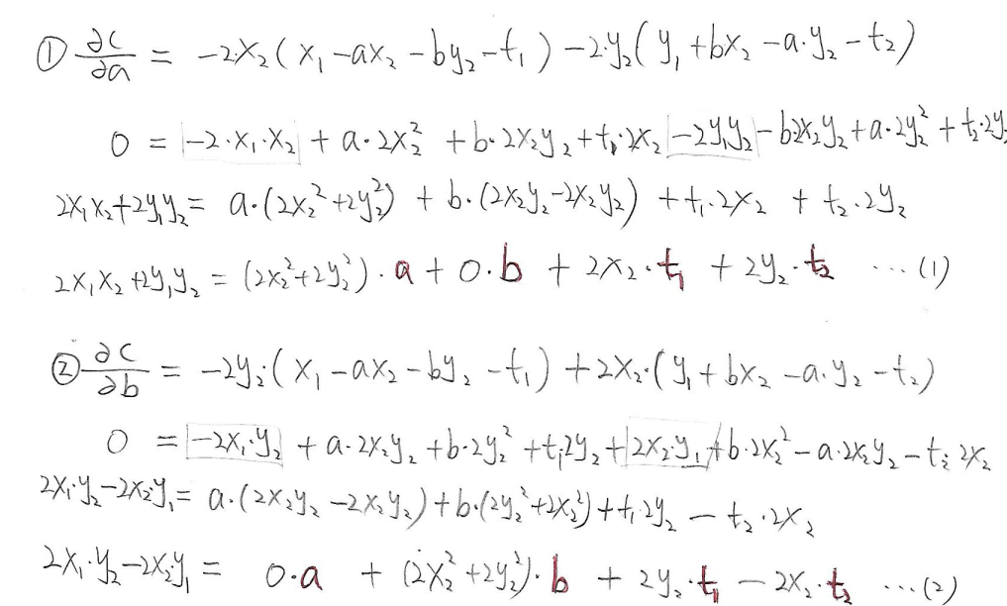

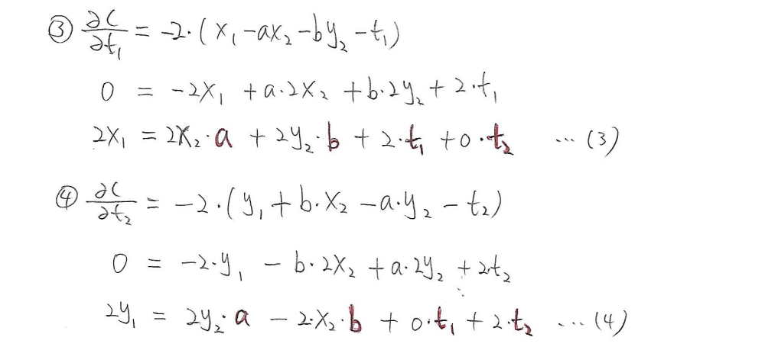

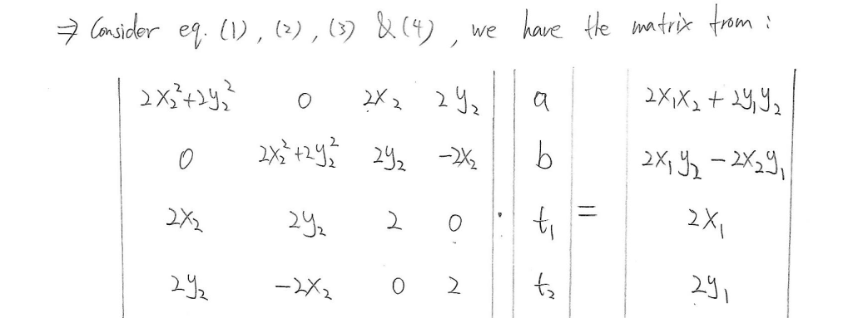

Part (b). Test program for determining and applying the transformation needed for Shape2:

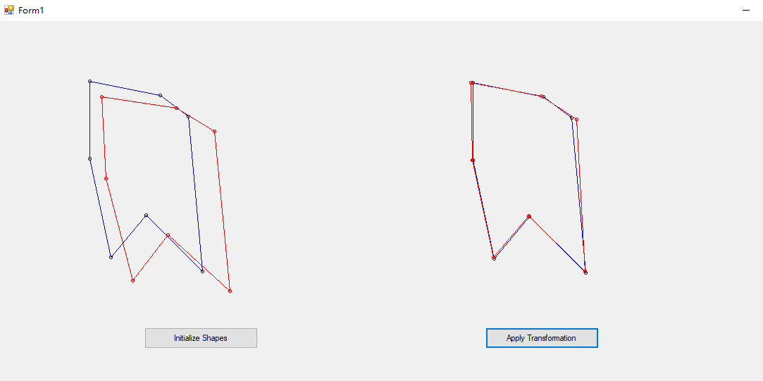

The left set of pictures corresponds to two shapes before registration. Right set of pictures shows Shape1 and transformed shape 2 after applying the transformation determined from partial derivative equations on Shape 2.