**CPEG 585 – Assignment #5**

**a)** **Outlier Removal using Exhaustive Evaluation**:

Suppose you are given a set of points in two shapes. Some of these points are outliers. We can remove these via exhaustive evaluation or via random sampling through a technique called RANSAC.

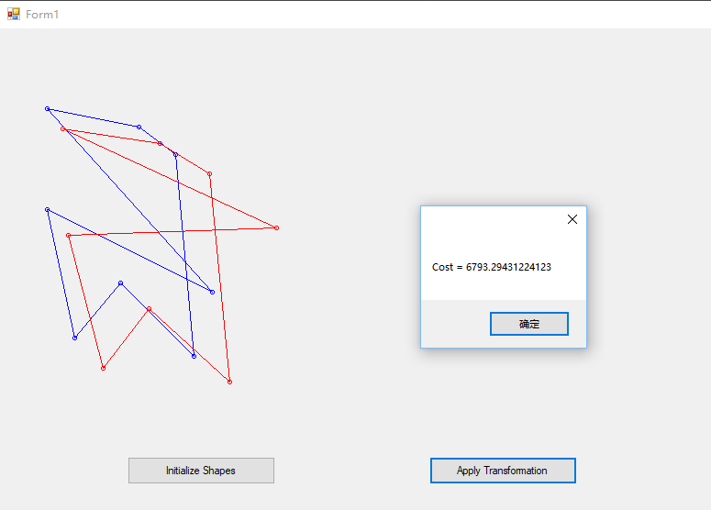

Added outliers, the cost increase to 6793.3.

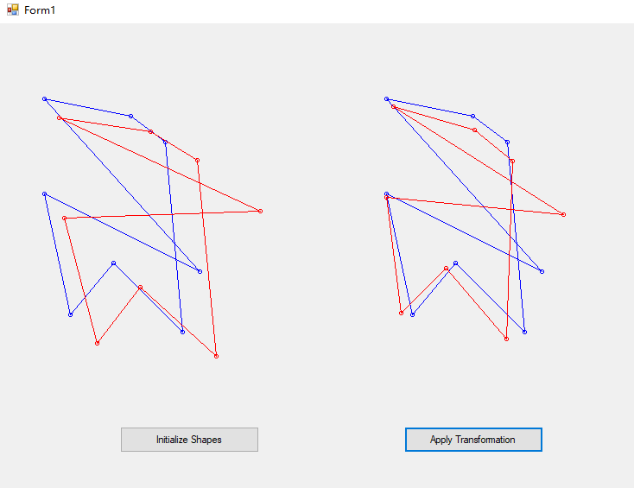

Showing the transform result w/o removal of outliers.

**b) Outlier Removal Using RANSAC:**

Repeat part a) using the RANSAC algorithm.

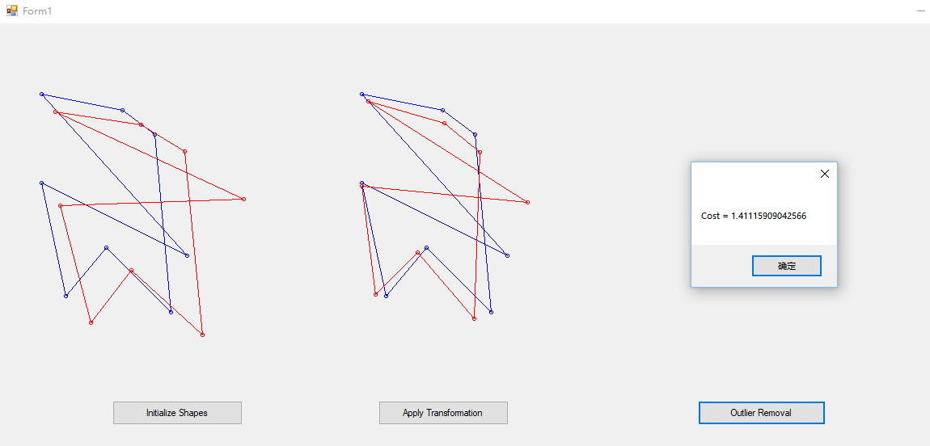

Remove outliers by RANSAC, the cost decreases to 1.41.

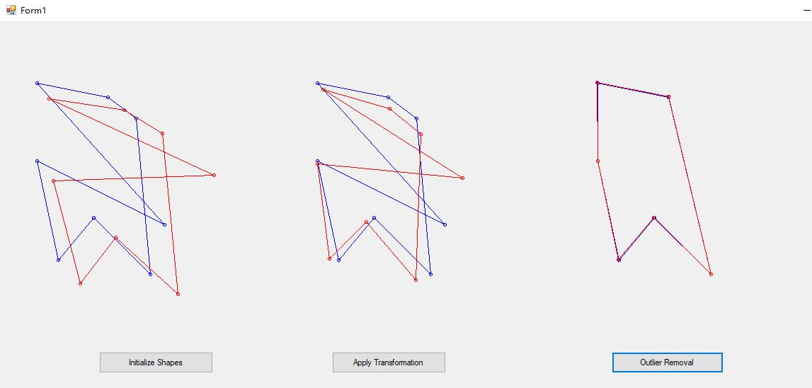

Showing the transform result after removal of outliers.