CPSC 590 – Assignment #1

Due date: September 18, 2017

Try the examples in Handout on Multithreading up to page 12 (i.e., up to the section on cross threading errors).

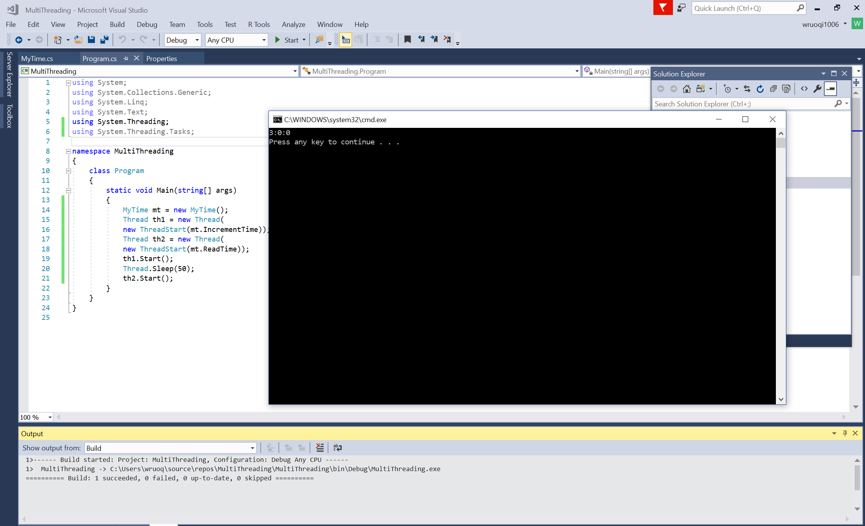

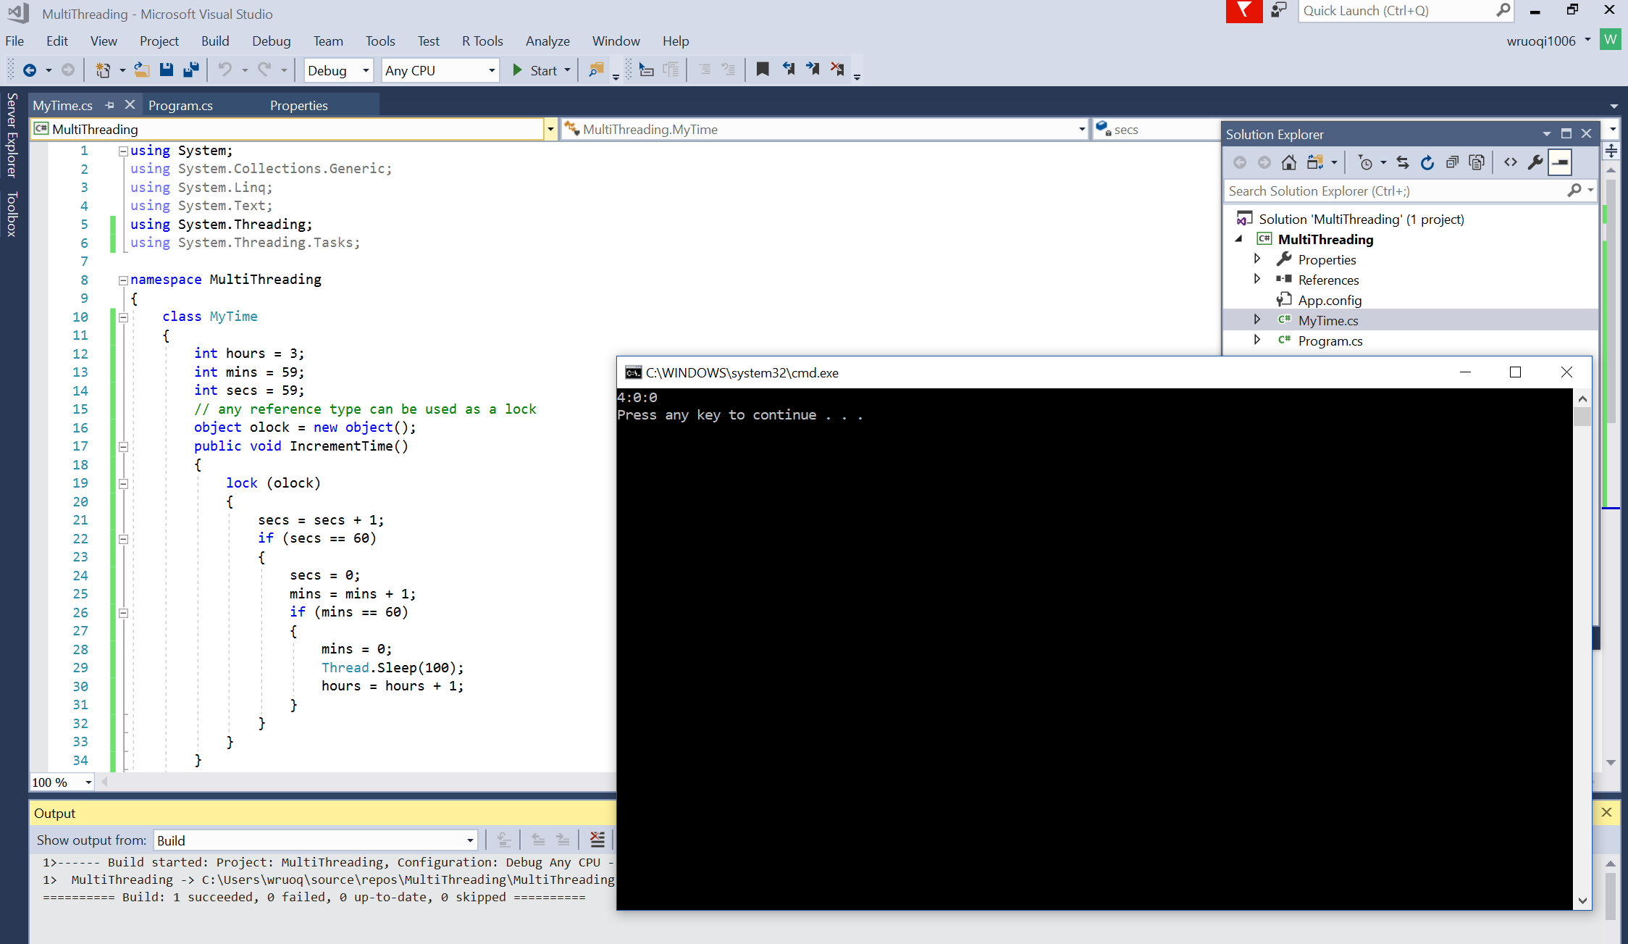

Threading2

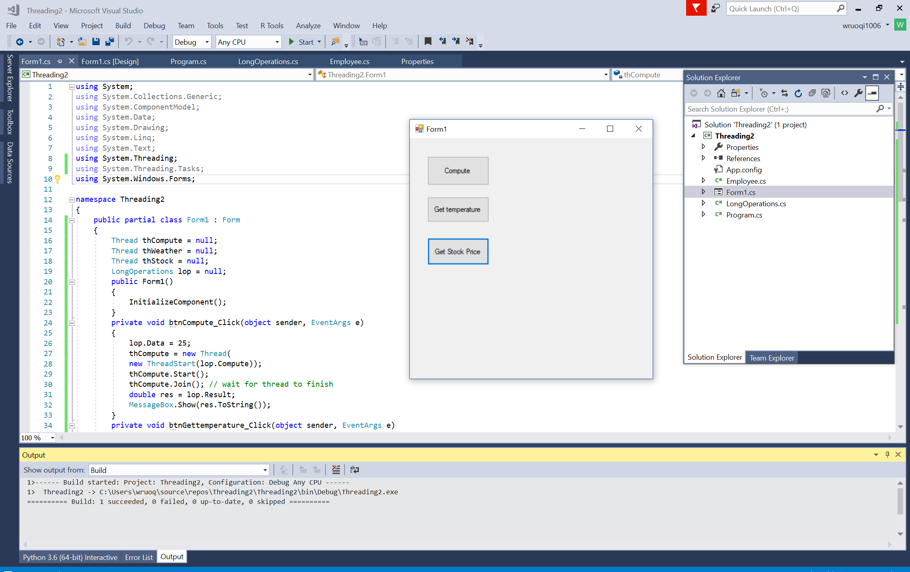

Cross Threading Errors:

