Contents

1. Introduction to Docker and Kubernetes – 04.26
- What is Docker?
- What is Kubernetes?
- Kubernetes Components

2. Kubernetes VS Docker
- Kubernetes with Docker
- Difference between Kubernetes and Docker

3. CKA Certification
- What is Certified Kubernetes Administrator?
- How to prepare for CKA Certification?

4. How to do Container Orchestration
- Uderstanding Container Orchestration
- Container Orchestration with Kubernetes

5. Kubernetes Commands – 1:39:20
- Understanding Kubectl
- Understanding Kubectl Commands

6. Networking In Kubernetes
- Learn about Kubernetes Networking & Components

7. How to create YAML Files in Kubernetes
- What is YAML?
- YAML usage in Kubernetes

8. Understanding Kubernetes Deployments
- Understanding Kubernetes Deployments
- Creating Deployments in Kubernetes

9. Kubernetes Controller and Services
- Understanding Controller and Services
- Accessing Kubernetes Services

10. Kubernetes Ingress
- Understanding Kubernetes Ingresses
- Creating Ingresses in Kubernetes

11. Kubernetes Stateful Sets
- Statefullsets vs Deployments
- Creating Statefulsets in Kubernetes

12. Kubernetes Storage
- Storage Solutions in Kubernetes
- Best Practices for Kubernetes Storage

13. Kubernetes Monitoring
- Understadnig Prometheus
- Understanding Graffana

14. Deployment Kubernetes
- Minikube
- AWS EKS
- AKS

15. Kubernetes Project
- Implementing an end-to-end project on Kubernetes

16. Kubernetes Interview Questions
- Important Interview Questions for Kubernetes

By Edureka Tutorial

Time start : 3:17:00
How to check Nodes (Master or Slave)

$ kubectl get nodes

How to check all namespace Running in Kubernetes

$ kubectl get pods –all-namespaces

Kubernetes Command

kubectl Syntax:
kubectl [command] [TYPE] [NAME] [flags]

Cluster info:
$ sudo kubectl cluster-info or kubectl cluster-info
Configurartion Infomation:
$ sudo kubectl config view or kubectl config view

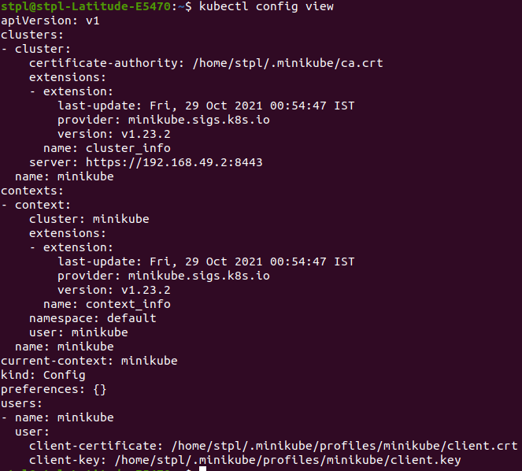

-> To Fetch list of Cluster Define in Your kube Config:
$ kubectl config get-clusters

-> To delete the cluster only config file, Not actual kubernetes Clusters
$ kubectl config delete-clusters

-> List of config context:
$ kubectl config get-contexts
$ kubectl config current-context

# How to set custome context:
$ kubectl config set-context <context1> --cluster=<cluster1> --user=<user1> -- namespace=<namespace1>

-> To switch context:
$ kubectl config use-context context1
$ kubectl config current-context

delete context:
$ kubectl config delete-context context1

Note: Context in kubernetes if object, that contains a set of access parameters of your clusters

-> Create Namespace: It is folder/directory
$ kubectl get namespace
$ kubectl create namespace <namespace2>
$ kubectl delete namespace <namespace2>

# Get all Pods infomation in particular namesapce:
$ kubectl get pods --namespace=default

-> API Version:
$ kubectl api-versions

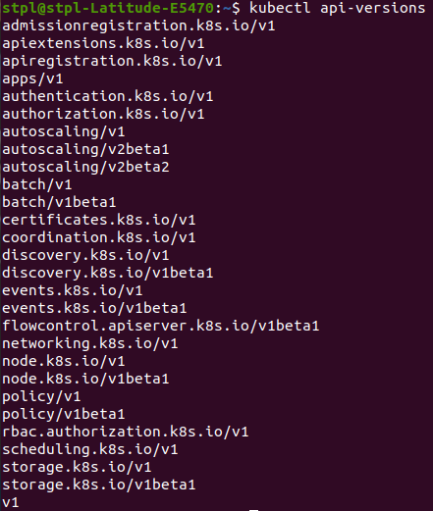

Development In Kubernetes:

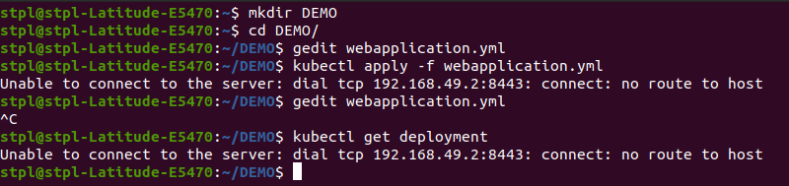
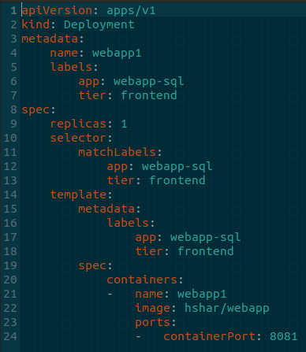
webapplication.yaml

webservice.yaml
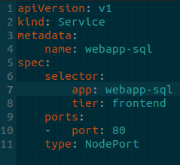

Note: kubectl get pods not working – server refused
Note Time : 2:52:57 – service and deployment

08. CREATE A POD USING YAML:
vi webapp.yaml

apiVersion: apps/v1
kind: Deployment
metadata:
name: webapp1
labels:
app: webapp-sql
tier: frontend
spec:
replicas: 1
selector:
matchLabels:
app: webapp-sql
tier: frontend
template:
metadata:
labels:
app: webapp-sql
tier: frontend
spec:
containers:
- name: webapp1
image: hshar/webapp
ports:
- containerPort: 8081

=> Describe Pods
$ kubectl describe pod <podname> | less

