Robin Mehta (robimeht)

Artificial Intelligence Homework 4

**Exercise 1:**

**1. Show the preconditions and effects of MoveToTable(A, B) and Move(B, Table, C)**

Action: MoveToTable(A, B)

Preconditions: On(A, B) ^ Clear(A) ^ Block(A) ^ (A ≠ B)

Effect: On(A, Table) ^ Clear(B) ^ ~On(A, B)

Action: Move(B, Table, C)

Preconditions: On(B, Table) ^ Clear(B) ^ Clear(C) ^ Block(C) ^ Block(B) ^ (B ≠ C) ^ (B ≠ Table) ^ (Table ≠ C)

Effects: On(B, C) ^ Clear(Table) ^ ~On(B, Table) ^ ~Clear(C)

**2. Show why achieving the subgoals On(A, B) and On(B, C) in order would prevent achieving the goal state.**

Subgoal 1: On(A, B)

Action: Do nothing from init state.

Subgoal 2: On(B, C)

Action: MoveToTable(A, B)

Effect: ~On(A, B)

Action: Move(B, Table, C)

Effect: ~On(A, B)

Goal state is not achieved because MoveToTable(A, B) is a necessary action for Subgoal 2: [On(B, C)], and results in ~On(A, B), which remains unchanged after Move(B, Table, C) and is a contradiction of the goal state.

**Exercise 2:**

**1. Describe the action schema:**

a) FindKeys()

Preconditions: ~HasKey()

Effect: HasKey()

b) GetInCar()

Preconditions: HasKey() ^ ~InCar()

Effects: InCar()

c) StarCar()

Preconditions: HasGas() ^ InCar() ^ HasKey()

Effects: EngineRunn  
 ing()

d) StepsOnGas()

Preconditions: EngineRunning() ^ ~CarMoving()

Effects: CarMoving()

e) StepsOnBreak()

Preconditions: CarMoving() ^ EngineRunning()

Effects: ~CarMoving() ^ ~EngineRunning() ^ AtParking()

**2. Draw the Planning Graph:**

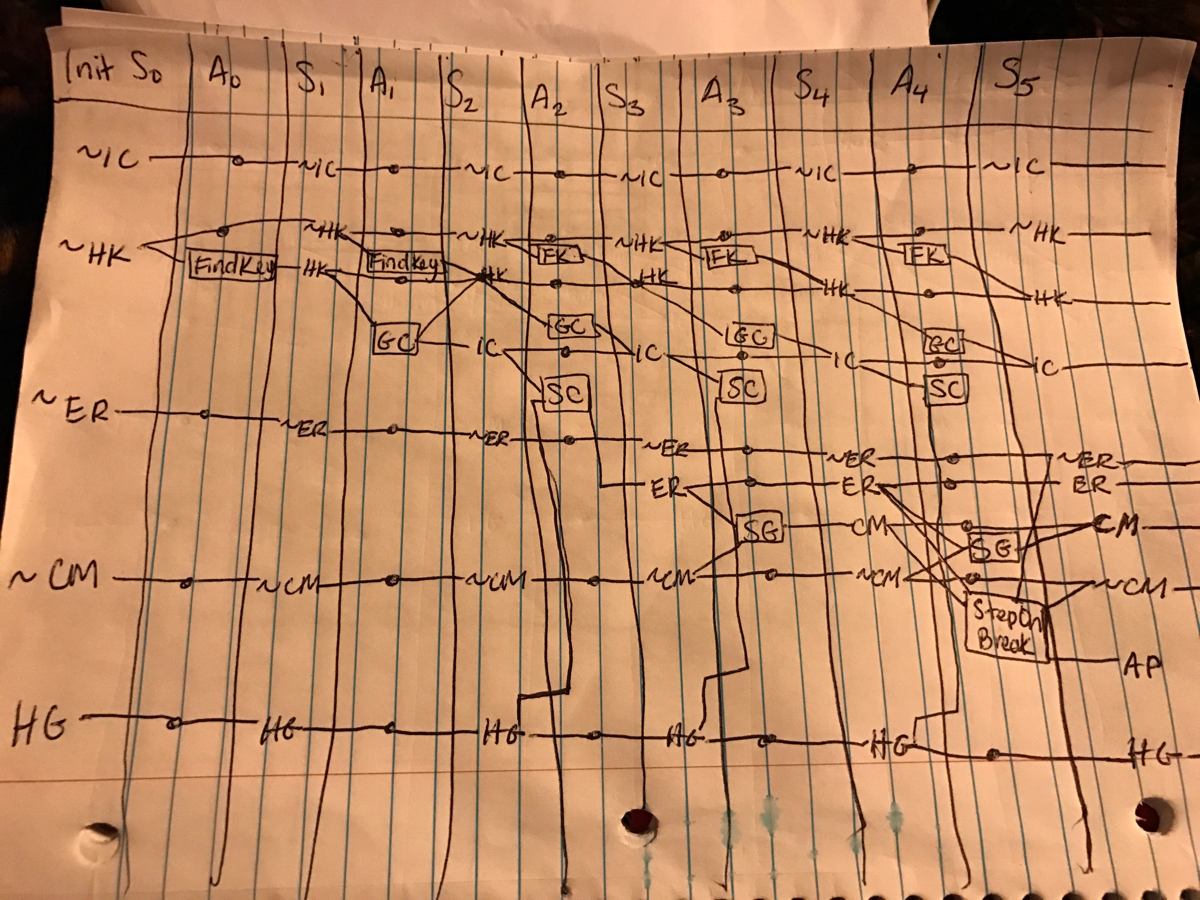

**3. What actions are mutex with StepOnBreak(SB)?**

**Inconsistent effects:** The effect (~CM) of SB is mutex with the persistent effect of CM. The effect (ER) of SB is mutex with it’s effect, ~ER.

**Interference:** The precondition of SB is CM, which is mutex with the persistent effect of ~CM.

**Competing Needs:** The precondition of SB is CM, which is in mutex with the precondition of the persistence of ~CM. Also, SG and SB are mutex actions because SG requires ~CM, and SB requires CM.

**4. What literals are mutex with EngineRunning(ER)?**

**Inconsistent support:** Persistence of ~ER is mutex with HK, HG, IC, which are preconditions to StartCar, which results in ER.

**Exercise 3:**

Action: GoThru(X, Y)

Precondition: In(R, X)

Effects: In(R, Y) ^ ~In(R, X)

Action: PushThru(B, X, Y)

Precondition: In(R, X) ^ In(B, X)

Effects: In(R, Y) ^ In(B, Y) ^ ~In(R, X) ^ ~In(B, X)

**1. State descriptions for initial and goal states:**

Initial State: In(R, 1) ^ In(B, 2) ^ Room(R1) ^ Room(R2) ^ Room(R3) ^ Door(R1, R2) ^ Door(R2, R3) ^ Box(B)

Goal State: In(B, 3)

**2. Planning graph:**

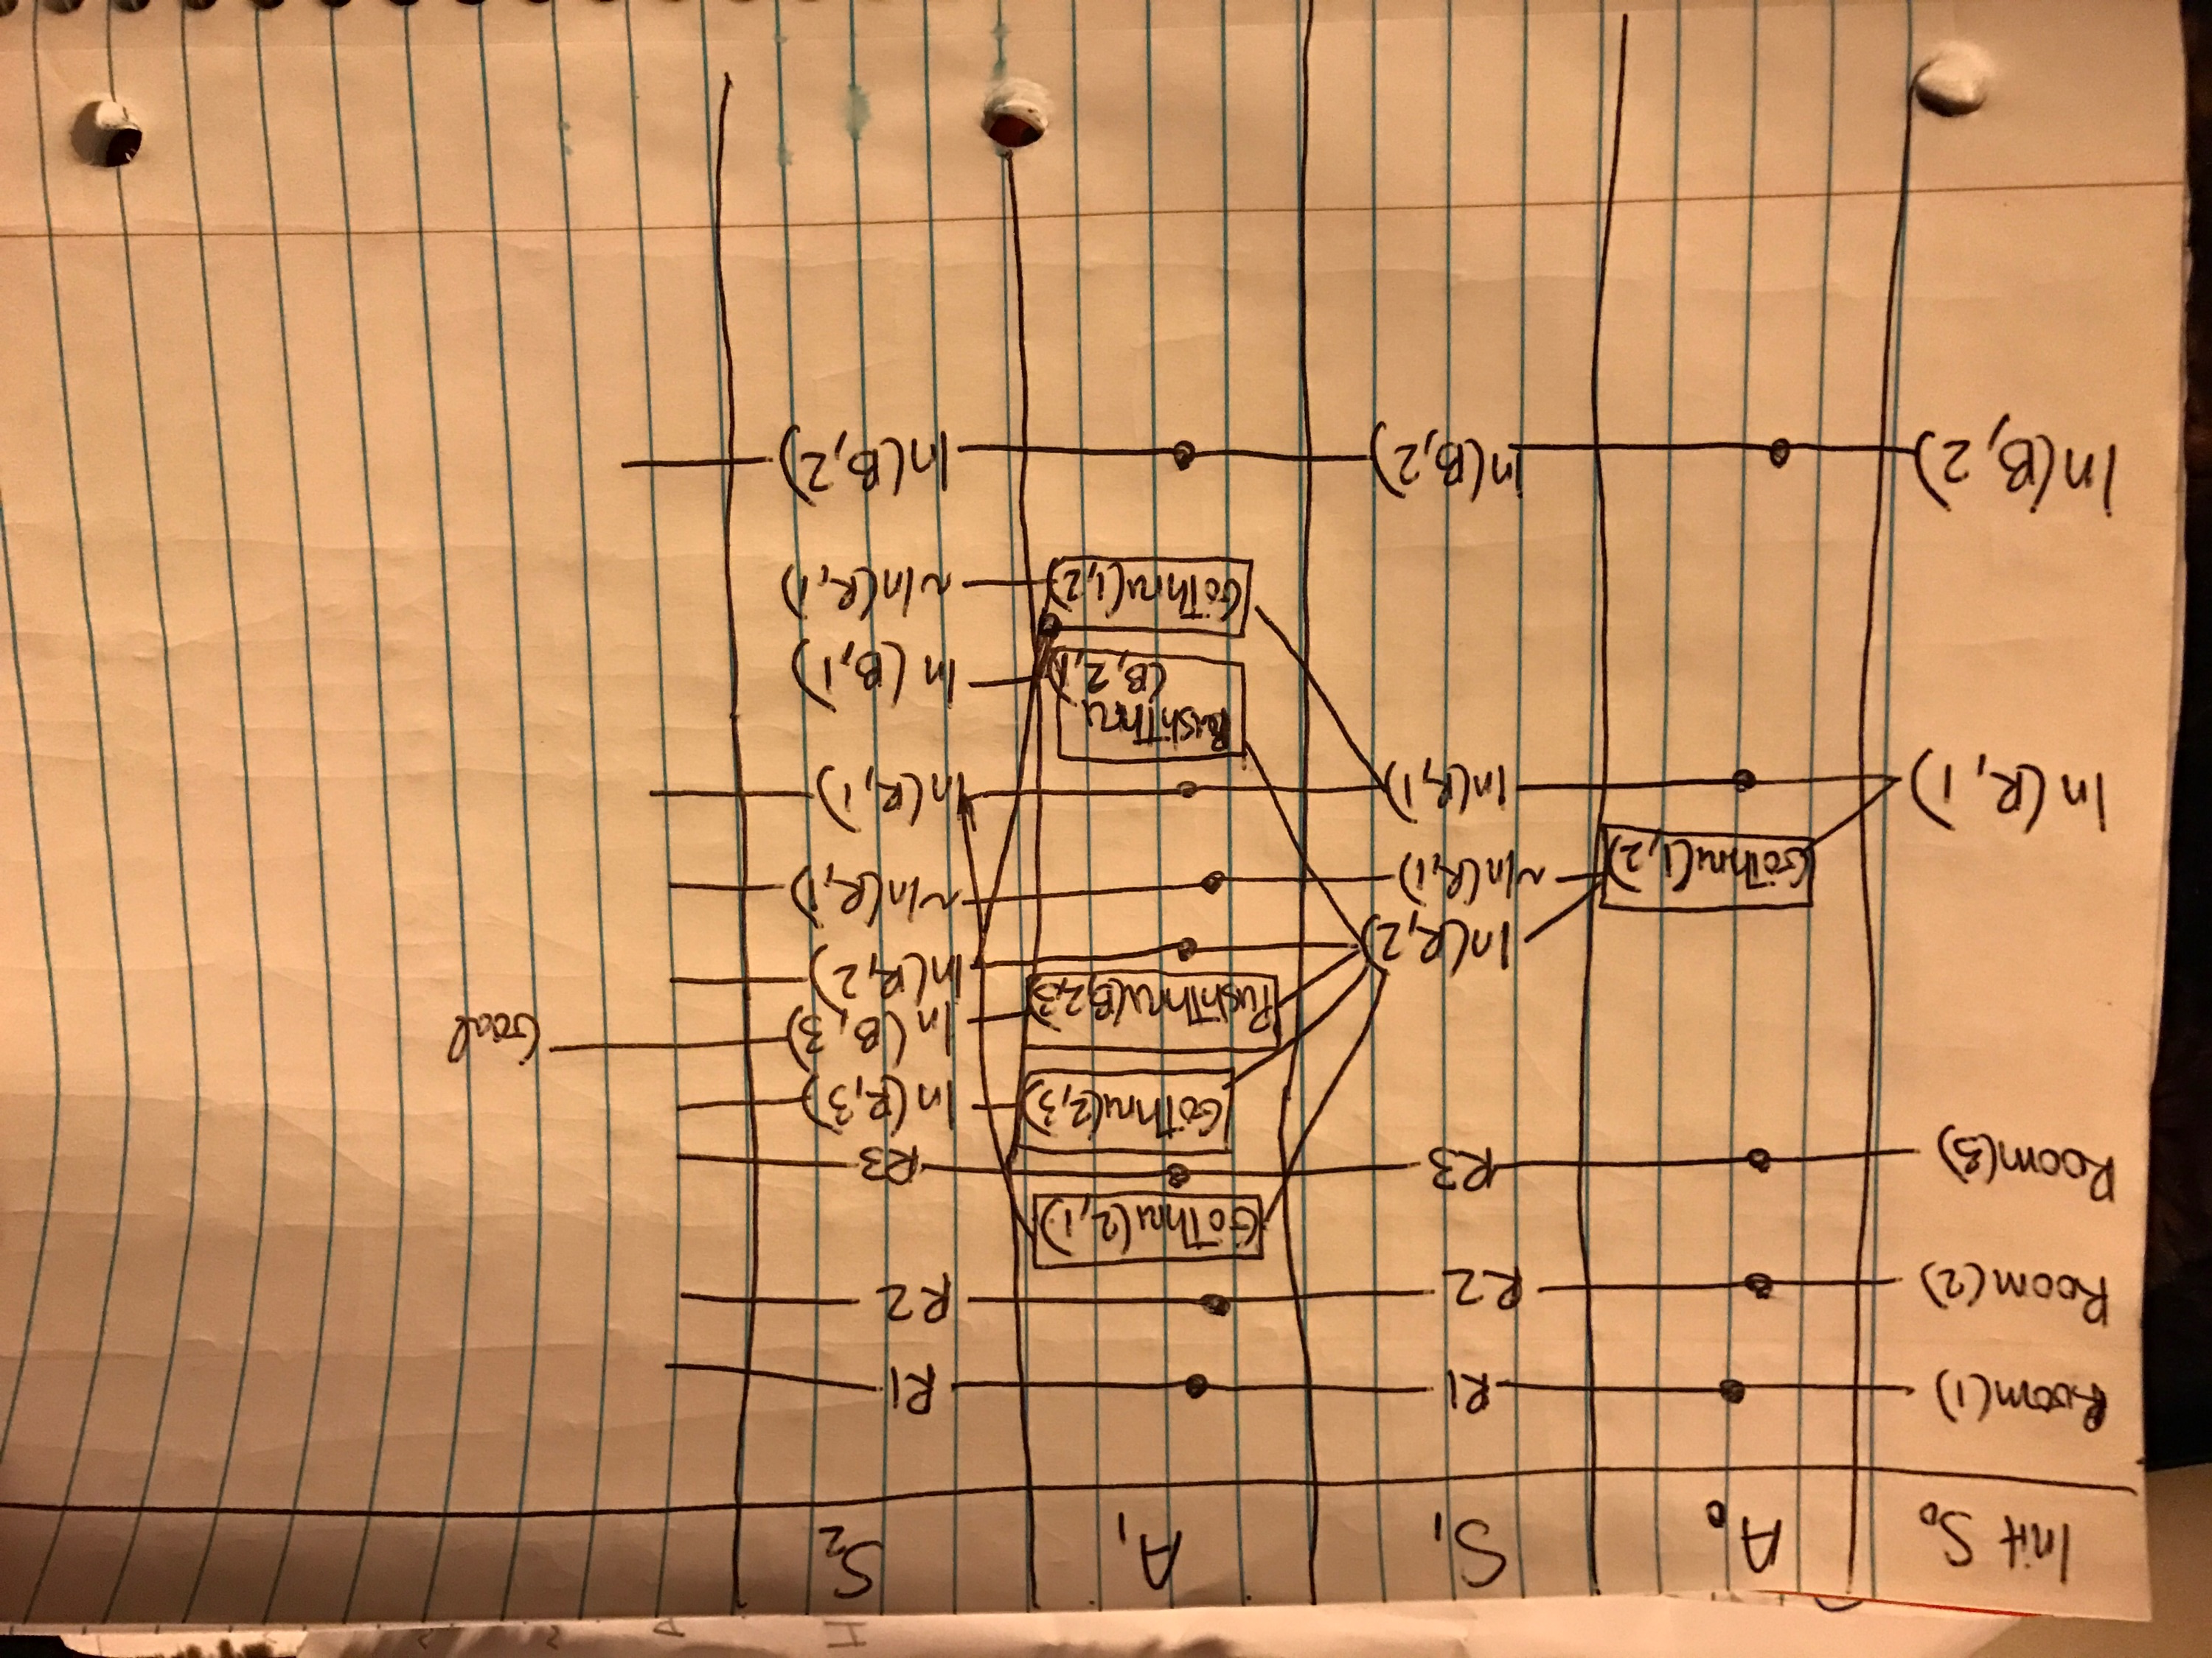

**3:**

**Mutexes for A0:**

Interference mutex, and Inconsistent effects:

The effect of GoThru(1, 2) is ~In(R, 1) which is the negation of the P[In(R, 1)].

**Mutexes for S1:**

Inconsistent Support:

Literal In(R, 2) mutex with persistent In(R, 1).

**4: Heuristic = num_go_thru + num_push_thru.**

1. Robot goes through Door(1, 2). Num_go_thru = 1
2. Robot pushes box through Door(2, 3)

Heuristic = 1 + 1 = 2

**Exercise 4:**

|  |  |  |
| --- | --- | --- |
| **Task #** | **Forward** | **Backward** |
| 1 | Yes | Yes |
| 2 | Yes | Yes |
| 3 | Yes | No |
| 4 | Yes | No |
| 5 | Yes | Infinite Loops |

