**AIM:-** Design automatic led Diwali lights (consisting of 6 led’s) such that it only works during night and can generate two patterns which can be toggled with switch. a. Pattern 1 –led chaser b. Pattern 2 – even-odd led’s

**APPRATUS:-**

**1: 6 LEDS**

**2: ARDUINO**

**3: LDR SENSOR**

**4: WIRES**

**5: RESISTORS**

**6: SWITCH**

**7: BREADBOARD**

CIRCUIT DIGRAM:-

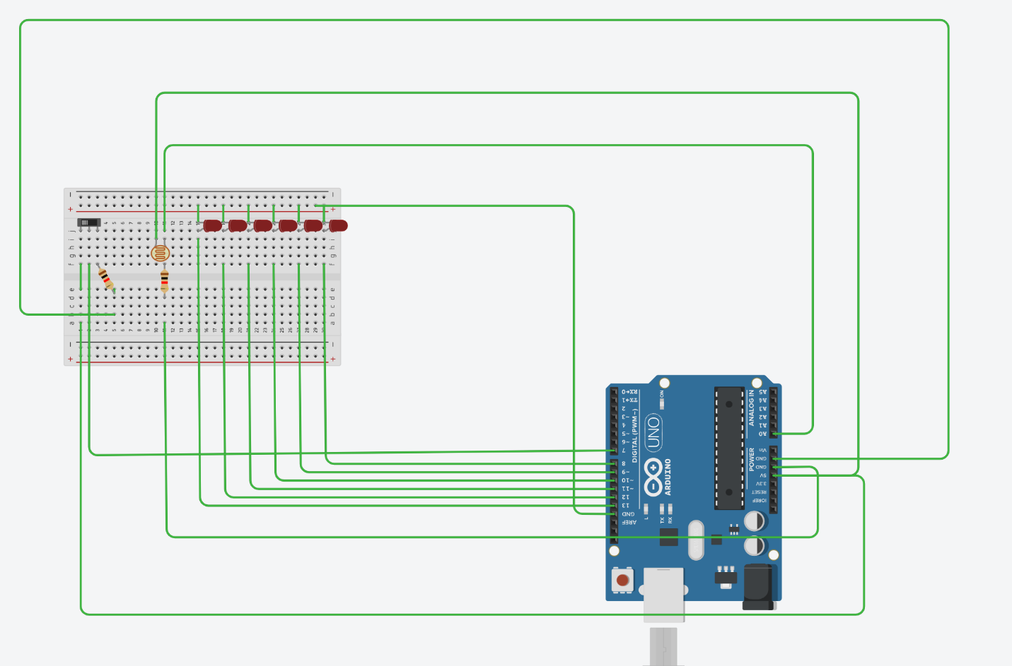

THEORY:-

CONCEPT USED:-

6 lights are used in parallel which are connected with **LDR SENSOR** and the **SWITCH,**

**First the ldr sensor is getting activated if the condition is satisfied then the current is passed to switch (SWITCH IS BASICALLY USED FOR DECIDEING THE PATTEREN OF THE LIGHT )**

**1: When switch is powered first**

**One by one every LED blinks.**

**2:when switch is pressed.**

**3 even led lights up at once and then other 3 odd led .**

**LEARNING AND OBSERVATIONS:-**

**1: Two different types of blinking pattern of led using Arduino.**

**2: To connect LDR sensor with LEDS.**

**3: To change the pattern of blinking of LEDS using switch.**

**PRECAUTIONS:-**

**1: Properly connect the wires.**

**2: Do not supply power to circuit before joining the wires.**

**3: Use of Resistance with LDR sensor.**

**Problems and Troubleshooting:-**

**1: Wires are not connected properly, circuit was incorrect as I rechecked and corrected it.**

**2: Errors in the program.**

**PROGRAM:-**

**void setup()**

**{**

**pinMode(8, OUTPUT);**

**pinMode(9, OUTPUT);**

**pinMode(10, OUTPUT);**

**pinMode(11, OUTPUT);**

**pinMode(12, OUTPUT);**

**pinMode(13, OUTPUT);**

**pinMode(7, INPUT);**

**pinMode(6,INPUT);**

**Serial.begin(9600);**

**}**

**void loop()**

**{**

**int s=analogRead(A0);**

**bool j=0,g=0;**

**if(s<=100&&s!=0)**

**{**

**j=digitalRead(7);**

**Serial.println(j);**

**g=digitalRead(6);**

**if(j==1)**

**{**

**for(int r=8;r<=13;r++)**

**{**

**digitalWrite(r, LOW);**

**}**

**for(int k=1;k>0;k++)**

**{**

**digitalWrite(8, HIGH);**

**delay(1000);**

**digitalWrite(8, LOW);**

**digitalWrite(9, HIGH);**

**delay(1000);**

**digitalWrite(9, LOW);**

**digitalWrite(10, HIGH);**

**delay(1000);**

**digitalWrite(10, LOW);**

**digitalWrite(11, HIGH);**

**delay(1000);**

**digitalWrite(11, LOW);**

**digitalWrite(12, HIGH);**

**delay(1000);**

**digitalWrite(12, LOW);**

**digitalWrite(13, HIGH);**

**delay(1000);**

**digitalWrite(13, LOW);**

**j=digitalRead(7);**

**if(j==0)**

**{**

**break;**

**}**

**}**

**}**

**if(j==0)**

**{**

**for(int d=1;d>0;d++)**

**{**

**digitalWrite(8, LOW);**

**digitalWrite(10, LOW);**

**digitalWrite(12, LOW);**

**digitalWrite(9, HIGH);**

**digitalWrite(11, HIGH);**

**digitalWrite(13, HIGH);**

**delay(1000);**

**digitalWrite(9, LOW);**

**digitalWrite(11, LOW);**

**digitalWrite(13, LOW);**

**digitalWrite(8, HIGH);**

**digitalWrite(10, HIGH);**

**digitalWrite(12, HIGH);**

**delay(1000);**

**j=digitalRead(7);**

**if(j==1)**

**{**

**break;**

**}**

**}**

**}**

**}**

**}**