Matt Rocco

Paul Bliudzius

Team BlueRock

Milestone 2

Change Log:

Milestone 2:

Updated Allocation, Module diagram

Added C&C Diagram

Updated UMLET diagram

Added Feature Listing

Allocation)

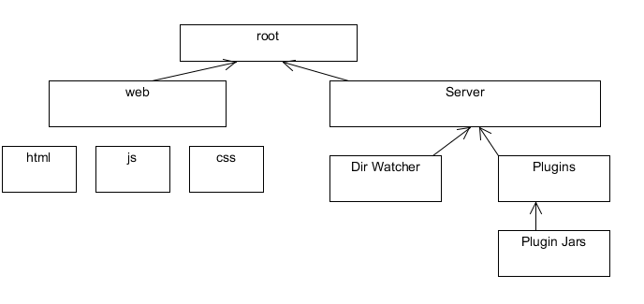

Module)

C&C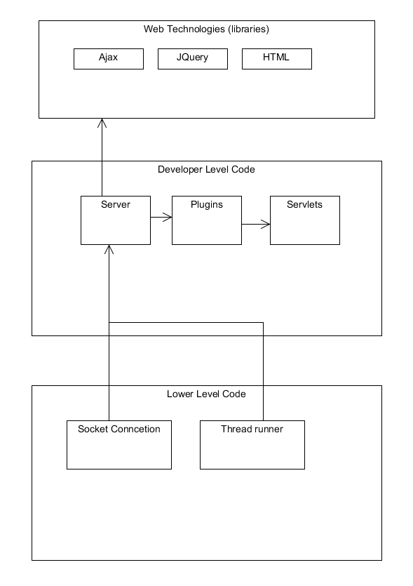

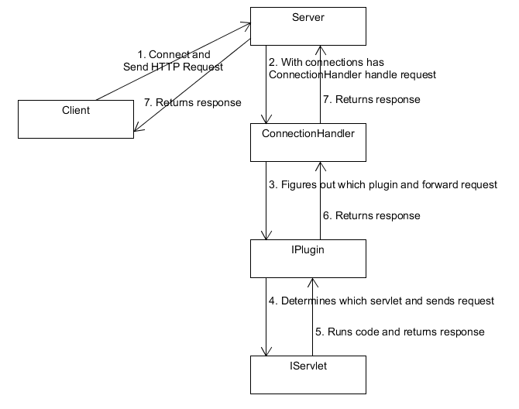

UML

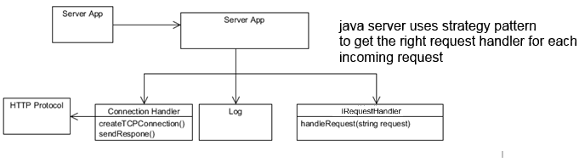

4) Feature Listing

Servlets Paul

Directory Watching Matt

Architecture design Paul and Matt

Jar -> Plugin Matt

Plugin strategy pattern Paul

5) Test Report

6)

7) Our code is written in a way using descriptive variable and function names that it does not need additional commenting.