HealthMon

In case of questions and comments about this document please feel free and contact
Phone: +49 (711) 4102 1541
Email: info@rockit.consulting

Detailed information about the document

Status of the document?
Status Details
Document Status | Date
Possible characteristics:  In progress  In approval  Approved | Since when?  Since when?  Date of approval
In progress | 03/08/2018

Who wrote or changed this document?
Version Control
Version | Changes |  | Author(s)
V 1.0 | Development |  | J. Boehm
V 2.0 | Development |  | A.Mueller

Who was involved in the approval or the review (technical design, review, approval etc.)?
Recipient
Name | Company
Y. Dmukh | rock IT Consulting GmbH

Content
Application “HealthMon” 4
Message Flows 4
HealthMon.msgflow 4
HTTPHealthReport.msqflow 5
XML-Files 6
Exposure of the XML-file containing the information of the interfaces 6
Exposure of the XML-file containing the results of the analysis 8

Application “HealthMon”

This application monitors external interfaces on the basis of an xml-file that describes the interfaces. The results of the monitoring are then provided in a report file.

Message Flows

The application consists of two message flows. The first flow monitors the external interfaces on the basis of an xml-file and writes the results in a report file. The second flow makes the report xml-file available in an internet browser.

HealthMon.msgflow

The “HealthMon” flow is designed to work automatically. However, it can also be triggered to a start message. Responsible for the automatic activation of the flow is a Timeout Notification Node which triggers the flow every half hour . The flow can also be activated through a File Input Node and a HTTP Input Node.

When the flow receives a trigger, it reads out the interface configuration of the xml file that is stored in the FileGetConfig folder. With this information, the flow builds requests that are sent to these interfaces (web sides, databases, queues and java keystores). Afterwards, the flow collects the answers from these interfaces and builds a report file. In the configuration of the xml file is the direction of the report file configured. The report file can be routed to mq, mail, jms, kafka or a folder.
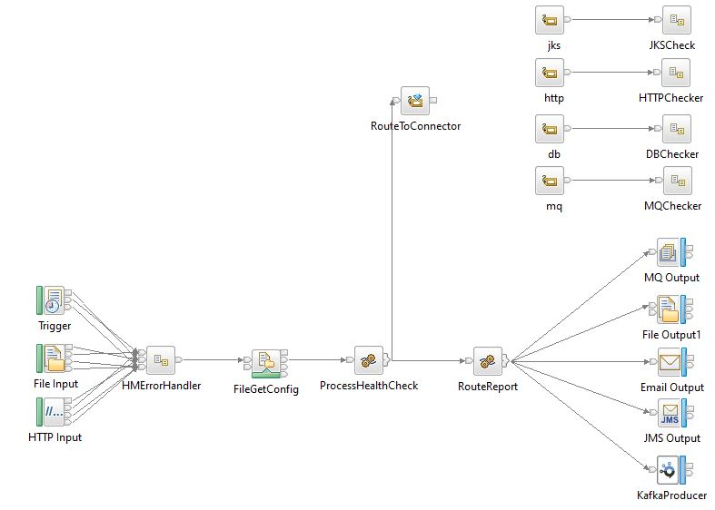
The “HealthMon” flow uses for the evaluation of the interfaces the following three subflows.

HTTPChecker.subflow
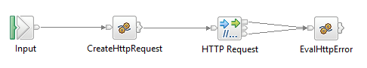
The “HTTPChecker” subflow checks the availability of a web site. There are three responses: side available, side not available and server not available. All the results are documented in the environment.

DBChecker.subflow
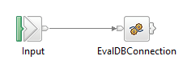
The “DBChecker” subflow controls a database connection. The flow tries to make a connection a table in a database schema. The outcome is stored in the environment and is available for processing in the main flow.

MQChecker.subflow
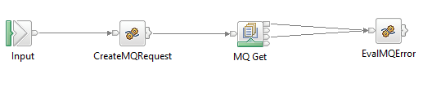
The “MQChecker” subflow tests the availability of a queue. The finding is again stored in the environment and afterwards processed from the main flow.

JKSChecker.subflow
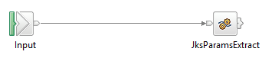
The “JKSChecker” subflow checks the connection and the input from the java keystore. The result after this process is stored in the environment and will be handled by the main flow.

HTTPHealthReport.msqflow

The “HTTPHealthReport” flow is started through a URL request. Subsequently, the flow reads out the report file which stands in the HEALTH.REPORT queue. Finally, the information gathered from the report file is depicted in xml structure in a browser.

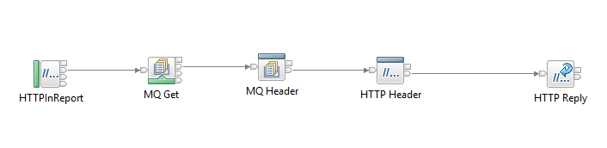

XML-Files

The application works with two xml files. The first file, contains the configuration of the interfaces. The second file is generated through the flow and contains the results from the requests.

Exposure of the XML-file containing the information of the interfaces
<?xml version="1.0" encoding="UTF-8"?>
<healthmon xmlns:n1="http://www.w3.org/2001/XMLSchema-instance" targetNamespace="http://com.rockit/healthmon" n1:noNamespaceSchemaLocation="C:\rockit\projects\rockitsvn_transition\IIB-HealthMon\IIB-HealthMon\healthmon.xsd">
<connectors>
<connector>
<db targetNamespace="http://com.rockit/healthmon/connector/db">
<property name="Id" value=""/>
<property name="ODBCDatasource" value=""/>
<property name="DBSchema" value=""/>
<property name="DBTable" value=""/>
</db>
</connector>
<connector>
<http xmlns:http="http://com.rockit/healthmon/connector/http">
<property name="Id" value=""/>
<property name="LbStatus" value=""/>
<property name="HTTPRequestHeader.Authorization" value=""/>
<property name="HTTPRequestHeader.Content-Type" value=""/>
<property name="RequestURL" value=""/>
<property name="RequestLine.Method" value=""/>
<property name="SSLProtocol" value=""/>
<requesttemplate><![CDATA[<body><xmlrequest></xmlrequest></body>]]></requesttemplate>
</http>
</connector>
<connector>
<jks targetNamespace="http://com.rockit/healthmon/connector/jks">
<property name="Id" value=""/>
<property name="TrustStoreFileName" value=""/>
<property name="TrustStorePwd" value=""/>
</jks>
</connector>
<connector>
<mq targetNamespace="http://com.rockit/healthmon/connector/mq">
<property name="Id" value=""/>
<property name="QueueName" value=""/>
</mq>
</connector>
</connectors>
<reports>
<report level="All" targetNamespace="http://com.rockit/healthmon/report">
<mq targetNamespace="http://com.rockit/healthmon/connector/mq">
<property name="QueueName" value=""/>
</mq>
</report>
<report level="Error" targetNamespace="http://com.rockit/healthmon/report">
<mail targetNamespace="http://com.rockit/healthmon/connector/mail">
<property name="SMTPServer" value=""/>
<property name="Port" value=""/>
<property name="Sender" value=""/>
<property name="Receiver" value=""/>
<property name="CC" value=""/>
</mail>
</report>
<report level="All" targetNamespace="http://com.rockit/healthmon/report">
<file targetNamespace="http://com.rockit/healthmon/connector/file">
<property name="Directory" value=""/>
<property name="FileName" value=""/>
</file>
</report>
<report level="All" targetNamespace="http://com.rockit/healthmon/report">
<jms targetNamespace="http://com.rockit/healthmon/connector/jms">
<property name="qName" value=""/>
</jms>
</report>
<report level="All" targetNamespace="http://com.rockit/healthmon/report">
<kafka targetNamespace="http://com.rockit/healthmon/connector/kafka">
<property name="kafkaConfigProperty" value=""/>
</kafka>
</report>
</reports>
</healthmon>

