SIMATS ENGINEERING (SAVEETHA SCHOOL OF ENGINEERING)
Department of Computer Science and Engineering
CO1 ASSESSMENT TOOL 1 – Case Study Analysis
Course Code: | CSA1001 | Course Title: | Software Engineering
CO Assessed: | CO1 | Assessment: | Assessment Tool 1 – Case Study Analysis
Weightage: | 20% | Total Marks: | 25
CO1 Statement: | Apply advanced methodologies and agile project management techniques to manage software projects effectively
Student Name: | Naveen.S | Reg. No.: | 192524030
Date: | 01-10-2026 | Duration: | 60 minutes

Code of Conduct
I Naveen.S – 192524030 certify that this submission is my original work and that I have adhered to the guidelines specified for this assessment. I understand that any violation of academic integrity rules will result in disciplinary action.
Signature of the Student: _________________________

Annexure A – Case Study Analysis
Instructions to Students:
Each student will be allotted one problem statement. Analyze the assigned problem systematically by following the steps given below. Your report should demonstrate your understanding of software engineering concepts and your ability to design an appropriate software solution.
Based on your allotted problem statement, prepare a report by answering the following questions:
Smart Agricultural Insurance Claim Management and Tracking System

1. Understand the Problem Statement

1.1 Explain the Problem in Your Own Words
• Agriculture is highly affected by risks such as floods, droughts, cyclones, pests, diseases, and crop failure.
• Farmers use agricultural insurance to receive financial compensation when their crops are damaged.
• The existing insurance claim process may involve manual applications, physical documents, field verification, and multiple levels of approval.
• This can result in delay in claim processing, difficulty in tracking claim status, documentation errors, lack of transparency, and communication gaps.
• Farmers may not know whether their claim is submitted, under verification, approved, rejected, or paid.
• Therefore, a smart software system is proposed to digitize, manage, verify, and track agricultural insurance claims.
Proposed idea: The Smart Agricultural Insurance Claim Management and Tracking System is a software platform that allows farmers to submit insurance claims digitally and track their status throughout the complete claim process.

1.2 Objectives of the Proposed System
• Provide a digital platform for agricultural insurance claim submission.
• Reduce manual paperwork and documentation errors.
• Allow farmers to track claim status in real time.
• Improve communication between farmers and insurance providers.
• Support faster claim verification and processing.
• Maintain centralized claim and farmer records.
• Provide notifications about important claim updates.
• Improve transparency in the claim settlement process.
• Support insurance officers in managing and reviewing claims efficiently.
• Maintain secure records of claims and supporting documents.

1.3 Scope of the Problem
The system covers:
• Farmer registration and login.
• Farmer profile management.
• Agricultural land/crop details.
• Insurance policy registration.
• Online claim submission.
• Uploading supporting documents and crop-damage evidence.
• Claim verification.
• Claim status tracking.
• Insurance officer dashboard.
• Claim approval/rejection management.
• Notification system.
• Claim history and settlement/payment status.
• Reports and analytics.
Outside the primary scope:
• Direct physical assessment of every crop field.
• Actual insurance fund management.
• Government policy formulation.
• Physical payment handling by the software.

2. Identify Key Stakeholders and Challenges

2.1 Key Stakeholders
Stakeholder | Role | Major Challenges
Farmers | Register in the system, maintain crop and insurance details, submit claims, upload required documents, and track claim status. | Lack of technical knowledge, difficulty understanding claim procedures, poor awareness of claim status, documentation problems, and internet/connectivity issues.
Insurance Companies | Manage insurance policies, receive claims, verify claim information, approve or reject claims, and process settlements. | Large number of claims, manual verification, duplicate or incorrect claims, processing delays, and maintaining large amounts of data.
Insurance Officers / Claim Assessors | Review submitted claims, verify farmer and crop information, examine damage evidence, update claim status, and recommend approval/rejection. | Incomplete information, difficult field verification, large claim workload, and time-consuming manual processes.
Field Officers | Conduct field-level verification, validate crop damage, collect field information, and submit verification reports. | Travelling to different locations, poor connectivity in rural areas, manual data collection, and difficulty maintaining accurate records.
System Administrator | Manage users, maintain system security, manage system data, monitor system performance, and handle access permissions. | Data security, system maintenance, unauthorized access attempts, backup, and recovery.
Government / Agricultural Authorities | Provide agricultural scheme/policy information, monitor insurance-related activities, support regulatory requirements, and use aggregated reports for decision-making. | Monitoring large numbers of farmers, data integration, and transparency/reporting.

2.2 Major Challenges
• Manual paperwork.
• Delayed claim processing.
• Lack of real-time status tracking.
• Data duplication.
• Incorrect or incomplete information.
• Difficult field verification.
• Poor communication.
• Lack of transparency.
• Fraudulent or duplicate claims.
• Internet connectivity problems in rural areas.
• Data privacy and security concerns.

3. Analyze the Current Approach

3.1 Existing System / Current Process
The following describes a typical traditional/manual claim process as the baseline for this case study.
Farmer → Insurance Office → Claim Registration → Document Submission → Field Verification → Claim Assessment → Approval/Reject → Settlement
1. Farmer identifies crop damage.
2. Farmer informs the insurance provider.
3. Farmer submits a claim application.
4. Required documents are collected.
5. Insurance officer checks the submitted information.
6. Field officer may visit the agricultural field.
7. Crop damage is verified.
8. Claim is assessed.
9. Claim is approved or rejected.
10. Settlement is processed.
11. Farmer receives the claim amount.

3.2 Strengths of Current Approach
• Familiar process for farmers and insurance staff.
• Human verification is possible.
• Physical field inspection can validate crop damage.
• Existing insurance procedures can be followed.
• Suitable for farmers with limited digital access.

3.3 Limitations of Current Approach
• Heavy dependence on paperwork.
• Slow claim processing.
• Difficult for farmers to track claim status.
• Multiple manual verification stages.
• Higher possibility of human errors.
• Repeated data entry.
• Difficult document management.
• Limited transparency.
• Communication delays.
• Difficult to generate real-time reports.

3.4 Problems / Gaps to Be Addressed
Current Gap | Proposed Improvement
Manual claim submission | Online claim submission
Paper documents | Digital document storage
No clear status tracking | Real-time claim tracking
Manual communication | Automated notifications
Difficult verification | Digital verification workflow
Duplicate data | Centralized database
Processing delays | Automated workflow
Limited reports | Dashboard and analytics
Security issues | Authentication and role-based access

4. Propose a Suitable Solution Using Software Engineering Principles

4.1 Proposed Solution
The proposed system is a web/mobile-based Smart Agricultural Insurance Claim Management and Tracking System.
Basic workflow:
Farmer Registration → Insurance Policy Registration → Crop Damage / Incident → Online Claim Submission → Document & Evidence Upload → Claim Verification → Officer Assessment → Approval / Rejection → Settlement → Farmer Tracks Status
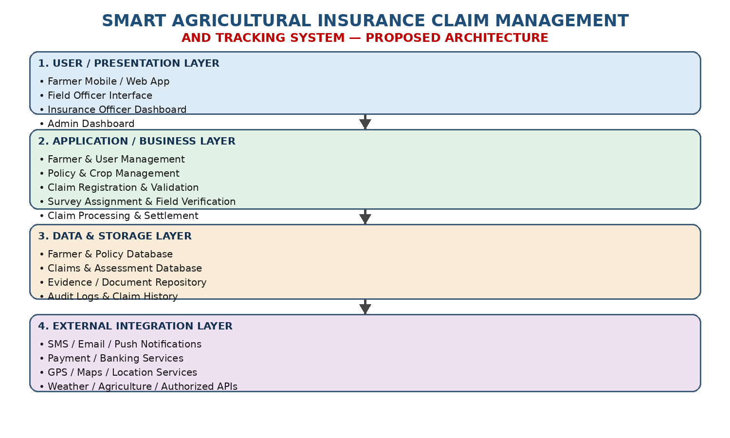

4.2 Major Functional Modules
Module 1 – Farmer Registration & Login
• Farmer creates an account.
• Secure login.
• Profile management.
• Farmer identification details.
• Contact information.
Module 2 – Crop & Insurance Policy Management
• Add crop details.
• Add agricultural land details.
• Record insurance policy information.
• Store policy validity and coverage details.
• View active policies.
Module 3 – Claim Submission
• Select the relevant insurance policy.
• Enter crop-damage details.
• Provide incident date and location.
• Upload photographs/documents.
• Submit the claim digitally.
Module 4 – Claim Verification
• Officer receives submitted claim.
• Checks farmer and policy details.
• Reviews uploaded evidence.
• Field officer can perform physical verification.
• Verification result is recorded.
Module 5 – Claim Processing
• Assign claim to the appropriate officer.
• Perform claim assessment.
• Update claim status.
• Approve, reject, or request additional information.
Module 6 – Claim Tracking
• Display statuses such as Submitted, Under Review, Field Verification, Approved/Rejected, Settlement Processing, and Settled.
• Provide transparency.
• Reduce repeated enquiries.
Module 7 – Notification System
• Claim submission notification.
• Verification notification.
• Approval/rejection notification.
• Additional-document request.
• Settlement notification.
Module 8 – Admin & Reporting Dashboard
• Manage users.
• Manage claims.
• Monitor pending claims.
• Generate reports.
• Monitor processing time.
• View claim statistics.

4.3 Functional Requirements
• Allow farmers to register and login.
• Allow farmers to enter crop and policy details.
• Allow farmers to submit claims.
• Allow uploading of supporting evidence.
• Allow officers to verify claims.
• Allow officers to approve/reject claims.
• Allow farmers to track claim status.
• Generate notifications.
• Maintain claim history.
• Generate administrative reports.

4.4 Non-Functional Requirements
Security
• Secure authentication.
• Role-based access control.
• Data encryption.
• Protection of farmer information.
Usability
• Simple interface.
• Easy navigation.
• Mobile-friendly design.
• Support for simple language/interface.
Reliability
• Accurate claim processing.
• Regular data backup.
• Recovery from system failures.
Scalability
• Support increasing numbers of farmers and claims.
• Allow addition of new insurance schemes.
Maintainability
• Modular software architecture.
• Easy bug fixing.
• Easy addition of new features.
Performance
• Fast claim submission.
• Quick status retrieval.
• Efficient database operations.

4.5 Software Engineering Principles
Modularity
Scalability
Maintainability
Reliability
Usability
Security

5. Justify the Chosen Methodology / Framework

5.1 Selected Methodology: Agile Scrum
Agile Scrum is selected because requirements may change during development, farmers and insurance officers may provide feedback, the system can be developed in small increments, and testing can be performed continuously.
• Requirements may change during development.
• Farmers and insurance officers may provide feedback.
• The system can be developed in small increments.
• Testing can be performed continuously.
• Problems can be identified early.
• New features can be added based on user feedback.
• Regular demonstrations help stakeholders understand progress.

5.2 Scrum-Based Development
1. Sprint 1 – User Management: Farmer registration, login, and profile management.
2. Sprint 2 – Policy Management: Crop details, insurance policy details, and policy management.
3. Sprint 3 – Claim Management: Claim submission, document upload, and claim database.
4. Sprint 4 – Verification: Officer dashboard, claim verification, and field verification records.
5. Sprint 5 – Tracking & Notification: Claim status tracking, SMS/app/email notifications, and claim history.
6. Sprint 6 – Testing & Deployment: System testing, security testing, user acceptance testing, and deployment.

5.3 How Agile Supports Successful Development
Customer feedback: Farmers and officers can provide feedback after each sprint.
Continuous testing: Each module can be tested before integration.
Early error detection: Bugs are identified earlier.
Flexible requirements: New requirements can be included in future sprints.
Incremental development: Working software is produced regularly.
Continuous improvement: Each sprint can improve the system.

5.4 Agile Scrum Team
Product Owner: Represents system/business requirements and prioritizes features.
Scrum Master: Supports the Scrum process and removes development obstacles.
Development Team: Designs and develops the software and performs testing and integration.
Stakeholders: Farmers, insurance companies, insurance officers, field officers, and government/agricultural authorities.

6. Discuss Expected Outcomes and Limitations

6.1 Expected Benefits
For Farmers
• Easy online claim submission.
• Reduced paperwork.
• Real-time claim status tracking.
• Faster communication.
• Greater transparency.
• Reduced need for repeated office visits.
For Insurance Companies
• Centralized claim management.
• Reduced manual work.
• Better document management.
• Faster processing.
• Easier monitoring of pending claims.
• Improved reporting.
For Field Officers
• Digital verification records.
• Better claim information.
• Reduced paperwork.
• Easier coordination with insurance officers.
For Government / Authorities
• Better monitoring.
• Centralized information.
• Improved reporting.
• Better visibility into claim-processing activities.

6.2 How the Solution Addresses Identified Challenges
Paperwork → Digital claim submission
Processing delay → Automated workflow
Lack of tracking → Real-time status tracking
Communication gap → Notifications
Data duplication → Centralized database
Difficult document management → Digital document storage
Manual errors → Input validation
Lack of transparency → Claim history/status
Security concerns → Authentication and access control
Large workload → Dashboard and workflow management

6.3 Potential Risks
• Poor internet connectivity in rural areas.
• Farmers may have limited digital literacy.
• Incorrect information may be entered.
• Cybersecurity threats.
• Data privacy issues.
• System downtime.
• Integration difficulties with existing insurance systems.
• Resistance to changing from manual processes to digital processes.

6.4 Implementation Challenges
• Training farmers and insurance staff.
• Establishing reliable network connectivity.
• Integrating with existing databases.
• Maintaining accurate farmer information.
• Handling large numbers of claims.
• Ensuring secure storage of documents.
• Designing an interface suitable for different levels of digital literacy.

6.5 Limitations
• The system cannot completely eliminate the need for physical field verification.
• Accuracy depends on the information submitted by farmers.
• Digital access may be limited in some rural areas.
• Automated processing cannot replace every human decision.
• Integration with external insurance/government systems may require additional infrastructure.

6.6 Future Enhancements
• AI-based crop damage detection using uploaded images.
• Satellite/drone-based crop monitoring.
• Automated fraud and duplicate-claim detection.
• Regional-language support.
• Offline claim submission for areas with poor connectivity.
• GPS-based field verification.
• Predictive analytics for crop-risk assessment.
• Integration with weather and agricultural data.
• Mobile application for Android/iOS.
• AI chatbot for farmer assistance.

Conclusion
• The proposed system converts the traditional agricultural insurance claim process into a digital and trackable workflow.
• It enables farmers to submit claims, upload evidence, receive notifications, and track claim status.
• Insurance officers can verify, process, approve, and manage claims through a centralized system.
• Software engineering principles such as modularity, scalability, maintainability, reliability, usability, and security improve the quality of the proposed system.
• Agile Scrum supports incremental development, continuous testing, stakeholder feedback, and future enhancement.
• The system aims to reduce paperwork, processing delays, communication gaps, and lack of transparency while improving the overall management of agricultural insurance claims.

Rubrics for Calculation
Criteria | Excellent (5 Marks) | Good (3 Marks) | Satisfactory (2 Marks) | Needs Improvement (1 Mark)
Problem Understanding (30%) | Clearly explains the problem, objectives, and scope with complete understanding. | Explains the problem with minor omissions. | Basic understanding with limited explanation. | Poor understanding; objectives and scope are unclear or missing.
Stakeholder & Challenge Analysis (25%) | Identifies all stakeholders, their roles, and challenges with clear analysis. | Identifies most stakeholders and challenges with adequate analysis. | Identifies only a few stakeholders or challenges. | Stakeholders and system analysis are incomplete or inaccurate.
Current System Analysis (20%) | Thoroughly analyzes the existing system, strengths, weaknesses, and identifies all gaps. | Good analysis with most strengths and weaknesses identified. | Limited analysis with partial identification of issues. | Proposed solution is unclear or inappropriate; requirements are largely missing.
Proposed Software Solution & Software Engineering Principles (15%) | Proposes an innovative, feasible solution applying appropriate software engineering principles (modularity, scalability, maintainability, security, etc.). | Suitable solution with good application of software engineering principles. | Basic solution with limited application of software engineering principles. | Methodology is inappropriate, poorly justified, or not discussed.
Methodology/ Framework Justification (10%) | Selects the most suitable SDLC/model/framework and provides strong technical justification. | Suitable methodology selected with adequate justification. | Methodology selected but justification is weak. | Outcomes, limitations, or future enhancements are missing; report lacks organization and clarity.
Criteria | Mark
Problem Understanding (30%) | /5
Stakeholder & Challenge Analysis (25%) | /5
Current System Analysis (20%) | /5
Proposed Software Solution & Software Engineering Principles (15%) | /5
Methodology/ Framework Justification (10%) | /5
TOTAL | /25

