Alternate Dimension
Flexible Dimension/Dual Chorus
Provided to the DIY community for non-commercial use by Brian Thornock, copyright 2022

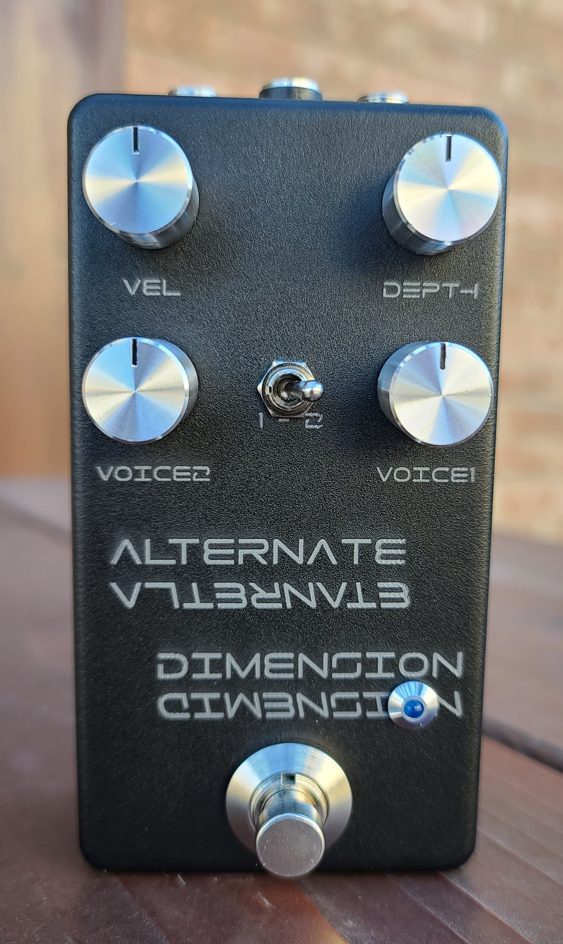
Overview

Dimension chorus is a legendary effect in the guitar world. Created by having two independent choruses driven by out of phase LFO signals, it creates a gorgeous modulation effect without the “wobbly” characteristic of a standard single chorus. It's presence in the DIY world is not well represented as it is both complex and traditionally utilizes analog BBD devices. If you want to build one yourself, you are usually limited to two options: the classic Boss DC-2 clone or the Dimension P DIY project. Both have their pros and cons. The DC-2 clone gets you the sound, but it has a very high parts count, uses expensive and hard to find chips, etc. The Dimension P is significantly easier to build and is based around the ubiquitous PT2399, but the PT2399 is not a great chorus chip, so you really only get an approximation of the sound. Not bad, necessarily, just not accurate.

While repairing a non-functional Boss CE-5, I was introduced to the chip that Boss now uses in all their modern chorus pedals: the ES56028. This is the big brother to the ES56033, which I have used in projects such as the Stalker, the Wobble Box, and the KDLA. The ES56028 has a very short minimum delay time, which is controlled by a single F_Adj pin like the PT2399 (as opposed to the two-pin configuration in the ES56033) which lends itself very well to classic LFO modulation. It also has some other cool features, but not most of them are needed for our purposes here.

When spec'ing out the Alternate Dimension, I decided I wanted to do a dimension chorus with a lot more flexibility. The DC-2 has four buttons which control preset resistor configurations in the LFO for speed and depth. The mix amount of the chorus stages is also fixed. I decided I wanted to have this chorus able to have adjustable mix between the two delay lines and with the clean signal, along with full control of depth and speed of LFO. This has resulted in some rather cool effects, such as single chorus, pseudo-rotary, and a “lopsided” dimension chorus in addition to the classic dimension chorus sounds. The circuit also has the ability to support full stereo in and out. It has been a very difficult project, as layout became critical for noise and other artifacts, but it's also been rather fulfilling. Let's look at how it works.

How it Works

At this point, it shouldn't be much of a surprise to see this input buffer. This is the same input buffer that many of my circuits use. It works well, so let's keep on using it. Note that below only shows the left side input buffer, but there is an identical one for the right side for use in stereo in/out configuration.

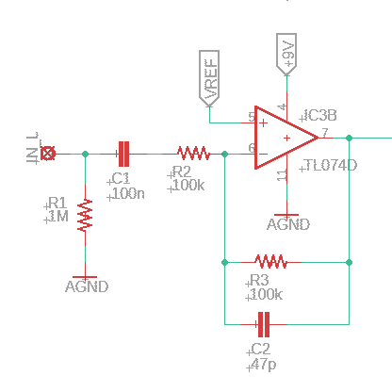
Alternate Dimension Input Buffer

After the input buffer, we have two parallel delay stages. The first stage is hard wired to the left output, while the second stage can be assigned to the right or left output. The stages are identical, save for the input signal and the LFO that feeds them. These stages are similar to what Boss uses as their delay stage for the current CE-5, CH-1, etc. but tuned to my liking. The delay time range is set by a series of pins on the left hand side of the package, which in our case are configured for a very short delay time. I don't know the exact value, as I dialed it in by ear.

Note the multifeedback filter arrangement for both the input and output to the chip (pins 27-28 and 23-24, respectively). These provide low pass filtering to get rid of unwanted high frequency content from the digital side of things. The other right hand side components are also setting filtering of the modulator and demodulator for the digital side of things, similar to what happens with the PT2399, ES56033, etc.

You may also notice that the resistance to ground for the F_Adj pin (pin 6) is split up into two equal resistances. This is done so that the LFO doesn't get shorted to ground or directly coupled to pin 6, each of which does bad things. Shorted to ground, you get no modulation, but coupled directly to pin 6, you get a lot of noise and, depending on LFO, can lock up the chip so there is no output signal at all.

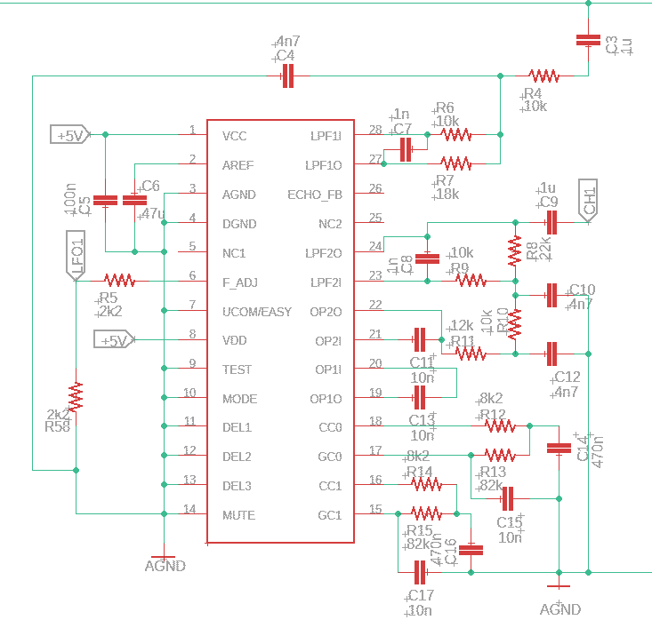
Alternate Dimension Delay Stage 1

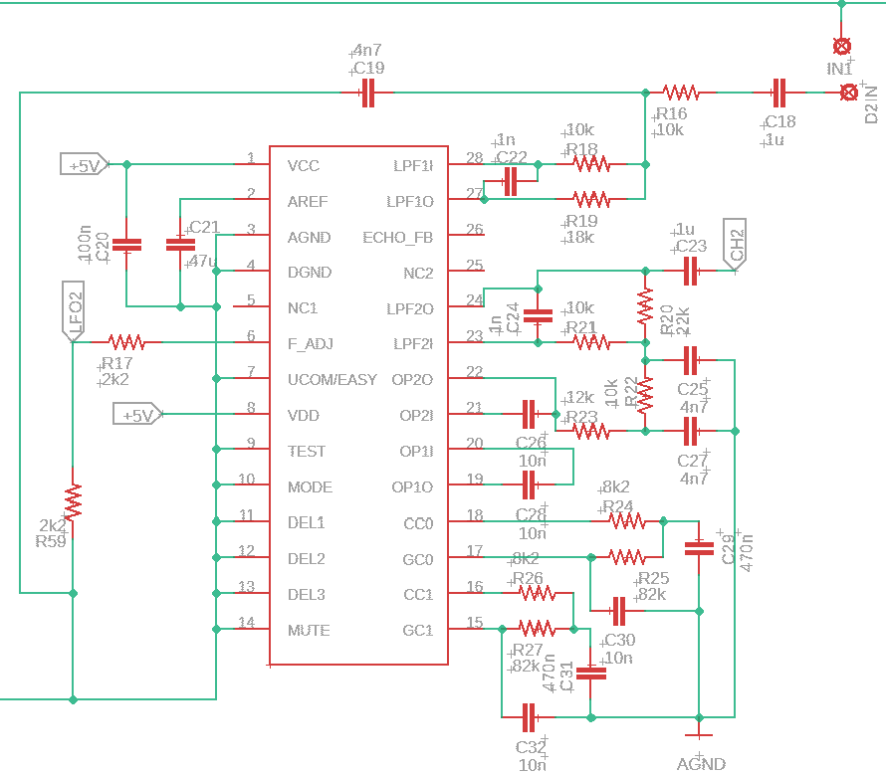
Alternate Dimension Delay Stage 2

Next is the LFO, which results in the modulation of the delayed signal. Because I wanted to get “that” dimension chorus sound as part of the capabilities, I used the DC-2 LFO. This architecture is somewhat different from what is used in the other Boss chorus pedals. However, I replaced the resistors from the DC-2 buttons with pots that were carefully chosen to give more range on either side of both speed and depth. For example, on the speed pot, note the resistor across lugs 1 and 3 to change the 250k pot value into something more like 170k, which gives a very useful range but gets rid of values that are too slow. The DC-2 architecture is what is in the black box in the figure below.

Now we diverge from the Boss architecture briefly. In the DC-2 the output of the LFO is simply buffered before being sent to one delay stage and also getting inverted and sent to the other. In the red box below, the simple buffer has been replaced with a Sallen-Key low pass filter with a corner of approximately 33 Hz to smooth the LFO very slightly, which is helpful in the more extreme settings while still producing a signal that results in a wonderful dimension chorus sound. The keen-eyed observer might note that the large DC blocking cap on the output of the LPF only applies to the input to the phase inverter. This is deliberately done, as a large DC blocking cap immediately after the opamp out (and prior to the pin 6 connection) results in a sloshing of signal from pin 6 which results in noise in the audio path the resembles the sound of an old school lawn sprinkler (chuk-chuk-chuk-chuk) at the rate of the LFO. The large value (470uF) is necessary so as not to get rid of LFO frequencies.

The blue box is the inverting opamp stage. It is set for unity gain and is a very standard configuration. The output is fed to the second delay stage.

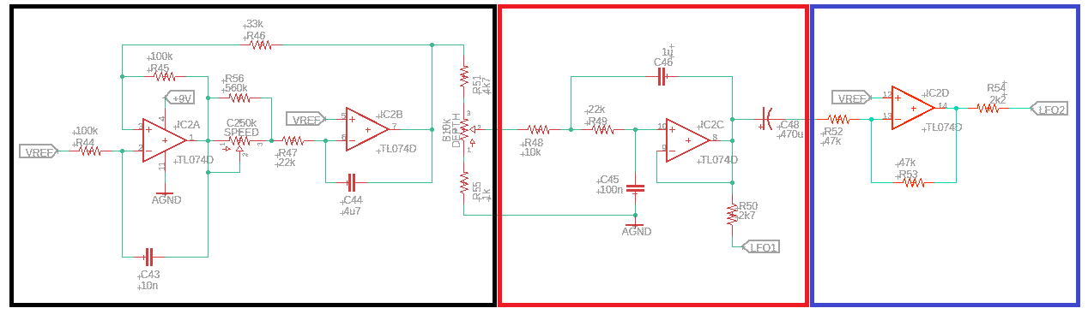
Alternate Dimension LFO

The remainder of the signal path is the summing of dry and delayed signal and output buffering. Note that this is a little complex to allow for the different output configurations available. These include:

- Stereo in/Stereo out
- Mono in/Stereo out
- Mono in/Mono out

Each delay stage has its own mix control. The first delay stage is always tied to the left side output, which is also the mono output in a “normal” guitar signal setup. The second delay stage, after the mix control, can be sent to the right side output buffer, or can be sent to the left side output buffer, which is set up as a summing amplifier for up to three signals (dry, delay 1, delay 2). When set to mono mode, there is a parallel trim pot in the left summing amplifier feedback look that is tuned so that there is no volume increase between mono and stereo (or single voice) chorus modes. The full 100k is pretty close, though playing around with it won't hurt.

Each summing amplifier/buffer output then has the DC blocking cap and a small voltage divider that also acts as a large pull down resistor for the DC blocking cap.
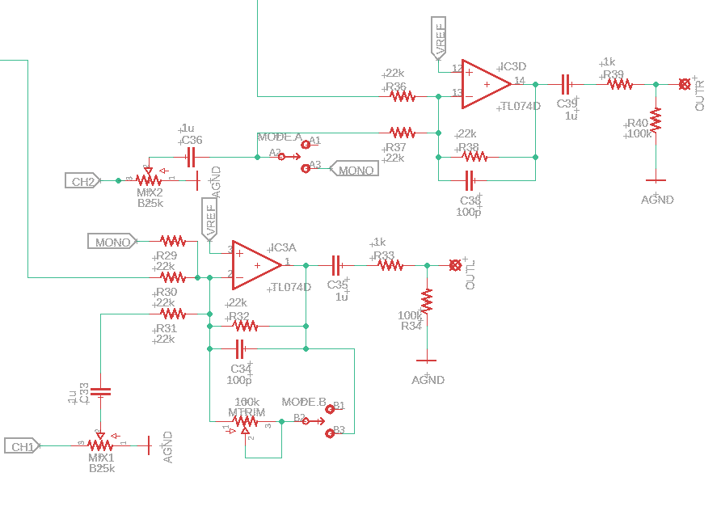
Alternate Dimension Output Mix and Buffer

The power section is pretty straightforward. The +9V and VREF (4.5V) power sources are for the input and output buffers and LFO, while the +5V is for the ES56028.

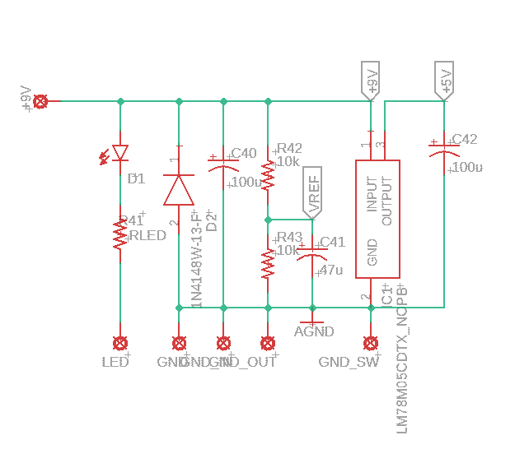
Alternate Dimension Power Section

BOM

The BOM below is the list of parts I used for mine along with quantities. Note that, apart from electrolytic capacitors, all other parts are surface mount with caps and resistors sized at 0805. This was done to keep the board size easy to fit in a 125B. The ES56028S is readily found from UTSource online, where they are reasonably priced. Since they are still used by current production Boss units, I don't imagine they will go EOL for a while.

Part | Qty. | Notes
1k Resistor | 3
2k2 Resistor | 5
2k7 Resistor | 1
4k7 Resistor | 1
8k2 Resistor | 4
10k Resistor | 11
12k Resistor | 2
18k Resistor | 2
22k Resistor | 11
33k Resistor | 1
47k Resistor | 2
82k Resistor | 4
100k Resistor | 8
560k Resistor | 1
1M Resistor | 2
RLED | 1 | CLR for LED
100k Trimmer | 1 | 3362P style
47pF Capacitor | 2
100pF Capacitor | 2
1nF Capacitor | 4
4.7nF Capacitor | 6
10nF Capacitor | 9
100nF Capacitor | 5
470nF Capacitor | 4
1uF Ceramic Capacitor | 9
4.7uF Ceramic Capacitor | 1
47uF Ceramic Capacitor | 2
47uF Electrolytic Capacitor | 1
100uF Electrolytic Capacitor | 2
470uF Electrolytic Capacitor | 1
B10k Potentiometer | 1 | 16mm PCB Mount
B25k Potentiometer | 2 | 16mm PCB mount
C250k Potentiometer | 1 | 16mm PCB mount
1N4148 | 1 | Voltage polarity protection
DPDT Toggle Switch | 1
LED | 1
LM78M05 | 1
TL074 | 2
ES56028S | 2 | 28 Pin SOIC
Enclosure | 1
1/4” input jack | 2
DC power jack | 1
4PDT footswitch | 1 | 4PDT needed for stereo out

Schematic

The schematic for this project is a little big to be legible on a single sheet, so it is also included as a separate PDF in the project documentation folder.
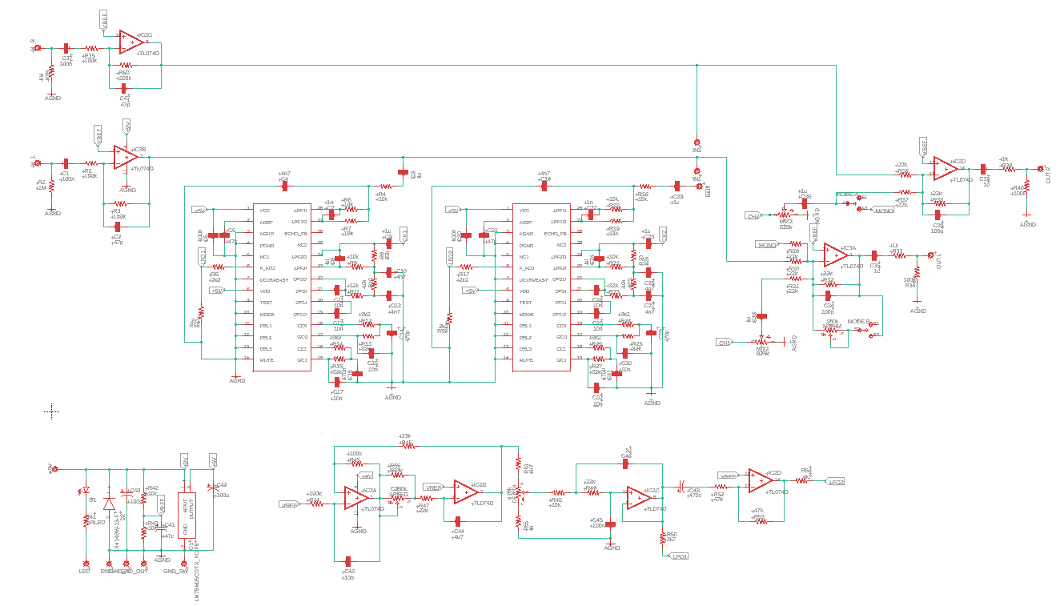

Alternate Dimension Full Schematic
Build Notes

Here are some things I noted from building the Alternate Dimension that might be helpful to you. Please read this section to make sure you don't go through excessive frustration.

Enclosure Size/Drilling

The Alternate Dimension fits nicely into a 125B. The board is a little too wide to fit a 1590B. I also noticed some pots seem to extend slightly more from the mounting holes than the ones I used in my board layout and require just a little finagling to get into the holes that I had laid out in my artwork. Specifically, the two Voice pots and the were slightly more towards the top than the switch, so I had to gently bend the pots such that they lined up with the switch.

Jacks

Whatever jacks you use for in/out and power in 125B are fair game; no restrictions here.

Configuring Input Mode

The board has a 3 pin header just about dead center in it that is used for determining the input signal used for the second delay stage. IN1 is the left side input and IN2 is the right side. For true stereo in, connect IN2 to D2IN. If you are using a mono input, connect IN1 to D2IN. If you will never use stereo mode, the following components can be omitted: R28, R35, R60, C37, C47.

Configuring Output Mode

Output mode can be stereo or mono, regardless of input mode. For mono input and stereo output, connect all three pins of the D2IN header. This will send the IN1 signal into the right summing amplifier so that you have dry signal in both channels. For stereo input and output, the header will connect IN2 to D2IN and have the mode switch set to “1”. For mono input and output, the header should connect IN1 to D2IN and the mode switch should be set to “2”. Additionally, you can set the mode switch to “1” in mono in/out mode to have a single chorus.

In Closing

This is a large project, not for the faint of heart, but incredibly rewarding. The ES56028 parts will easily be the hardest parts to find, but I suggest buying a few, because I have more projects coming that will use them as well.

