Riptide
Real Spring Reverb
Provided to the DIY community for non-commercial use by Brian Thornock, copyright 2021

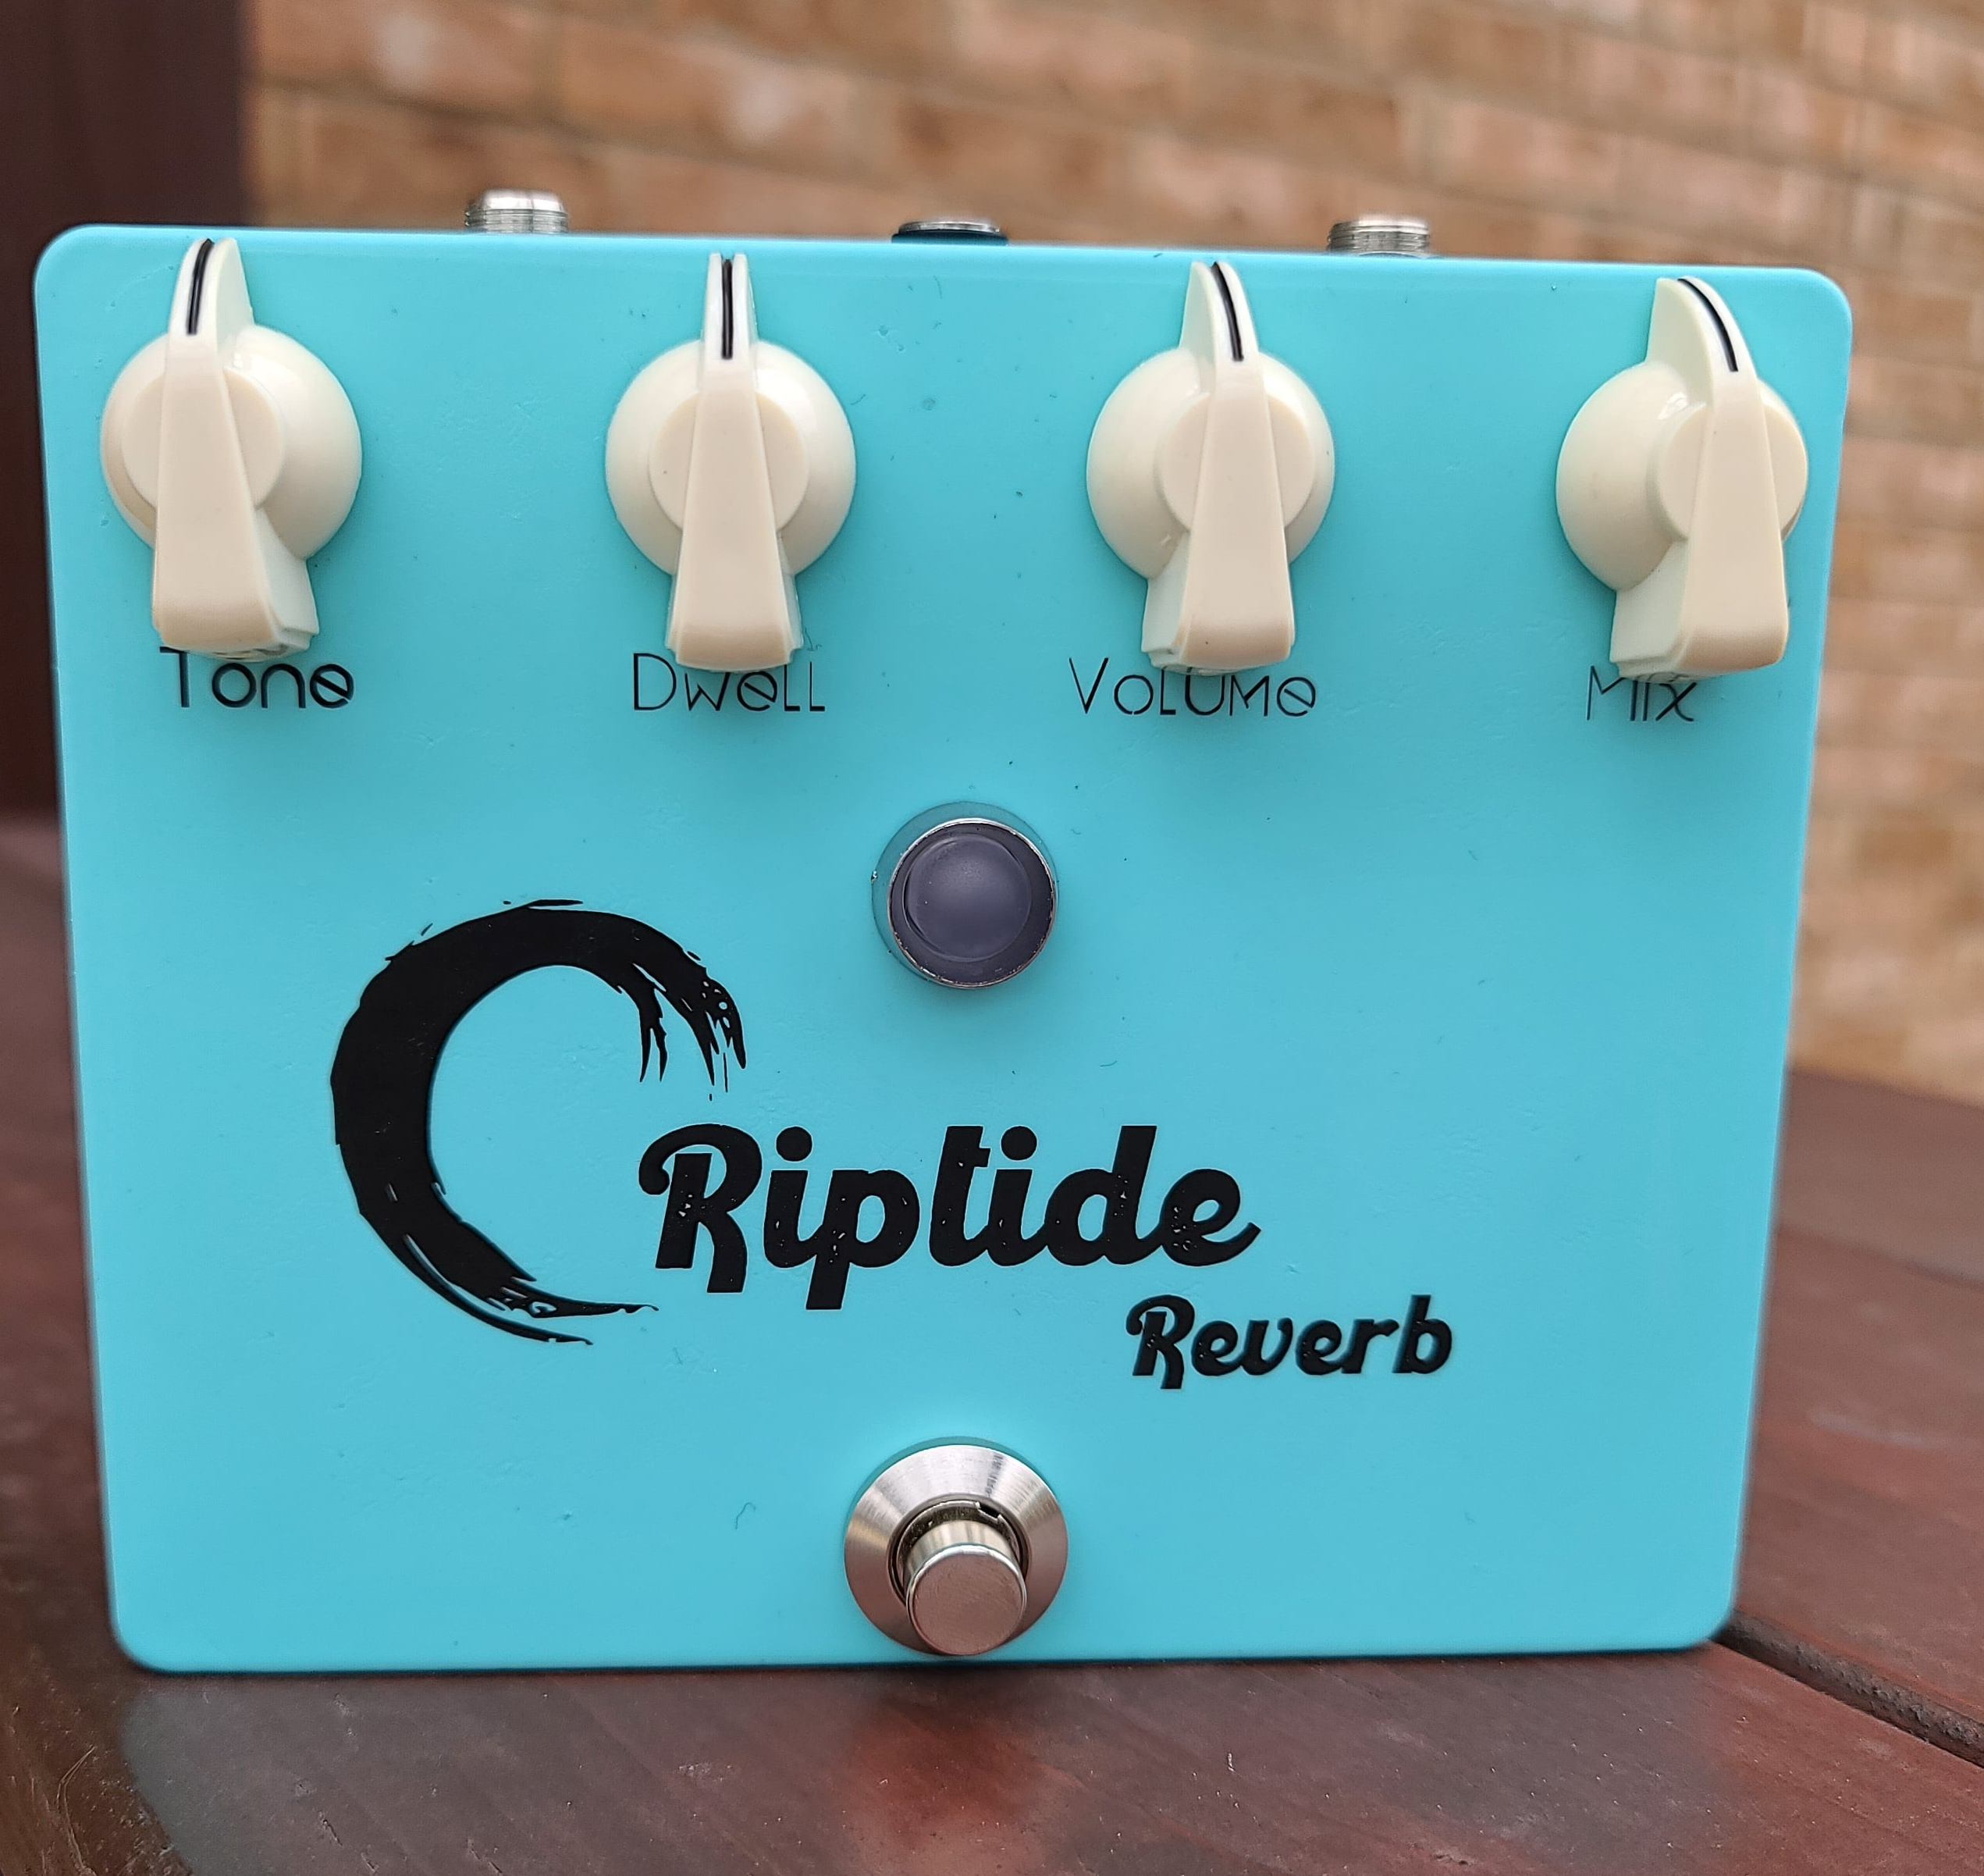

Overview

Reverb is a great effect; it's used almost everywhere. The first portable reverb units were those build into early amplifiers, such as the Fender “Reverb” series amplifiers. Many pedal incarnations seek to capture the drippy, surfy tone of spring reverb through use of DSP, PT2399 chips, or various other methods. However, there is very little that can really substitute for the physical motion of sound through springs. There are nonlinearities and other effects that are very hard to program in DSP and that are impossible to capture with components like PT2399.

A real spring reverb in pedal size is difficult because the springs need physical space to be placed in, along with their corresponding drivers. The reverb tanks found in amps are far too large for pedals, but fortunately Accutronics (makers of most spring reverb tanks as well as the Belton reverb bricks) make a small, two-spring, plastic-encased spring tank for approximately $10 US. At half the price of the FV-1 or Belton brick, it's an attractive option. Keep in mind that springs this small inherently won't have really long decay times, but it gives you plenty of springy goodness that fits in a 1590XX enclosure. In fact, this tank is what Spaceman uses in their $500 Orion spring reverb pedal.

How it Works

Having a spring tank is only part of the equation. The spring tank needs to be driven by our audio signal. Because we are driving a physical transducer, the selection of components such as opamps is more critical, as not any old opamp, for example, can provide enough drive current for the low input impedances of physical transducers. In the case of Riptide, we are driving a 150 Ohm tank, which is like driving a set of headphones.

In addition to component selection, Riptide further taps into the vintage tone profile by using a JFET preamp that gives some great color. It's essentially the Dunlop EP101 Echorec Preamp with a fixed gain, which sounds great and helps lend some of the vintage warmth associated with an old school spring reverb. Note that C2 is adjusted for overall circuit brightness, if desired. As specified, it provides a nice, balanced tone that doesn't go too bright or too dark.

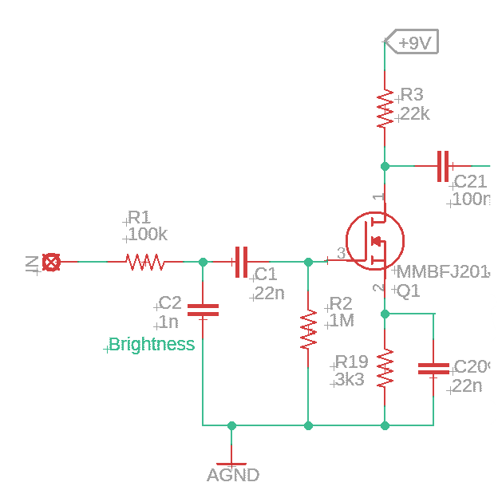
Riptide Preamp

One design choice with Riptide was the ability to have reverb tails. To do this, a J112 JFET is used as a switch for the reverb path, so that when reverb is disengaged, whatever signal is still in the system is able to propagate to the output. This also means that the preamp is always active, which can be great if you like the tone of it. Of course, it can also be wired up as true bypass without a problem. For specific instructions, see the Build Notes section near the end.

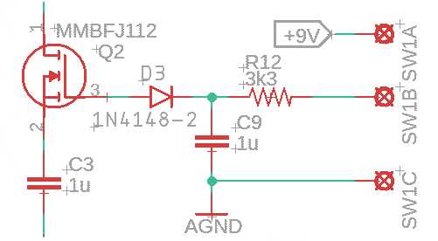
Riptide Tails Switching

Next is the tank driver section. This is pretty straightforward and is a pretty bog-standard implementation of the spring reverb driver found on the excellent Elliot Sound website: https://sound-au.com/articles/reverb.htm. The Dwell control determines how hard the tank is driven. Driving it harder introduces more nonlinearities and possibly some saturation of the springs. The use of the NE5532 is critical because of its current drive capabilities. This is also a great opamp for driving headphones, as found in deadastronaut's ASTROSIM cab sim (an excellent project that I highly recommend! https://deadastronaut.wixsite.com/effects/astrosimcabsimulator). I experimented with feedback in the system, but it ran away easily and when it didn't, it still wasn't terribly musical or even pleasant sounding. Note that RS stands for Reverb Send, with the + and – indicating the connections to the reverb tank input terminals.

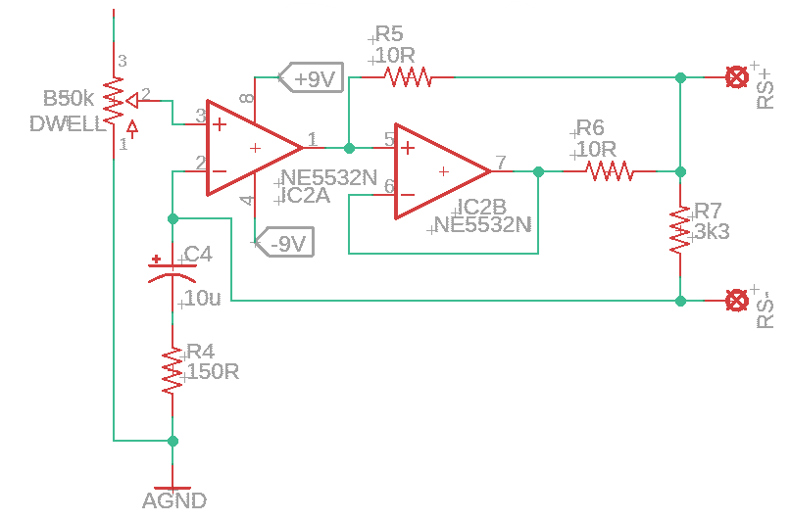
Riptide Drive Stage

Once the signal has been amplified and sent to the tank successfully, the reverb signal needs to be shaped and amplified. The NE5532 is used here as well, though it is probably less critical than the drive stage, but still highly recommended, as that is what I used. R8 and C5 change the tonal response of the output signal, where R9 acts as the gain control of the peak created and C5 determines the frequency of the peak. I played around with various values and found that these sounded quite good. It is possible to replace R8 with a pot to give an adjustable peak gain, but I didn't find it necessary (given the inclusion of a tone control later). R9 is to prevent railing out the opamp if the tank gets disconnected, and R11 controls the overall gain of the recovery stage (in conjunction with R10, do you see the basic non-inverting opamp gain stage structure?). Note that RR stands for Reverb Recovery and the + and – symbols indicate the appropriate connection to the tank output terminals.
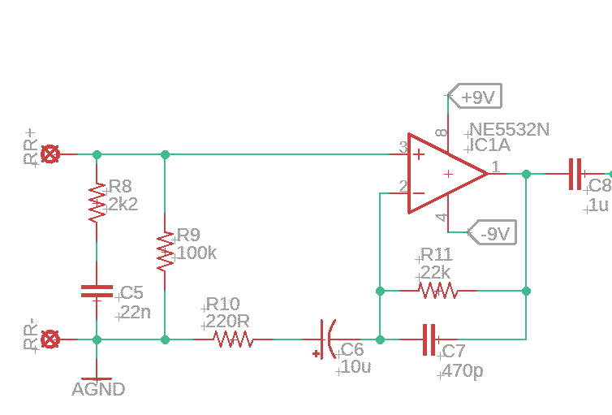

Riptide Recovery Stage

Now that we have our fully wet signal, we have the final stages which provide the tone and mix controls as well as the summing output buffer to combine the wet and dry signals. The tone control is one I've used before, and is the same architecture as that used in some EQD pedals. It's pretty flexible with a minimal parts count. The summing amplifier/output buffer is pretty standard stuff and, if you've seen any of the other projects, you've likely come across something very similar.
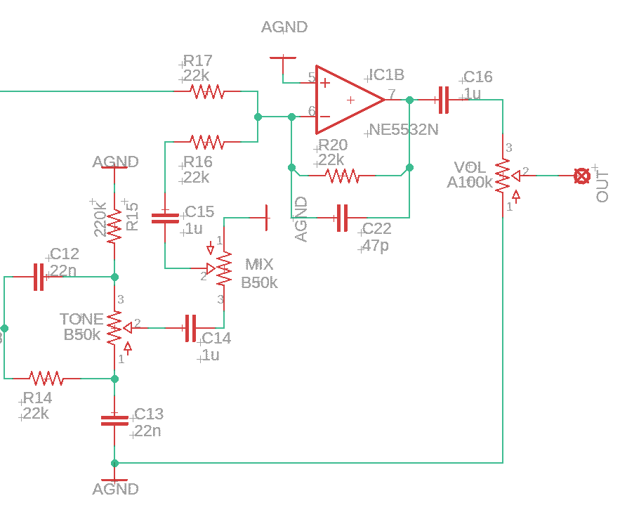
Riptide Output Stage

The power section provides both + and – 9V so that the opamps can be run at a dual voltage supply. Using the bipolar supply instead of just doubling to 18V allows for the elimination of a few extra passive components.

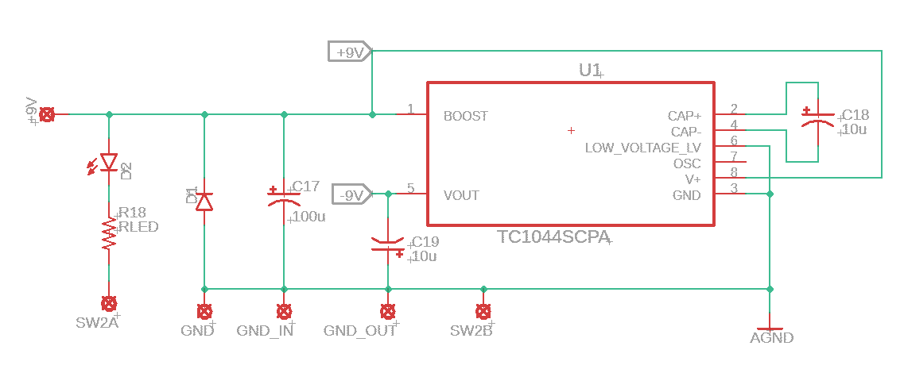
Riptide Power Section

BOM

The BOM below is the list of parts I used for mine along with quantities. I purchased everything from Tayda except for the reverb tank, which I got from AmplifiedParts.com. Also note that the BOM is for all components, including those used for tails switching. If you choose to forego tails, see the section in Build Notes regarding which parts can be changed or eliminated.

Part | Qty. | Notes
10R Resistor | 2
150R Resistor | 1
220R Resistor | 1
2k2 Resistor | 1
3k3 Resistor | 3
22k Resistor | 6
100k Resistor | 2
220k Resistor | 1
1M Resistor | 1
RLED | 1 | CLR for bypass LED
47pF Capacitor | 1
470pF Capacitor | 1
1nF Capacitor | 1
22nF Capacitor | 5
100nF Capacitor | 1
1uF Capacitor | 6 | Ceramic/film
10uF Capacitor | 1 | electrolytic
100nF Capacitor | 1 | electrolytic
A100k Potentiometer | 1 | 16mm PCB Mount
B50k Potentiometer | 3 | 16mm PCB Mount
1N5817/1N4001 | 1 | Voltage polarity protection
1N4148 | 1 | Only used for Tails switching
MMBFJ112 | 1 | Only used for Tails switching
MMBFJ201 | 1
LED | 1
TC1044S | 1
NE5532 | 2
Accutronics AMC2BF2 | 1 | 150 Ohm reverb tank
Enclosure | 1 | 1590XX or 1590DD
1/4” input jack | 2
DC power jack | 1
3PDT footswitch | 1 | Only for True Bypass switching
DPDT footswitch | 1 | Only for Tails switching

Schematic

The schematic for this project is a little big to be legible on a single sheet, so it is also included as a separate PDF in the project documentation folder in addition to the figure shown below. Note that the schematic does not actually show the tank. The RS +/- and RR +/- connection points indicate where the tank is attached.

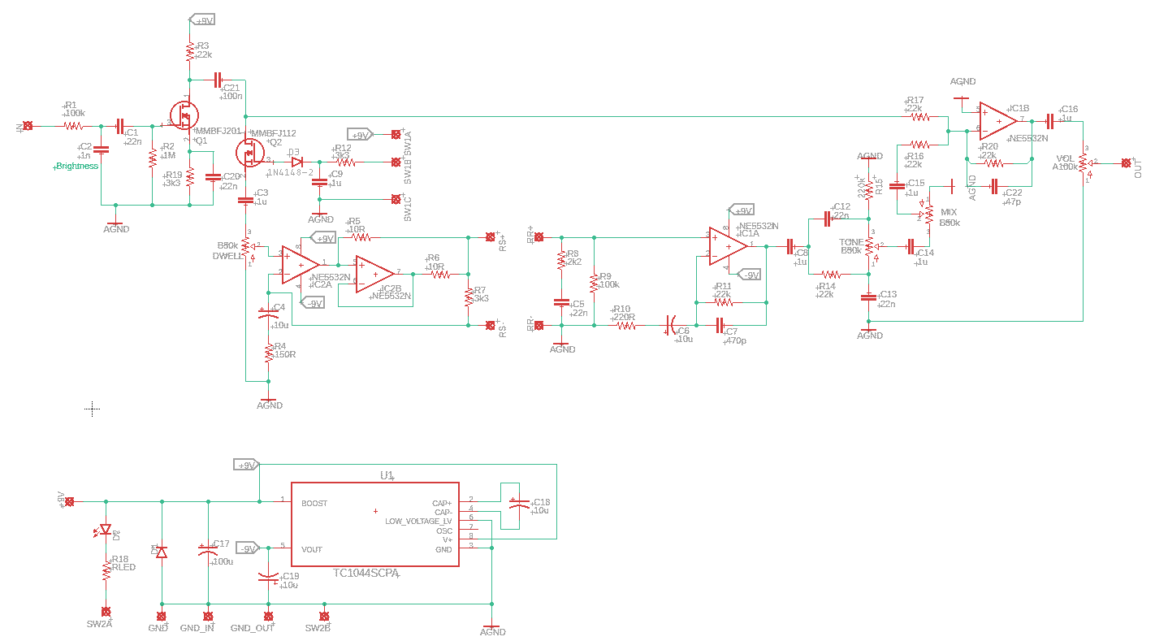
Riptide Full Schematic
Build Notes

Here are some things I noted from building the Riptide that might be helpful to you. Please read this section to make sure you don't go through excessive frustration.

Enclosure Size/Drilling

The Riptide was made to fit into a 1590XX or 1590DD, but it does require some careful planning if using the XX. The tank will just fit inside and will require four mounting holes to be drilled. See the Reverb Tank section below for further details.

The board would also work as a standalone driver unit with jacks for the RS and RR connections, but if you do this, keep in mind that this is specifically designed for low input impedance tanks. Some adjustments may be needed for larger tanks, which tend to have higher input impedances.

Jacks

The board has some empty space right below the Mix and Tone pots (don't reference my finished pedal picture for this, as I labeled it wrong... :( ). You can use pretty much any type of jack in this location. In other locations, you may need to use open frame jacks, like I did.

Foot Switch

The footswitch is mounted between the tank and the edge of the enclosure. In order to minimize conflicts, a low profile switch is advisable, whether using a 3PDT or DPDT.

Tails/True Bypass Switching

As mentioned, Riptide is capable of either tails or true bypass switching. If using tails, the input jack is wired directly to the IN pad on the PCB and the output jack is wired directly to the OUT pad on the PCB. The SW1_A, SW1_B, and SW1_C pads get wired to one pole of the DPDT switch, while the SW2_A and SW2_B pads get wired to the other pole.

When using true bypass, wire up the 3PDT in the standard fashion, where SW2_A and SW2_B are used for the indicator LED. In this arrangement, SW1_A, SW1_B, and SW1_C pads are left unconnected. Also, true bypass allows for elimination of Q2, D3, R12, and C9. If doing this, jumper pads 1 and 2 for Q2. This is how I have mine wired.

Reverb Tank Considerations

Since we are using a physical tank, we need to take a few things into account. First is that vibrations will cause tank rattle/splash. Not necessarily a problem, but something to take into account. To minimize this, you can buy rubber grommets for mounting reverb tanks. I ordered a set and cut them in half, since they were a little tall for a 1590XX enclosure. Additionally, using a low contact force switch is advisable. You could even do a soft touch relay bypass here if you like. I just used a standard 3PDT blue switch, so listen to the demo when switching on.

Next thing to consider is connecting the tank to the board. The tank comes with quick disconnects. You can purchase the connectors and solder them to the board, but I just clipped them off and soldered the wires directly to the board, since I'm not going to remove the tank at any point.

Finally, I mounted the tank to the bottom cover so that there wouldn't be any screws showing on the top face of the pedal. The tank has holes that are sized for #4/M3 screws to go through. My local hardware store, however, stopped carrying #4 sized screws, so I threaded the plastic holes of the tank to be #6-32 and screwed them directly in. Not a lot of force is needed to keep the tank snug. Make sure you measure the location carefully so that you don't accidentally end up with a tank colliding with the PCB when closing it up.

In Closing

This is a great surfy reverb that can be built for surprisingly little money. The enclosure and tank together cost about the same as the Belton brick. While it may not get the same reverb as a Twin, it sure sounds great and takes up about as much board space as a popular digital pedal. Happy surfing!

