Spare Room
Compact Reverb
Provided to the DIY community for non-commercial use by Brian Thornock, copyright 2021

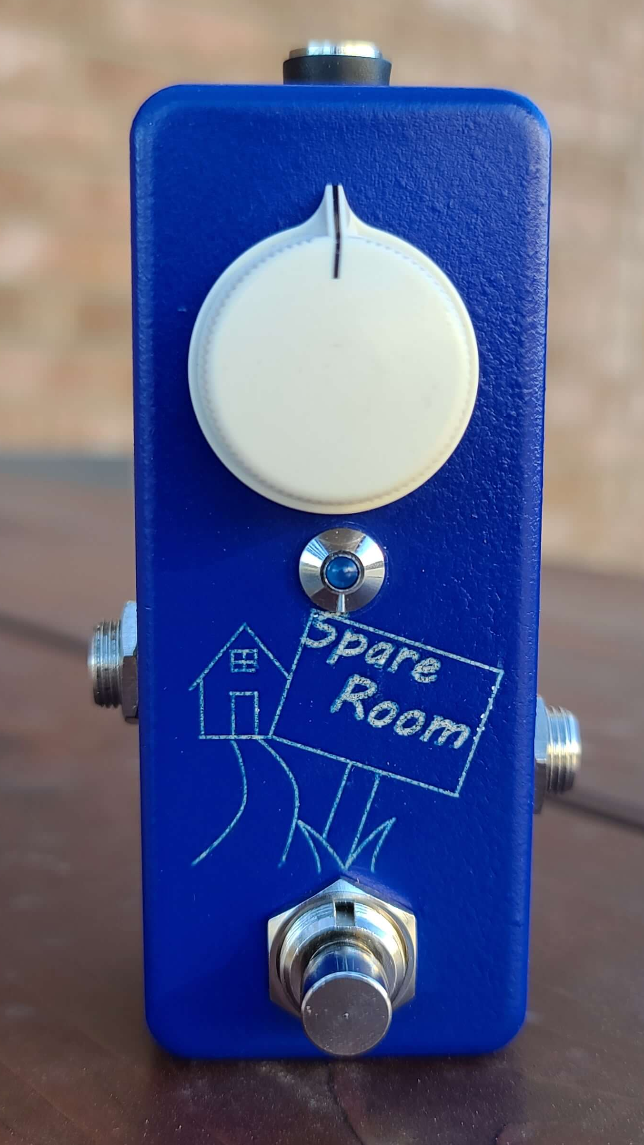
Overview

In the DIY world, reverb projects seem to be few and far between. Most that are out there rely on the Belton brick or the FV-1 DSP chip. Both are great options, but both are also approximately $20 each, which makes for a pricey component. One of the more popular DIY reverb projects that requires neither of these is the Equinox II by Merlin Blencowe (AKA ValveWizard). When researching for the T60 Reverberator, I built the Equinox II and didn't really like the sort of metallic ringing sound it had to it. I moved on from it without any real experimentation.

After completing the T60, I decided to try my hand a simplified reverb. In doing so, I came back to the Equinox II and found that a few moderate changes made for a much more pleasing effect, thus the Spare Room.

The Spare Room PCB is just a little larger than the potentiometer footprint, making it ideally suited as a standalone reverb module for small practice amps, multi- effects pedals, or just in a small enclosure to use the spare room on your pedalboard.

How it Works

As mentioned, the Spare Room started life as the Equinox II, but there are some notable changes which make it it's own thing. The primary changes from the Equinox II are:

- Remove JFET bypass for tails
- Send the output of stage one through a filter and feed it into the input of stage two
- Modulate the delay time for second delay stage using a simple LFO

The removal of the JFET and associated components for tails bypassing was a more logistical thing, as I wanted to put this into a 1590a enclosure. Could I have squeezed it in there? Maybe, but I didn't feel comfortable doing it with the board space I had left due to ground plane considerations. If you are building it in a larger footprint and want tails, go for it.

Taking the output of stage one and feeding it into stage two allows for a perceived third delay line in the signal. We all know that the Belton brick has 3 PT2399's in it, so I figured if I could get a third delayed signal, it would help provide a sense of additional space. However, as sound propagates, some frequencies get lost. In a room, the high frequencies get dampened due to absorption of both surfaces and air more readily than lower frequencies, so I passed the signal through a single order low pass filter to roll off a touch of the highs to give a more realistic effect.

The addition of an LFO providing subtle modulation of the delay time of the second chip makes a world of difference. The source of the metallic ringing in the Equinox II is having static delay times that build on top of each other. With just a little modulation to the delay time, this effect is drastically reduced and the resulting reverb effect is far more pleasing. The LFO used in this case is a single transistor design from the modified EA tremolo. This is a great LFO for space-conscious designs, which was a requirement for fitting all of this into a 1590a, even going full surface mount.

The Spare Room uses the same input buffer as the Equinox II, as it works well enough and I already had it on the breadboard.

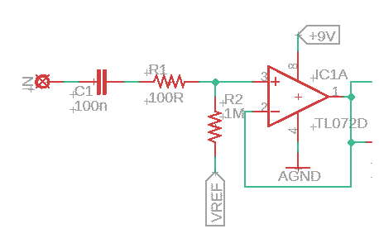
Spare Room Input Buffer

Next up is the first delay stage. The input filtering to the PT2399 uses a slightly different topology from my other designs. Instead of being a multifeedback design, this is a more straightforward low pass filter design. This is a very basic stage, though notice how pin 12 has two outputs. The TO2 marker indicates that it will go to pin 12 of the second delay stage, just like the original Equinox II. However, R7 and C11 provide low pass filtering and R8 connects the filtered output to the input of the second delay stage.

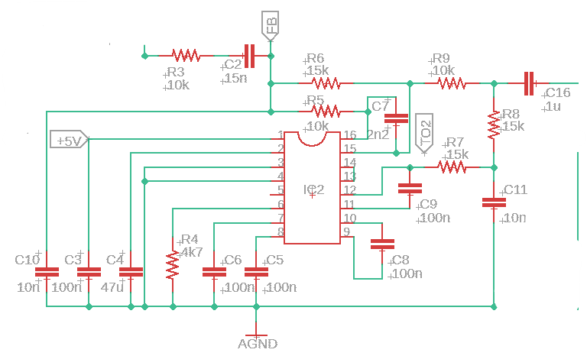
Spare Room First Delay Stage

The second delay stage is another fairly straighforward delay stage, except for the addition of the LFO signal between R32 and R10 off of pin 6. The delay time is set as two similar resistors so that the LFO does not (a) go to ground and (b) go directly to pin 6. If the LFO goes to ground, then there is no modulation. If it goes directly to pin 6, it can actually cause the chip to latch up under certain circumstances. Notice the filtering networks starting with C20 that filters the outputs of both delay stages before being sent to the mix control and output buffer.

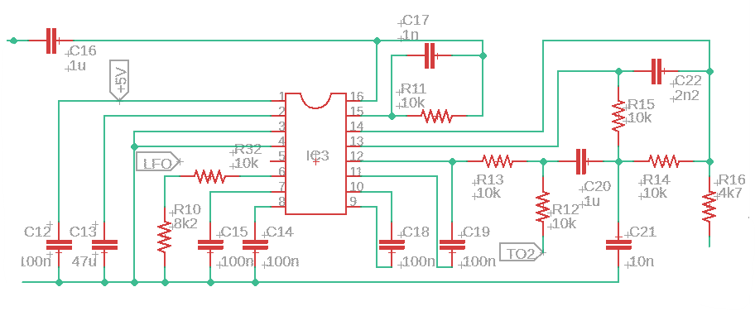
Spare Room Second Delay Stage

Once both delay lines are filtered, the signal gets sent back to the feedback input for both chips as well as the mix control. The mix control and output buffer are set up the same as the Equinox II, because if it ain't broke, don't fix it. The output buffer adds some additional brightness compared to the true bypassed signal, but overall volume remains comparable.

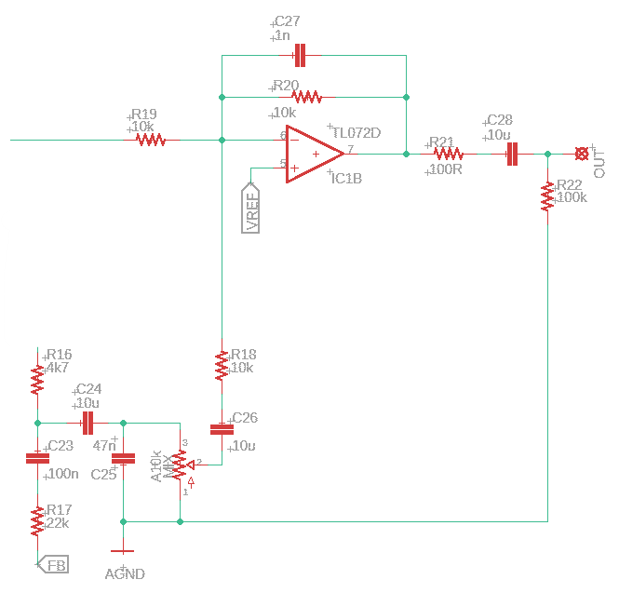
Spare Room Output Buffer

In order to minimize size, a single transistor LFO was chosen. Opamp-based LFO's are great, but take up much more space, which is at a premium with a 1590a project. This LFO comes from the modified EA tremolo that has been a mainstay in the DIY community for some 20 years now. The depth and rate were carefully tuned to provide a subtle modulation that results in delay times that shift just enough to eliminate the metallic ringing effect of the static delay times. It is a slow and subtle LFO, but extremely effective. I actually quite like this LFO and will likely use it whenever a static rate and depth LFO is needed.
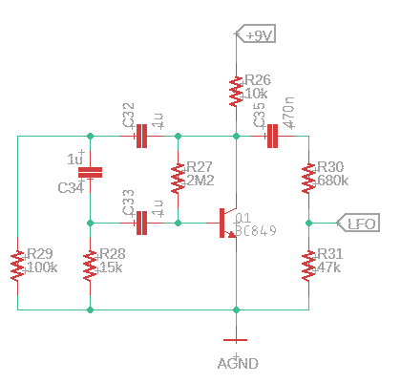
Spare Room LFO

The power section is pretty standard. It provides +9V, +4.5V for VREF, and +5V for the PT2399 chips with appropriate filtering.

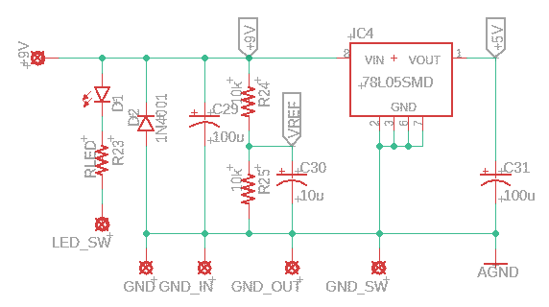
Spare Room Power Section

BOM

The BOM below is the list of parts I used for mine along with quantities. All parts are SMD except for the electrolytic capacitors, polarity protection diode, and potentiometer. All caps and resistors are 0805 sized and the PT2399's are the standard 150mil width SMD version.

Part | Qty. | Notes
100R Resistor | 2
4k7 Resistor | 2
8k2 Resistor | 1
10k Resistor | 15
15k Resistor | 4
22k Resistor | 1
47k Resistor | 1
100k Resistor | 2
680k Resistor | 1
1M Resistor | 1
2M2 Resistor | 1
RLED | 1 | CLR for bypass LED
1nF Capacitor | 2
2.2nF Capacitor | 2
10nF Capacitor | 3
15nF Capacitor | 1
47nF Capacitor | 3
100nF Capacitor | 12
470nF Capacitor | 1
1uF Ceramic Capacitor | 5
10uF Ceramic Capacitor | 3
47uF Ceramic Capacitor | 2
10uF Electrolytic Capacitor | 1
100uF Electrolytic Capacitor | 2
A10k Potentiometer | 1 | 16mm PCB Mount
1N5817/1N4001 | 1 | Voltage polarity protection
BC849 | 1
LED | 1
78L05SMD | 1
TL072 | 1
Enclosure | 1
1/4” input jack | 2
DC power jack | 1
3PDT footswitch | 1

Schematic

The schematic for this project is a little big to be legible on a single sheet, so it is also included as a separate PDF in the project documentation folder in addition to the figure shown below.

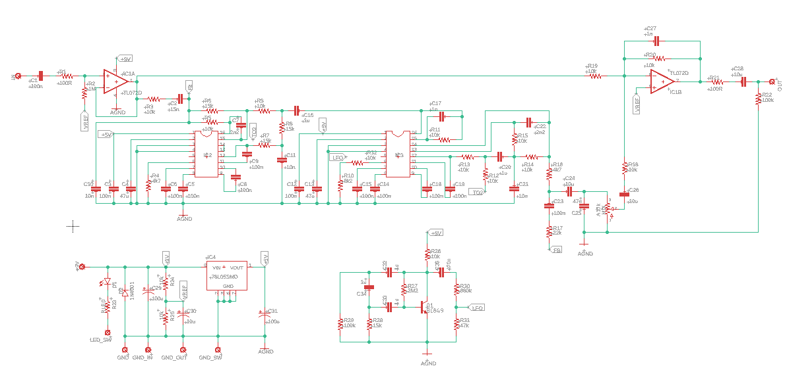
Spare Room Full Schematic
Build Notes

Here are some things I noted from building the Spare Room that might be helpful to you. Please read this section to make sure you don't go through excessive frustration.

Voltage Regulator Orientation

While I try to make it so that all IC's are oriented with pin 1 to the top left, in this design it was easier to have it be at the bottom right. For this reason, make sure you double and triple check the orientation of this IC before powering on. Putting it in the wrong way around and applying power WILL fry the IC. Trust me, I did it several times building up the first few boards...

Enclosure Size/Drilling

The Spare Room was made to fit into a 1590a, but it does require some careful planning. If using a 1590a, I recommend a long PC pin potentiometer, with the DC jack drilled near the top of the enclosure. This allows for the board to be placed so that it touches the front of the enclosure on the inside.

The board will also work well in a 1590G. If using a 1590G, do the following:

- Use short PC pin potentiometer
- Mount electrolytic caps so that they are folded down to the PCB. They are laid out such that one can be bent on each of the three sides of the potentiometer that don't have the pins, allowing for the board to be low-profile enough to fit the depth of a 1590G.
- Use “outie” style DC power jack to save as much internal space as possible. Drill so that the PCB is as close to the DC jack as possible to leave the most space for the jacks

The board will obviously work in a 1590B or 125B without an issue. Since the board is just larger than the pot, it also can work well as a standalone reverb unit for small amplifiers or multi-effects boxes.

Jacks

Try to use a low profile jack here. Lumberg would be a great choice. I used open frame jacks such that the cable plugs just don't touch internally. It was a little bit of a squeeze, but totally doable.

3PDT Switch

Use a low-profile switch in a 1590a. It saves some very valuable space.

When using a 1590G, a standard blue 3PDT can be used if there is no internal nut or washer used, but it's a tight squeeze vertically.

In Closing

This is a fanstastic little reverb that can be built for cheap. It's small enough that it can fit most anywhere and provides enough spare room to your sound that playing is much more enjoyable.

