Merc Carbine Reference
Original game prop for Meshy modeling. Use these four views for the main shape and equipment placement.
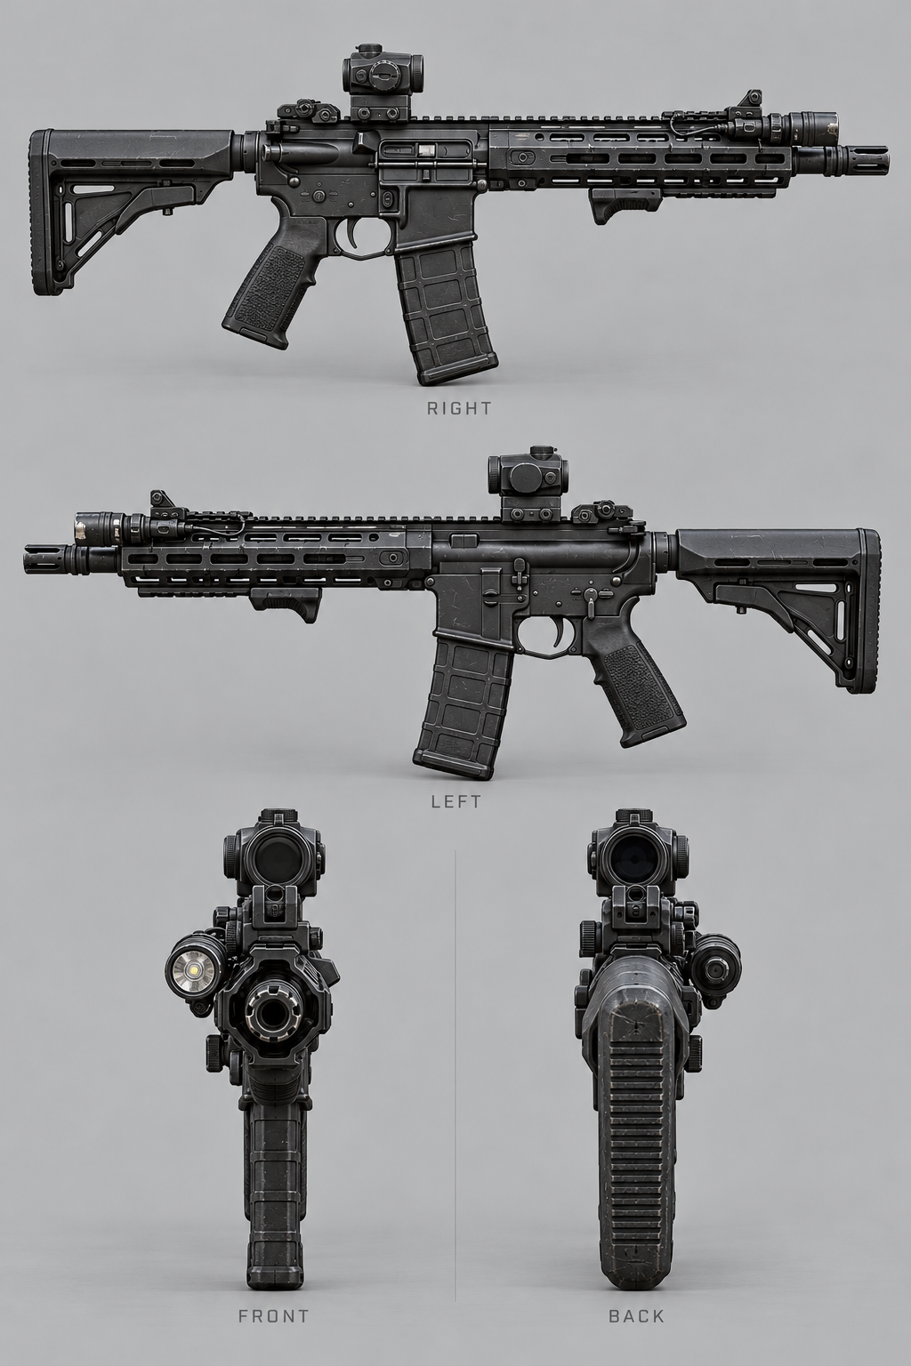
Dark graphite finish, compact optic, restrained wear and handguard flashlight. Keep the weapon separate from the character mesh.

Merc First Person View
Use this image to guide the on-screen size, angle and silhouette of the merc weapon.
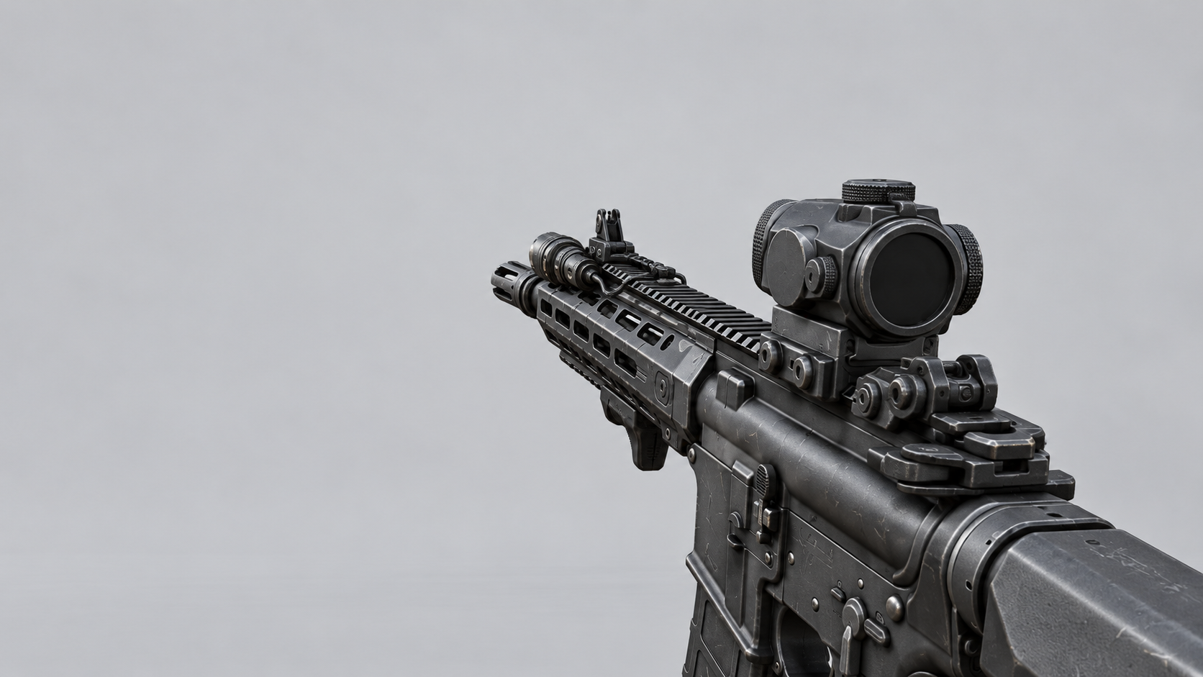
The weapon sits at the lower right and points toward the center of the screen. Keep the optic and flashlight readable without covering the center of the view.
Use the four-view plate for modeling and this image for camera framing. Hands and first-person animations will be added separately in Unreal.

