Merc Character Reference
Four views for Meshy modeling. Preserve the broad SWAT silhouette and grounded tactical equipment.
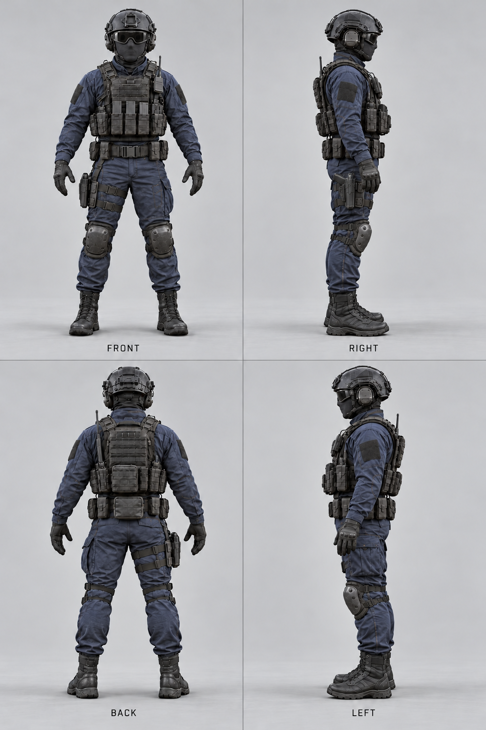
Navy uniform, black plate carrier, helmet, opaque goggles and fully masked face. Keep the right-thigh holster on the same side in every view.

