Spy Character Reference
Four views for Meshy modeling. Preserve the charcoal suit, olive harness and lean silhouette.
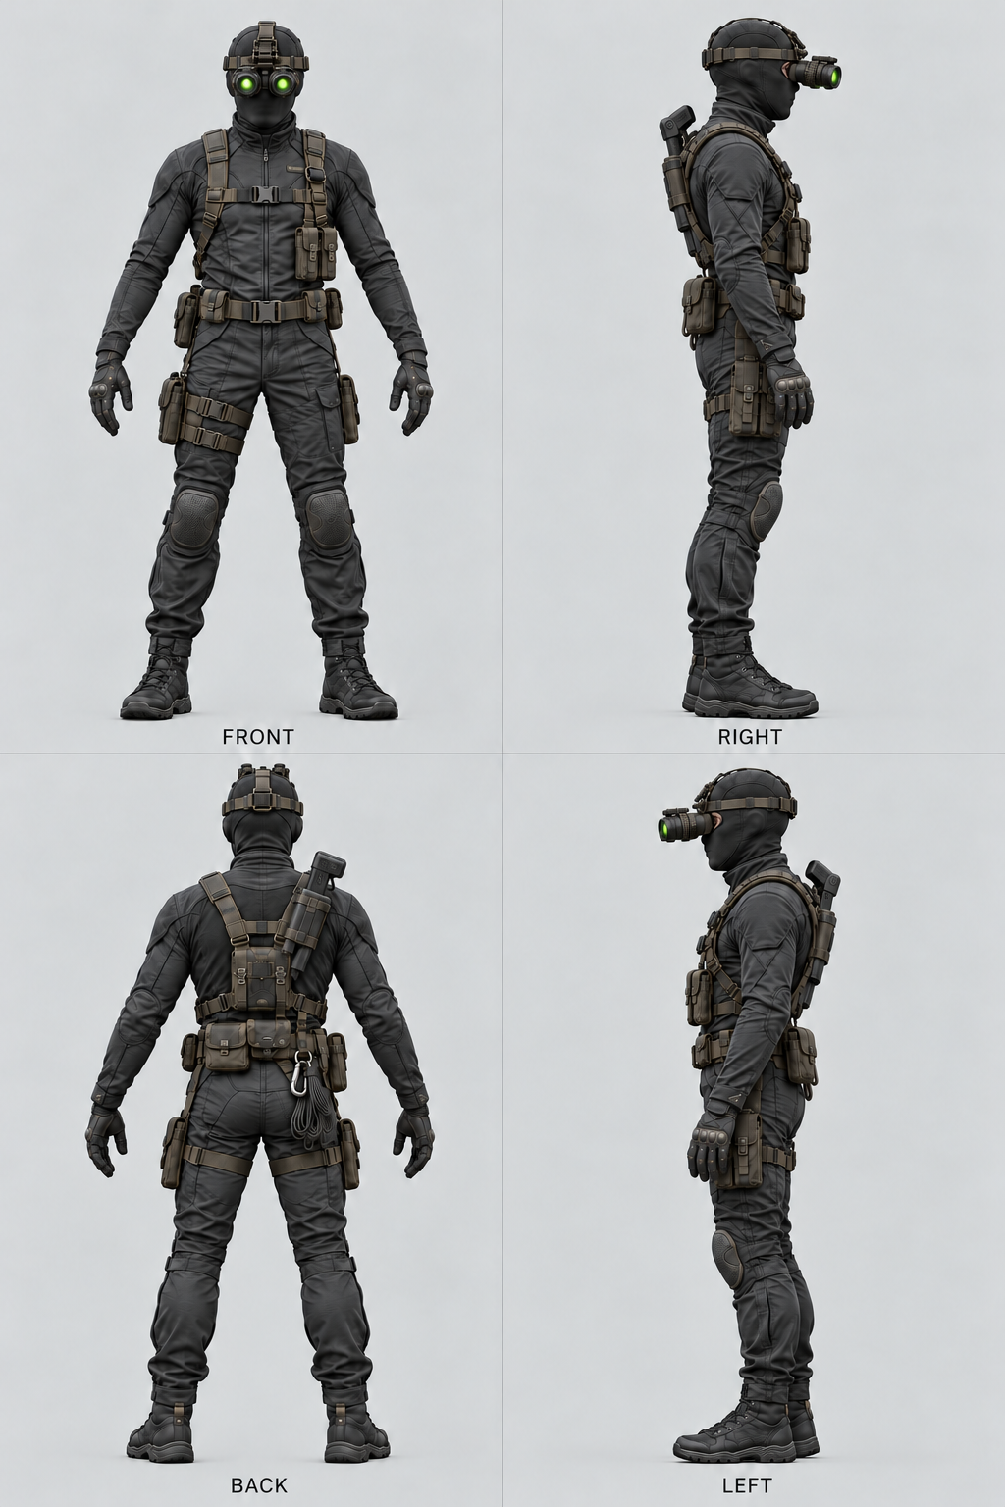
Lowered goggles emit two green lights. The compact taser and sticky-camera launcher is carried in a back holster.

Spy Goggles States
Use the same character and equipment with the goggles lowered or raised.
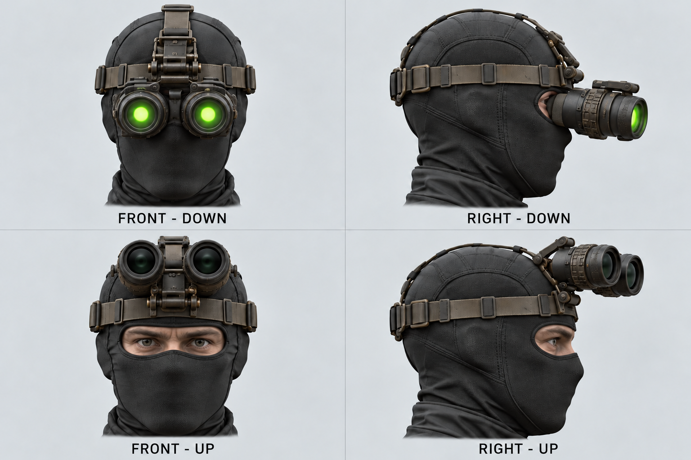
Lowered goggles have two green LED-like optical lights. Raised goggles have dark lenses and leave the eyes visible. Keep the binocular unit separate so it can pivot up and down.
Model the launcher and back holster as separate accessories. The launcher is drawn for taser and sticky-camera actions, then returned to the holster.
In Unreal, assign the two optical lights an emissive material and switch it with the goggle state. A generated texture alone does not create the in-game light effect.

