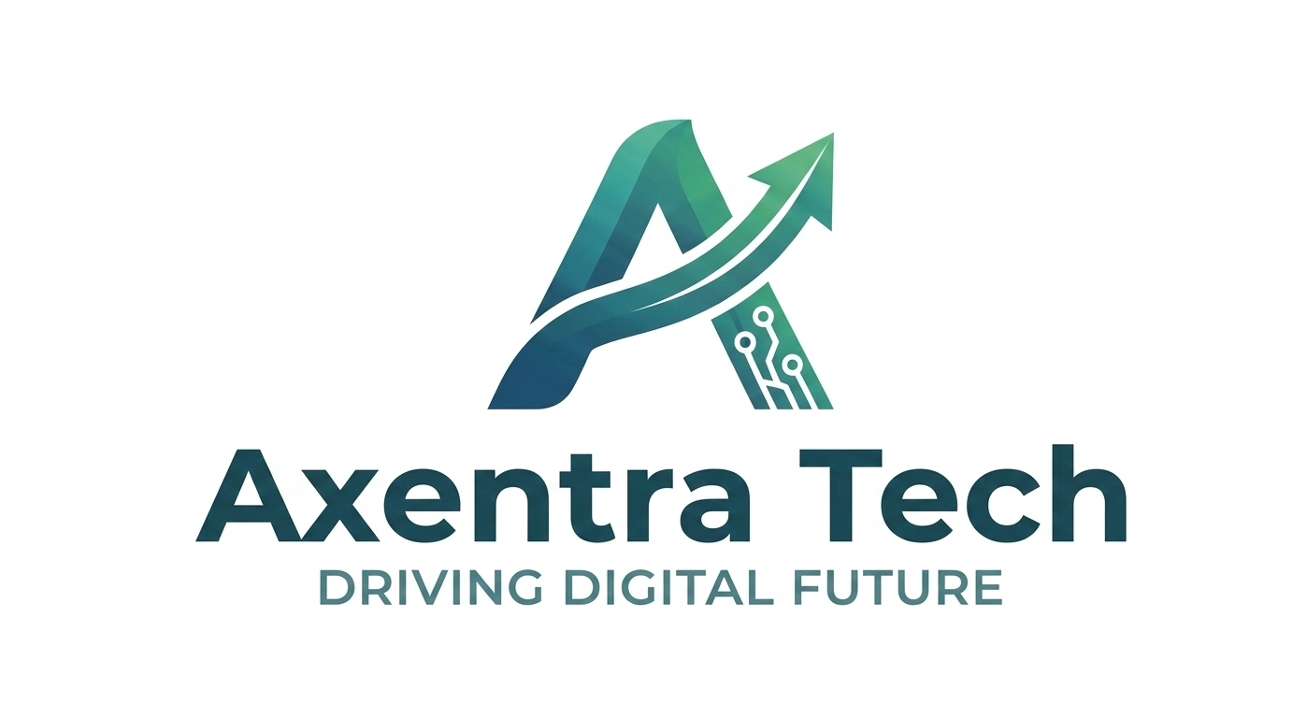

COMMERCIAL & TECHNICAL PROPOSAL
Heritage Web Portal, Experiential Booking & CRM Console

Prepared For: Rock One Wild Tea Management Team Project Title: Heritage Web Portal & CRM Platform | Prepared By: Axentra Tech Software Solution Reg No: UVA/MON/SIY/3171 Founder & CEO: Hasitha Weerasinghe Website: www.axentratech.com Contact: +94 77 175 7556

1. INTRODUCTION
Axentra Tech Software Solution is pleased to present this commercial proposal to engineer the official web portal for Rock One Wild Tea. We deliver premium, bespoke digital products designed to scale your operations. This system couples an immersive, high-converting customer storefront with a secure administrative dashboard to streamline bookings, payments, and client communications.

2. SCOPE OF WORK
The platform has been engineered with modular sections, optimized for high usability:
- E-Commerce Experience: Exquisite Dark Green and Gold design reflecting the brand. Features product catalogs, limited edition gift chests, scarcity indicators, and sommelier brewing guides.
- Experiential Tour Scheduler: Interactive date/time booking slot matrix. Captures client dietary preferences and chauffeur hotel pick-up arrangements.
- Concierge Operational CRM: Authorized dashboard allowing operators to verify payments, cancel bookings, manage announcements, and download email dispatch logs as CSV.

3. TECHNICAL SPECIFICATIONS
To eliminate recurring server fees and provide a robust environment, we utilize a serverless architecture:
Component | Provider | Price (USD) | Limit / Capacity
Frontend Website | Netlify / Vercel | $0.00 / Free | 100GB monthly bandwidth
Backend API | Netlify / Vercel Functions | $0.00 / Free | 125,000 requests / month
Database | Superbase | $0.00 / Free | 500MB storage capacity
Email Services | EmailJS | $0.00 / Free | Up to 200 emails / month
Custom Domain | Domain Registrar | ~$1.00 / month | $12.00 billed annually

4. PRICING
# | Service Description | Price (USD)
1 | Development & Integration of Custom Web Portal (incl. Catalogs, Tours, CRM console, and email integration) | $1,200.00
2 | Domain & Staging Setup (1-year domain registration, Netlify build setup, SSL configuration) | $100.00
- | TOTAL PROJECT COST | $1,300.00

5. PAYMENT SCHEDULE
Milestone | Description | % | Amount (USD)
Milestone 1 | Down Payment - Upon Agreement Signing | 30% | $390.00
Milestone 2 | Development Complete - After UAT Sign-off | 40% | $520.00
Milestone 3 | Go-Live & Final System Handover | 30% | $390.00
TOTAL | Fully developed portal package. | 100% | $1,300.00

6. PROJECT TIMELINE
The development timeline is organized sequentially to support regular feedback and staging reviews:
- Week 1 (UI/UX Layouts): Design assets integration, e-commerce templates, package schedules configuration (Completed & Delivered).
- Week 2 (Concierge Desk & Gaps): Redesigned CRM dashboard tab layout, status verify/cancel actions, dynamic release of reserves, CSV exporters (Completed & Delivered).
- Week 3 (Email Integration): EmailJS API integration, connecting custom Gmail or SMTP servers, custom templates design (Ready for Dev - Estimated 3 days).
- Week 4 (Staging & Launch): Custom domain mapping setups, Netlify serverless deployment, SSL certificate integration, and handover (Ready for Dev - Estimated 2 days).

7. WHAT IS INCLUDED
Item | Status
Full source code ownership transferred to client | ✔ Included
1 year domain registration & web hosting | ✔ Included
SSL certificate (HTTPS) | ✔ Included
Staging and production deployment setup | ✔ Included
User training session (up to 2 hours) | ✔ Included
User manual & system documentation | ✔ Included
30-day post-launch free bug support | ✔ Included

8. WHAT IS NOT INCLUDED
- Annual domain & hosting renewal after Year 1
- Additional features beyond the agreed scope
- Hardware - laptops, display terminals, label printers
- Internet connection or local network infrastructure setup
- Annual Maintenance Contract (available separately)

9. SUPPORT SERVICES & SLA
Axentra Tech does not disappear after launch. We offer structured, reliable post-delivery support to ensure your software continues to run reliably and improves over time.
9.1 Free Post-Launch Support - Included (30 Days) Covers bug fixes for issues found after delivery, minor config adjustments, and guidance on usage.
9.2 Annual Maintenance Contract (AMC) Optional AMC Basic: Bug fixes, minor updates, email/WhatsApp support - $150.00/year AMC Standard: Basic + performance monitoring, small feature enhancements - $300.00/year AMC Premium: Standard + custom updates, same-day response SLA - $500.00/year

9.3 Support Response Time SLA:
Issue Type | Free 30-Day | AMC Basic | AMC Standard | AMC Premium
Critical - site down | 24 hrs. | 24 hrs. | 12 hrs. | 2 hrs.
Major - booking failed | 48 hrs. | 48 hrs. | 24 hrs. | 8 hrs.
Minor - small tweaks | 72 hrs. | 72 hrs. | 48 hrs. | 24 hrs.

10. REFUND POLICY
- Milestone 1 - Down Payment ($390.00): Non-refundable once signed and dev has commenced. Covers planning, design, and setup costs.
- Milestone 2 - UAT Payment ($520.00): Non-refundable once the client has signed off on UAT approval. If we fail to deliver agreed features to a working standard, a partial refund of up to 50% of this milestone may be requested.
- Milestone 3 - Go-Live Payment ($390.00): Non-refundable once the system is deployed and the client has accepted final delivery.

11. TERMS & CONDITIONS
- Validity: This proposal is valid for 30 days from the date of issue.
- Commencement: Work begins only after the signed agreement and Milestone 1 payment are received.
- Client Inputs: The client must provide required content (logo, product images, brand text) within agreed timelines. Delays caused by the client will not count against the project deadline.
- Showcase: Axentra Tech retains the right to showcase this project in its portfolio unless the client requests otherwise in writing.
- Communications: All project change communications must be made in writing via email or WhatsApp.
- Jurisdiction: This agreement is governed by the laws of Sri Lanka.

12. ACCEPTANCE SIGN-OFF
By signing below, both parties confirm they have read, understood, and agree to all terms outlined in this proposal.

CLIENT SIGN-OFF Full Name: _______________________ Signature: _______________________ Date: _______________________ Contact No: _______________________ | AXENTRA TECH SIGN-OFF Full Name: Hasitha Weerasinghe Signature: _______________________ Date: _______________________ Contact No: +94 77 175 7556

