**Cases For and Against Remaking *Final Fantasy IX***

**For: The Artwork Can Only Get Better**

One of my friends posted something very interesting to my Facebook the other day: a link to some “lost” *Final Fantasy IX* artwork. I’ve owned *The Art of Final Fantasy IX* for years, so when I saw the link, my first thought was “yeah, okay, but I’ve definitely seen this before”.

Boy, was I wrong.

(Before I go any further, I’ll give y’all the link: <http://www.neogaf.com/forum/showthread.php?t=551612>).

My jaw dropped. There were about 100 pictures here that I had never seen before, all in a resolution about three times what the original PlayStation disc could handle. As Mama Robotnik, the author of the above forum post, said, “The ‘lost art’ referenced in the thread title isn’t meant to describe this content as having been lost and found – it refers to the art details that were lost when the graphics were downconverted to a limited 32-bit console”.

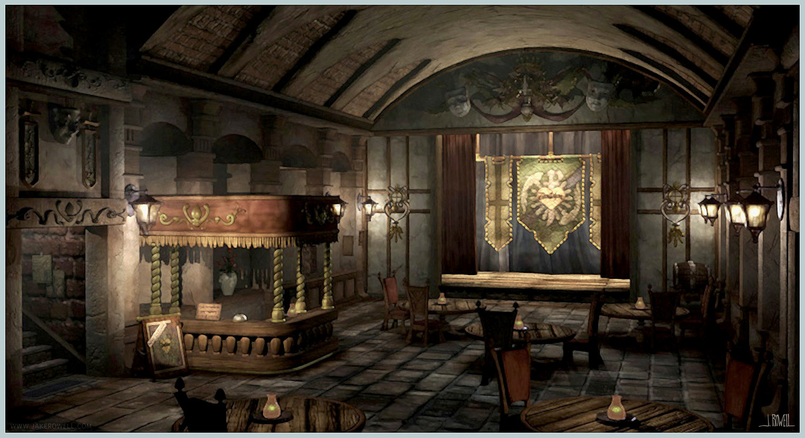

Ruby's Mini Theater Never Looked So Good.

Needless to say, I was amazed. After purely enjoying the artwork for a while, a thought popped into my head: if they’ve got these really high-resolution backgrounds already, that *must* make it easier to craft a remake, should they choose to do so. They’ve already got a bunch of great work already set up for them, for cryin’ out loud! So why won’t they do it?

At first, I was against a remake of *FFIX*; I thought that the original was perfect, and that they needn’t do anything else. However, when I watched *Yu Yu Hakusho*, my favorite anime, [in 1080p Blu Ray](http://www.youtube.com/watch?v=CfbCzQ5fq9A), I realized that making things look prettier given newer technology could, if not increase my enjoyment, give me another, more detailed look at exactly what the artists were going for when they created the work.

**Against: *Final Fantasy VII* Fans are Mad Enough**

Seriously, though. They thought they were getting a PS3 makeover for the franchise’s most popular game *years* ago. Square Enix has said that they won’t remake it until they make a new title that surpasses the original, both in sales and in quality (see [this GameSpot article](http://www.gamespot.com/news/no-final-fantasy-vii-remake-until-square-enix-tops-original-6384331), if you haven’t heard this already).

Look, Square Enix: it’s just not going to happen.

It’s a vicious cycle: basically, they’re trying to make a game that is so good that it will make people forget about *VII* as being considered “the best”. However, people can’t get the idea of a *VII* remake out of their heads. They won’t give Square Enix a chance until it’s done. It’s not all your fault that you won’t make a game that’s better; it’s equally the fault of the gaming community for being really bad at looking at new games in the same nostalgic light of the old classics that they hold so dear. That’s just a part of human nature, though, I think – there’s a reason they’re called “the good old days”.

So yeah, they won’t remake *VII…* But they’re remaking *FFX* in HD, which was already made with quite-sexy PS2 graphics. Way sexier than “the-first-PS1-FF” graphics, for sure. They’ve remade *I* and *II* for the GBA, and *III* and *IV* for the DS. I just get the feeling that if they remake any more *Final Fantasy* titles before *FFVII*, there will be pitchforks sharpened and torches lit. Even I, who thinks that *FFIX* is one of the greatest pieces of media ever created, far more philosophically and artistically intriguing than *VII*, am waiting impatiently for Square Enix to remove their craniums from their posteriors.

I think I can sum up most everyone’s opinion on this with three simple words:

God dammit, Squeenix. (Cute nickname, right?)

**For: It Will Remind Square Enix About What Squaresoft was Doing Right**

This may be a bit of a radical opinion, but I honestly think that if the next *FF* were released without the use of voice actors, the overall opinion on the quality of the game would rise. I’m not going to spend much time on defending myself here; just check out Ian’s blog post, “[Hearing Voices](http://finalfantasyix.com/2013/05/02/hearing-voices-published-2192013/)”, and you’ll basically have an idea of what my argument is behind this.

I think that, recently, *Final Fantasy* has gone the way of most game companies, focusing more and more on *realism* – *real-looking* people, dynamically-rendered, interactive worlds, and the like.

*Realism*. When the title of the game is *Final* ***Fantasy***.

I feel like they’ll get the idea when they’re in the middle of an HD makeover for, say, Hippaul.

*Final Fantasy IX*, like most of the great *Final Fantasy* titles before it, has an expansive, colorful world. There were many different, non-human races that looked distinctly fantastical (again, Hippaul). Even the main characters aren’t supposed to look *real*; they’re chibi to the max, and I love it. There was always something new to discover, to explore. By the third disc, you’re basically let loose, able to take care of most side quests, etc. in the game. No more rails. The game designers had enough faith in your intelligence to let you go do your own thing, make your own mistakes and get out of them. This is getting ever rarer in the big-name game companies, and it’s something that they could take a lesson in if they look at their old games.

**Against: Square Enix Has to Let People Know that They Can Craft Good Games**

Personally, I enjoyed *FFX:2* (I will understand if you stop reading now). *FFXII* was a solid game, to the point of MetaCritic giving it a [92 out of 100](http://www.metacritic.com/game/playstation-2/final-fantasy-xii), which is equal to [*FFVII*’s score](http://www.metacritic.com/game/playstation/final-fantasy-vii). However, it was nowhere near as popular as *VII* was (to the chagrin of many a *XII* fan). There was one thing that *VII* had more of than most other *FF* titles: [a giant North American marketing campaign](http://en.wikipedia.org/wiki/Final_Fantasy_VII#Release). I don’t ever remember seeing any pre-release brouhaha for *XII*. While it proves that Squeenix *can* make a solid game, they need to promote it more. A remake of *FFIX* now could create the image that all they’re good for is remaking the games of their predecessors, basically admitting defeat and saying they can’t surpass the classics.

Poor Squeenix.

**My Opinion: If You’re Gonna Use It, Keep It; If Not, Give It to Someone Who Will**

Correct me if I’m wrong, but I’m pretty sure that characters from *FFIX* have been used only a handful of times since its release (Zidane/Kuja in *Dissidia*; Zidane in *Theatrhythm*; Vivi in *KH2* are the ones I can think of immediately). Because *VII* is still making money off of its spin-offs and movies and such, keep those rights; however, if you’re not gonna use the characters, art, etc. from other franchises… why not give these to the public? *FFIX* may not be popular enough to make much money off of anymore, but from my experience, it has a cult-like following of rabidly dedicated players who would *love* to sink their teeth into community-made remakes/sequels/etc. While unrealistic, I think that would be a great thing for Squeenix to do.

Like the people waiting for a *VII* remake, however, I won’t hold my breath.