So. you got Google’s Foobar Invitation. First of all, very very congratulations on that, you should have known that this is not an ordinary invitation but the special one that Google sends to only some special type of developers.
If you have not got the invitation yet, this article still can be useful to you in many aspects.
Now we know Foobar is some weird invitation from Google, but I want to talk about a little in detail. So, let’s explore all the questions you have in mind.

I’m a novice, tell me in details about Google Foobar:
Google Foobar is Google’s secret hiring challenge. Google uses this to hire some of the best developers around the globe which they think can be a good match for their organization. Many developers in Google have been hired through this hiring challenge.

I want to take this challenge:

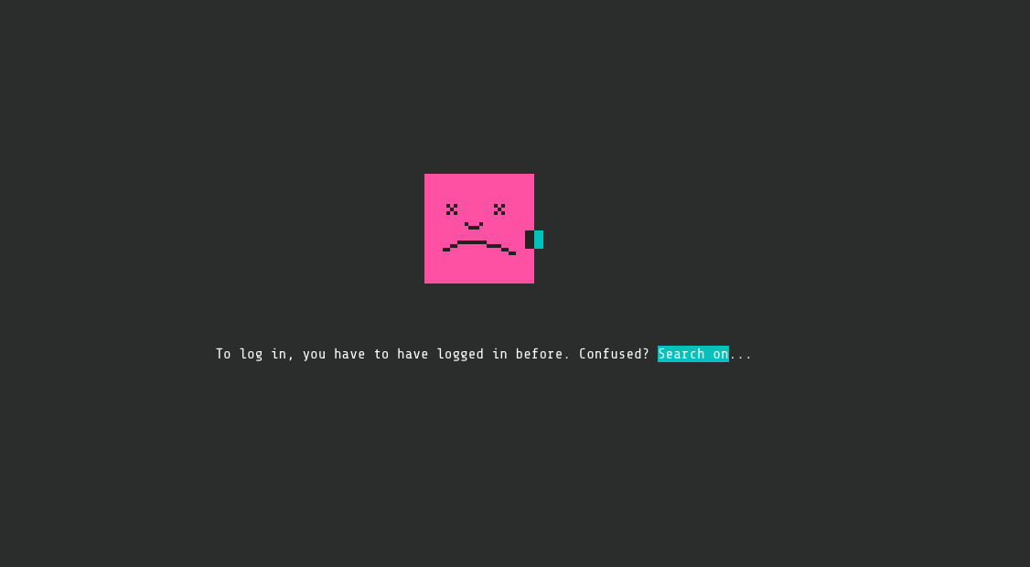
it’s good to see your spirit, but there is a sad thing that not everyone can take this challenge.
Google Foobar is an invitation based hiring challenge. Means, you can only take the challenge if you have got the invitation from Google for Foobar.

How can I get the invitation:
Getting the invitation for Google Foobar is also a mysterious thing, no one exactly knows the criteria for the Google Foobar invitation eligibility. The suggestions from the people who got the invitation are:
Google send the invitation on the basis of your search history and your problem solving related keyword searches, like if you are a developer, it is obvious that you search a lot of problems related to programming on Google or Stack Overflow. And based on Google search algorithms, they show you an invitation for Google Foobar.

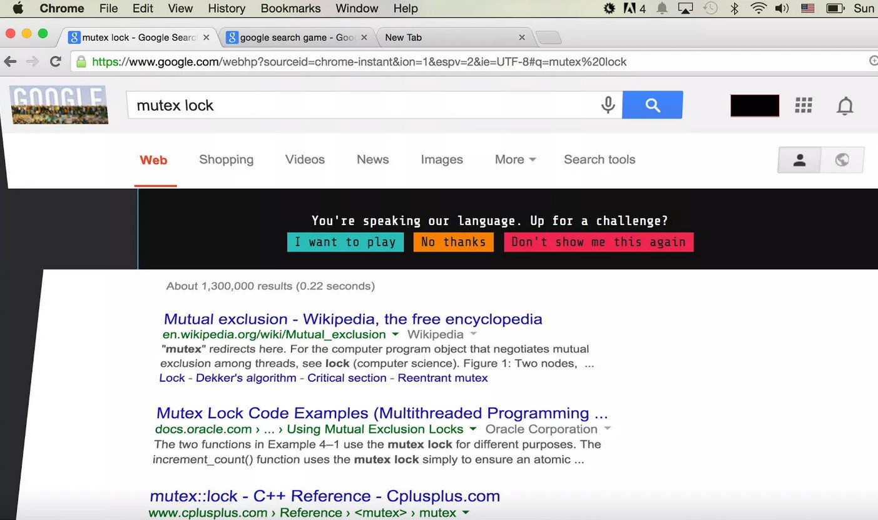
Google Foobar Invitation
And when you get the invitation, it looks like this and it says
“You’re speaking our language. Up for a challenge?”

What happens after I get the invitation:
When you get the invitation, and you choose to accept it, you are redirected to a website that kind of look like UNIX command line like interface.
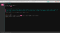
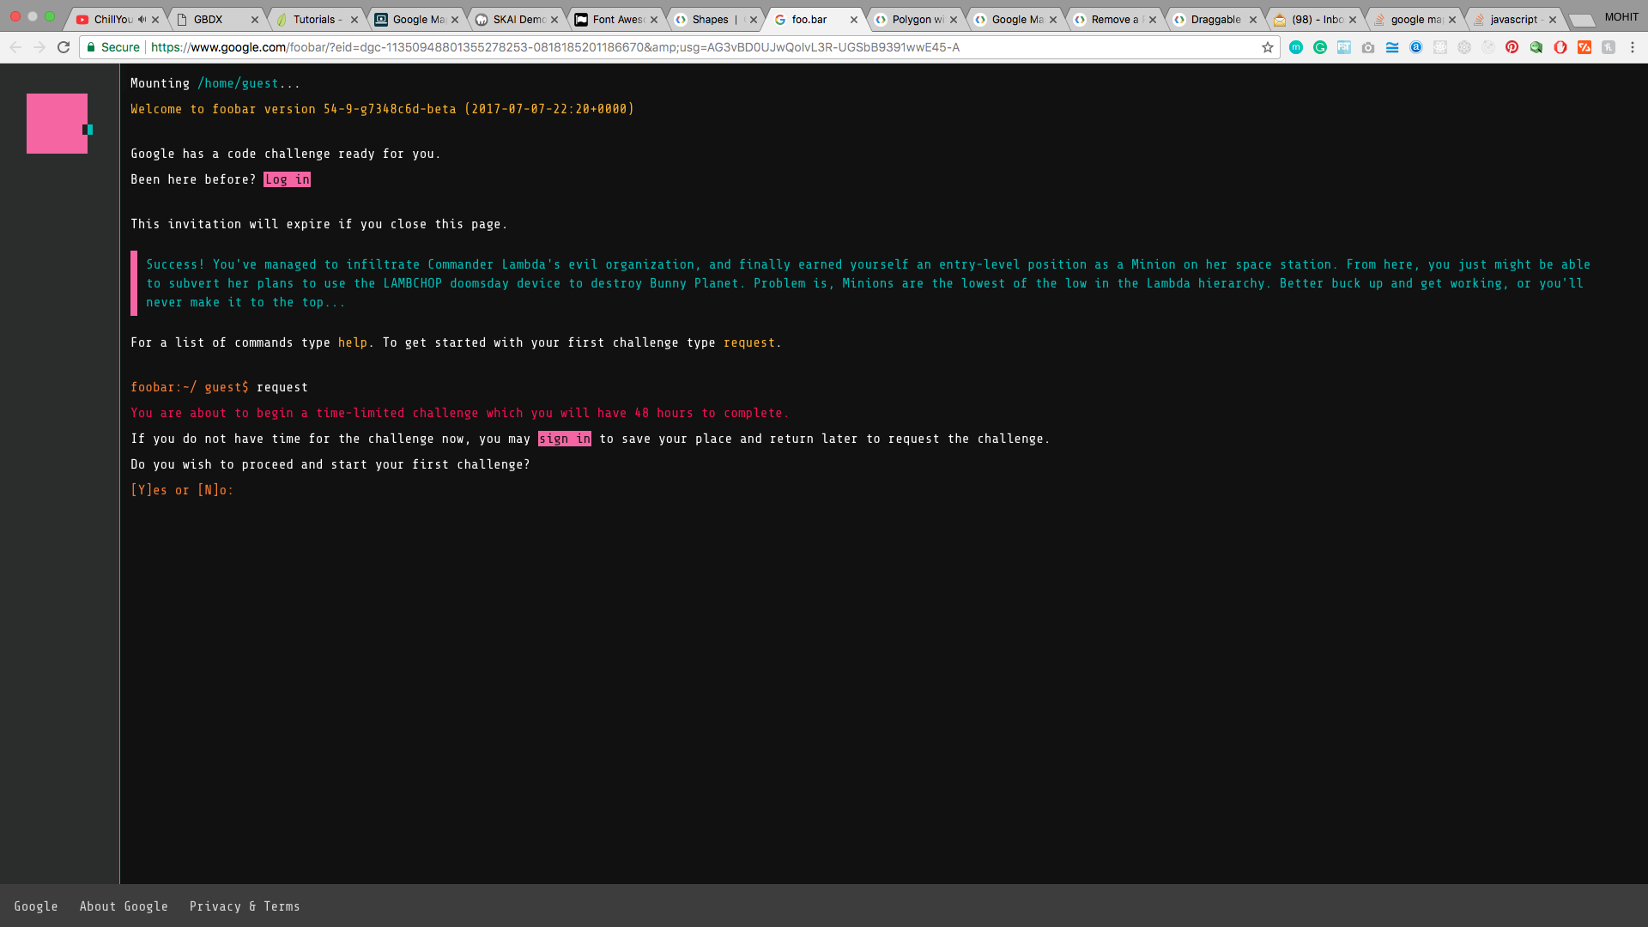
And it gives you access to traverse into some folders using UNIX commands, and help command to see all of the available commands. In all of the commands available, you have to type the command “request” to get the challenge started.
After you request for the challenge, you get some files in your Foobar command-line folder, and you have a question waiting for you to solve. When you are reading the question file, you can also see that you can submit your answers either in JAVA or Python.
You get two files to write the solution to your problem statement “solution.java” and “solution.py”. You can write your solution in any of the files depending upon your preferred language for the solution.
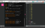
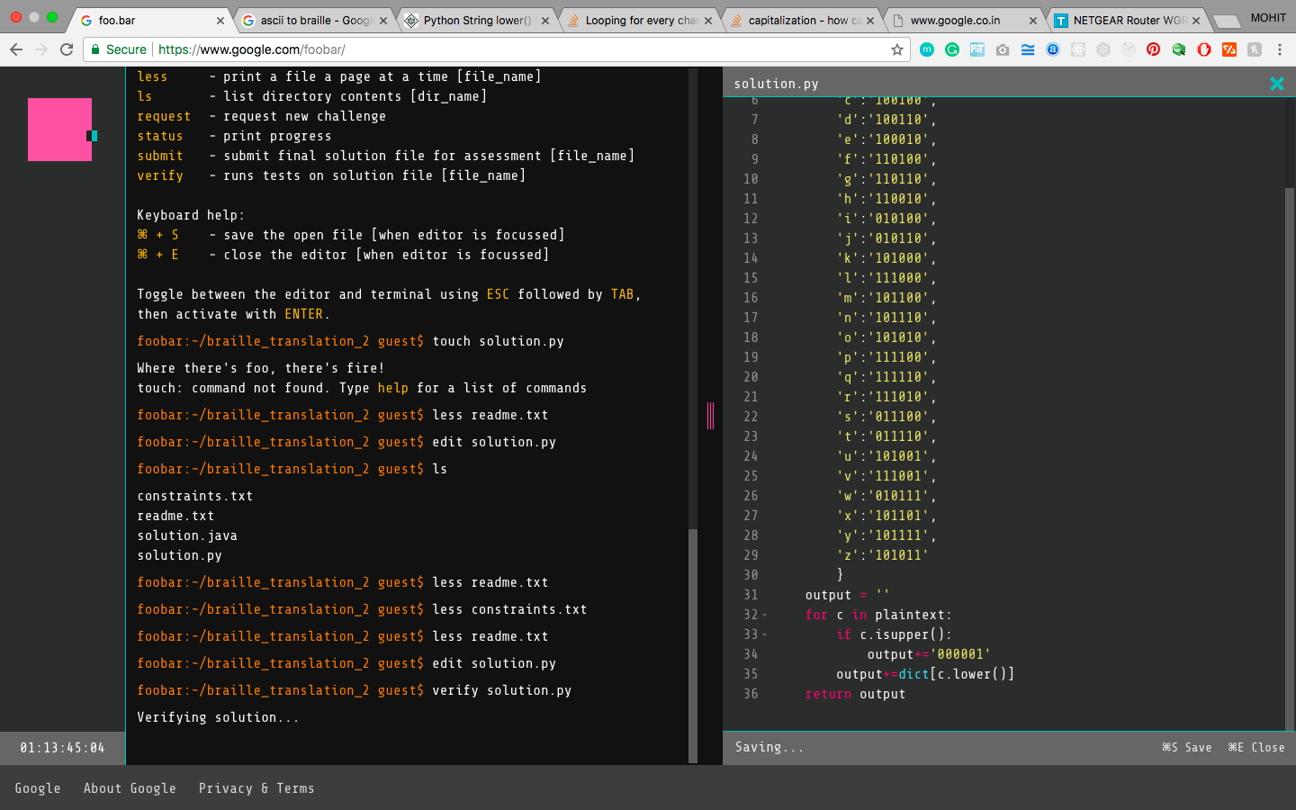
And to edit the file you can run the command “ edit filename”, and you get a tab on your same webpage and in the tab, an editor with your file open.
you can “Save” your file with the use of shortcut keys.
After you have done the editing, and you are confident enough that the solution you wrote is correct and error-free, you can verify it with “verify filename” command and it shows you the test case result of your solutions. To submit your submission type “submit filename” and it will accept your solution and check if it is correct or not and if all the test cases are passed by your solution, you get a success message.
This is a success message when you finish level 1, and you get to know there is a total of 5 levels to solve.

What will happen after the completion of all 5 levels :
After you complete all the 5 levels, you get some fields to fill your details and your contact details to contact you and when you are done with these details.
You get a call or a mail from Google after one or two days, in which you can get the invitation for interview in Google and if you pass the interview, you can be hired into Google.

So, if I get hired, what will be the post of joining :
When you are done with your Google Foobar challenge, you get the chance for the interview, but the post of joining is not the same for all.
It can be high-end developer or assistant developer depending upon your Foobar Challenge solutions and your interviews.

Has Google hired anyone through Foobar Challenge? :
And the answer is “Yes”. Most of the people who complete the Foobar challenge, also get the joining offers.
And in my opinion, the reason is simple.
You only get the Google Foobar invitation, if you are qualified enough to join the Google and if you get the invitation and you are also completing the Foobar Challenge, there must be something in you that Google need.
Although, this Google Foobar challenge looks like an invitation from a secret society, and it also feels like this when you get the invitation. But if you get the invitation, I recommend you to go through it and try to solve the challenges whether you want to get hired into Google or not. This challenge can give you the best of the experience you ever had in all the coding challenges you ever took part in.

