MBC (MALEK BATETA CENTER)
FOOD ORDERING & RESTAURANT MANAGEMENT SYSTEM
Comprehensive Software Engineering Project Report
Covering SDLC, Architecture, ERD, DFDs, Data Dictionary & UI Workflows
____________________________________________________
Prepared for: Academic & Technical Project Review
Technology Stack: PHP, MySQL, HTML5, CSS3, JavaScript, Bootstrap 5
Date: September 2026

Executive Summary
The Malek Bateta Center (MBC) Online Food Ordering and Restaurant Management System is a web application designed to digitize ordering, inventory, and customer management for a famous traditional eatery based in Dhoraji, Gujarat (established in 1983).
The primary objective of this project is to provide customers with an intuitive online menu ordering platform featuring real-time cart handling, takeaway/delivery order options, and flexible payment methods (Cash on Delivery, UPI). Simultaneously, it equips restaurant administrators with a comprehensive management portal to monitor live customer orders, manage food item categories, update order fulfillment status, update site settings, and print formatted tax invoices.
This project report presents an end-to-end technical overview of the system, including Software Development Life Cycle (SDLC) methodologies, 3-Tier System Architecture, Data Flow Diagrams (Context Level 0 and Detailed Level 1), Entity-Relationship (ER) Diagram, detailed Data Dictionary schemas for all 9 database tables, and step-by-step user interface workflow screenshots.

Chapter 1: System Overview & Project Scope

1.1 Background & Problem Statement
Traditional food outlets face significant operational challenges when relying on manual pen-and-paper order taking, telephone calls, and physical queues. Key bottlenecks include order entry errors, communication delays during peak hours, inability to track live order delivery status, and fragmented sales records.

1.2 Objectives
• Provide an accessible, responsive web application for customers to browse food items, customize orders, and place online food orders seamlessly.
• Centralize order processing into a unified real-time admin portal with instant status updates (Pending -> Preparing -> Out for Delivery -> Completed).
• Automate tax and delivery fee calculations with dynamic invoice print generation.
• Maintain an audit trail of user registrations, reviews, contact messages, and item catalogs in a normalized relational database.

1.3 Scope of the Project
The scope spans two major modules: Customer Frontend Module (menu browsing, cart management, checkout, order tracking, review submission) and Administrator Backend Module (category & food CRUD, order fulfillment, status toggling, invoice generation, customer management, review moderation, and site configuration).

Chapter 2: Software Development Life Cycle (SDLC)
The MBC Food Ordering System was built following an Agile-Waterfall Hybrid SDLC Model. This approach combined structured phase-by-phase design deliverables (requirements, ER diagrams, DFDs) with iterative sprint execution for fast frontend/backend feature validation.

2.1 Detailed SDLC Phases
Phase 1: Requirement Analysis & Feasibility Study — Conducted stakeholder interviews with restaurant staff and customers to capture core operational requirements. Identified key functional needs including order type selection (Home Delivery, Takeaway, Dine-in) and payment gateway choices.
Phase 2: System & Architectural Design — Created high-level system architectural models, process flow specifications, and database schema definitions. Formulated Data Flow Diagrams (DFDs) to map information movement across external actors and internal datastores.
Phase 3: Database Design & Data Modeling — Designed normalized database tables (3NF) in MySQL and established foreign key relationships between Users, Categories, Foods, Orders, and Order Items.
Phase 4: System Implementation & Coding — Implemented backend business logic using PHP 8.x with PDO/MySQLi prepared statements for SQL injection prevention. Standardized frontend layouts using Bootstrap 5, custom CSS3 variables, and vanilla JavaScript.
Phase 5: Verification & System Testing — Executed multi-tier testing including component unit testing, cart integration testing, end-to-end order placement verification, and user acceptance testing (UAT).
Phase 6: Deployment & Maintenance — Deployed the web server application on an Apache HTTP server with MySQL engine. Ongoing maintenance includes regular database backups, catalog updates, and session security audits.

Chapter 3: System Architecture & Data Flow Diagrams

3.1 3-Tier System Architecture
The application follows a standard 3-Tier Software Architecture guaranteeing separation of concerns between presentation, business logic, and database storage.
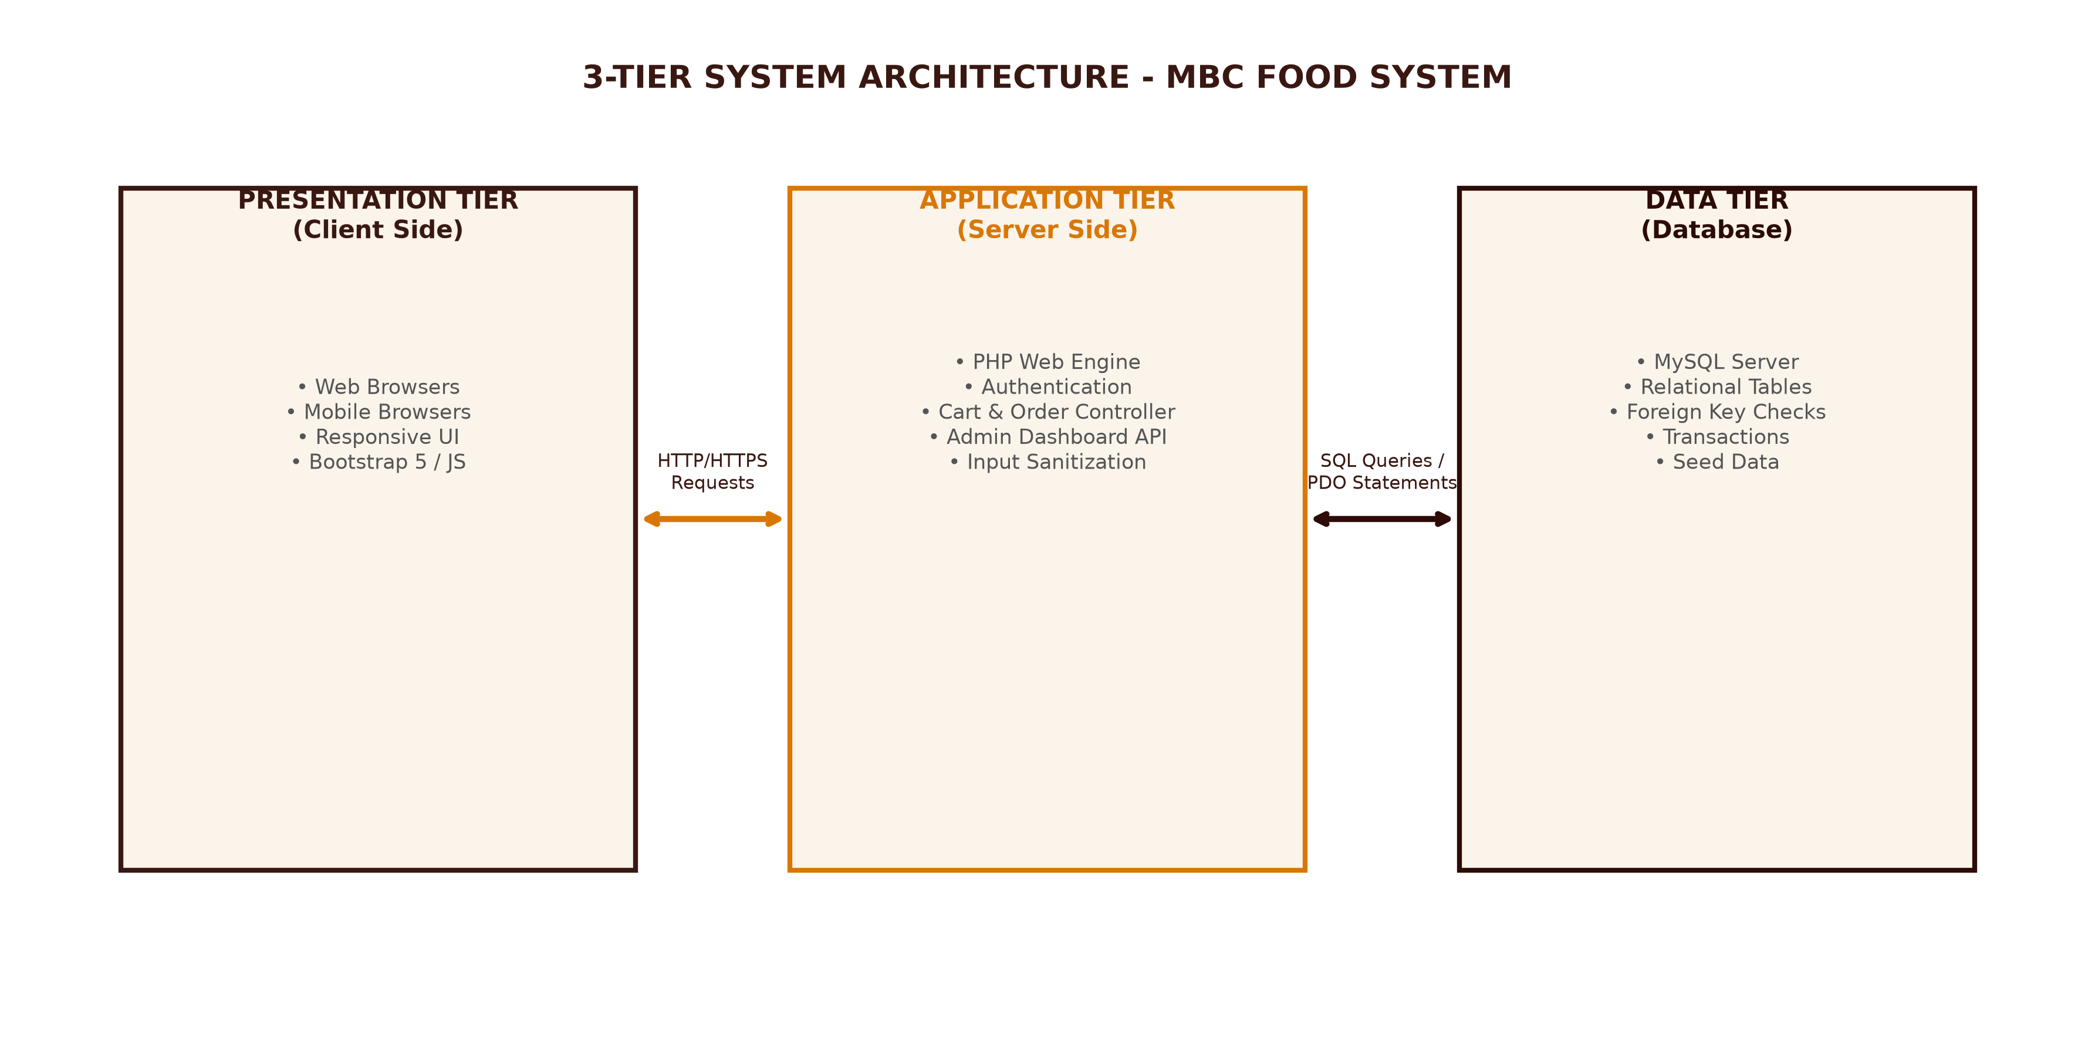
Figure: 3-Tier System Architecture Model for MBC Project

3.2 DFD Level 0 (Context Diagram)
The Context Diagram defines the system boundaries and highlights data interactions between external entities (Customer, Admin, Guest Visitor) and the central MBC System.
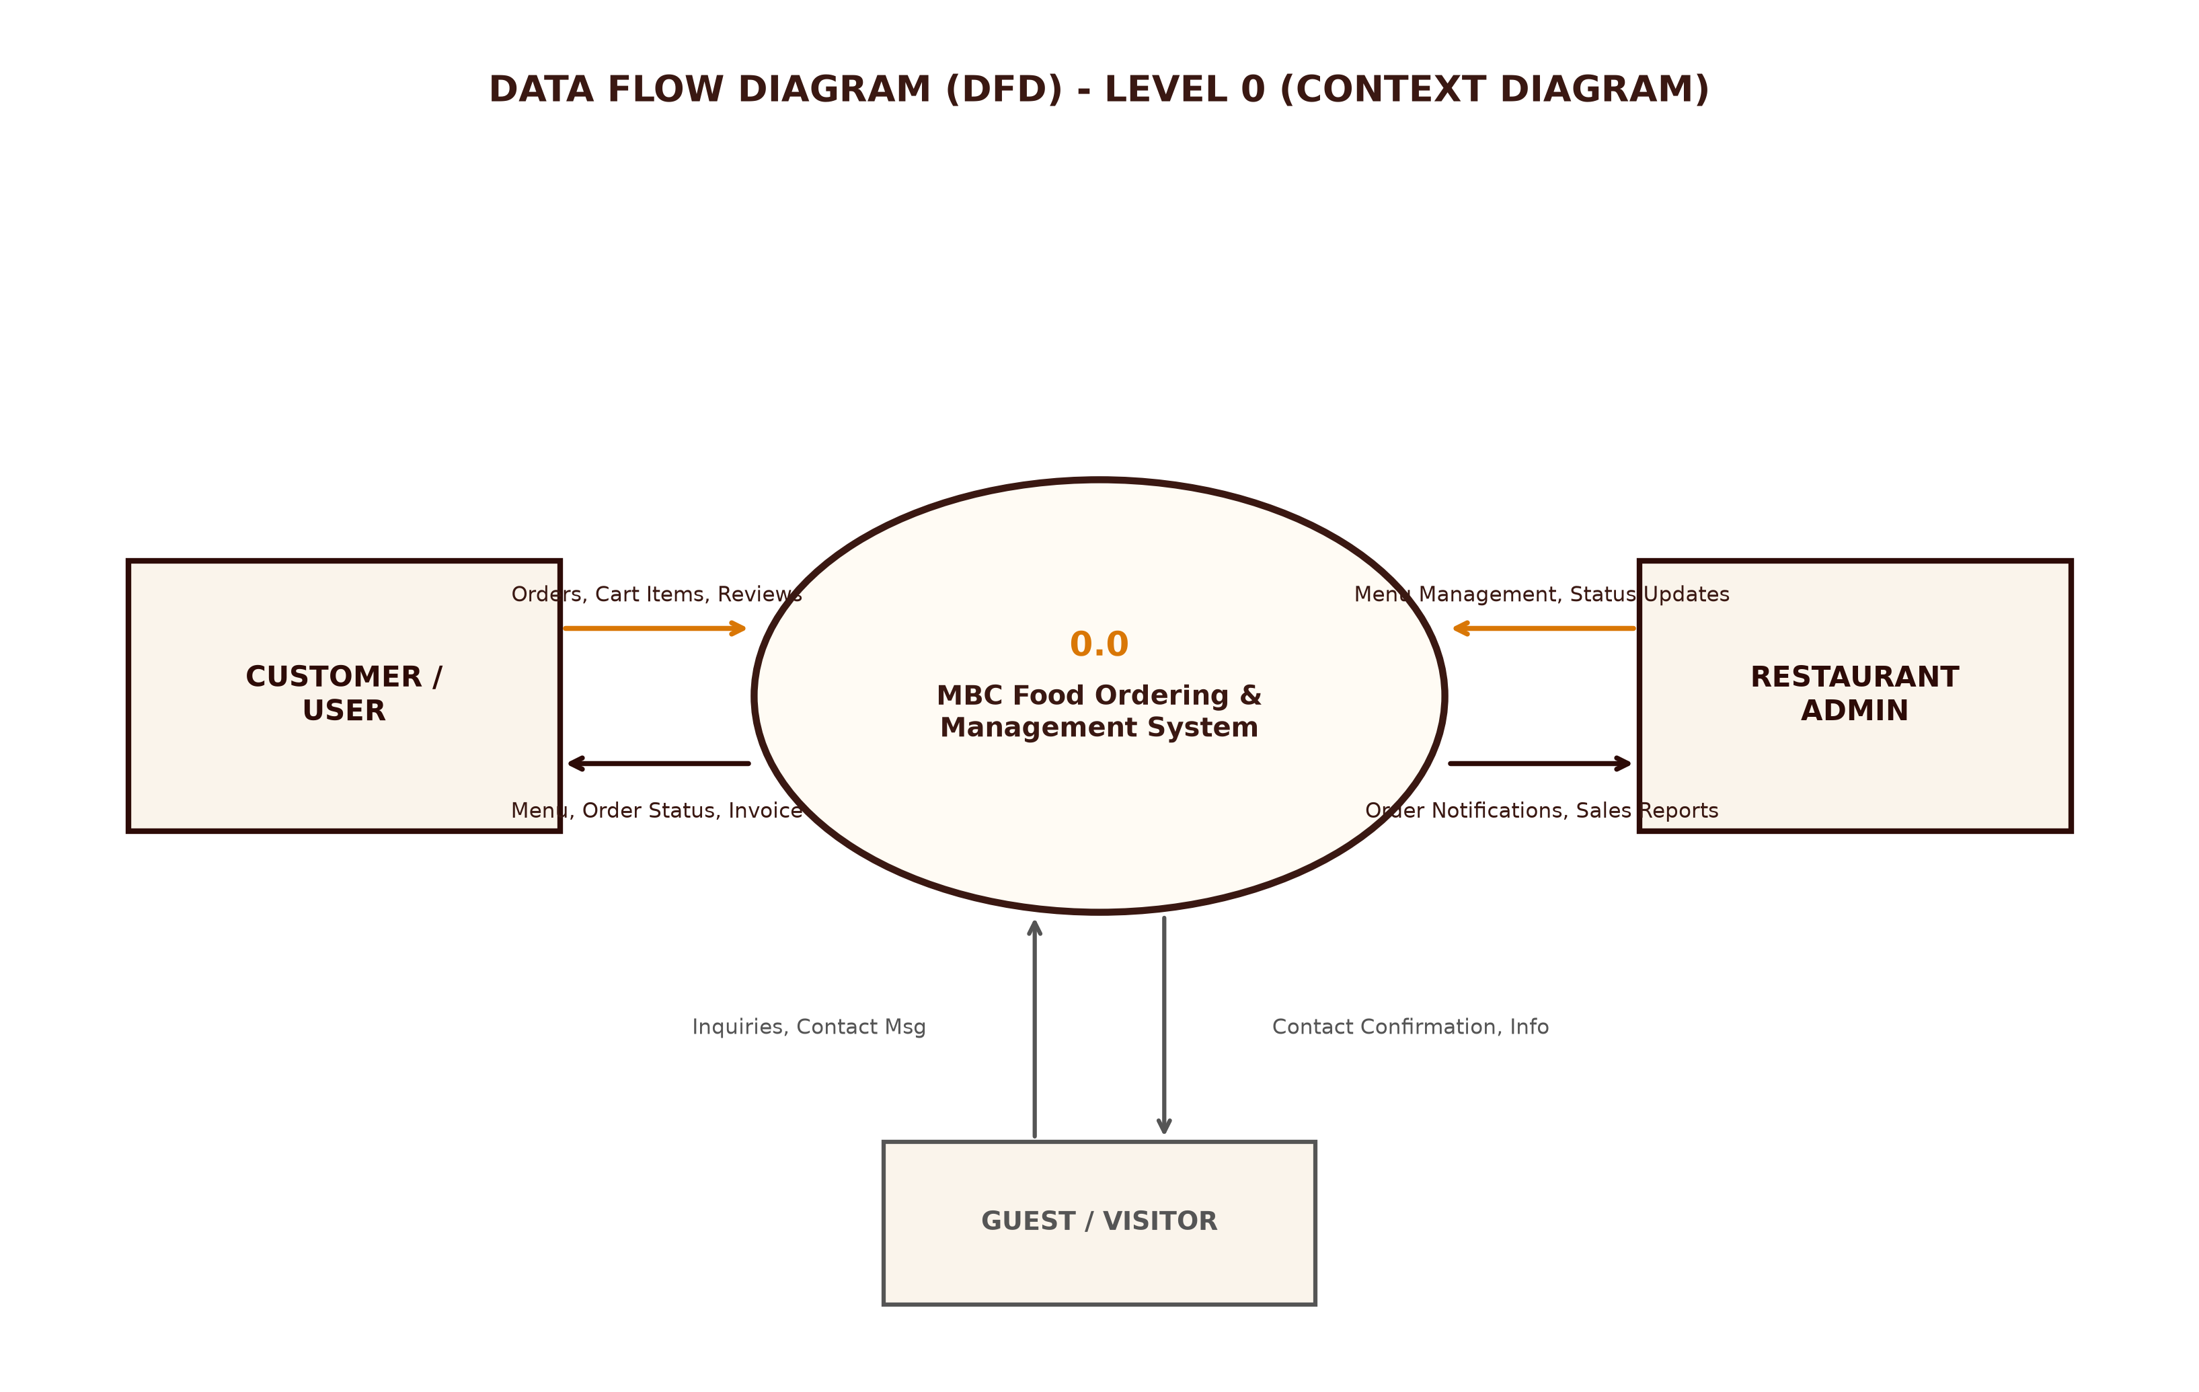
Figure: Data Flow Diagram (DFD) - Level 0 Context Diagram

3.3 DFD Level 1 Diagram
The DFD Level 1 decomposes the system into 6 core processes: User Authentication (1.0), Menu Browsing (2.0), Cart & Order Processing (3.0), Payment & Invoice Generation (4.0), Admin Order Fulfillment (5.0), and Reviews & Feedback (6.0), alongside key data stores D1-D4.
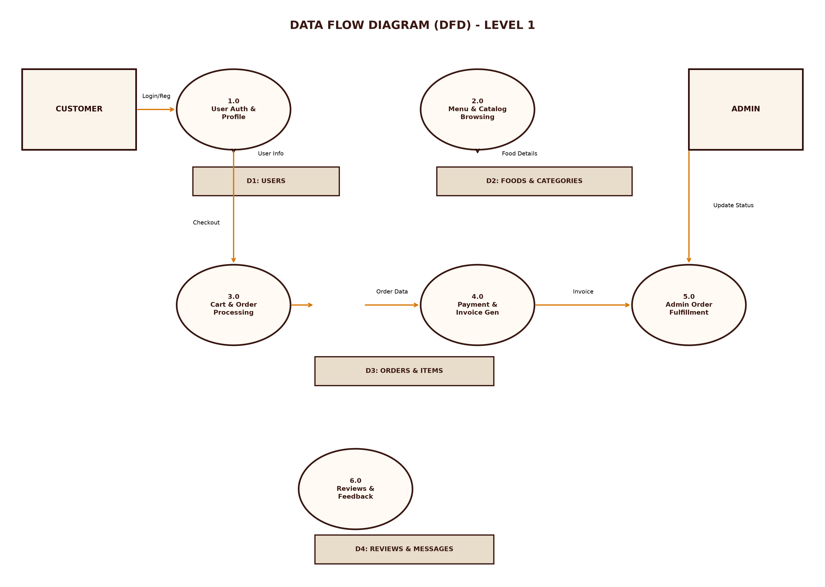
Figure: Data Flow Diagram (DFD) - Level 1 Detailed Process Model

Chapter 4: Database Design & Data Dictionary

4.1 Entity-Relationship (ER) Diagram
The ER Diagram illustrates the relational database model connecting entities through primary and foreign key constraints.
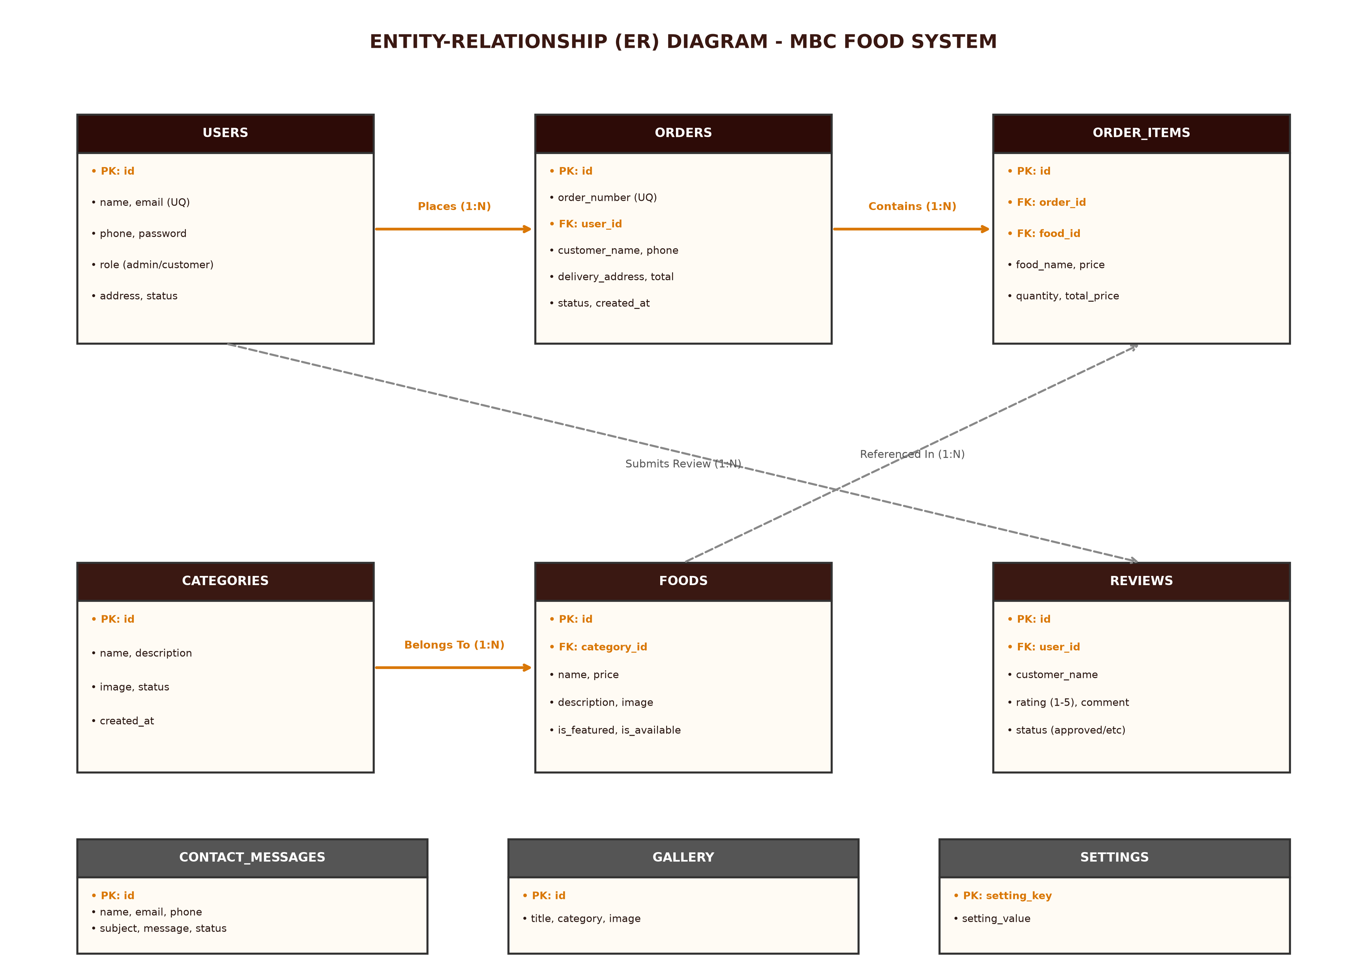
Figure: Entity-Relationship (ER) Diagram for Database `mbc_db`

4.2 Data Dictionary (All 9 Database Tables)
The data dictionary provides exact field attributes, data types, key constraints, and business descriptions for every table in `mbc_db`.

Table 1: `users`
Field Name | Data Type | Constraint | Default | Description
id | INT | PK, AUTO_INC | NULL | Unique user identifier
name | VARCHAR(100) | NOT NULL | None | Full customer or admin name
email | VARCHAR(100) | NOT NULL, UNIQUE | None | User login email address
phone | VARCHAR(20) | NOT NULL | None | Contact phone number
password | VARCHAR(255) | NOT NULL | None | Bcrypt hashed password
role | ENUM | NOT NULL | 'customer' | User role ('admin', 'customer')
address | TEXT | NULL | NULL | Default delivery address
status | ENUM | NOT NULL | 'active' | Account state ('active', 'blocked')
created_at | TIMESTAMP | NOT NULL | CURRENT_TIMESTAMP | Registration timestamp

Table 2: `categories`
Field Name | Data Type | Constraint | Default | Description
id | INT | PK, AUTO_INC | NULL | Category primary key
name | VARCHAR(100) | NOT NULL | None | Category title (e.g., Bateta Special)
description | VARCHAR(255) | NULL | NULL | Brief category summary
image | VARCHAR(255) | NULL | NULL | Category banner image filename
status | ENUM | NOT NULL | 'active' | Visibility ('active', 'inactive')
created_at | TIMESTAMP | NOT NULL | CURRENT_TIMESTAMP | Creation timestamp

Table 3: `foods`
Field Name | Data Type | Constraint | Default | Description
id | INT | PK, AUTO_INC | NULL | Food item primary key
category_id | INT | FK -> categories(id) | None | Associated category ID
name | VARCHAR(150) | NOT NULL | None | Dish name
description | TEXT | NULL | NULL | Detailed food description
price | DECIMAL(10,2) | NOT NULL | None | Unit selling price
image | VARCHAR(255) | NULL | NULL | Item image filename
is_featured | TINYINT(1) | DEFAULT 0 | 0 | Featured item flag (1=Yes, 0=No)
is_available | TINYINT(1) | DEFAULT 1 | 1 | Stock availability (1=Yes, 0=No)
created_at | TIMESTAMP | NOT NULL | CURRENT_TIMESTAMP | Record creation timestamp

Table 4: `orders`
Field Name | Data Type | Constraint | Default | Description
id | INT | PK, AUTO_INC | NULL | Order primary key
order_number | VARCHAR(30) | NOT NULL, UNIQUE | None | Formatted order code (e.g. MBC-849201)
user_id | INT | FK -> users(id) | NULL | Customer account ID (if logged in)
customer_name | VARCHAR(100) | NOT NULL | None | Customer full name
customer_email | VARCHAR(100) | NOT NULL | None | Customer contact email
customer_phone | VARCHAR(20) | NOT NULL | None | Delivery contact phone
delivery_address | TEXT | NOT NULL | None | Complete physical shipping address
order_type | ENUM | DEFAULT | 'Home Delivery' | Type ('Home Delivery', 'Takeaway', 'Dine-in')
payment_method | ENUM | DEFAULT | 'Cash on Delivery' | Payment ('Cash on Delivery', 'UPI', etc)
subtotal | DECIMAL(10,2) | NOT NULL | None | Total items sum
tax_amount | DECIMAL(10,2) | NOT NULL | 0.00 | Calculated tax (5% GST)
delivery_fee | DECIMAL(10,2) | NOT NULL | 0.00 | Flat delivery fee
total_amount | DECIMAL(10,2) | NOT NULL | None | Final grand total
status | ENUM | NOT NULL | 'Pending' | Status ('Pending', 'Preparing', 'Completed')
notes | TEXT | NULL | NULL | Special customer instructions
created_at | TIMESTAMP | NOT NULL | CURRENT_TIMESTAMP | Order placement timestamp

Table 5: `order_items`
Field Name | Data Type | Constraint | Default | Description
id | INT | PK, AUTO_INC | NULL | Order item line ID
order_id | INT | FK -> orders(id) | None | Parent order reference ID
food_id | INT | FK -> foods(id) | NULL | Purchased food item ID
food_name | VARCHAR(150) | NOT NULL | None | Historical food item title
price | DECIMAL(10,2) | NOT NULL | None | Item price at time of purchase
quantity | INT | NOT NULL | None | Quantity ordered
total_price | DECIMAL(10,2) | NOT NULL | None | Line item total (price * quantity)

Table 6: `reviews`
Field Name | Data Type | Constraint | Default | Description
id | INT | PK, AUTO_INC | NULL | Review primary key
user_id | INT | FK -> users(id) | NULL | Reviewer user ID
customer_name | VARCHAR(100) | NOT NULL | None | Display name
rating | INT | NOT NULL | 5 | Star rating scale (1-5)
comment | TEXT | NOT NULL | None | Review feedback text
status | ENUM | DEFAULT | 'approved' | Moderation ('approved', 'pending', 'rejected')
created_at | TIMESTAMP | NOT NULL | CURRENT_TIMESTAMP | Review date

Table 7: `gallery`
Field Name | Data Type | Constraint | Default | Description
id | INT | PK, AUTO_INC | NULL | Gallery image ID
title | VARCHAR(150) | NOT NULL | None | Image caption/title
category | VARCHAR(100) | DEFAULT | 'General' | Category classification
image | VARCHAR(255) | NOT NULL | None | Stored image filename
created_at | TIMESTAMP | NOT NULL | CURRENT_TIMESTAMP | Upload date

Table 8: `contact_messages`
Field Name | Data Type | Constraint | Default | Description
id | INT | PK, AUTO_INC | NULL | Message primary key
name | VARCHAR(100) | NOT NULL | None | Sender full name
email | VARCHAR(100) | NOT NULL | None | Sender email
phone | VARCHAR(20) | NULL | NULL | Sender phone
subject | VARCHAR(150) | NULL | NULL | Message subject line
message | TEXT | NOT NULL | None | Full message body
status | ENUM | DEFAULT | 'unread' | Read status ('unread', 'read')
created_at | TIMESTAMP | NOT NULL | CURRENT_TIMESTAMP | Sent timestamp

Table 9: `settings`
Field Name | Data Type | Constraint | Default | Description
setting_key | VARCHAR(50) | PK | None | Unique system configuration key
setting_value | TEXT | NOT NULL | None | Configuration key value

Chapter 5: User Interface & Screenshots
This section illustrates the key screen layouts and step-by-step user workflow interactions across both customer and administrator interfaces.

5.1 Customer Landing Page
The landing page (`index.php`) features a branded header banner, quick navigation bar, popular category grid, and featured traditional Dhoraji dishes.
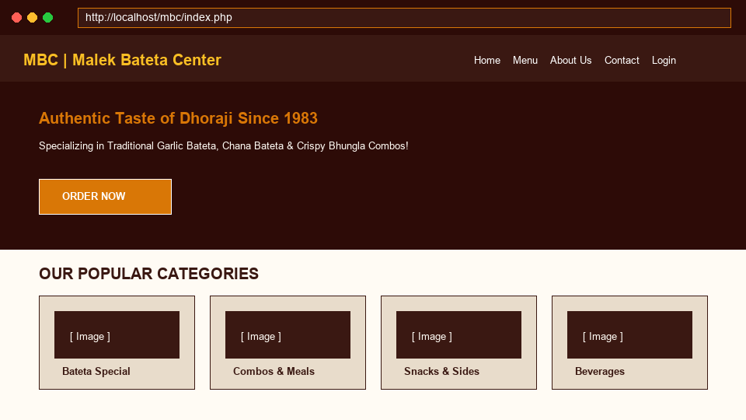
Figure: Customer Landing Page (`index.php`)

5.2 Food Menu & Interactive Cart Page
The menu page (`menu.php`) enables category filtering (Bateta Special, Combos, Snacks, Drinks), item card display with pricing, and instant AJAX 'Add to Cart' actions.
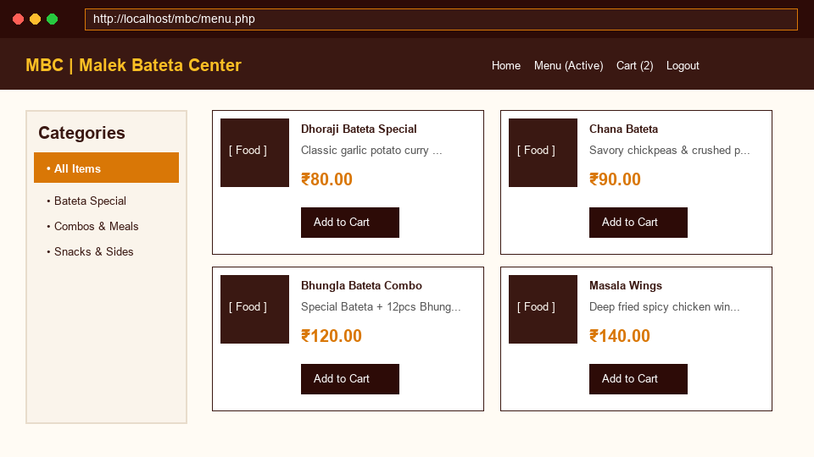
Figure: Interactive Food Menu & Item Catalog (`menu.php`)

5.3 Order Checkout & Summary Page
The checkout page (`checkout.php`) allows customers to enter delivery addresses, choose order types (Home Delivery, Takeaway), select payment methods (COD, UPI), and view an itemized tax/delivery summary.
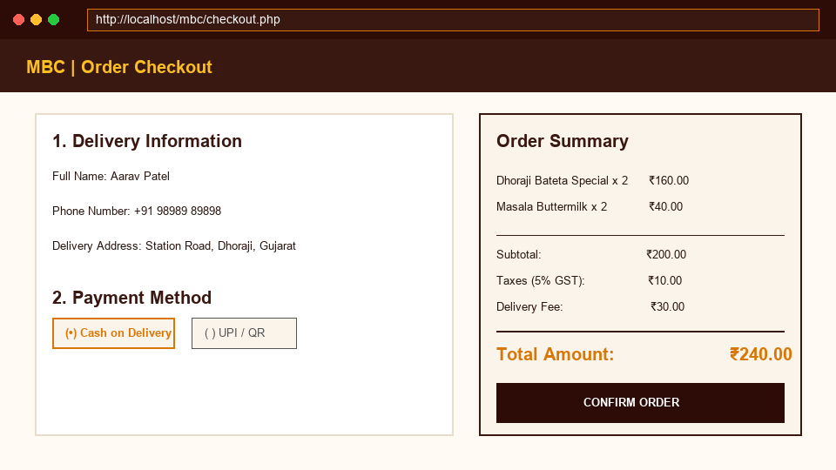
Figure: Order Checkout & Payment Selection (`checkout.php`)

5.4 Administrator Portal Dashboard
The admin dashboard (`admin/index.php`) displays real-time operational statistics (Total Orders, Pending Orders, Total Revenue, Active Customers) and a live order fulfillment queue.
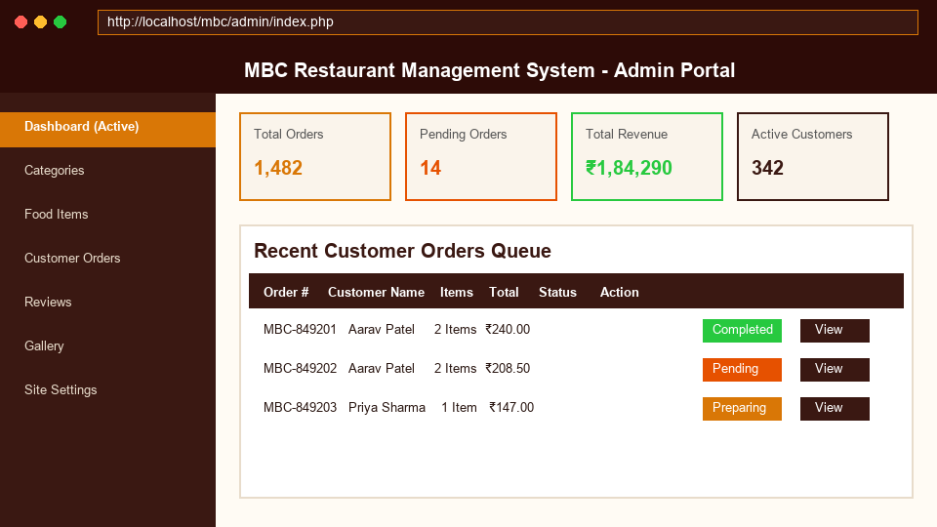
Figure: Admin Control Panel Dashboard (`admin/index.php`)

5.5 Live Order Management & Invoice Screen
The order management screen (`admin/orders.php`) allows administrators to inspect complete order line items, update delivery lifecycle status, and launch print-ready invoices (`print-invoice.php`).
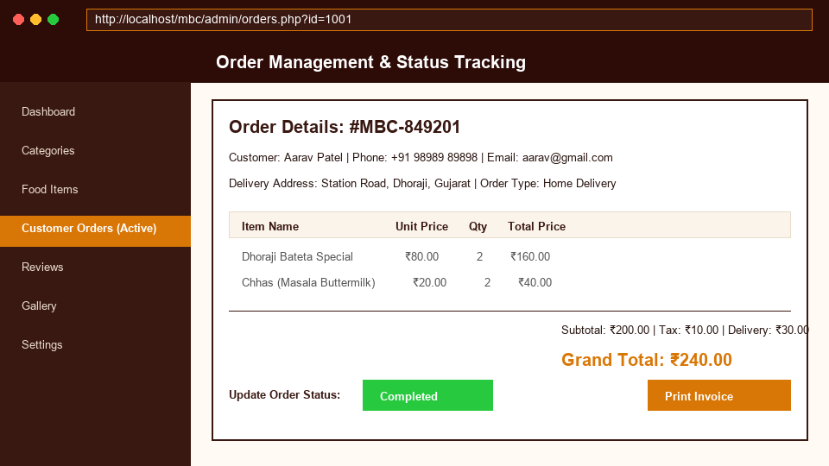
Figure: Live Order Processing & Invoice Print Interface (`admin/orders.php`)

Chapter 6: System Testing & Verification Matrix
System verification was executed using structured test cases spanning authentication, catalog retrieval, cart calculation, order insertion, and admin fulfillment workflows.
Test Case ID | Module | Test Scenario | Expected Result | Status
TC-001 | User Auth | Submit registration with valid email & phone | Account created, redirect to login | PASSED
TC-002 | User Auth | Attempt login with incorrect password | Display error alert 'Invalid credentials' | PASSED
TC-003 | Menu | Filter dishes by 'Bateta Special' category | Grid updates showing only Bateta dishes | PASSED
TC-004 | Cart | Add 2x Dhoraji Bateta Special to cart | Session cart updates subtotal to ₹160.00 | PASSED
TC-005 | Checkout | Confirm order with COD payment option | Order saved in DB (`orders`), cart cleared | PASSED
TC-006 | Admin | Change order status from 'Pending' to 'Completed' | Database updated, status badge turns green | PASSED
TC-007 | Invoice | Click 'Print Invoice' for order MBC-849201 | Opens formatted printable invoice window | PASSED

Chapter 7: Conclusion & Future Scope

7.1 Conclusion
The MBC Food Ordering and Restaurant Management System successfully digitizes traditional restaurant workflows into a modern, responsive web application. The platform streamlines online food ordering for customers and provides administrators with an efficient order fulfillment dashboard.

7.2 Future Scope
• Real-Time Push Notifications: Integrate WebSocket or Firebase Cloud Messaging (FCM) for instant kitchen order alerts.
• Live GPS Delivery Tracking: Integrate Google Maps API to track delivery drivers in real time.
• Payment Gateway SDK: Integrate Razorpay / Paytm SDKs for seamless online card and UPI auto-settlements.
• Mobile App Integration: Develop Flutter / React Native Android and iOS mobile applications utilizing the PHP REST API endpoints.

