**EXPLORATORY DATA ANALYSIS AND CUSTOMER EXPERIENCE ANALYSIS IN AUTOMOBILE SERVICE COMPANY**

Summer Internship Project Report submitted in partial fulfilment of the requirements for the degree of

Master of Business Administration

**By**

**ROSHAN RAVINDRA MALAPUR**

**REGISTER NUMBER**

**2128324**

**Under the Guidance of**

**PROF. NAGENDRA B V**

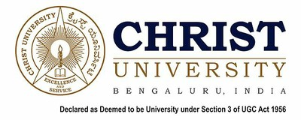

**School of Business and Management**

**CHRIST (Deemed to be University), Bangalore**

**AUGUST 2022**

**EXPLORATORY DATA ANALYSIS AND CUSTOMER EXPERIENCE ANALYSIS IN AUTOMOBILE SERVICE COMPANY**

Summer Internship Project Report submitted in partial fulfilment of the requirements for the degree of

Master of Business Administration

**By**

**ROSHAN RAVINDRA MALAPUR**

**REGISTER NUMBER**

**2128324**

**Under the Guidance of**

**PROF. NAGENDRA B V**



**School of Business and Management**

**CHRIST (Deemed to be University), Bangalore**

**AUGUST 2022**



**Declaration**

I hereby declare that the Summer Internship Report entitled “Exploratory Data Analysis and Customer Experience Analysis” has been undertaken by me for the award of Master of Business Administration. I have completed this study under the guidance of Prof. Nagendra B V.

I also declare that this Summer Internship Report has not been submitted for the award of any Degree, Diploma, Associate ship, Fellowship or any other title, in CHRIST (Deemed to be University) or in any other university.

Place: Bengaluru _____________________

Date 20/08/2022 Roshan Ravindra Malapur

2128324



**Certificate**

This is to certify that the Summer Internship Project Report submitted by Roshan Ravindra Malapur on the title ““Exploratory Data Analysis and Customer Experience Analysis” is a record of Summer Internship Project work done by him during the academic year 2022-23 under my guidance and supervision in partial fulfilment of Master of Business Administration.

Place: Bengaluru

Date: 20/8/2022

___________________________

Prof. Nagendra B V

Assistant Professor

School of Business and Management

CHRIST (Deemed to be University)

Bengaluru

**Acknowledgement**

I am indebted to many people who helped me accomplish this Internship successfully.

First, I thank the Vice Chancellor Dr Fr Abraham V M, CHRIST (Deemed to be University) for giving me the opportunity to do my project.

I thank Dr. Jain Mathew, Dean, Dr. Georgy Kurien, Associate Dean, Prof. Sirish, Head of the Department and Dr. Lakshmi Shankar Iyer, Head – Business Analytics, School of Business and Management, CHRIST (Deemed to be University) for their kind support.

I thank Prof. Nagendra B V for his support and guidance during the course of my internship. I remember him with much gratitude for his/her patience and motivation, but for which I could not have submitted this work.

I wish to express my sincere thanks to my corporate mentor, Mr Ullas Ragi, Manager, Modern Motors, Gadag for giving me an opportunity to work under his/her guidance and successfully complete my internship.

I thank my parents for their blessings and constant support, without which this internship project would not have seen the light of day.

_____________________

Roshan Ravindra Malapur

(2128324)

**Certificate**

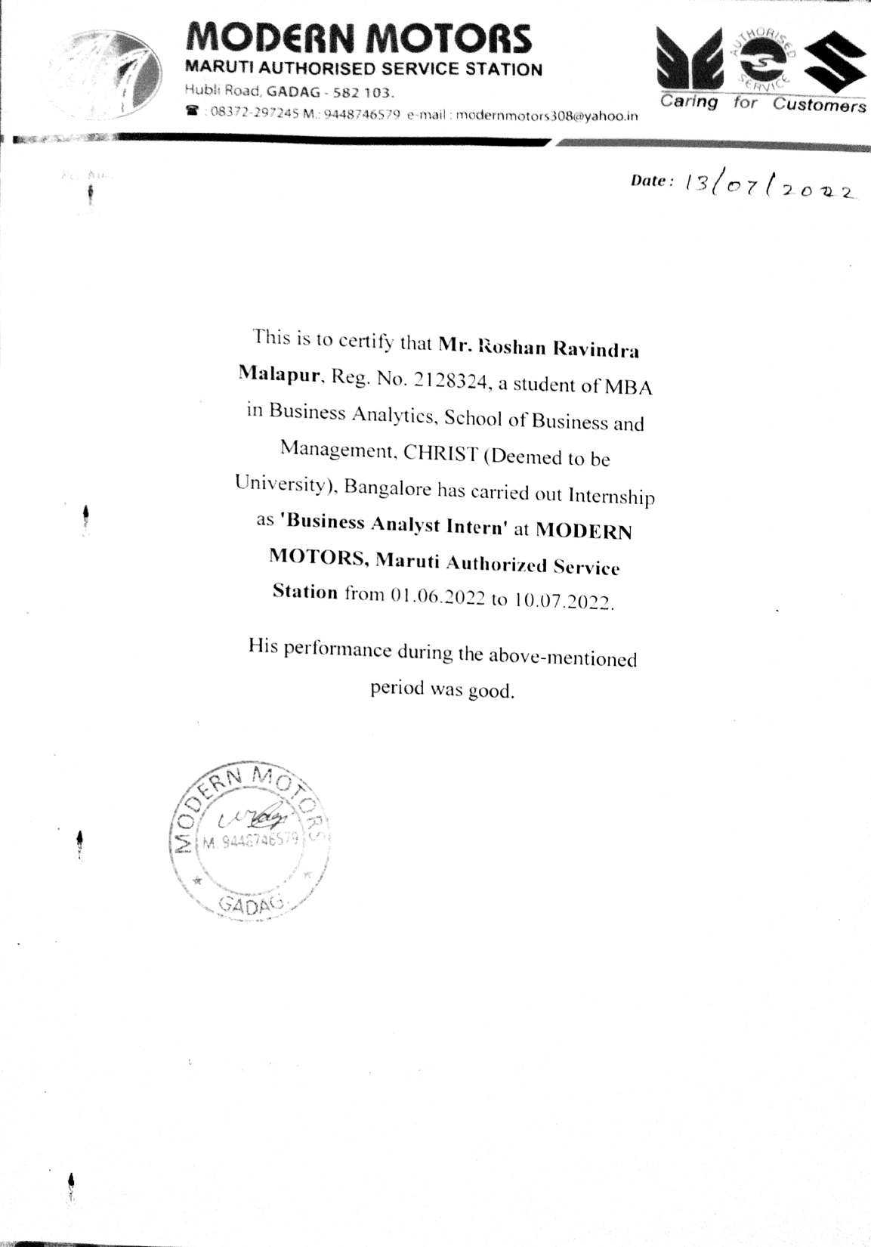

|  |  |  |
| --- | --- | --- |
| Chapter No. | **TABLE OF CONTENTS** | Page No. |
| 1 | Introduction | 2 |
| 2 | Industry and Company Profile | 5 |
| 3 | Project Design and Methodology | 10 |
| 4 | Data Analysis & Interpretation | 14 |
| 5 | Findings, Conclusion, Recommendations & Learnings | 20 |
|  | References |  |
|  | Appendix   * Screenshot of Similarity Index Report * Feedback forms by the corporate mentor, University mentor and the viva panel |  |

|  |  |  |
| --- | --- | --- |
| Figure  No. | **LIST OF FIGURES** | Page No. |
| 1 | Authorized Service Centre | 5 |
| 2 | Organizational Structure | 8 |
| 3 | SWOT Analysis | 9 |
| 4 | Dataset_1 | 11 |
| 5 | Dataset_2 | 11 |
| 6 | CRISP_DM Framework | 12 |
| 7 | Type of Service v/s Average time take taken | 14 |
| 8 | Number of Cars v/s Type of Service | 15 |
| 9 | Number of Cars arriving per week for Service | 15 |
| 10 | Service Level Agreement (SLA) | 16 |
| 11 | Topic Modelling using LDA | 17 |
| 12 | VADER | 17 |
| 13 | Polarity Scores of VADER | 18 |
| 14 | VADER Graph | 19 |

**Executive Summary**

Modern Motors is a Maruti Suzuki Authorized Service Centre situated in Gadag district of Karnataka. Servicing of an automobile includes several of processes carried out. Today, service industries are booming in the market since there are a lot of technological advancements that are taking place. The increasing demand for original parts of the automobiles since there is increase in the counter fit spare parts which are sold by unauthorized or independent service centres. Service centres also include franchises and company-owned hubs.

The present study is about how Modern Motors is a well-established company, its processes and to know how the company has performed over a period of past three months. The project also mainly focus on the major problem of the company which is the inability to understand the customer experience and satisfaction about their quality of service. The company has always been a profitable company since many years and well performing. Modern Motors has different types of services like washing, body repair, running repair, 1st, 2nd and 3rd free service and paid service. The exploratory data analysis of the data of past three months reveal about the number of cars that arrive to the company for service per week, the average time taken for each model of Maruti Suzuki to service and the average time taken for each of the service to complete. Also, Modern Motors has a Service level agreement to deliver the vehicle within six hours. The project also includes to check whether the company has complied with its agreement. The major problem of the company that is to analyse the customer experience about their quality of service, the google reviews of the company are analysed and through topic modelling using Latent Dirichlet Allocation. Through this technique, the company is able to know the major topics that have been put up by their customers which will be easy for the company to analyse their service quality, customer friendliness and timeliness, thus make necessary improvements on it. The polarity scores of the customer reviews are analysed using VADER model. These polarity scores reveal the compounded score which divides the reviews into positive, negative and neutral reviews based on their scores. Modern Motors, by deploying this model will be able to analyse their customer reviews in future. At the end, the report consists of the limitations of this project and also the suggestions and recommendations provided to the company.

**CHAPTER 1**

**INTRODUCTION**

Modern Motors is an automobile service company which is situated in Gadag district of Karnataka. The company is a Maruti Suzuki Authorized Service Station. Authorized service centres are those which are the franchises or the company-owned service stations. Today, automobile service stations are gaining a lot of importance since the market for the automobile companies is increasing. When new technologies are introduced in the automobiles, the service centres have to equip themselves by training their staff and maintaining the inventory of new spare parts. The growth of automobile industry directly impacts on the service stations. In India, the automobile industry accounts to 5% of overall GDP. This reveals that India has a wider market for automobile industries in coming years which would automatically reflect in the increase of service centres.

The authorized service centres mainly focus in complying with the set of guidelines that are given by the company which provide its franchise. Modern Motors was established in 2010 by Mr. Ullas Ragi, who is now the head of the company. The company has different types of services like washing, running repair, body repair, first, second, third free services and paid services. All these services are charged with varying prices depending upon the amount of work put in and the number of spare parts which are replaced. Modern Motors as a Maruti Suzuki Authorized Service Station, deals only with the Maruti Suzuki cars for service.

The present study is about the exploratory data analysis of the company to know how is the company performing in past three months in terms of number of cars arriving for service, the time taken for each type of service, to check whether the company has followed its service level agreement and the next part of this project is about analysing the customer experience analysis of the customers who have serviced their vehicles in the company. This analysis is done by deploying a model called VADER and Topic Modelling using LDA which helps is to understand the overall analysis of the reviews of the customers. Through this study, Modern Motors will be able to understand the overall performance of the company and improve on it and also understand about its customer reviews to know their satisfaction levels and upgrade their quality of service.

**LITERATURE REVIEW**

Globally, Automobile Service industry has a wide market. The recent years have proved that India, China and South East Asia are the countries where the new markets for automobile service industry open up. In India, the automobile service industry contributes around 5% of GDP. The employment rate has also increased in recent years. The biggest challenge for the automobile service companies is the retention of its customers. The range of automobiles being released with very little differentiation and similar prices has given more choices for the customers. Here comes the part of after sales service quality of the companies. By providing high quality service to its customers, the automobile companies can retain their customers. There are many developments going on in the automobile service sectors which is making a way to the companies to establish good relationship with its customers and satisfy their needs. The article depicts about a model which is developed by Mr. Parasuraman called SERVQUAL which is used by many companies and researchers to measure the quality of service and satisfaction of customers.

In service quality, there are components known as reputational quality, technical quality and functional quality. The article explains about the five dimensions of the SERVQUAL model. Reliability as a major factor is assessing the quality of service would help the company in a great way. Delivery of the vehicles at the promised time has the major impact on the satisfaction level of the customers. This dimension is considered as most important in the service quality. Building confidence and trust of the customers is also equally important. When the company gives assurance to its customers, it has to abide by it and see to it that the customer is happy about its service. Being professional in terms of communication and interaction with its customers is necessary to gain the confidence of the customers. The physical cues such as the layout of the dealership, showing empathy towards its customers and the way the company responds to its customers have a major impact on the quality of service provided by the company.

The main objective of the article is to know the gap between the perceived and the expected service by the companies. The article has also made an analysis about the service quality factors of commercial and personal vehicles and understand the differences between them if any. A Likert seven point scale is used by the researcher and the answers for the questionnaire is collected. Totally, there were seventeen factors which were then divided into five main factors and named the model as SERVQUAL. The hypothesis given in the article is

that the customer has many types of expectations from the automobile service company. The company should have a clear understanding of the expectations of its customers so that they are able to measure and manage their level of service. The service quality gap is the gap between the expected quality of service by the customers and their opinions about the service which is actually delivered by the company. The first hypothesis is that there is a significant difference of ratings between the perceived and the expected service level for personal vehicles and the second hypothesis is there is a significant difference of ratings between the perceived and the expected service level for commercial vehicles.

The analysis part of this research is about the factors which were given by the respondents about how the ideal service company should be and how actually it is. Responsiveness, reliability, tangibility, empathy and assurance were the main keys which the company has to focus on to improve their level of service and retain customers. Automobile industry is growing at a faster pace and in order to stay in the competition, the companies have to always on their toes to equip themselves with latest technologies and move along with the trend so as to make their customers happy. From this research, it is concluded that there is a gap between the perceived and the expected service quality and without working on it, the companies cannot move forward in the market.

**CHAPTER 2**

**PART- A INDUSTRY PROFILE**

**PART-B COMPANY PROFILE**

The Automotive Industry is always the main pillar of Indian Economy. It is one of the key factor to drive the economy. The recent technological advancements happening in the automobile industry has been a major reason for the increase in the growth of automobile industries in India. Today, the emerging automobile start-up companies have great opportunity to penetrate into the market and make huge profits. The Indian automobile industry is becoming highly competitive in recent years. It is the fourth largest automotive industry in the world. A study estimates that the overall worth of automobile industry in India accounts to 34,000 crore rupees. The trends in this industry change every day since the number of automobiles that are being released in the market by different companies in increasing. This majorly impacts on the overall decision making of the people. It is a normal tendency of people to change their choices every now and then when they are given with many choices. The service centres are also being well equipped now-a-days as the automobile service industries are being more advanced. The service stations have to always keep up the pace and walk along with the automobile manufacturing industry so as to have well trained staff for the efficient service of the automobiles. The service centres are divided into three types.

* **Authorized Service Centres**

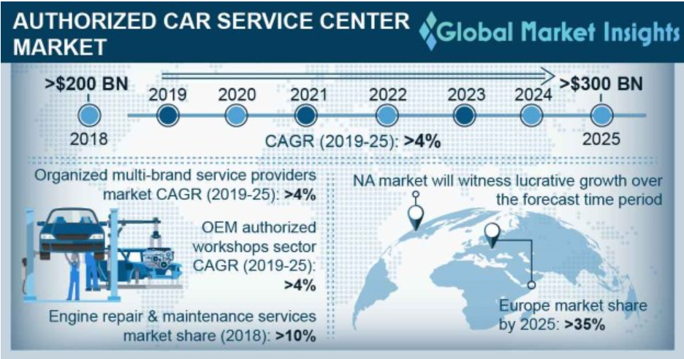Authorized Service Centres are those service stations which are company owned or franchises. These service centres are set up the manufacturing companies to help its customers get the best service quality and customer experience. Today, authorized service centres are increasing in the market due to the rising concerns about the counterfeit spare parts of the automobiles.

Figure 1

From the image, we can see that the market for the authorized service centres was worth 200 billion in 2018 and it is estimated that it will be worth of 300 billion by the end of 2025. This insight can clearly let us know the importance of authorized service centres for the customers because of its original spare parts and quality service.

* **Unauthorized Service Centres**

Unauthorized Service Centres are the service stations which are the local garages who are neither good in the quality of service or the timeliness in the delivery of vehicles. These service stations are fulfil the needs of the customers who are not interested in spending a lot of money on the maintenance of their vehicles. The use of traditional or the used spare parts of automobiles is more in such service centres. The staff in these service centres don’t have expertise.

* **Multi-branded Service Centres**

Multi-branded service centres are those which are newly introduced in the market in the automobile service industry. These service stations cater the same quality of service which is similar to the authorized service centres, with original spare parts but at a lower cost than the authorized service centres. Assurance of high quality and timeliness are the main factors of the multi-branded service centres. These service centres will be moving ahead than the other two types of service centres in the future and gain a great competitive advantage.

The future of automobile industry and the service centres is dependent on the technological advancements and the innovations. The emergence of the electrical vehicles can also be a great opportunity to the automobile industry to boost up.

**PART – B – COMPANY PROFILE**

Modern Motors is a Maruti Suzuki Authorized Service Station located in Gadag district of Karnataka. Initially, Modern Motors was an unauthorized or independent service station. In 2010, Modern Motors took the franchise of Maruti Suzuki Service centre and branded themselves as an authorized service station. The company was started by Mr. Ullas Ragi, who is the head of the company. Since, the automobile industry is growing at a very faster pace today, its impact is created on the service centres to be more equipped with all the technological advancements and well trained staff. Modern Motors, as a company has always been competitive in the market and is known to be one of the best service centres in Gadag. The popularity of this company is so wide that many customers from all the nearby places come here for the service of their vehicles. The mission statement of the company is ‘**Quality Service, Customer Satisfaction, On time delivery’.** The company is abiding by its mission to be the best authorized service in Gadag. The company also has its strategy which is ‘Increasing revenue by 10% 2023 expanding the customer relationships and setting up service centres in unique geographical locations’.

The service centres are basically of three types; authorized, unauthorized and multi-branded service centres. Modern Motors as an unauthorized service had gained great number of customers due to its quality of service, customer friendliness and on time delivery of vehicles. This helped the company is continuing with the retained customers and also new customers when the company took the franchise of Maruti Suzuki Service Station. Since, Modern Motors is a Maruti Suzuki Authorized Service Station, it only does the servicing of Maruti Suzuki Automobiles. There are a set of guidelines which are given by the Maruti Suzuki Company to Modern Motors, which are to be followed so as to take the franchise of it. Some of the regulations given by Maruti Suzuki to Modern Motors are:

* Proper training of workshop staff
* Health monitoring of workshop staff
* Online Service-Minimising customer staff interaction
* Workshop preparedness
* Staying relevant to customers

The committee of Maruti Suzuki visits its authorized service centres once in two months to verify and cross check if the company is complying with all its rules and regulations. There are penalties that have to be paid to the company if any rule is exploited or not followed. Being an authorized service centre, Modern Motors has to always be careful about the 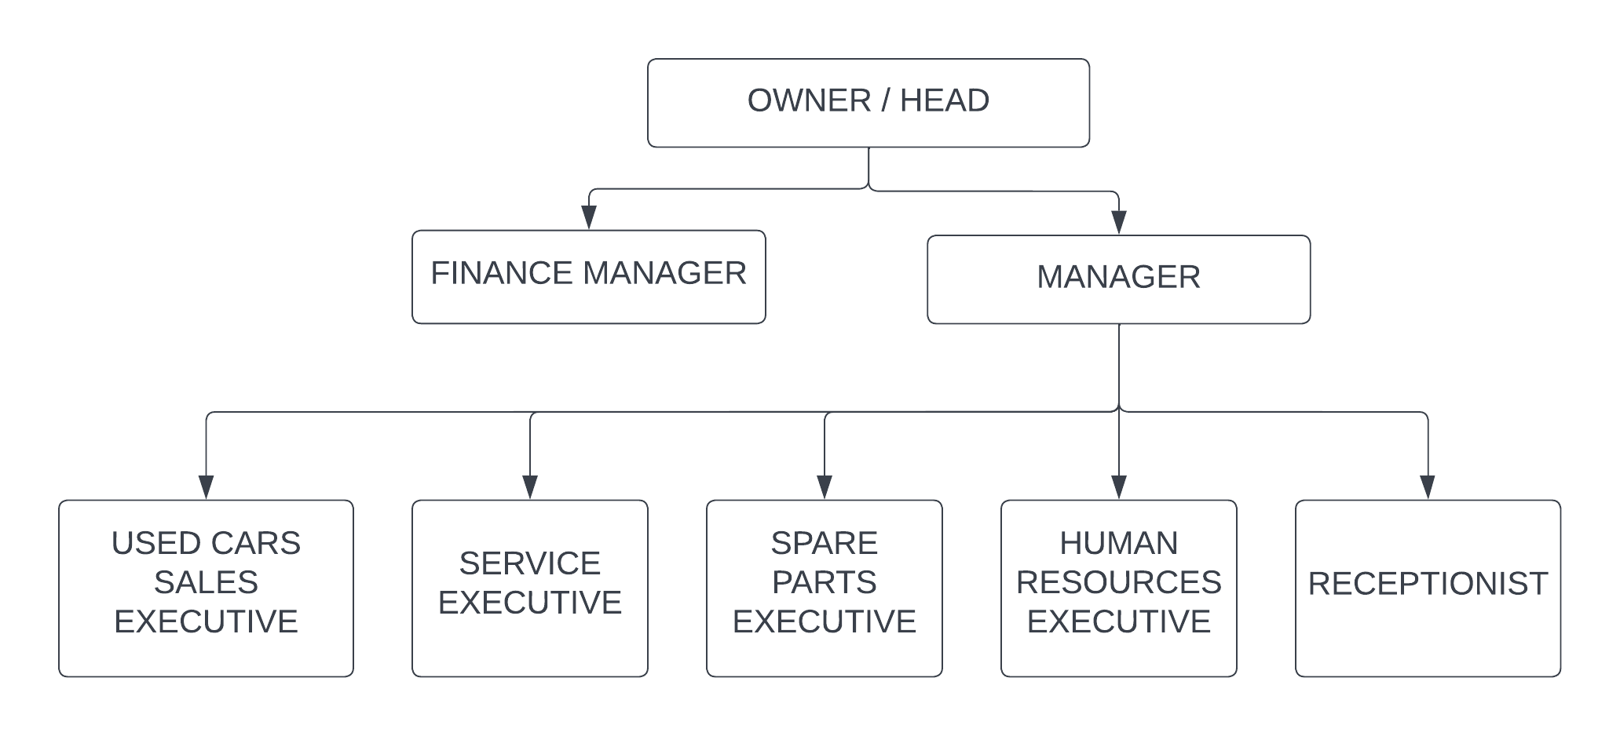regulations of Maruti Suzuki and abide by them to gain the trust of Maruti Suzuki.

Figure 2

The organizational Structure of Modern Motors consists of the Head of the company on the top. Below him are the finance manager and the other manager who is in charge of all the processes that take place in the company. There are executives for used car dealership, service, Spare parts, Human resources and a receptionist. Modern Motors has a float or a horizontal type of organizational structure. This type of organizational structure is majorly used by smaller companies. It gives more responsibility to all the employees of the company. The speed of implementing ideas is faster in such organizational structure. But, it would be difficult for the company to maintain once it starts getting bigger.

The competitors for Modern Motors are the Maruti Suzuki Arena which is another Authorized Service Station which is also into sales of cars and the other competitor is SRV care. The advantage for Modern Motors is the geographical location of the company. Since, the company is situated in the outskirts of the district which is near to the National Highway, the company gets more number of customers who travel by the highway. There are different types of services which are done by the company. Washing, Body repair, Running repair, paid service, 1st, 2nd and 3rd free services are some of them. The employees in the company are well aware of the strategy of the company and are dedicated. The service level agreement set by the company is six hours which means that any vehicle for service will be delivered by the company within six hours.

* **SWOT ANALYSIS**

**STRENGTHS**

* Top authorized company in Gadag district.
* Gained the trust of its customers being a local service company earlier.
* Well trained staff and workers.
* Availability of equipment and components.
* Addressing to every customer grievance.

**OPPORTUNITIES**

* Declining competition due to pandemic crisis.
* Emergence of new technologies to reduce costs.
* Increase in customers due to quality of service.
* Entry into used car dealership business.

**WEAKNESSES**

* Long queues.
* Delay in supply of components.
* Small territory.

**THREATS**

* Adverse tax policy.
* Emergence of EV market.
* Rise in local/unorganized services.

Figure 3

Overall, Modern Motors as a company is growing ahead with great profits and the company has to keep in pace with the technological advancements that happen in the automobile industry so as to train its staff and gain competitive advantage over its competitors.

**CHAPTER 3**

**PROJECT DESIGN AND METHODOLOGY**

**PROBLEM STATEMENT**

Modern Motors as an automobile service company has been performing very well since many years and wanted to know its performance in terms of number of vehicles arrived for service, the average time taken for each type of service, the type of models that arrive for the service, whether the company has been able to comply with its Service Level Agreement (SLA) and so on. The company wanted to have a proper method which can visualize its performance with its historical data. The other major problem faced by Modern Motors was the inability to understand its customer experience for their quality of service. The company wanted a proper model which will help them to analyse their customer reviews and improve on their service quality and customer service so that they meet their customer satisfaction.

**PROJECT OBJECTIVE**

The main objective of this project is to do the exploratory data analysis of the past data of the company and know its performance. The other objective is to deploy Machine Learning model called Topic Modelling using Latent Dirichlet Allocation to know the customer perceptions about the service of the company. To know the number of customers who have positive and negative reviews about the company, VADER (Valence Aware Dictionary for Sentimental Reasoning). This model gives the scores for the reviews which can be analysed and the overall conclusion can be drawn from the reviews for the quality of service provided by the company.

**CRISP DM FRAMEWORK**

This project is designed according to the CRISP DM framework. CRISP DM stands for cross-industry process for data mining. This approach of project design allows us to build a proper model that fits our data and cater to our project objective. It involves Business Understanding, Data Understanding, Data Preparation, Modelling, Evaluation and Deployment. This method of solving a problem focuses on business goals to ensure that the company gets benefited. It gives us opportunity to evaluate the progress of our project aligned with its objectives. This is very helpful to reduce the risks of getting wrong at the end of the project which is not meeting the business objectives.

**SOURCE OF DATA**

* **Primary Data**

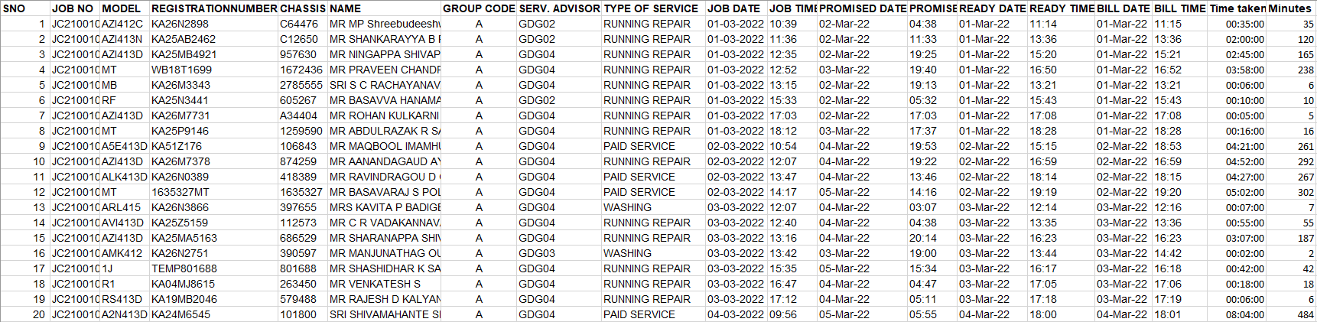The primary data about the company related to the number of cars arriving to the company daily for the service, type of model, the job time, the promised delivery date and time and the time taken for the service to complete was provided by the company. The dataset contains categorical variables and continuous variables.

Figure 4

* **Secondary data**

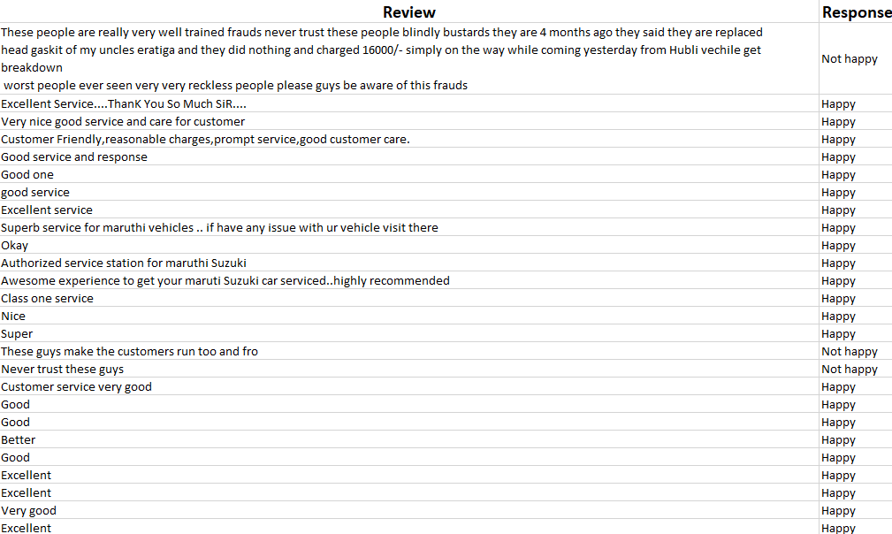The secondary data is about the reviews of the customers collected from google and also manually collected by the customers coming to the company for servicing the vehicles. This dataset contains the reviews of the customers and the sentiment of the review whether it is happy or unhappy. Using this dataset, the ML model is built to analyse the reviews and improve the service quality of the company based on the reviews given by the customers.

Figure 5

**TOOLS AND TECHNIQUES**

The tools and techniques used to solve a problem is a very important component of a project. The tools used to do this project were Microsoft Excel and Python. Microsoft Excel was used for data cleaning, data preparation and visualizations. The dataset was put into an excel sheet and different visualizations regarding the performance of the company was analysed. Python was used to build Machine Learning models; VADER and Topic Modelling using LDA. Using these models, the customer review analysis of the customers that have arrived for the service of their vehicles is done.

* Here, the business idea of Modern Motors is analyzed. Modern Motors is an automobile service company which is situated in Gadag district of Karnataka. In 2010, Modern Motors took the franchise of Maruti Suzuki Service centre and branded themselves as an authorized service station. . There are different types of services which are done by the company. Washing, Body repair, Running repair, paid service, 1st, 2nd and 3rd free services are some of them.
* In this step, the dataset provided by the company is broken down into parts and the variables which are required for our analysis are only taken. Data preparation also includes data cleaning and imputations to convert a raw dataset into a meaningful dataset which will be easy for the analysis.
* In Data understanding, the dataset provided by the company is analysed. The type of variables present in the dataset is analysed. The dataset contains categorical and continuous variables. The continuous variables are the time series data which are useful to forecast the number of vehicles that will arrive for service in the future.
* In data modelling, various data models suited for our project objective are built. In this project, topic modelling using LDA and VADER, an unsupervised machine learning model is built to analyse the customer reviews so that the company gets benefited and improve on its service level.
* Evaluation of the model means to check if the model built best suits the problem of the company and will be able to solve the issue faced by the company. Here, the VADER and the Topic modelling models are very helpful to the company to analyse and understand the needs of the customers and improve its service quality.
* Deployment is the process where the company uses the models built to solve its problems in the company. To deploy a model in the company, the model has to be accurate and solve the real world business problem. To analyse its customer reviews, Modern Motors is going to use the model built and understand the overall responses of its customers for its service.

Figure 6

**CHAPTER 4**

**DATA ANALYSIS & INTERPRETATION**

The data anaysis part of the project involves a set of visualizations that are helpful for the company to understand their performance. The next part of the analysis is about the customer reviews using machine learning model called VADER (Valence Aware Dictionary for Sentimental Reasoning) and Topic Modelling using LDA The analysis is made on the past three months of data from March 1st 2022 to May 31st 2022. Since, the company was able to provide only the data for three months, the insights drawn are based on the analysis made from this three months dataset. The below visualizations and the analysis will help the company in improving their service in terms of timely delivery, good customer relationship, proper training of their staff and so on.

* **Type of Service v/s Average time taken**

Figure 7

This bar graph represents the type of services which are being done by the company and the average time taken for each type of services. We can see that the paid service takes the maximum time when compared with all other types of service. This is because the paid service includes complete service of the vehicle from wheel alignment, tyre pressure, oil change, body wash and so on. The next service which takes the maximum time is the 3rd free service. We can observe that the free services takes less time. One reason for this might be the ignorance from the staff since the service is free. The washing and running repair takes 55 and 79 minutes respectively.

* **Number of Cars v/s Type of Service**

Figure 8

From this graph, we can see that the number of cars that arrive for service are mainly for running repair. Running repair is a type of service where, there is no oil change but rest of the services are done for the vehicle. Running repair usually doesn’t take much time for service when compared to body wash and paid services. From the 648 vehicles that had arrived in three months, 465 vehicles are for running repair.

* **Number of Cars arriving per week for Service**

Figure 9

The number of cars arriving for service for Modern Motors follows a stationary graph pattern. This depends on the season. Usually customers come for the service during the first week of February or the last weeks of July or august since people go on vacations and trips

during these months. The average number of cars that arrive per week to Modern Motors is 49. Through this data, we can forecast the number of cars that would be arriving for the service in the future days.

* **Service Level Agreement (SLA)**

Figure 10

The Service Level Agreement is an agreement set up by the company in terms of delivery of the vehicle. Modern Motors has its service level agreement as 6 hours. The company would deliver the vehicle after the service within 6 hours. The above graph shows that the company has not been able to comply with its SLA for 38 times in three months. Due to this, there are chances that the customers would give bad reviews for the company. Modern Motors should carefully comply with its SLA so that it gains the trust of its customers.

**CUSTOMER EXPERIENCE ANALYSIS**

The next part of our project is to analyse the customer reviews of Modern Motors to understand the quality of service, customer friendliness and timeliness of the company in terms of delivery of vehicles. For the customer review analysis, first topic modelling using LDA (Latent Dirichlet Allocation) is used. This technique will help us to understand the topics which are present in the reviews of the customers.

* **Topic Modelling using LDA**

Topic Modelling is an unsupervised machine learning technique. It is a type of natural language processing model which helps us to identify the main topics which have are present in a large document. It is a type of distance learning with hundreds of

Documents. It is mainly used to form a subset of large documents to closely read on specific common topics present on the documents. Topic Modelling is a type of generative probabilistic model. **Latent Dirichlet Allocation** is a method to extract 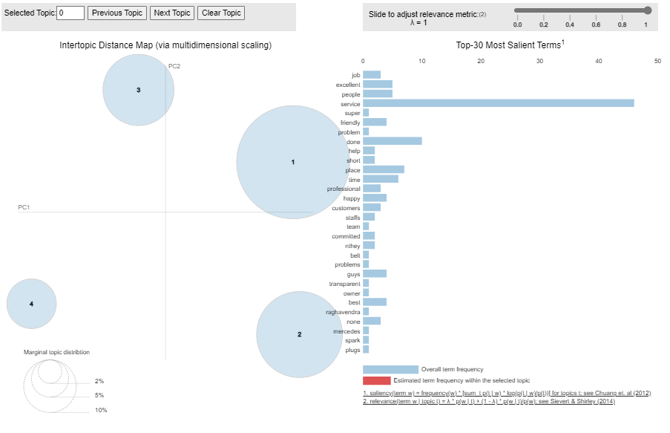topics from a large document and is one of the popular technique.

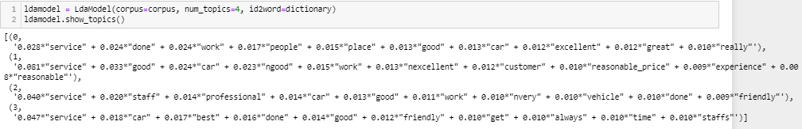

Figure 11

The above images represent the model built using topic modelling using LDA. Here, the number of topic that are chosen are 4. These 4 topics reveal the topics present in the reviews made by the customers. The four topics which are present in the reviews are as follows:

* Place and quality of service
* Pricing and trained staff
* Customer friendliness
* On time delivery

These topics reveal that Modern Motors is performing well in terms of its service. The customers are happy about the service quality, the place of the service centre, pricing of the services, trained staff and on time delivery of the vehicles after service. This model is very useful in helping the companies know the exact analysis of the customer experiences from a huge number of reviews.

* **VADER(Valence Aware Dictionary for Sentiment Analysis)**

VADER is a type of sentimental analysis which is an unsupervised machine learning technique. This method is sensitive to the strength of the emotion and also the polarity (positive/negative) of the review. This technique is present in NLTK package and can be applied to unlabelled data. This method uses a pre-defined list of words called as list of lexical features which are labelled as positive or negative. From this reference, it calculates the sentiment of the text based on the scores.

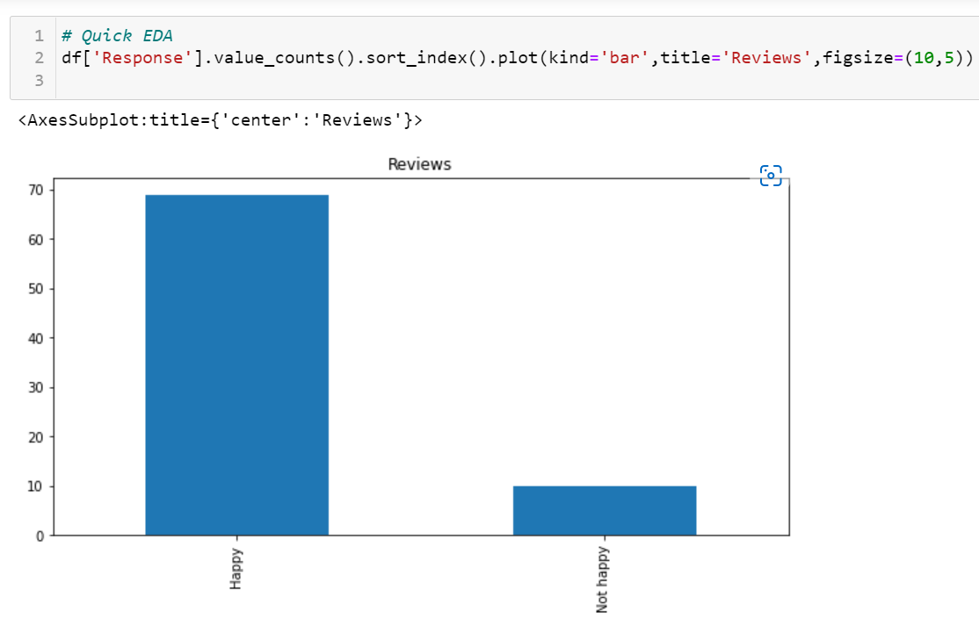

Figure 12

Below mentioned are the polarity scores given for each of the reviews given by the customers for the service quality of Modern Motors. These scores are summed up and the final compound score is analysed.

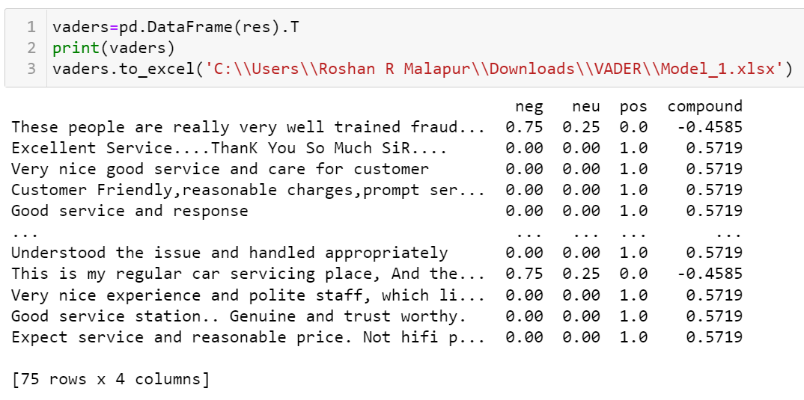

Figure 13

* **Compund score > = 0.05 🡪 Positive**
* **0.05 > = Compund score = < - 0.05 🡪Neutral**
* **Compund score < = - 0.05 🡪 Negative**

**13.3%**

**86.6%**

Figure 14

**CHAPTER 5**

**FINDINGS, CONCLUSION, RECOMMENDATIONS & LEARNINGS**

**FINDINGS**

From the analysis of all the visualizations extracted from the dataset provided by the company, there are some of the findings which will help the company in terms of improving their service.

* We can see that the paid service takes the maximum time. It means that the company has to look for more staff who can be assigned for the paid service so that the service time is reduced without lowering the efficiency and quality of service. It can also be inferred that the free services take the lower time since the workers consider the free services as less important. Due to this, the company can have bad reviews about its service and there are chances of losing customers.
* From the second visualization, we can say that the majority of the cars that come for service to Modern Motors are for running repair. The running repair type of service has the maximum number of cars accounting to 465 out of 648 cars in three months. This means that the company has to focus more on that type of service and allocate proper resources which have to be utilized properly so that the customer needs are delivered.
* The number of cars that arrive for service at Modern Motors follow a stationary pattern. There is no any trend that is observed in the line graph. We can see that the highest number of cars that have arrived for service is during the second week of April. The vehicles coming for service depends on the season. . Usually customers come for the service during the first week of February or the last weeks of July or august since people go on vacations and trips during these months. The average number of cars that arrive per week to Modern Motors is 49.
* The service level agreement is very important to the company. Modern Motors has failed 38 times in three months to comply with its SLA. If the vehicle is not delivered within the promised delivery time, the customers are unhappy about the service and there are high chances of losing such customers. Therefore, the company has to carefully follow its SLA and deliver the vehicles on time.
* From the topic modelling using LDA, we can see that there are four major topics which are present in the customer reviews. The topics present are about the place and trained staff, quality of service, customer friendliness and on time delivery of vehicles. The customers are really happy about the service about Modern Motors.
* The VADER model reveals that 86.6% of the customers are happy about the service provided by the company whereas 13.3% of the customers are unhappy about the quality of service, pricing and timely delivery of vehicles.

**CONCLUSION**

The automobile service industry is growing at a faster rate. It is one of the most competitive industry in the world. It is estimated that the automotive service industry is worth 34,000 crore today. The recent technological advancements happening in the automobile industry is impacting the decision making process of the customers. Since the customers are getting many choices in terms of automobiles because there are many automobile companies which are competing in the market with nearly similar models and pricing strategies, the customers are very choosy about the selection of their desired car. This also impacts the service sector of automobiles. The automobile service industry is emerging in all ways possible. The demand for the authorized service centres in increasing due to the rising concerns for the counterfeit parts of the cars.

Modern Motors, as an authorized service centre is performing with great profits. Since there is growing preference for the authorized service centres, the customers are moving towards such service centres instead of local garages. The world is moving towards digitization and the increasing automation in the automobiles has revolutionized this industry. To be equipped with the latest trends and advancements happening in the industry, Modern Motors has to always be on the edge to implement new technologies in terms of its service and should also be more equipped in terms of its staff who are technically sound and understand the trends of the market.

Gaining the trust of customers is the major challenge today. The use of analytics in automobile service industry is very much needed so as to understand the pulse of the customers and make the customers happy about the quality of their service. There are also threats to this industry since there is a great demand for workers in the market today. Being always ready for any change in the market is also a big task. The demand for the replacement of the auto spare parts is reducing since there is too much of complexity in it. The customers find it difficult to service their vehicles. Overall, tackling the threats and moving forward, the automotive service industry has a great future in the market.

**RECOMMENDATIONS**

Modern motors, as an authorized service company is performing well in terms of its quality of service, customer satisfaction and so on. The analysis made in this project reveal some of the suggestions that the company has to incorporate to be more efficient. The customer review analysis done in this project reveals that 13.3% of the customers who have serviced their vehicles in the company are unhappy. The reasons given in their review summarize that the company has to be more careful about the timely delivery of the serviced vehicles. Also, the pricing for the different types of services was also a concern of the customers. Being able to make good profits, Modern Motors has to set a price which is best suited to all types of customers so that they do not miss on any of them. The other recommendation for the company is that, the company should have a proper model to track the number of cars that arrive for the service every week. This is because, the inventory management system containing the spare parts of the vehicles depends on the number of cars that arrive for the company. When there is no idea about the cars that arrive for the service, the inventory will not be in control and there are chances of excess and less inventory of parts in the company. The use of analytics to deploy a forecasting model will definitely help the company to analyse the vehicles coming and keep a track of the inventory required. Also, the other recommendation is about a separate department for customer care. Since, the auto service industry is majorly dependent on the satisfaction of customers, it is very much needed that a separate customer care is required to remind the customers of timely service of their vehicles and address every grievance of them to gain their trust.

**LEARNINGS**

The learnings made through this project will be very helpful in building my skills and increase the value of my resume. This project at an automobile service company gave me a great exposure to the corporate world. The way of communication that has to be followed in the company was a great learning. Being an intern at the company, I got to understand all the processes that undergo in an automobile service company from the arrival of car for service to its delivery. The major part of learning was through the skills which I developed working with the data. I learnt to understand to deploy models for different problems faced by industry which will be very useful when I enter the corporate world. Overall, the project at Modern Motors was very insightful and helped me a lot to gain more knowledge in all the aspects of it.

**REFERENCES**

1. Ambedkar, u. (2013, March). Service quality gap analysis of automobile service centres. *Research Gate*. Retrieved August 3, 2022
2. Bajaj, A. (2021, June 29). *Can Python understand human feelings through words? – A brief intro to NLP and VADER Sentiment Analysis*. Retrieved from Analytics Vidhya: https://www.analyticsvidhya.com/blog/2021/06/vader-for-sentiment-analysis/
3. Bhasin, A. (2020, February). *Amid The Slowdown, Why Are Auto Servicing Betting Big On B2C Market?* Retrieved from Inc42: https://inc42.com/resources/amid-the-slowdown-why-are-auto-servicing-betting-big-on-b2c-market/
4. Bhasin, A. (n.d.). *The Current And Futuristic Trend In Automobile Servicing*. Retrieved from Silicon India: https://industry.siliconindia.com/viewpoint/cxoinsights/the-current-and-futuristic-trend-in-automobile-servicing-nwid-21352.html
5. Dutta, M. (2022, July 8). *Analytics Vidhya*. Retrieved from Topic Modelling With LDA -A Hands-on Introduction: https://www.analyticsvidhya.com/blog/2021/07/topic-modelling-with-lda-a-hands-on-introduction/
6. Sharma, V. (2021, July 28). *Future trends in the auto-service industry*. Retrieved from YourStory: https://yourstory.com/2021/06/future-trends-auto-service-industry/amp

**APPENDIX**

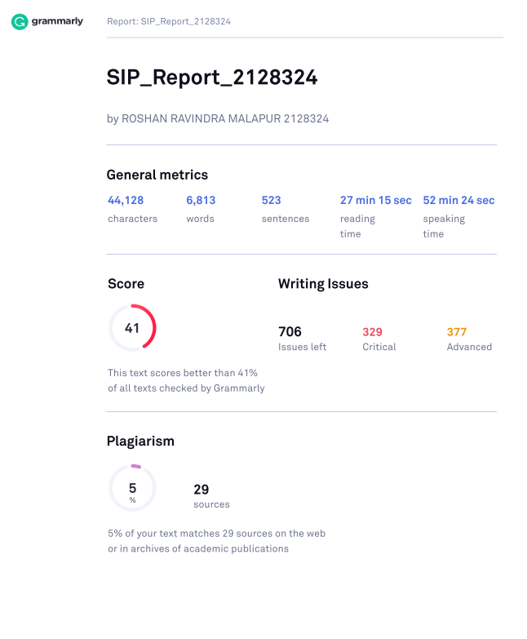**Similarity Index Report**

**Feedback from the Academic Mentor**

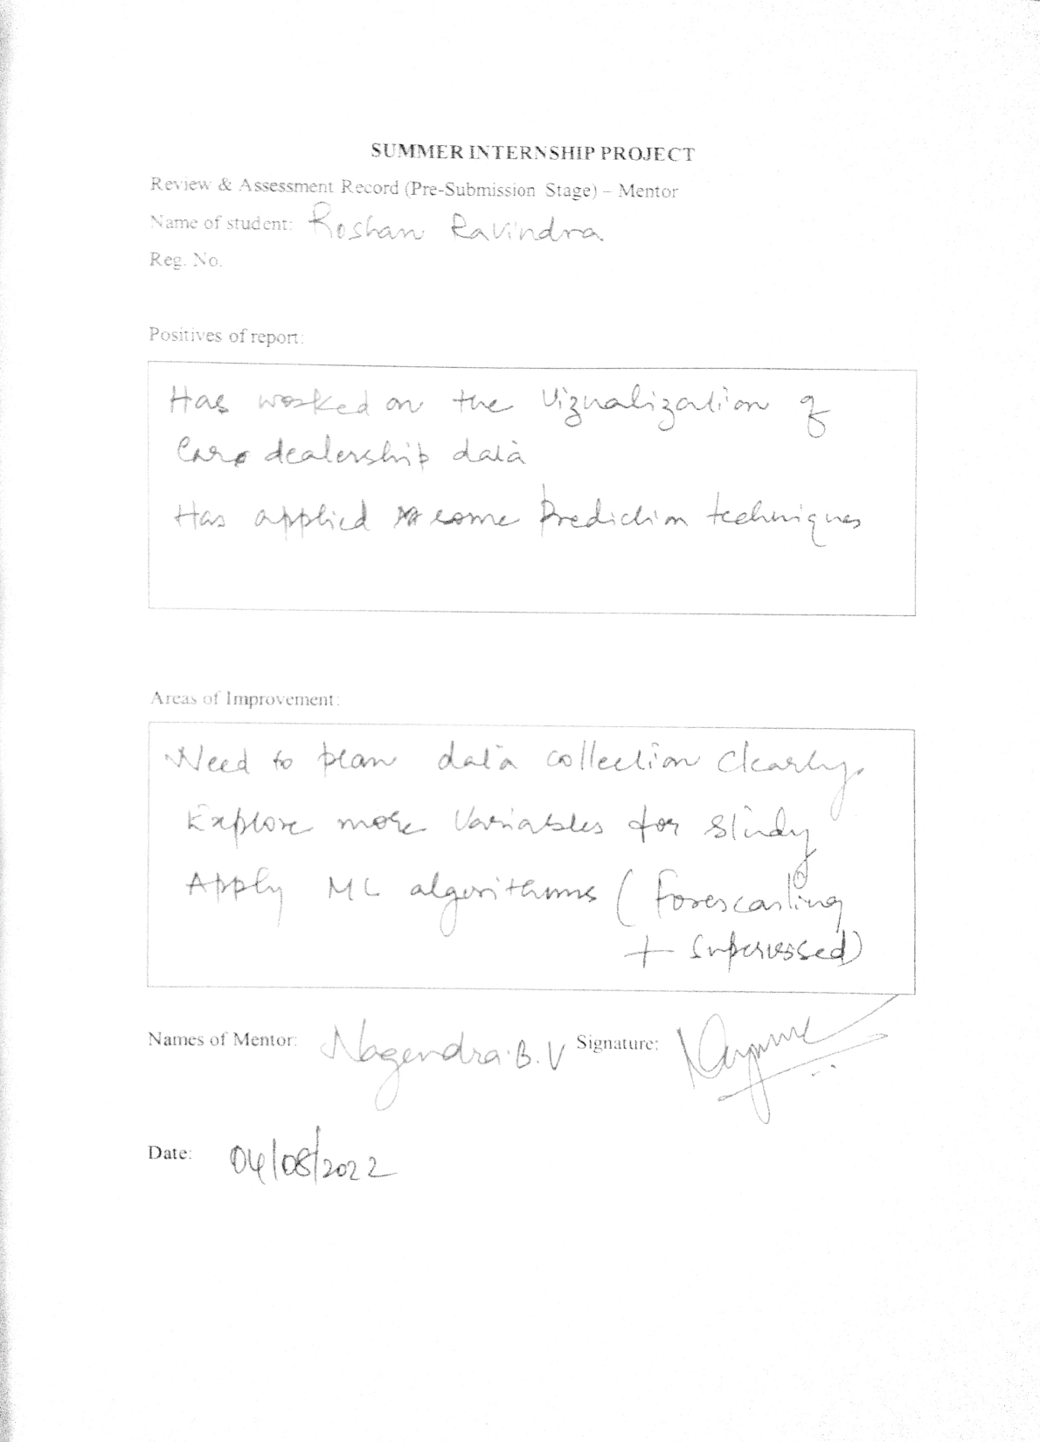

**Feedback from the Panellist**

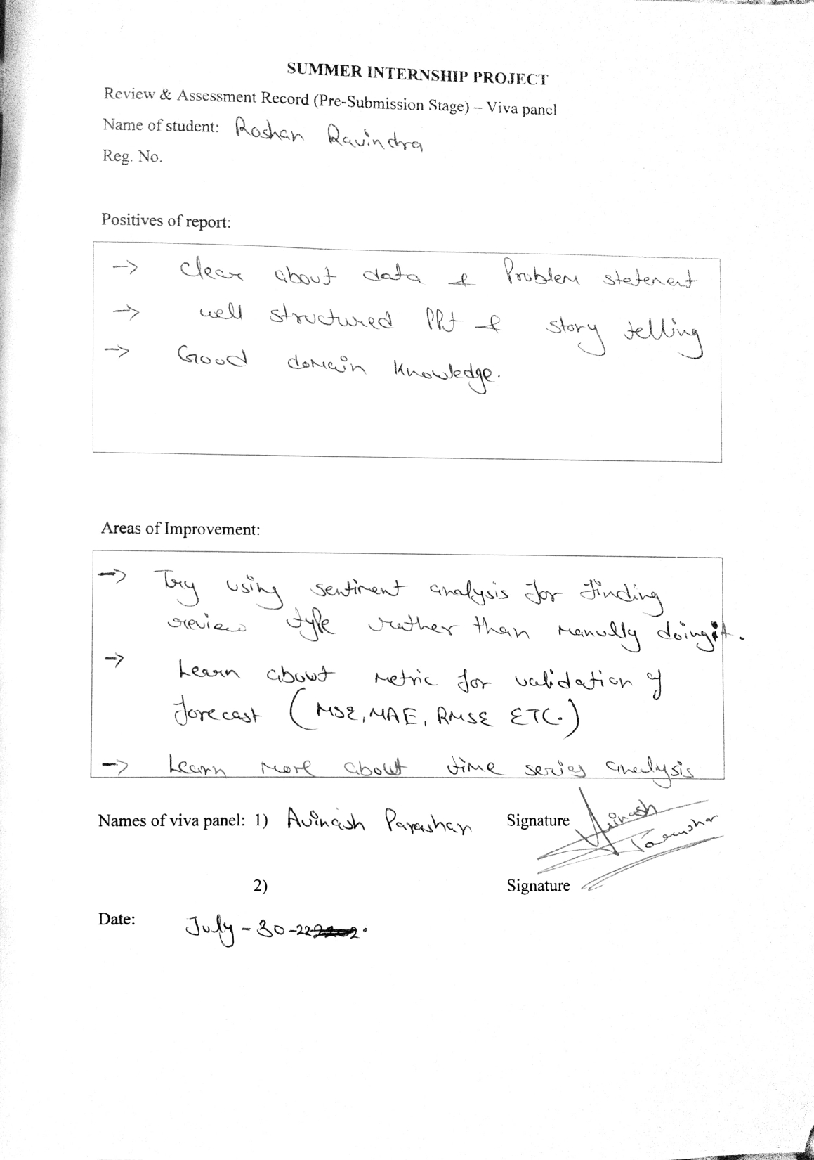

**Feedback from the Corporate Mentor**



