PROJECT TITLE : FARMBUY

GROUP MEMBERS :
1. R CHANDU (23KT1A4343) (TL)
2. T NIKSHAY RAJ (23KT1A4358)
3. PURNANANDA (24KT5A4306)

1. Introduction to FarmBuy
FarmBuy is an online platform designed to bridge the gap between local farmers and consumers. In today’s fast-paced world, access to fresh, high-quality farm products can be a challenge. FarmBuy aims to solve this problem by offering a direct marketplace where customers can easily purchase farm-fresh produce, groceries, dairy products, and more.
Our vision is to empower farmers by giving them better market access, while also providing consumers with nutritious, organic, and affordable food options. With a user-friendly interface and a wide variety of farm goods, FarmBuy is your trusted partner in building a healthier lifestyle and supporting sustainable agriculture.

2. Website Structure – HTML, CSS, and JavaScript
Now, let's look at the basic structure of the FarmBuy website using HTML, CSS, and JavaScript.

- ICON – FARMBUY :
<!DOCTYPE html>
<html lang="en">
<head>
<meta charset="UTF-8">
<meta name="viewport" content="width=device-width, initial-scale=1.0">
<title>Farmbuy</title>
<style>
@import url('https://fonts.googleapis.com/css2?family=Playfair+Display:wght@700&display=swap');
@keyframes animatedBg {
0% { background-position: 0% 50%; }
50% { background-position: 100% 50%; }
100% { background-position: 0% 50%; }
}
body {
background: linear-gradient(-45deg, #e0f7fa, #a7ffeb, #81c784, #66bb6a);
background-size: 400% 400%;
animation: animatedBg 10s ease infinite;
text-align: center;
font-family: Arial, sans-serif;
margin: 0;
padding: 0;
height: 100vh;
display: flex;
flex-direction: column;
justify-content: center;
align-items: center;
overflow: hidden;
}
.container {
background: rgba(255, 255, 255, 0.9);
padding: 30px;
border-radius: 15px;
box-shadow: 0 0 15px rgba(0, 0, 0, 0.3);
border: 5px solid #008000;
width: 350px;
text-align: center;
position: relative;
overflow: hidden;
}
.container::before {
content: "";
position: absolute;
top: -10px;
left: -10px;
right: -10px;
bottom: -10px;
border: 3px dashed #32CD32;
border-radius: 15px;
animation: borderAnimation 6s infinite linear;
}

@keyframes borderAnimation {
0% { transform: rotate(0deg); }
100% { transform: rotate(360deg); }
}
.logo-container img {
max-width: 150px;
border: 3px solid #006400;
border-radius: 10px;
padding: 5px;
transition: transform 0.3s ease-in-out;
}
.logo-container img:hover {
transform: scale(1.1);
}
.farmbuy-title {
font-family: 'Playfair Display', serif;
font-size: 40px;
color: #006400;
margin-top: 15px;
border-top: 3px solid #008000;
padding-top: 10px;
display: inline-block;
width: 80%;
}
.floating-effect {
position: absolute;
width: 100px;
height: 100px;
background: rgba(255, 255, 255, 0.2);
border-radius: 50%;
animation: float 6s infinite alternate ease-in-out;
}
.floating1 { top: 10%; left: 10%; }
.floating2 { top: 60%; right: 15%; animation-delay: 2s; }
.floating3 { bottom: 10%; left: 50%; animation-delay: 4s; }

@keyframes float {
from { transform: translateY(0) scale(1); }
to { transform: translateY(20px) scale(1.1); }
}
</style>
</head>
<body>
<div class="container">
<div class="logo-container">
<img src="farmbuyicon.jpg" alt="Farmbuy Logo">
</div>
<h2 class="farmbuy-title">FARMBUY</h2>
</div>
<div class="floating-effect floating1"></div>
<div class="floating-effect floating2"></div>
<div class="floating-effect floating3"></div>
<script>
setTimeout(function() {
window.location.href = "login.html";
}, 1600);
</script>
</head>
</body>
</html>
THE OUTPUT :
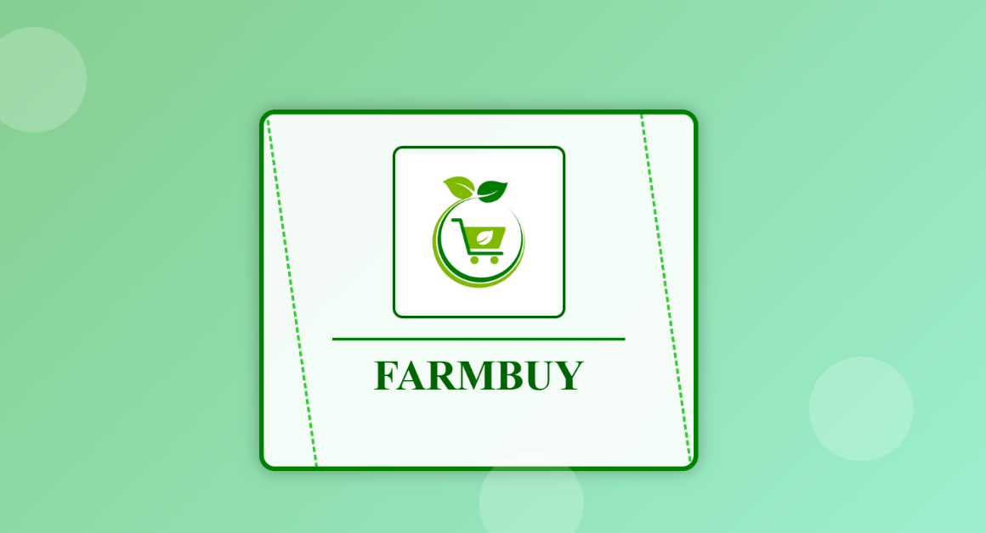
- LOGIN – FARMBUY
<!DOCTYPE html>
<html lang="en">
<head>
<meta charset="UTF-8">
<meta name="viewport" content="width=device-width, initial-scale=1.0">
<title>Login Form | Farmbuy</title>
<link rel="stylesheet" href="login.css">
<script defer src="login.js"></script>
<link href='https://unpkg.com/boxicons@2.1.4/css/boxicons.min.css' rel='stylesheet'>
</head>
<body>
<div class="wrapper">
<form id="loginForm" action="Buy&sell.html" method="post">
<h1>Login</h1>
<div class="input-box">
<input type="text" placeholder="Username" required>
<i class='bx bxs-user'></i>
</div>
<div class="input-box">
<input type="password" placeholder="Password" required>
<i class='bx bxs-lock-alt'></i>
</div>
<button type="submit" class="btn">Login</button>
<div class="register-link">
<p>Don't have an account?<a href="register.html">Register</a></p>
</div>
</form>
</div>
</body>
</html>
* {
margin: 0;
padding: 0;
box-sizing: border-box;
font-family: "Poppins", sans-serif;
}
body {
display: flex; /* Fixed typo */
justify-content: center;
align-items: center;
min-height: 100vh;
background: url(brr.jpg) no-repeat;
background-size: 100% 100%;
background-position: center;
}
.wrapper {
width: 420px;
background: rgba(0, 0, 0, 0.8);
color: #fff;
border-radius: 10px;
padding: 30px;
box-shadow: 0px 4px 15px rgba(0, 0, 0, 0.3);
}
.wrapper h1 {
font-size: 28px;
margin-bottom: 30px;
text-transform: uppercase;
letter-spacing: 2px;
border-left: 5px solid #4CAF50;
padding-left: 10px;
}
.input-box {
position: relative;
width: 100%;
margin-bottom: 25px;
}
.input-box input {
width: 100%;
padding: 15px 20px;
background: rgba(255, 255, 255, 0.1);
border: 1px solid #4CAF50;
border-radius: 30px;
color: #fff;
font-size: 15px;
outline: none;
transition: all 0.3s ease;
}
.input-box input:focus {
box-shadow: 0 0 8px #4CAF50;
}
.input-box input::placeholder {
color: rgba(255, 255, 255, 0.7);
}
.input-box i {
position: absolute;
top: 50%;
right: 20px;
transform: translateY(-50%);
color: #4CAF50;
font-size: 18px;
}
.remember-forgot {
display: flex; /* Fixed typo */
justify-content: space-between;
font-size: 14px;
margin: 10px 0 20px;
}
.remember-forgot label input {
accent-color: #4CAF50;
margin-right: 5px;
}
.remember-forgot a {
color: #4CAF50;
text-decoration: none;
transition: color 0.3s ease;
}
.btn {
display: inline-block;
width: 100%;
padding: 12px 20px;
background: linear-gradient(to right, #4CAF50, #2c3e50);
color: #fff;
border: none;
border-radius: 30px;
font-size: 16px;
font-weight: bold;
cursor: pointer;
text-transform: uppercase;
transition: background 0.3s ease;
}
.btn:hover {
background: linear-gradient(to right, #2c3e50, #4CAF50);
}
.register-link {
text-align: center;
margin-top: 10px;
font-size: 14px;
}
.register-link a {
color: #4CAF50;
text-decoration: none;
font-weight: bold;
transition: color 0.3s ease;
}
document.addEventListener("DOMContentLoaded", function () {
document.getElementById("loginForm").addEventListener("submit", function (event) {
let username = document.getElementById("username").value.trim();
let password = document.getElementById("password").value.trim();
if (!username || !password) {
alert("Please fill in all fields.");
event.preventDefault(); // Stop form submission
}
});
});
THE OUTPUT :
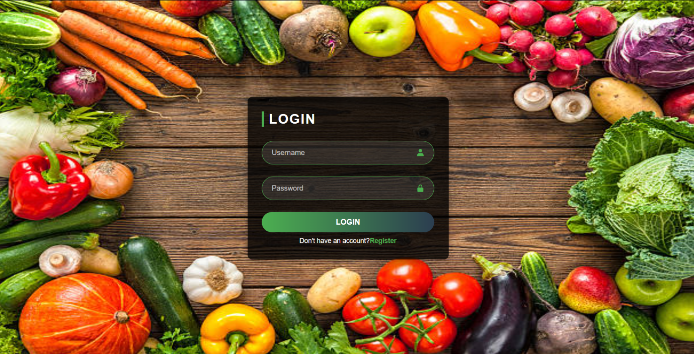

- REGISTER – FARMBUY
<!DOCTYPE html>
<html lang="en">
<head>
<meta charset="UTF-8">
<meta name="viewport" content="width=device-width, initial-scale=1.0">
<title>Register | Farmbuy</title>
<link rel="stylesheet" href="Register.css">
<link href='https://unpkg.com/boxicons@2.1.4/css/boxicons.min.css' rel='stylesheet'>
<script defer src="register.js"></script></head>
<body>
<div class="wrapper">
<form id="registerForm" action="Buy&sell.html" method="post">
<h1>Register</h1>
<div class="input-box">
<input type="text" placeholder="Full Name" required>
<i class='bx bxs-user'></i>
</div>
<div class="input-box">
<input type="text" placeholder="Username" required>
<i class='bx bxs-user'></i>
</div>
<div class="input-box">
<input type="email" placeholder="Email" required>
<i class='bx bxs-envelope'></i>
</div>
<div class="input-box">
<input type="password" placeholder="Password" required>
<i class='bx bxs-lock-alt'></i>
</div>
<div class="input-box">
<input type="password" placeholder="Confirm Password" required>
<i class='bx bxs-lock-alt'></i>
</div>
<button type="submit" class="btn">Register</button>
<div class="register-link">
<p>Already have an account? <a href="login.html">Login</a></p>
</div>
</form>
</div>
</body>
</html>
* {
margin: 0;
padding: 0;
box-sizing: border-box;
font-family: "Poppins", sans-serif;
}
body {
display: flex;
justify-content: center;
align-items: center;
min-height: 100vh;
background: url(brr.jpg) no-repeat;
background-size: 100% 100%;
background-position: center;
}
.wrapper {
width: 420px;
background: rgba(0, 0, 0, 0.8);
color: #fff;
border-radius: 10px;
padding: 30px;
box-shadow: 0px 4px 15px rgba(0, 0, 0, 0.3);
}
.wrapper h1 {
font-size: 28px;
margin-bottom: 30px;
text-transform: uppercase;
letter-spacing: 2px;
border-left: 5px solid #4CAF50;
padding-left: 10px;
}
.input-box {
position: relative;
width: 100%;
margin-bottom: 25px;
}
.input-box input {
width: 100%;
padding: 15px 20px;
background: rgba(255, 255, 255, 0.1);
border: 1px solid #4CAF50;
border-radius: 30px;
color: #fff;
font-size: 15px;
outline: none;
transition: all 0.3s ease;
}
.input-box input:focus {
box-shadow: 0 0 8px #4CAF50;
}
.input-box input::placeholder {
color: rgba(255, 255, 255, 0.7);
}
.input-box i {
position: absolute;
top: 50%;
right: 20px;
transform: translateY(-50%);
color: #4CAF50;
font-size: 18px;
}
.btn {
display: inline-block;
width: 100%;
padding: 12px 20px;
background: linear-gradient(to right, #4CAF50, #2c3e50);
color: #fff;
border: none;
border-radius: 30px;
font-size: 16px;
font-weight: bold;
cursor: pointer;
text-transform: uppercase;
transition: background 0.3s ease;
}
.btn:hover {
background: linear-gradient(to right, #2c3e50, #4CAF50);
}
.register-link {
text-align: center;
margin-top: 10px;
font-size: 14px;
}
.register-link a {
color: #4CAF50;
text-decoration: none;
font-weight: bold;
transition: color 0.3s ease;
}
document.addEventListener("DOMContentLoaded", function () {
document.getElementById("registerForm").addEventListener("submit", function (event) {
let password = document.getElementById("password").value;
let confirm_password = document.getElementById("confirm_password").value;
if (password !== confirm_password) {
alert("Passwords do not match.");
event.preventDefault();
}
});
});
THE OUTPUT :
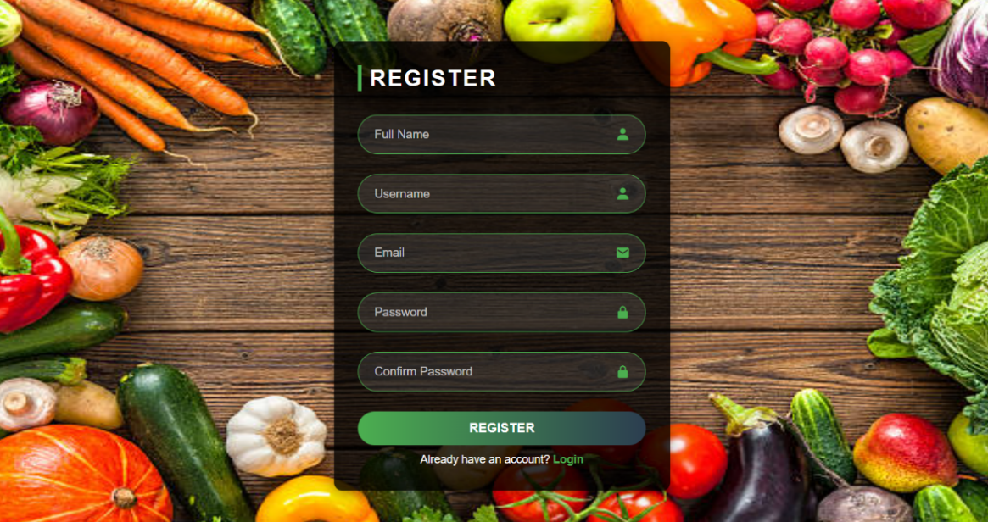

- HOME – FARMBUY

<!DOCTYPE html>
<html lang="en">
<head>
<meta charset="UTF-8">
<meta name="viewport" content="width=device-width, initial-scale=1.0">
<title>Buyer & Seller Selection</title>
<style>
body {
display: flex;
flex-direction: column;
justify-content: center;
align-items: center;
height: 100vh;
background: linear-gradient(135deg, #e0f7fa, #a7ffeb);
font-family: Arial, sans-serif;
margin: 0;
}
h1 {
margin: 20px 0;
font-size: 2.5rem;
color: green;
font-weight: bold;
letter-spacing: 2px;
}
.container {
text-align: center;
padding: 30px;
border: 3px solid #4CAF50;
border-radius: 15px;
background-color: white;
}
.button {
width: 160px;
padding: 15px;
background-color: #4CAF50;
color: white;
font-size: 20px;
font-weight: bold;
border-radius: 12px;
border: none;
cursor: pointer;
margin: 15px;
}
.button:hover {
transform: scale(1.1);
}
</style>
</head>
<body>
<h1>FARMBUY</h1>
<div class="container">
<button class="button" id="buyerBtn">Buyer</button>
<button class="button" id="sellerBtn">Seller</button>
</div>
<script>
document.getElementById("buyerBtn").addEventListener("click", function () {
localStorage.setItem("userType", "buyer"); // Store user type
window.location.href = "home.html";
});
document.getElementById("sellerBtn").addEventListener("click", function () {
localStorage.setItem("userType", "seller"); // Store user type
window.location.href = "home.html";
});
</script>
</body>
</html>

THE OUTPUT ;
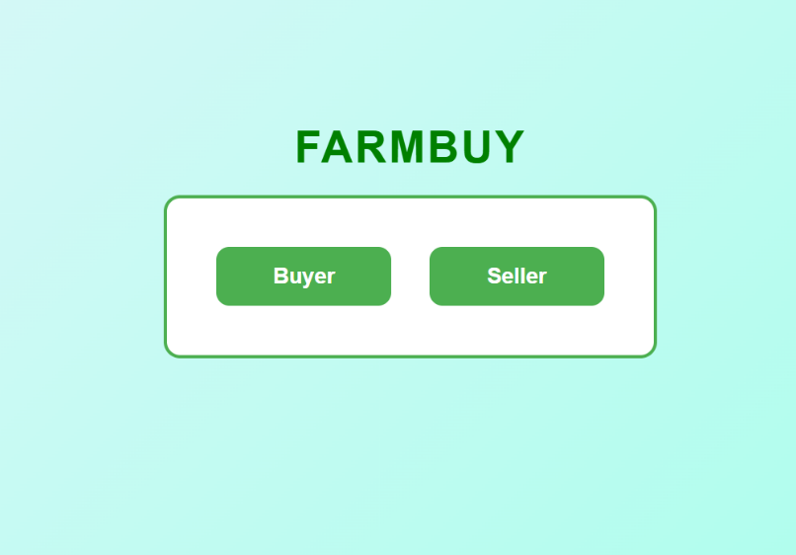

- CATEGORIES – FARMBUY
<!DOCTYPE html>
<html lang="en">
<head>
<meta charset="UTF-8">
<meta name="viewport" content="width=device-width, initial-scale=1.0">
<title>Farmbuy</title>
<link rel="stylesheet" href="Home.css">
<script defer src="home.js"></script>
</head>
<body>
<!-- Header Section -->
<header>
<h1>FARMBUY</h1>
<nav>
<a href="Buy&sell.html">Home</a>
<a href="vegestore.html">Order</a>
<a href="about.html">About</a>
<a href="contact.html">Contact</a>
</nav>
</header>
<!-- Buyer & Seller Selection -->
<div class="user-selection">
<button id="buyerBtn">Buyer</button>
<button id="sellerBtn">Seller</button>
</div>
<!-- Main Content Section -->
<main>
<div class="content">
<div class="category">
<img src="vegetable.jpg" alt="Vegetables">
<p>VEGETABLES</p>
</div>
<div class="category">
<img src="fruits.jpg" alt="Fruits">
<p>FRUITS</p>
</div>
<div class="category">
<img src="groceries.jpg" alt="Groceries">
<p>GROCERIES</p>
</div>
<div class="category">
<img src="dairy products.jpg" alt="Dairy Products">
<p>DAIRY PRODUCTS</p>
</div>
</div>
</main>
<!-- About Section -->
<section id="about">
<h2>About</h2>
<p>Check out our YouTube channel and other useful websites:</p>
<ul>
<li><a href="https://www.youtube.com/" target="_blank">YouTube Channel</a></li>
<li><a href="https://www.example.com/" target="_blank">Duplicate Website</a></li>
</ul>
</section>
<!-- Contact Section -->
<section id="contact">
<h2>Contact</h2>
<p>Email: example@example.com</p>
<p>Phone: +123 456 7890</p>
</section>
</body>
</html>
body {
margin: 0;
font-family: Arial, sans-serif;
background-color: #e8f4fc; /* Light blue background */
}
header {
display: flex;
flex-direction: column;
align-items: center;
background-color: #ffffff; /* White background */
padding: 20px;
box-shadow: 0 2px 5px rgba(0, 0, 0, 0.9); /* Subtle shadow */
position: fixed; /* Keeps the header at the top */
width: 100%;
top: 0;
z-index: 1000; /* Ensures it stays above other content */
}
header h1 {
margin: 10px;
font-size: 3rem; /* Increased font size */
color: #33cc33; /* Bright orange color */
font-weight: bold; /* Bold for emphasis */
}
nav {
background-color: black; /* Black background for navigation */
padding: 10px 0; /* Add padding around the links */
width: 100%; /* Ensure it spans the full width */
text-align: center; /* Center align the links */
box-shadow: 0 2px 5px rgba(0, 0, 0, 0.5); /* Optional shadow */
}
nav a {
margin: 0 15px;
text-decoration: none; /* Removes underline */
color: white; /* White text color for contrast */
font-size: 1rem; /* Standard size for links */
}
nav a:hover {
text-decoration: underline; /* Underline effect on hover */
}
main {
margin-top: 180px;
text-align: center;
}
.content {
display: grid;
grid-template-columns: repeat(2, 1fr);
gap: 40px;
padding: 40px;
max-width: 800px;
margin: auto;
}
.category {
text-align: center;
border: 2px solid #007bff;
border-radius: 10px;
padding: 30px;
background-color: #f9f9f9;
max-width: 250px;
width: 100%;
box-shadow: 0 2px 10px rgba(0, 0, 0, 0.2);
transition: transform 0.3s ease;
}
.category:hover {
transform: translateY(-5px);
}
.category img {
max-width: 100%;
border-radius: 5px;
}
.category p {
margin-top: 15px;
font-size: 1rem;
font-weight: bold;
}
@media (max-width: 600px) {
.content {
grid-template-columns: repeat(1, 1fr);
}
}
document.addEventListener("DOMContentLoaded", function () {
let userType = localStorage.getItem("userType") || "buyer"; // Default to buyer
document.querySelectorAll(".category").forEach(category => {
category.addEventListener("click", function () {
let categoryName = this.querySelector("p").textContent.trim().toLowerCase();
let pageMap = {
"vegetables": userType === "seller" ? "sellerinfo.html" : "vegestore.html",
"fruits": userType === "seller" ? "sellerinfo.html" : "Fruitstore.html",
"groceries": userType === "seller" ? "sellerinfo.html" : "Groceriesstore.html",
"dairy products": userType === "seller" ? "sellerinfo.html" : "Diarystore.html"
};
if (pageMap[categoryName]) {
window.location.href = pageMap[categoryName]; // Redirect to the correct page
}
});
});
});

THE OUTPUT :
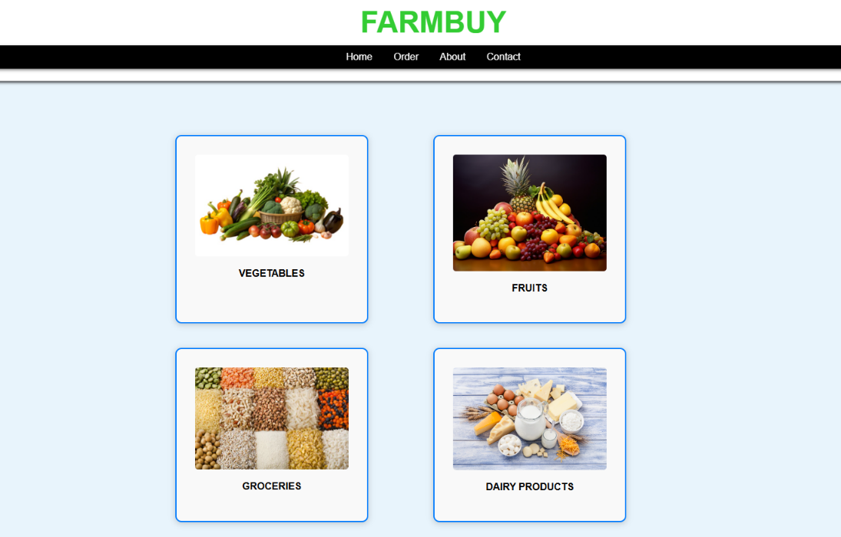

- ABOUT – FARMBUY
<!DOCTYPE html>
<html lang="en">
<head>
<meta charset="UTF-8">
<meta name="viewport" content="width=device-width, initial-scale=1.0">
<title>About Us</title>
<link rel="stylesheet" href="styles.css">
</head>
<body>
<header>
<h1>About Us</h1>
</header>
<section>
<h2>Who We Are</h2>
<p>Farmbuy is an online marketplace connecting buyers and sellers of fresh farm products, groceries, and dairy items.</p>
</section>
<section>
<h2>Find Us Online</h2>
<ul>
<li><a href="https://www.youtube.com/" target="farmbuy">YouTube Channel</a></li>
<li><a href="https://www.instagram.com/" target="_blank">Instagram</a></li>
<li><a href="https://twitter.com/" target="_blank">Twitter</a></li>
<li><a href="https://t.me/" target="_blank">Telegram</a></li>
<li><a href="https://www.example.com/" target="_blank">Official Website</a></li>
</ul>
</section>
<footer>
<p>&copy; 2025 Farmbuy. All rights reserved.</p>
</footer>
</body>
</html>
THE OUTPUT :
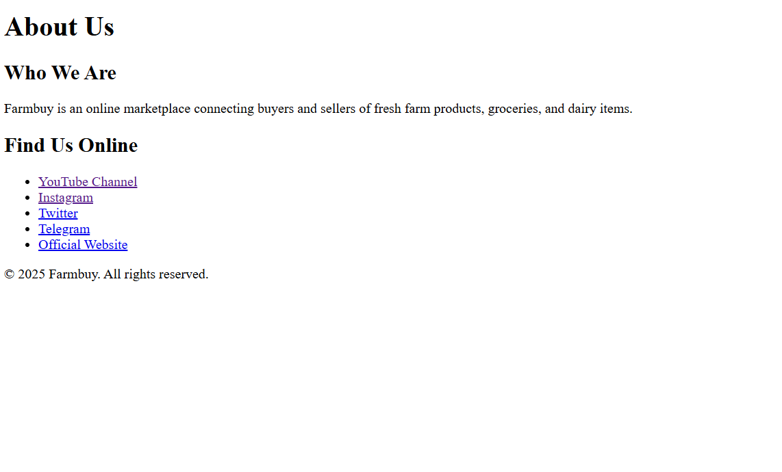

- CONTACT – FARMBUY
<!DOCTYPE html>
<html lang="en">
<head>
<meta charset="UTF-8">
<meta name="viewport" content="width=device-width, initial-scale=1.0">
<title>Contact Us</title>
<link rel="stylesheet" href="styles.css">
</head>
<body>
<header>
<h1>Contact Us</h1>
</header>
<section>
<h2>Get in Touch</h2>
<p>Email: <a href="mailto:example@example.com">example@example.com</a></p>
<p>Phone: <a href="tel:+1234567890">+123 456 7890</a></p>
<p>Address: 123 Farm Street, Green City, Country</p>
</section>
<section>
<h2>Follow Us</h2>
<ul>
<li><a href="https://www.youtube.com/" target="_blank">YouTube</a></li>
<li><a href="https://www.instagram.com/" target="_blank">Instagram</a></li>
<li><a href="https://twitter.com/" target="_blank">Twitter</a></li>
<li><a href="https://t.me/" target="_blank">Telegram</a></li>
</ul>
</section>
<footer>
<p>&copy; 2025 Farmbuy. All rights reserved.</p>
</footer>
</body>
</html>
THE OUTPUT :
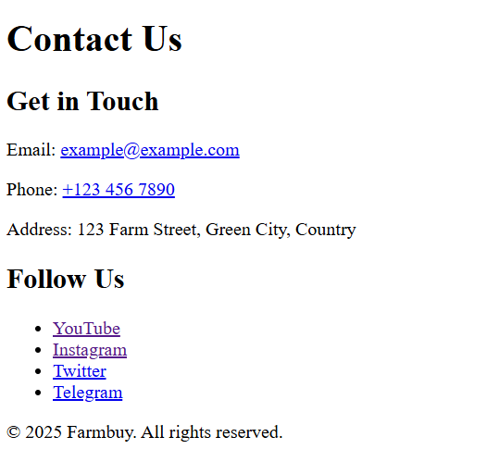
- STORE – FARMBUY
<!DOCTYPE html>
<html lang="en">
<head>
<meta charset="UTF-8">
<meta name="viewport" content="width=device-width, initial-scale=1.0">
<title>Vegetable Store</title>
<link rel="stylesheet" href="Vegestore.css">
</head>
<body>
<div class="container">
<div class="header">
<span>Vegetable Store</span>
<div class="search-container">
<input type="text" id="search-input" placeholder="Search for products">
<button id="search-btn">Search</button>
</div>
</div>
<div class="products" id="product-list">
<!-- Products will be dynamically inserted using JavaScript -->
</div>
</div>
</form>
<script src="Vegestore.js"></script>
</body>
</html>
* {
margin: 0;
padding: 0;
box-sizing: border-box;
font-family: Arial, sans-serif;
}

body {
background-color: #f5f5f5;
text-align: center;
}
.container {
width: 80%;
margin: auto;
}
.header {
background-color: black;
color: white;
padding: 15px;
font-size: 24px;
display: flex;
justify-content: space-between;
align-items: center;
}
.search-container {
display: flex;
gap: 10px;
}
.search-container input {
padding: 8px;
font-size: 16px;
border-radius: 5px;
border: none;
}
.search-container button {
padding: 8px 15px;
font-size: 16px;
border: none;
background-color: green;
color: white;
cursor: pointer;
border-radius: 5px;
transition: background 0.3s ease;
}
.search-container button:hover {
background-color: darkgreen;
}
.products {
display: grid;
grid-template-columns: repeat(4, 1fr);
gap: 20px;
margin-top: 20px;
}
.product-card {
background-color: white;
padding: 15px;
box-shadow: 0px 0px 10px rgba(0, 0, 0, 0.1);
border-radius: 10px;
transition: transform 0.3s ease;
cursor: pointer;
position: relative;
overflow: hidden;
}
.product-card:hover {
transform: scale(1.05);
}

.product-card img {
width: 100%;
height: 150px;
border-radius: 10px;
transition: transform 0.3s ease;
}
.product-card:hover img {
transform: scale(1.1);
}
.product-card h3 {
margin: 10px 0;
}
.product-card p {
color: green;
font-weight: bold;
}
.buy-btn {
background-color: green;
color: white;
padding: 10px;
border: none;
cursor: pointer;
border-radius: 5px;
transition: background 0.3s ease;
}
.buy-btn:hover {
background-color: darkgreen;
}
document.addEventListener("DOMContentLoaded", () => {
const products = [
{name: 'Potato', img: 'https://thumbs.dreamstime.com/b/potatoes-fresh-wooden-basket-33186647.jpg'},
{name: 'Tomato', img: 'https://media.istockphoto.com/id/847335116/photo/tomatoes-on-the-vine.jpg?s=612x612&w=0&k=20&c=XspM2ySvUfqjnt7HL5qKyn0tyRb5qLsf1GAP6-3xQsw='},
{name: 'Onion', img: 'https://plantix.net/en/library/assets/custom/crop-images/onion.jpeg'},
{name: 'Carrot', img: 'https://www.economist.com/sites/default/files/20180929_BLP506.jpg'},
{name: 'Capsicum', img: 'https://www.apnikheti.com/upload/crops/5808idea99Harvested-Capsicum.jpg'},
{name: 'Beetroot', img: 'https://www.eurokidsindia.com/blog/wp-content/uploads/2023/11/10-delicious-beetroot-dishes-for-kids.jpg'},
{name: 'Garlic', img: 'https://tildaricelive.s3.eu-central-1.amazonaws.com/wp-content/uploads/2022/04/25115428/Full-garlics-edit-1440x970.jpg'},
{name: 'Cabbage', img: 'https://assets.clevelandclinic.org/transform/871f96ae-a852-4801-8675-683191ce372d/Benefits-Of-Cabbage-589153824-770x533-1_jpg'},
{name: 'Spinach', img: 'https://images.ctfassets.net/4f3rgqwzdznj/69J2Y3FEmjaSxSRzf5KU53/2e798fa8702971ef0916794d2faa8ef7/GettyImages-183852454.jpg'},
{name: 'Cauliflower', img: 'https://encrypted-tbn0.gstatic.com/images?q=tbn:ANd9GcRfE9Co-fyaLr9OTvmJR8Nr3HHw6Nmil5NJew&s'},
{name: 'Cucumber', img: 'https://www.marthastewart.com/thmb/QIX8Xkp0Uwk9Iyqqr0bKGmT23Cs=/1500x0/filters:no_upscale():max_bytes(150000):strip_icc()/ms-cucumber-getty-280779505f9c4daaa0bc803e7dd6af8c.jpg'},
{name: 'Brinjal', img: 'https://gourmetgarden.in/cdn/shop/products/Brinjal_Long_Purple_3890c15e-875d-466f-8625-3e8da2207e1d_1280x.jpg?v=1740195023'}
];
const productList = document.getElementById("product-list");
const searchInput = document.getElementById("search-input");
const searchBtn = document.getElementById("search-btn");
function generatePriceAndDiscount() {
const basePrice = Math.floor(Math.random() * (200 - 50 + 1)) + 50; // Random price between 50 and 200
const discount = Math.floor(Math.random() * (30 - 5 + 1)) + 5; // Random discount between 5% and 30%
const discountedPrice = (basePrice - (basePrice * (discount / 100))).toFixed(2);
return { basePrice, discount, discountedPrice };
}
function displayProducts(filteredProducts) {
productList.innerHTML = ""; // Clear previous results
filteredProducts.forEach((product) => {
const { basePrice, discount, discountedPrice } = generatePriceAndDiscount();
const productCard = document.createElement("div");
productCard.classList.add("product-card");
productCard.innerHTML = `
<img src="${product.img}" alt="${product.name}">
<h3>${product.name}</h3>
<p><s>Rs ${basePrice}</s> <span style="color: red;">${discount}% OFF</span></p>
<p><b>Rs ${discountedPrice}</b></p>
<button class="buy-btn">Buy Now</button>
`;
productCard.addEventListener("click", () => {
window.location.href = `productinfo.html?name=${encodeURIComponent(product.name)}&price=${discountedPrice}`;
});
productList.appendChild(productCard);
});
}
displayProducts(products);
function searchProducts() {
const searchValue = searchInput.value.toLowerCase();
const filteredProducts = products.filter(product =>
product.name.toLowerCase().includes(searchValue)
);
displayProducts(filteredProducts);
}
searchBtn.addEventListener("click", searchProducts);
searchInput.addEventListener("keyup", searchProducts);
});
THE OUTPUT :
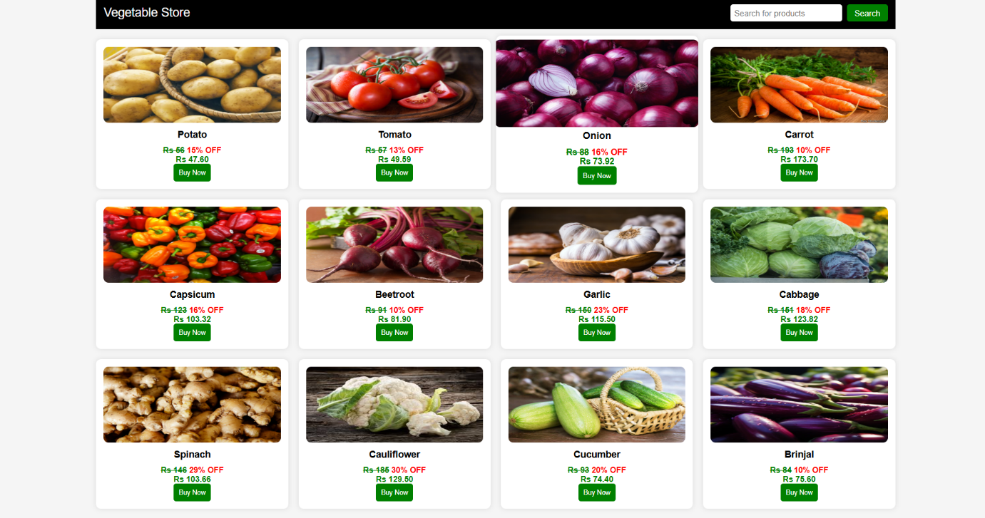
- PRODUCT INFO – FARMBUY
<!DOCTYPE html>
<html lang="en">
<head>
<meta charset="UTF-8">
<meta name="viewport" content="width=device-width, initial-scale=1.0">
<title>Farmbuy - Product Information</title>
<link rel="stylesheet" href="productinfo.css">
<script defer src="productinfo.js"></script>
</head>
<body>
<header>
<h1>FARMBUY</h1> <!-- Farmbuy in Green -->
</header>

<div class="container">
<h1>Product Information</h1>
<form id="pro" action="tracing.html" method="post">
<label for="name">Item Name:</label>
<input type="text" id="name" name="name" readonly>
<label for="weight">Weight (kg):</label>
<input type="text" id="weight" name="weight" required>
<label for="price">Price (Rs):</label>
<input type="text" id="price" name="price" readonly>
<label for="delivery">Delivery Within (days):</label>
<input type="text" id="delivery" name="delivery" required>
<button type="submit" class="submit-btn">Submit</button>
</form>
</div>
</body>
</html>
@import url('https://fonts.googleapis.com/css2?family=Imprint+MT+Shadow&display=swap');
body {
font-family: Arial, sans-serif;
background: linear-gradient(135deg, #e0f7fa, #a7ffeb);
text-align: center;
margin: 0;
padding: 0;
display: flex;
flex-direction: column;
justify-content: center;
align-items: center;
height: 100vh;
}
.container {
width: 50%;
background: rgba(255, 255, 255, 0.9);
padding: 30px;
border-radius: 15px;
box-shadow: 0px 0px 15px rgba(0, 0, 0, 0.2);
backdrop-filter: none;
transition: transform 0.3s ease-in-out;
}
.container:hover {
transform: scale(1.02);
}
header h1 {
margin: 20px 0;
font-size: 2.5rem;
font-family: 'Imprint MT Shadow', serif;
color: green;
font-weight: bold;
letter-spacing: 2px;
}
h1 {
color: #007acc;
text-align: center;
font-size: 2.5rem;
margin-bottom: 20px;
}
form {
display: flex;
flex-direction: column;
gap: 12px;
}
label {
font-weight: bold;
color: #004d40;
font-size: 1.1rem;
}
input[type="text"], input[type="file"] {
padding: 10px;
font-size: 14px;
border: none;
border-radius: 6px;
width: 60%;
margin: 0 auto;
outline: none;
background: rgba(255, 255, 255, 0.85);
box-shadow: 0px 0px 8px rgba(0, 77, 64, 0.2);
transition: all 0.3s ease-in-out;
}
.custom-file-label:hover {
background: linear-gradient(135deg, #2E7D32, #1B5E20);
box-shadow: 0px 0px 15px rgba(76, 175, 80, 0.9);
}
.submit-btn {
padding: 10px;
font-size: 14px;
font-weight: bold;
color: white;
border: none;
border-radius: 25px;
cursor: pointer;
text-transform: uppercase;
background: linear-gradient(135deg, #4CAF50, #2E7D32);
box-shadow: 0px 0px 10px rgba(76, 175, 80, 0.8);
transition: all 0.3s ease-in-out;
width: 50%;
margin: 12px auto;
}
.submit-btn:hover {
background: linear-gradient(135deg, #2E7D32, #1B5E20);
box-shadow: 0px 0px 15px rgba(76, 175, 80, 0.9);
transform: scale(1.03);
}
.submit-btn:active {
transform: scale(0.96);
box-shadow: 0px 0px 8px rgba(76, 175, 80, 0.5);
}
@media (max-width: 800px) {
.container {
width: 80%;
padding: 25px;
}
input[type="text"], input[type="file"] {
width: 80%;
font-size: 13px;
padding: 8px;
}
.submit-btn {
width: 60%;
padding: 10px;
font-size: 14px;
}
}
document.addEventListener("DOMContentLoaded", function () {
const urlParams = new URLSearchParams(window.location.search);
const itemName = urlParams.get("name");
const itemPrice = urlParams.get("price");

if (itemName) {
document.getElementById("name").value = itemName;
}
if (itemPrice) {
document.getElementById("price").value = ` ${itemPrice}`;
}
const form = document.querySelector("form");
form.addEventListener("submit", function (event) {
let isValid = true;
const weight = document.getElementById("weight");
const delivery = document.getElementById("delivery");
document.querySelectorAll(".error").forEach(el => el.remove());
if (!weight.value.trim() || isNaN(weight.value) || Number(weight.value) <= 0) {
showError(weight, "Please enter a valid weight in kg");
isValid = false;
}
if (!delivery.value.trim() || isNaN(delivery.value) || Number(delivery.value) <= 0) {
showError(delivery, "Please enter a valid delivery time in days");
isValid = false;
}
if (!isValid) {
event.preventDefault();
}
});
function showError(input, message) {
let error = document.createElement("div");
error.className = "error";
error.style.color = "red";
error.style.fontSize = "0.9rem";
error.style.marginTop = "5px";
error.innerText = message;
input.parentNode.insertBefore(error, input.nextSibling);
}
});
THE OUTPUT :
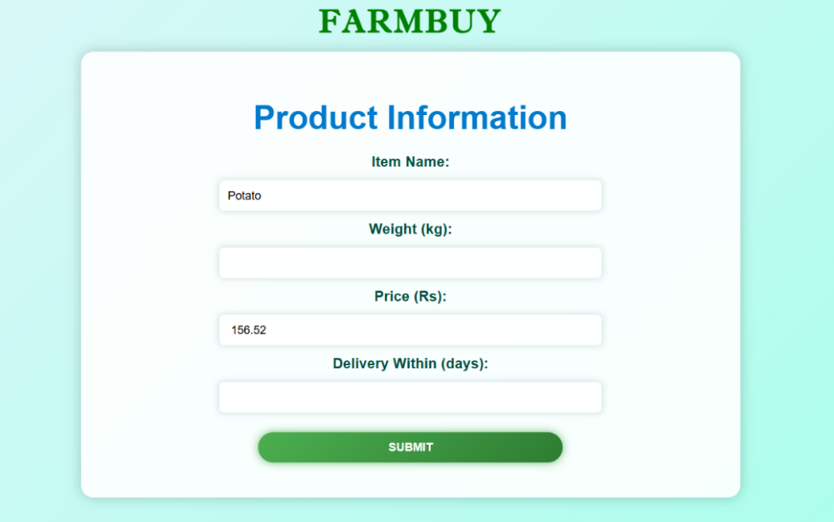
- ORDER PLACING – FARMBUY

<!DOCTYPE html>
<html lang="en">
<head>
<meta charset="UTF-8">
<meta name="viewport" content="width=device-width, initial-scale=1.0">
<title>Placing Order</title>
<style>
body {
margin: 0;
font-family: Arial, sans-serif;
background-color: #e8f4fc;
text-align: center;
padding: 20px;
}
header {
display: flex;
flex-direction: column;
align-items: center;
background-color: #ffffff;
padding: 20px;
box-shadow: 0 2px 5px rgba(0, 0, 0, 0.9);
position: fixed;
width: 100%;
top: 0;
z-index: 1000;
}
header h1 {
margin: 10px;
font-size: 3rem;
color: #33cc33;
font-weight: bold;
}
nav {
background-color: black;
padding: 10px 0;
width: 100%;
text-align: center;
box-shadow: 0 2px 5px rgba(0, 0, 0, 0.5);
}
nav a {
margin: 0 15px;
text-decoration: none;
color: white;
font-size: 1rem;
}
nav a:hover {
text-decoration: underline;
}
main {
margin-top: 180px;
text-align: center;
}
.progress-bar {
width: 50%;
background: #ddd;
height: 20px;
border-radius: 10px;
margin: 20px auto;
overflow: hidden;
box-shadow: 0px 4px 10px rgba(0, 0, 0, 0.2);
position: relative;
}
.progress {
height: 100%;
width: 0%;
background: #28a745;
border-radius: 10px;
}
.status {
margin-top: 15px;
font-weight: bold;
color: #333;
}
</style>
</head>
<body>
<header>
<h1>Placing Your Order</h1>
</header>
<nav>
<a href="#">Home</a>
<a href="#">Shop</a>
<a href="#">Orders</a>
<a href="#">Contact</a>
</nav>
<main>
<h2>Processing Your Order...</h2>
<div class="progress-bar">
<div class="progress" id="progress"></div>
</div>
<p class="status" id="status">Processing...</p>
</main>
<script>
function placeOrder() {
let progress = document.getElementById("progress");
let statusText = document.getElementById("status");
let width = 0;
let interval = setInterval(() => {
if (width >= 100) {
clearInterval(interval);
statusText.innerText = "Order Placed Successfully!";
setTimeout(() => {
window.location.href = "last.html"; // Change URL as needed
}, 1000);
} else {
width += Math.random() * 10; // Simulates uneven loading speed
if (width > 100) width = 100; // Ensure it doesn't exceed 100%
progress.style.width = width + "%";
}
}, 150); // Updates every 150ms for a smooth effect
}
placeOrder();
</script>
</body>
</html>

THE OUTPUT :
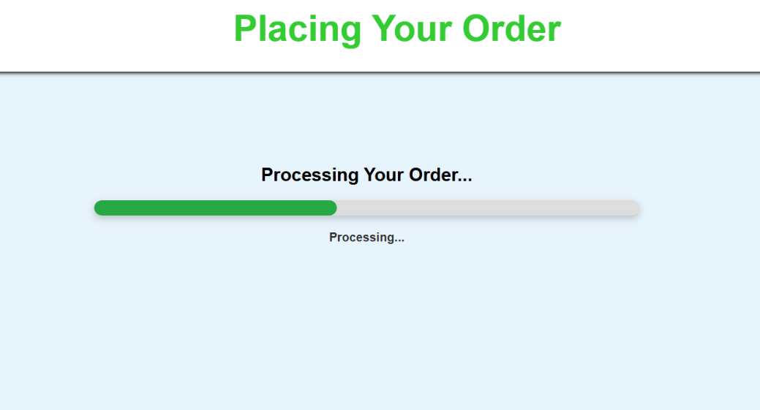

- ORDER DONE – FARMBUY
<!DOCTYPE html>
<html lang="en">
<head>
<meta charset="UTF-8">
<meta name="viewport" content="width=device-width, initial-scale=1.0">
<title>Order Placed</title>
<style>
body {
margin: 0;
font-family: Arial, sans-serif;
background-color: #e8f4fc; /* Light blue background */
text-align: center;
}
header {
display: flex;
flex-direction: column;
align-items: center;
background-color: #ffffff; /* White background */
padding: 20px;
box-shadow: 0 2px 5px rgba(0, 0, 0, 0.9); /* Subtle shadow */
position: fixed; /* Keeps the header at the top */
width: 100%;
top: 0;
z-index: 1000; /* Ensures it stays above other content */
}
header h1 {
margin: 10px;
font-size: 3rem; /* Increased font size */
color: #33cc33; /* Green color */
font-weight: bold; /* Bold for emphasis */
}
nav {
background-color: black; /* Black background for navigation */
padding: 10px 0; /* Add padding around the links */
width: 100%; /* Ensure it spans the full width */
text-align: center; /* Center align the links */
box-shadow: 0 2px 5px rgba(0, 0, 0, 0.5); /* Optional shadow */
}
nav a {
margin: 0 15px;
text-decoration: none; /* Removes underline */
color: white; /* White text color for contrast */
font-size: 1rem; /* Standard size for links */
}
nav a:hover {
text-decoration: underline; /* Underline effect on hover */
}
main {
margin-top: 180px;
text-align: center;
}
.order-container {
background: white;
padding: 100px;
border-radius: 100px;
box-shadow: 0px 4px 10px rgba(0, 0, 0, 0.2);
display: inline-block;
text-align: center;
max-width: 200px;
}

.thumb-img {
width: 150px;
height: 150px;
border-radius: 10px;
margin-bottom: 10px;
}
.order-text {
font-size: 20px;
font-weight: bold;
color: #28a745;
}
</style> </head>
<body>
<header>
<h1>Order Confirmation</h1>
</header>
<nav>
<a href="#">Home</a>
<a href="#">Shop</a>
<a href="#">Orders</a>
<a href="#">Contact</a>
</nav>
<main>
<div class="order-container">
<img src="https://cdn-icons-png.flaticon.com/512/8683/8683794.png" alt="Order Placed" class="thumb-img">
<p class="order-text">Your Order has been Placed Successfully!</p>
</div>
</main>
</body>
</html>
THE OUTPUT :
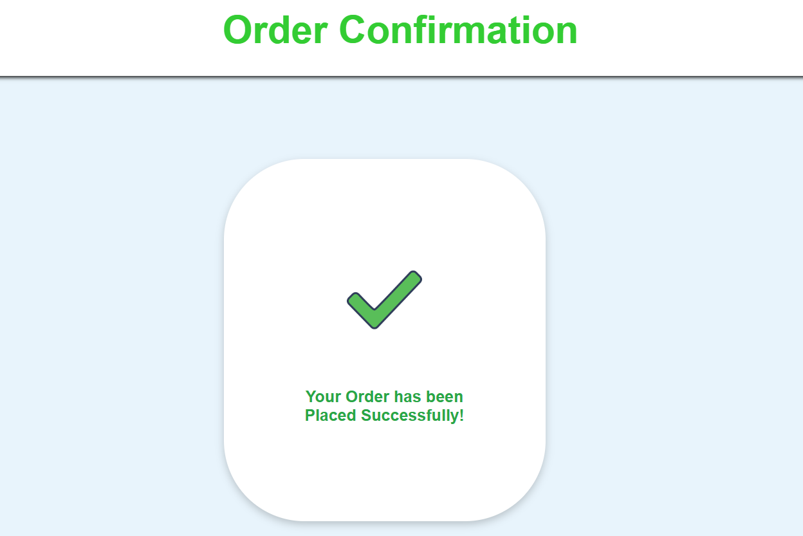
- SELLER INFO – FARMBUY
<!DOCTYPE html>
<html lang="en">
<head>
<meta charset="UTF-8">
<meta name="viewport" content="width=device-width, initial-scale=1.0">
<title>Farmbuy</title>
<link rel="stylesheet" href="sellerinfo.css">
</head>
<body>
<header>
<h1 class="main-heading">FARMBUY</h1>
</header>
<div class="container">
<h1>Seller Information</h1>
<form id="pro" action="tracing1.html" method="post">
<form id="seller-form">
<label for="product-name">Product Name:</label>
<input type="text" id="product-name" name="product-name" required>
<label for="category">Category:</label>
<select id="category" name="category" required>
<option value="vegetables">Vegetables</option>
<option value="fruits">Fruits</option>
<option value="groceries">Groceries</option>
<option value="dairy">Dairy Products</option>
</select>
<label for="price">Price:</label>
<input type="number" id="price" name="price" required>
<label for="image">Upload Product Image:</label>
<input type="file" id="image" name="image" accept="image/*" required>
<button type="submit" class="submit-btn">Submit </button>
</form>
</div>
</main>
<script src="sellerinfo.js"></script>
</body>
</html>
@import url('https://fonts.googleapis.com/css2?family=Imprint+MT+Shadow&display=swap');
body {
font-family: Arial, sans-serif;
background: linear-gradient(135deg, #e0f7fa, #a7ffeb);
text-align: center;
margin: 0;
padding: 0;
display: flex;
flex-direction: column;
justify-content: center;
align-items: center;
min-height: 100vh;
}
.container {
width: 90%;
max-width: 500px;
background: rgba(255, 255, 255, 0.95);
padding: 30px;
border-radius: 15px;
box-shadow: 0px 0px 15px rgba(0, 0, 0, 0.2);
transition: transform 0.3s ease-in-out;
}
.container:hover {
transform: scale(1.02);
}
header h1 {
margin: 20px 0;
font-size: 2.5rem;
font-family: 'Imprint MT Shadow', serif;
color: green;
font-weight: bold;
letter-spacing: 2px;
}
h1 {
color: #007acc;
text-align: center;
font-size: 2rem;
margin-bottom: 20px;
}
form {
display: flex;
flex-direction: column;
gap: 15px;
}
label {
font-weight: bold;
color: #004d40;
font-size: 1.1rem;
}
input, select {
padding: 12px;
font-size: 14px;
border: 1px solid #ccc;
border-radius: 6px;
width: 100%;
background: rgba(255, 255, 255, 0.85);
box-shadow: 0px 0px 8px rgba(0, 77, 64, 0.2);
transition: all 0.3s ease-in-out;
}
input:focus, select:focus {
box-shadow: 0px 0px 12px rgba(0, 77, 64, 0.8);
outline: none;
}
.submit-btn {
padding: 12px;
font-size: 16px;
font-weight: bold;
color: white;
border: none;
border-radius: 25px;
cursor: pointer;
text-transform: uppercase;
background: linear-gradient(135deg, #32CD32, #228B22);
box-shadow: 0px 0px 15px rgba(50, 205, 50, 0.8);
transition: all 0.3s ease-in-out;
width: 100%;
margin-top: 15px;
}
.submit-btn:hover {
background: linear-gradient(135deg, #228B22, #006400);
box-shadow: 0px 0px 20px rgba(50, 205, 50, 0.9);
transform: scale(1.03);
}
.submit-btn:active {
transform: scale(0.96);
box-shadow: 0px 0px 8px rgba(50, 205, 50, 0.5);
}
@media (max-width: 600px) {
.container {
width: 90%;
padding: 20px;
}
input, select {
font-size: 14px;
padding: 10px;
}
.submit-btn {
font-size: 15px;
padding: 10px;
}
}
document.getElementById("seller-form").addEventListener("submit", function(event) {
event.preventDefault();

let productName = document.getElementById("product-name").value;
let category = document.getElementById("category").value;
let price = document.getElementById("price").value;
let image = document.getElementById("image").files[0];
if (productName && category && price && image) {
alert("Product submitted successfully!");
this.reset();
} else {
alert("Please fill all fields!");
}
});

THE OUTPUT :
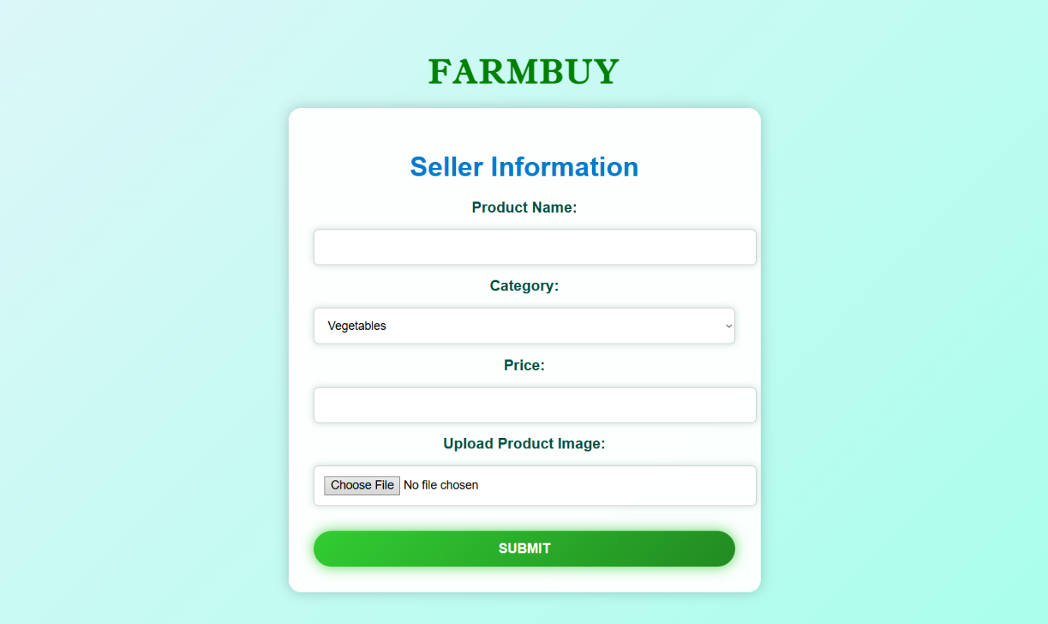

- PRODUCT SELLING – FARMBUY
<!DOCTYPE html>
<html lang="en">
<head>
<meta charset="UTF-8">
<meta name="viewport" content="width=device-width, initial-scale=1.0">
<title>Product Sold</title>
<style>
body {
margin: 0;
font-family: Arial, sans-serif;
background-color: #e8f4fc;
text-align: center;
padding: 20px;
}
header {
display: flex;
flex-direction: column;
align-items: center;
background-color: #ffffff;
padding: 20px;
box-shadow: 0 2px 5px rgba(0, 0, 0, 0.9);
position: fixed;
width: 100%;
top: 0;
z-index: 1000;
}
header h1 {
margin: 10px;
font-size: 3rem;
color: #33cc33;
font-weight: bold;
}
nav {
background-color: black;
padding: 10px 0;
width: 100%;
text-align: center;
box-shadow: 0 2px 5px rgba(0, 0, 0, 0.5);
}
nav a {
margin: 0 15px;
text-decoration: none;
color: white;
font-size: 1rem;
}
nav a:hover {
text-decoration: underline;
}
main {
margin-top: 180px;
text-align: center;
}
.progress-bar {
width: 50%;
background: #ddd;
height: 20px;
border-radius: 10px;
margin: 20px auto;
overflow: hidden;
box-shadow: 0px 4px 10px rgba(0, 0, 0, 0.2);
position: relative;
}

.progress {
height: 100%;
width: 0%;
background: #28a745;
border-radius: 10px;
}
.status {
margin-top: 15px;
font-weight: bold;
color: #333;
}
</style>
</head>
<body>
<header>
<h1>Selling Your Product</h1>
</header>
<nav>
<a href="#">Home</a>
<a href="#">Dashboard</a>
<a href="#">Sales</a>
<a href="#">Contact</a>
</nav>
<main>
<h2>Processing Your Sale...</h2>
<div class="progress-bar">
<div class="progress" id="progress"></div>
</div>
<p class="status" id="status">Processing...</p>
</main>

<script>
function processSale() {
let progress = document.getElementById("progress");
let statusText = document.getElementById("status");
let width = 0;
let interval = setInterval(() => {
if (width >= 100) {
clearInterval(interval);
statusText.innerText = "Product Sold Successfully!";
setTimeout(() => {
window.location.href = "last1.html"; // Change URL as needed
}, 1000);
} else {
width += Math.random() * 10; // Simulates uneven loading speed
if (width > 100) width = 100; // Ensure it doesn't exceed 100%
progress.style.width = width + "%";
}
}, 150); // Updates every 150ms for a smooth effect
}
processSale();
</script>
</body>
</html>

THE OUTPUT :
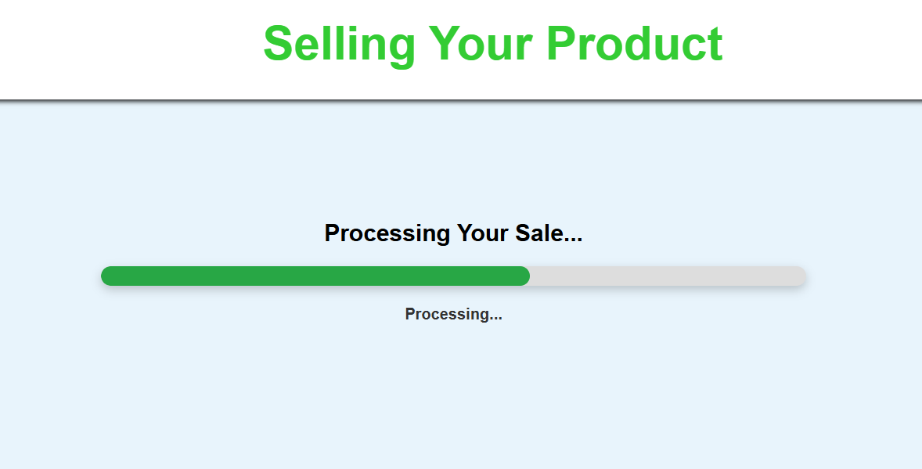

- PRODUCT SOLD – FARMBUY
<!DOCTYPE html>
<html lang="en">
<head>
<meta charset="UTF-8">
<meta name="viewport" content="width=device-width, initial-scale=1.0">
<title>Order Placed</title>
<style>
body {
margin: 0;
font-family: Arial, sans-serif;
background-color: #e8f4fc; /* Light blue background */
text-align: center;
}
header {
display: flex;
flex-direction: column;
align-items: center;
background-color: #ffffff; /* White background */
padding: 20px;
box-shadow: 0 2px 5px rgba(0, 0, 0, 0.9); /* Subtle shadow */
position: fixed; /* Keeps the header at the top */
width: 100%;
top: 0;
z-index: 1000; /* Ensures it stays above other content */
}
header h1 {
margin: 10px;
font-size: 3rem; /* Increased font size */
color: #33cc33; /* Green color */
font-weight: bold; /* Bold for emphasis */
}
nav {
background-color: black; /* Black background for navigation */
padding: 10px 0; /* Add padding around the links */
width: 100%; /* Ensure it spans the full width */
text-align: center; /* Center align the links */
box-shadow: 0 2px 5px rgba(0, 0, 0, 0.5); /* Optional shadow */
}
nav a {
margin: 0 15px;
text-decoration: none; /* Removes underline */
color: white; /* White text color for contrast */
font-size: 1rem; /* Standard size for links */
}
nav a:hover {
text-decoration: underline; /* Underline effect on hover */
}

main {
margin-top: 180px;
text-align: center;
}
.order-container {
background: white;
padding: 100px;
border-radius: 100px;
box-shadow: 0px 4px 10px rgba(0, 0, 0, 0.2);
display: inline-block;
text-align: center;
max-width: 200px;
}
.thumb-img {
width: 150px;
height: 150px;
border-radius: 10px;
margin-bottom: 10px;
}
.order-text {
font-size: 20px;
font-weight: bold;
color: #28a745;
}
</style>
</head>
<body>
<header>
<h1>Product Sold Confirmation</h1>
</header>

<nav>
<a href="#">Home</a>
<a href="#">Shop</a>
<a href="#">Orders</a>
<a href="#">Contact</a>
</nav>
<main>
<div class="order-container">
<img src="https://cdn-icons-png.flaticon.com/512/8683/8683794.png" alt="Order Placed" class="thumb-img">
<p class="order-text">Your Product has been Sold Successfully!</p>
</div>
</main>
</body>
</html>

THE OUTPUT :
