**Report:-**

Created a file containing this URL http://www.semanticweb.org/v0cn037/ontologies/2023/11/Pizza_in_10minutes. This will open the Pizza_in_10minutes ontology in Protege.

In the Protege window, I created the class hierarchy for the ontology. The top-level class is Pizza_in_10minutes, which has two subclasses: Pizza Base and Pizza Topping.

The Pizza Base class has two subclasses: Deep Pan Base and Thin And Crispy Base.

The Pizza Topping class has four subclasses: Cheese Topping, Vegetable Topping.

The Cheese Topping class has three subclasses: Mozzarella Topping, Parmesan Topping.

The Vegetable Topping class has three subclasses: Mushroom Topping, Olive Topping, and Tomato Topping.

My fav pizza:-The properties for Margherita of the class Pizza;

Base: Thin And Crispy Base;

Topping: Mozzarella Topping, Tomato Topping;

This can be used to find all pizzas that have a thin and crispy base and a tomato topping.

Summary:-

The Pizza_in_10minutes ontology is a simple ontology that describes the different components of a pizza and how they can be combined to create different types of pizzas.

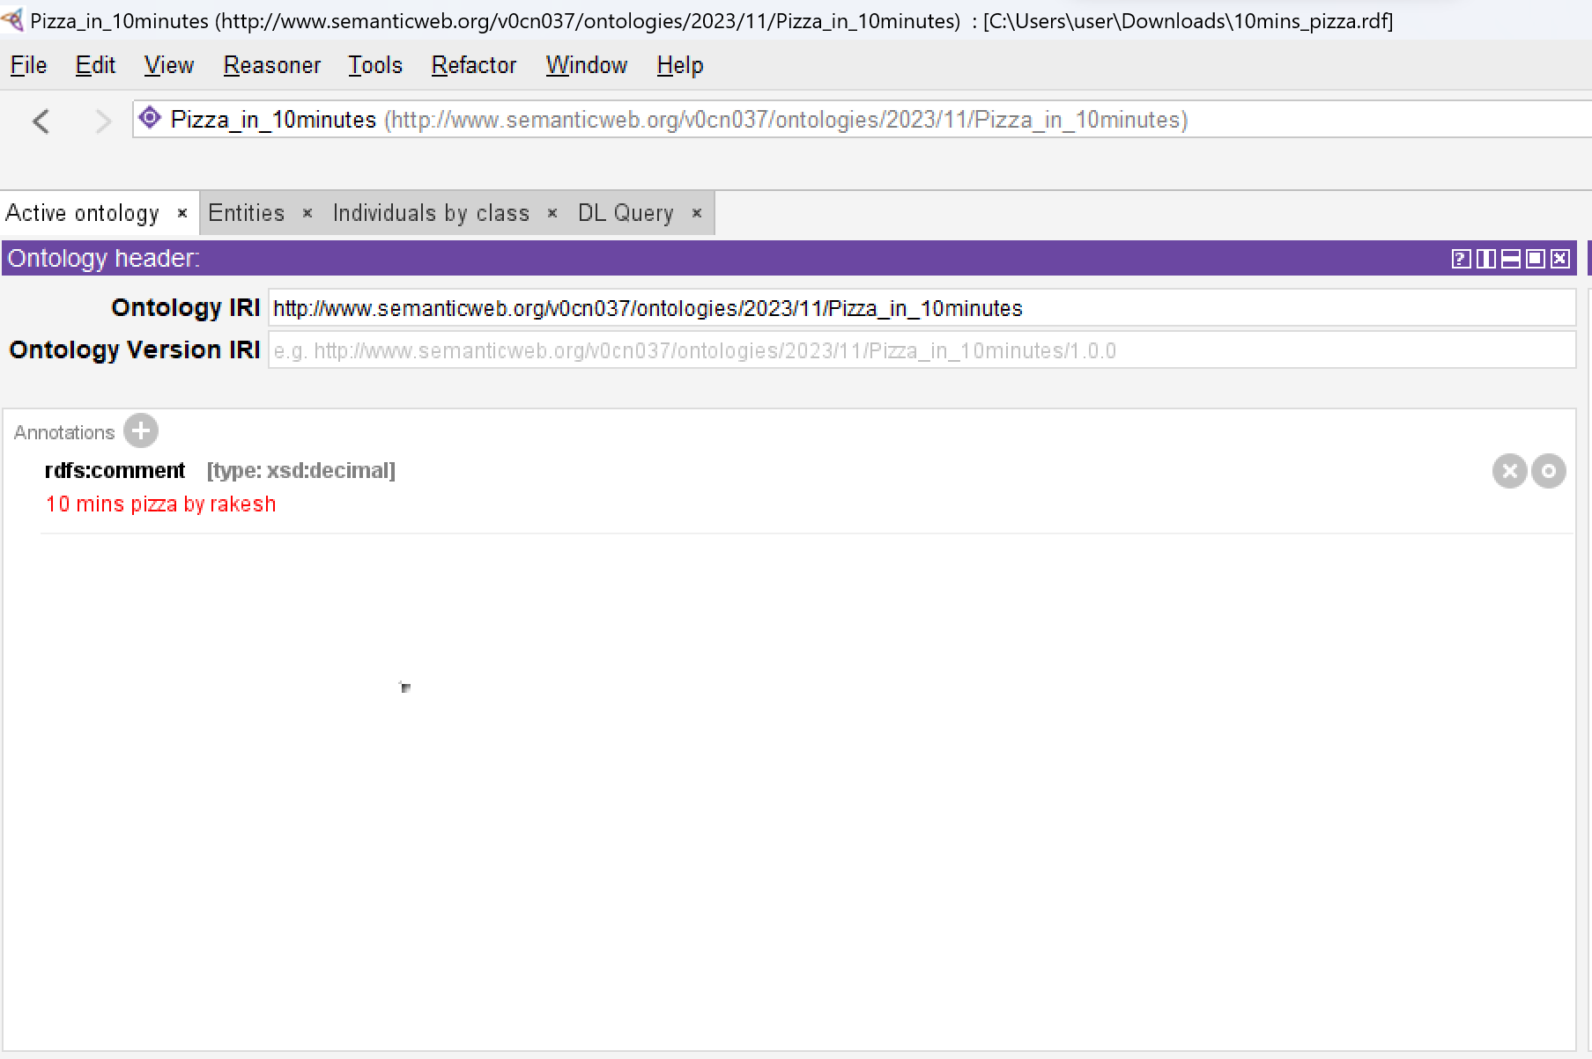

Annotation.

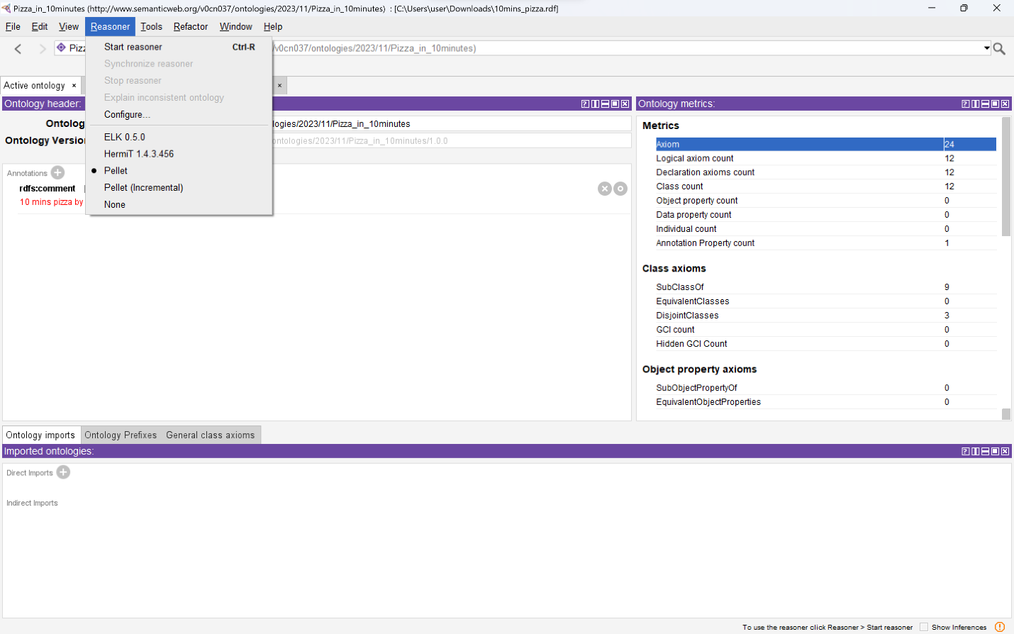

Execute a reasoner.

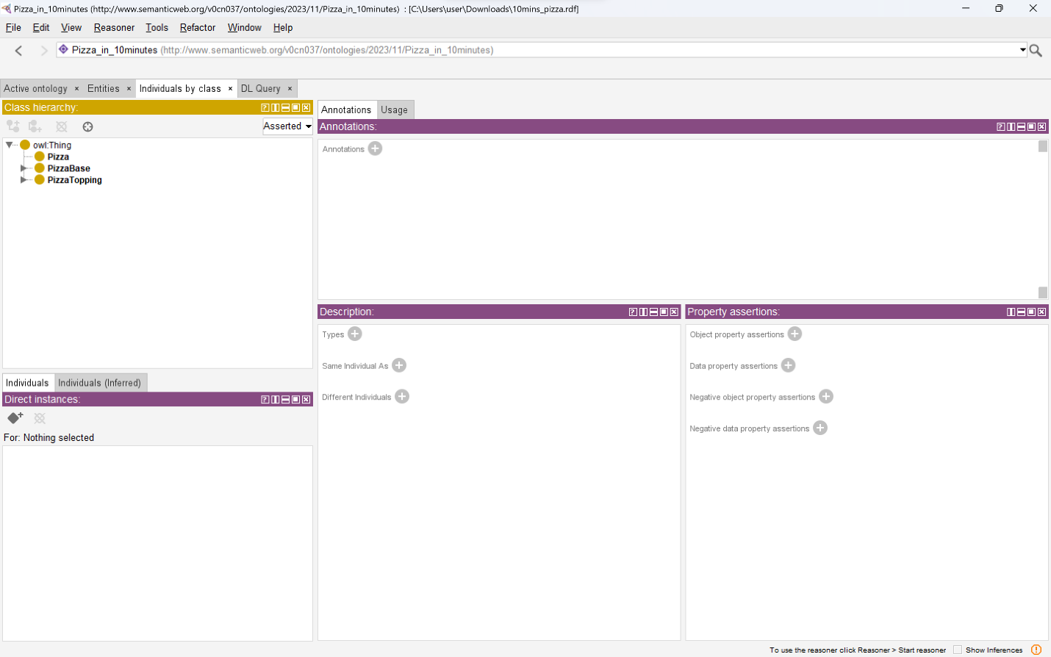

Representation of Sub-classes

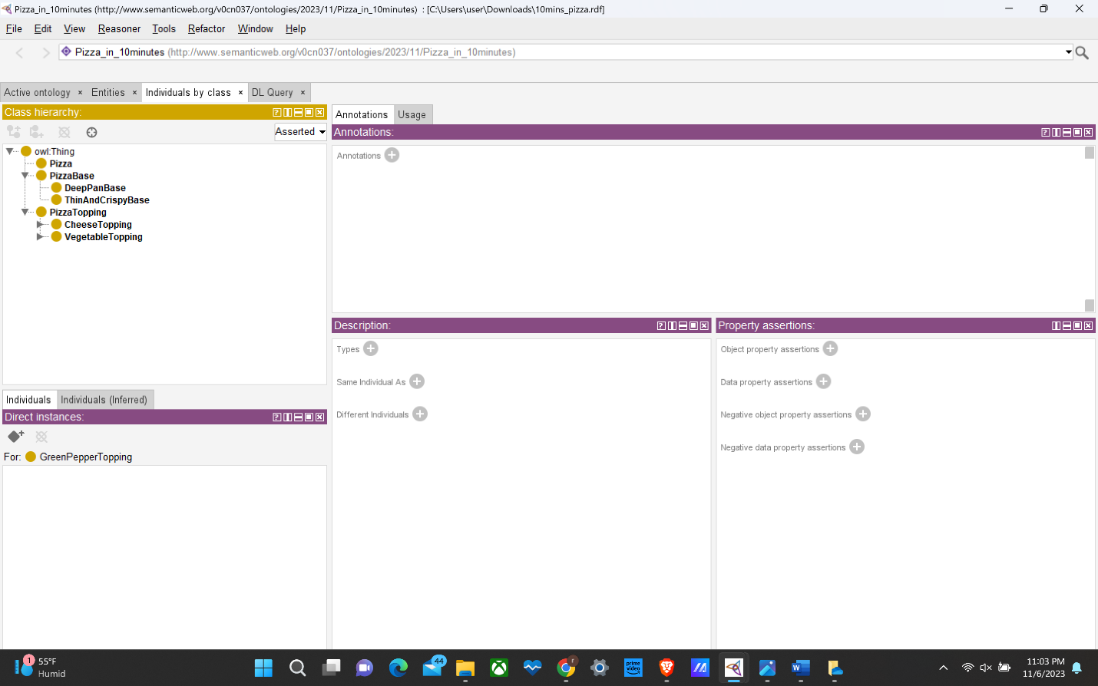

Dis-joints

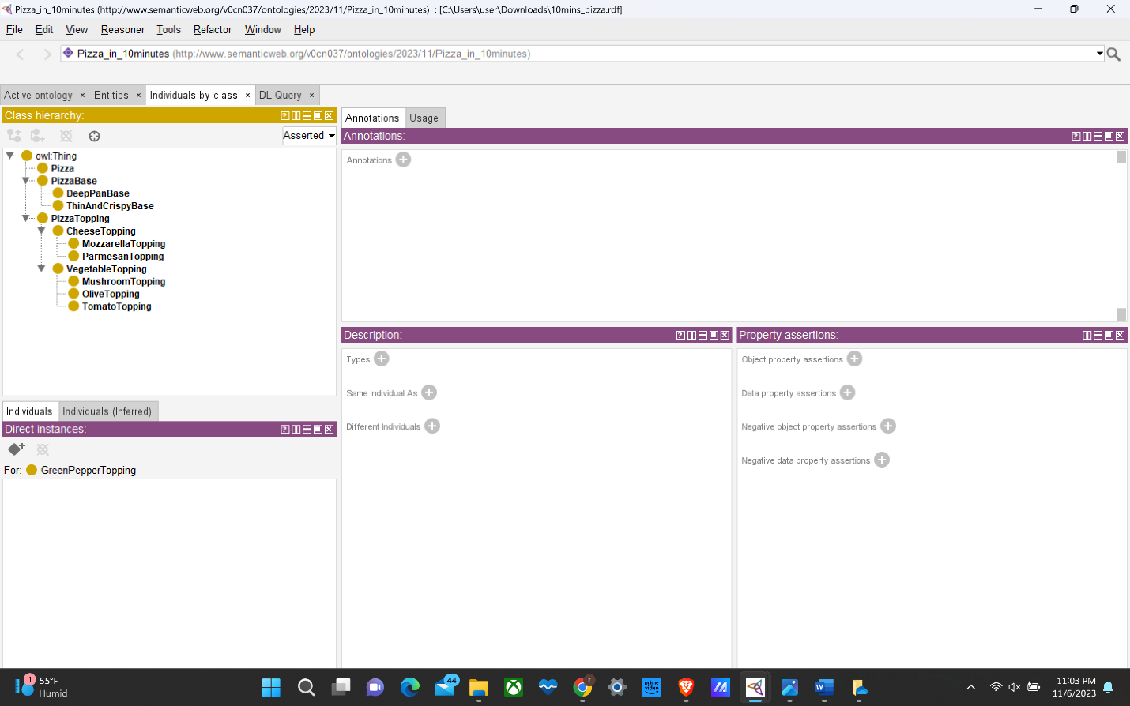

Total-Structure.