This is the result produced by text parsing.

From the parse, we can find the relation of each word in a sentence to all the others, and typically also its function in the sentence. And the efficient and accurate dependency parsers that seek to uncover dependencies between words in a sentence. Especially in texts with a free and flexible word order, these dependencies may not be arranged linearly.

The Results window displays a variety of tabular and graphical output is helpful for analyzing the terms and their instances in the ABSTRACT data source.

The Number of Documents by Frequency scatter plot displays the number of documents in which a term appears versus the frequency of occurrence of that term in the entire document collection. Each data point represents a parsed term. If you position the mouse pointer over a plotted point, then a tooltip indicates the term name, the number of documents in which that term appears, and the number of times that term appears in the entire document collection.

The Role by Freq bar chart displays the total frequency of occurrence of parsed terms in the document collection, broken down by term role. Each bar represents a role. If you position the mouse pointer over a bar, then a tooltip indicates the role name and the number of times a parsed term with that role appears in the entire document collection.

The Attribute by Frequency bar chart displays the total frequency of occurrence of parsed terms in the document collection, broken down by attribute. If you position the mouse pointer over a bar, then a tooltip indicates the attribute name and the number of times a term with that attribute appears in the entire document collection.

The ZIPF Plot displays a scatter plot of the number of documents for each term where each is sorted and plotted by rank. If you position the mouse pointer over a point, then a tooltip indicates the term name, rank, and number of documents.

In term plot when you select a term, like the parts of speech, in the Terms table whether it is in noun group or not and what type of attribute it is, the point that corresponds to that term in the Text Parsing Results plots is highlighted.

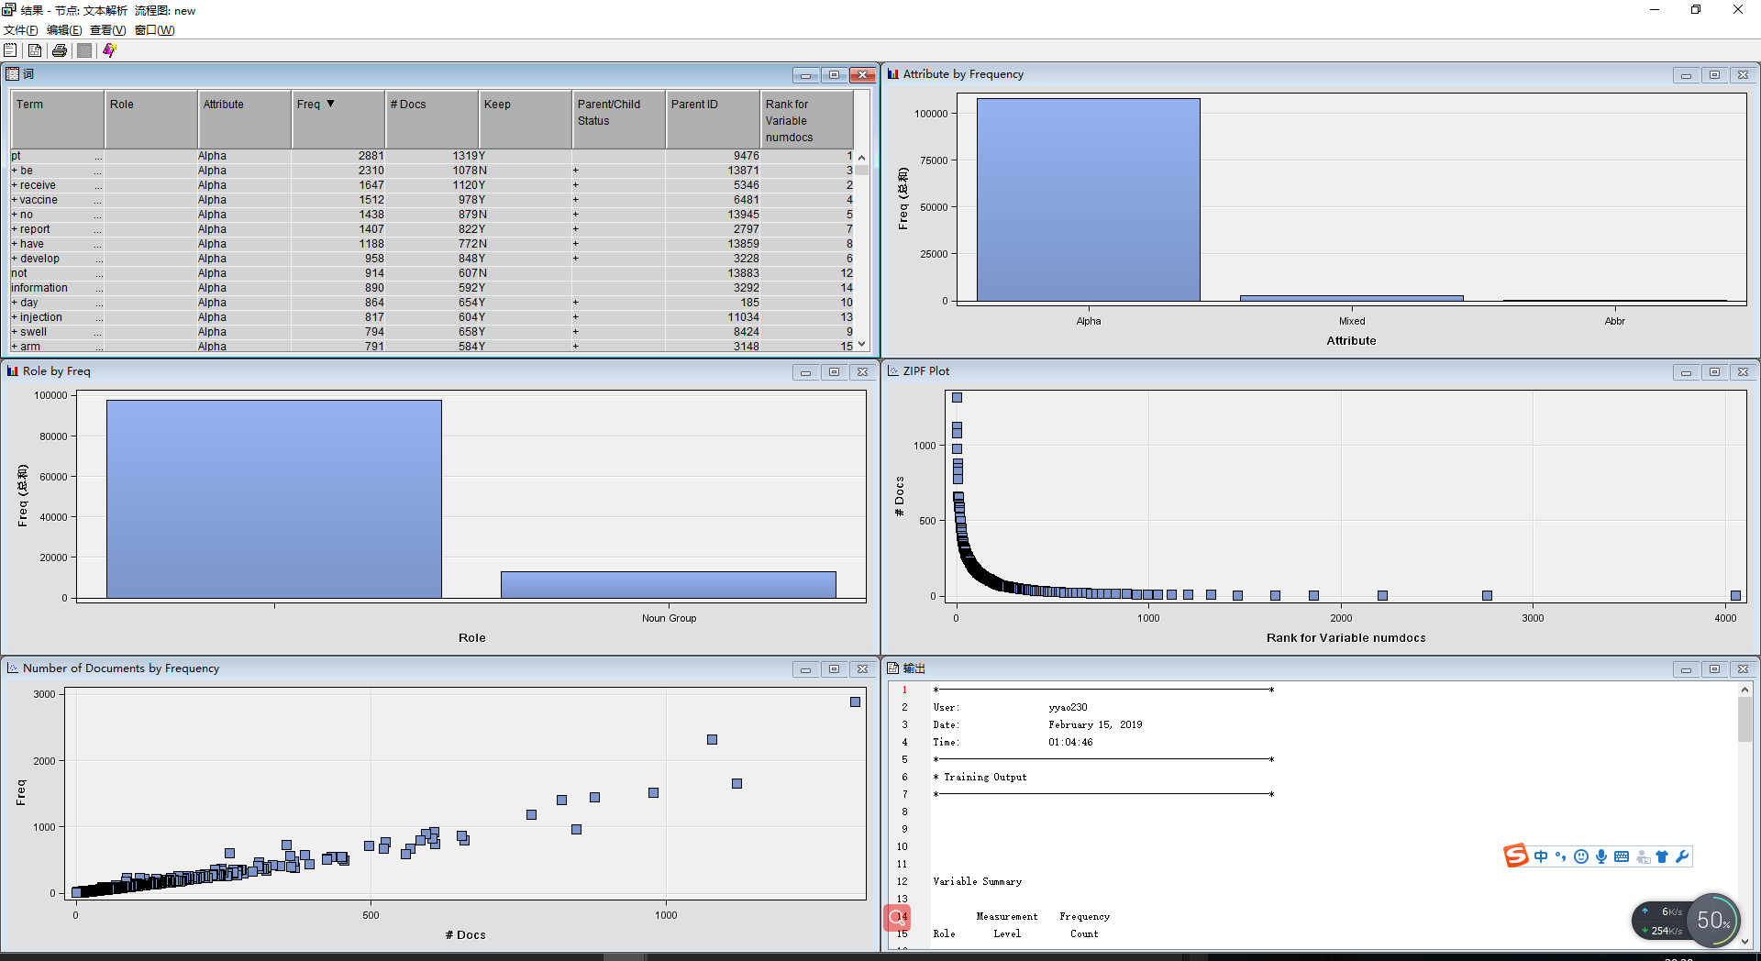

This the result of text filter.

Like stand-alone filter used in dealing with XML documents, we use Text Filter node remove unwanted terms and to keep only documents that discuss a particular issue. And the smaller but contains different terms data set is shown as follows.

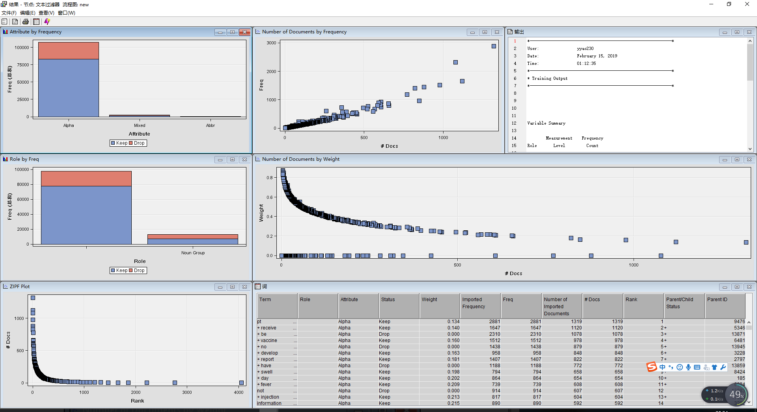

This is the result produced by Text Cluster node.

The Text Cluster node clusters documents into disjointed sets of documents and reports on the descriptive terms for those clusters. Then the node uses Hierarchical clustering algorithm groups clusters into a tree hierarchy.

Then we use Filter Viewer to show the result which is shown as follows.

