Engineers' Certificate of Inspection

On highway use vehicle

The 1976 VW Dune Buggy, shown below and identified by the vehicle identification number 1162080095, has been modified by the addition of an El Lobo body kit. The vehicle has been inspected by Grove Auto and Offroad, and the Department of Transport, and is considered to be in good general maintenance and overall condition. I have inspected it, and it has all the necessary safety equipment, signal lights, headlights and exhaust system.

This vehicle is suitable for use on highways and roads.

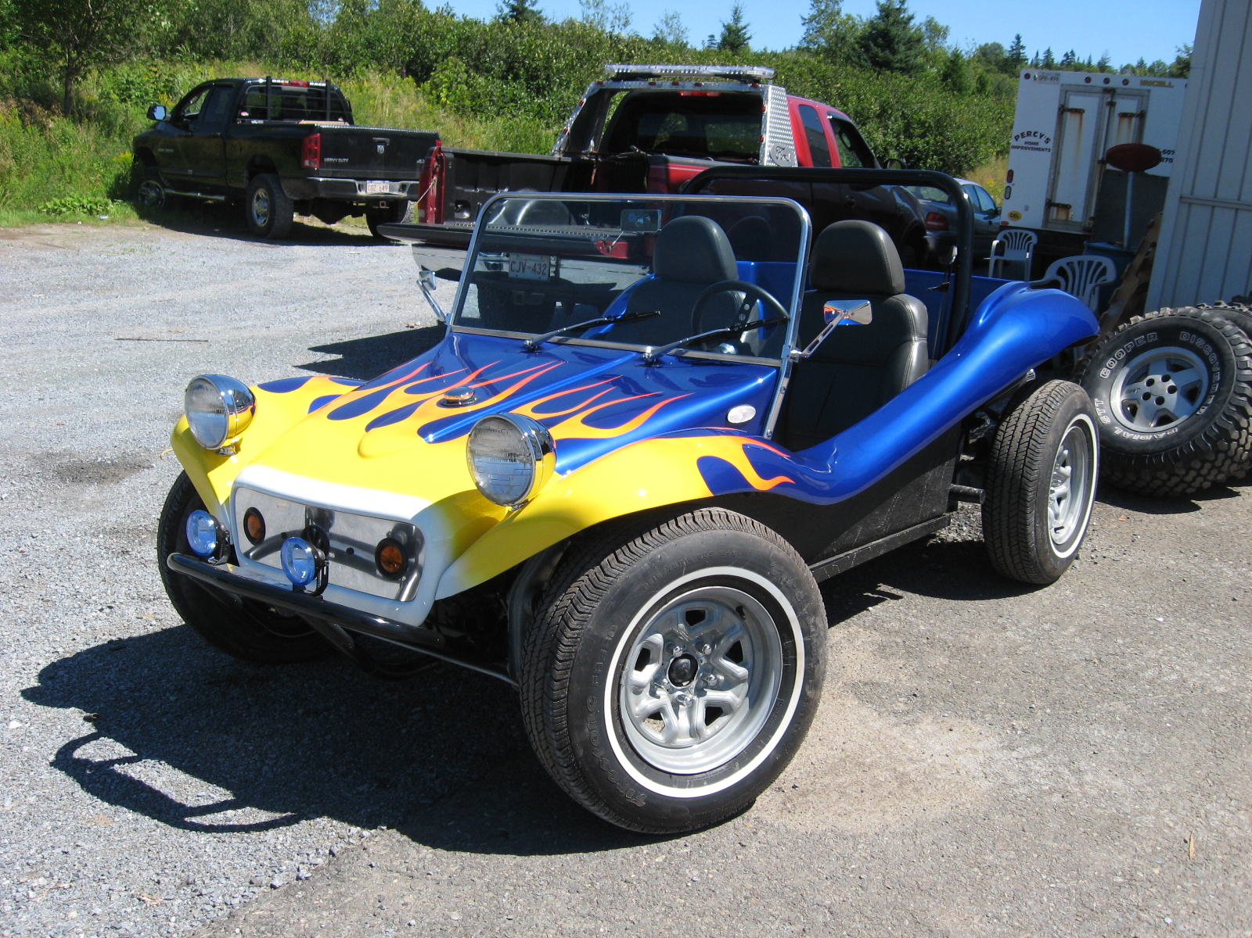

Dated: 2013-08-06

Signed: Steve Adamson P.Eng

Steve Adamson 14 Rothesay Park Road, Rothesay NB E2E 5T6 Tel:(506)849-2870

