Applied Biostat Project

DominicLaRoche

Wednesday, October 29, 2014

# Introduction

|  |  |  |  |  |  |  |  |
| --- | --- | --- | --- | --- | --- | --- | --- |
|  |  | No | No % | Yes | Yes % | Total | Total % |
| Variable | Categories | N | % | N | % | N | % |
| Under 5 | No | 2002 | 72.3% | 753 | 62% | 2755 | 69.2% |
|  | Yes | 768 | 27.7% | 461 | 38% | 1229 | 30.8% |
|  |  |  |  |  |  |  |  |
| Under 1 | No | 2570 | 92.8% | 1005 | 82.8% | 3575 | 89.7% |
|  | Yes | 200 | 7.2% | 209 | 17.2% | 409 | 10.3% |
|  |  |  |  |  |  |  |  |
| Under 18 | No | 2292 | 82.7% | 1019 | 83.9% | 3311 | 83.1% |
|  | Yes | 478 | 17.3% | 195 | 16.1% | 673 | 16.9% |
|  |  |  |  |  |  |  |  |
| Peripheral Family | No | 2626 | 94.8% | 1093 | 90% | 3719 | 93.3% |
|  | Yes | 143 | 5.2% | 121 | 10% | 264 | 6.6% |
|  | Missing | 1 | 0% | 0 | 0% | 1 | 0% |
|  |  |  |  |  |  |  |  |
| House Sprayed | No | 2107 | 76.1% | 1034 | 85.2% | 3141 | 78.8% |
|  | Yes | 663 | 23.9% | 180 | 14.8% | 843 | 21.2% |
|  |  |  |  |  |  |  |  |
| Site | High | 2211 | 79.8% | 1168 | 96.2% | 3379 | 84.8% |
|  | Low | 559 | 20.2% | 46 | 3.8% | 605 | 15.2% |
|  |  |  |  |  |  |  |  |
| House Head Sex | F | 873 | 31.5% | 379 | 31.2% | 1252 | 31.4% |
|  | M | 1780 | 64.3% | 794 | 65.4% | 2574 | 64.6% |
|  | Missing | 117 | 4.2% | 41 | 3.4% | 158 | 4% |
|  |  |  |  |  |  |  |  |
| numocc |  | 4.2 (2.3) |  | 4.8 (2.3) |  | 4.4 (2.3) |  |
| numFem |  | 2.1 (1.5) |  | 2.5 (1.4) |  | 2.3 (1.5) |  |
| numMale |  | 2.1 (1.4) |  | 2.3 (1.5) |  | 2.1 (1.5) |  |
| oldest |  | 47.6 (17.8) |  | 44.3 (15.4) |  | 46.6 (17.2) |  |
| youngest |  | 14.6 (19.4) |  | 9.1 (14.1) |  | 12.9 (18.1) |  |
| headage |  | 47.6 (17.5) |  | 43.9 (14.5) |  | 46.4 (16.7) |  |
| elev |  | 1631.9 (382.6) |  | 1729.2 (447.3) |  | 1661.6 (405.8) |  |
| Total |  | 2770 | 69.5% | 1214 | 30.5% | 3984 |  |

Table 1. Summary of household attributes by houses with and without nets.

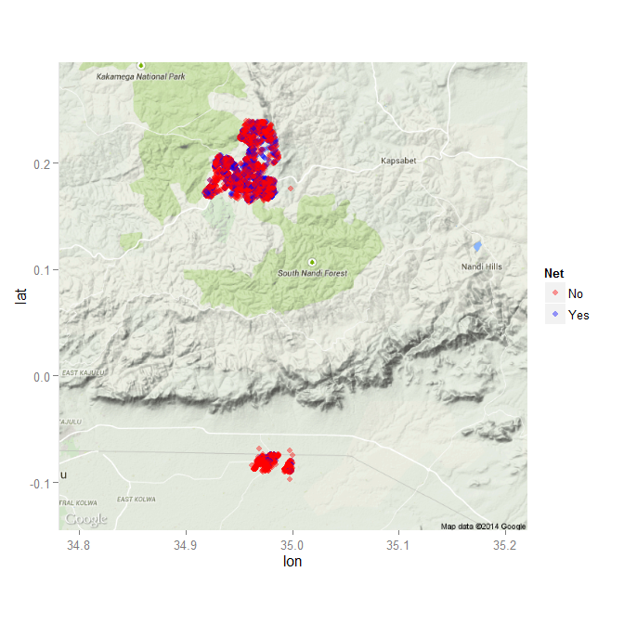

Figure.1 Locations of households in study. Blue dots represent households with nets.

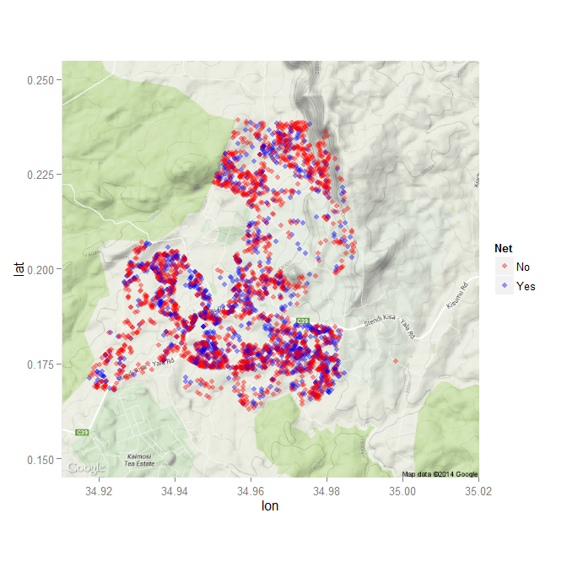

Figure 3. Households with and without nets at the high site.

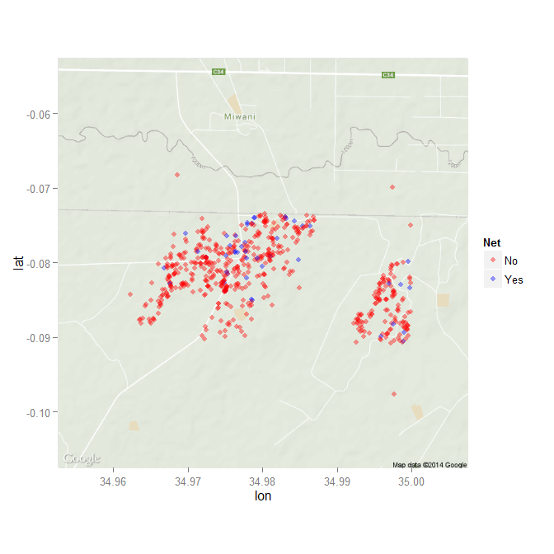

Figure 4. Households with and without nets at the low site.

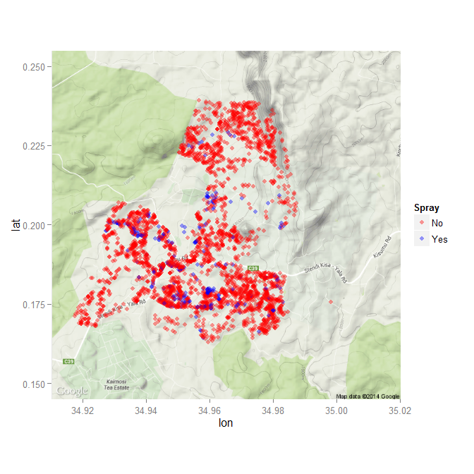

Figure 3. Households with and without spraying at the high site.

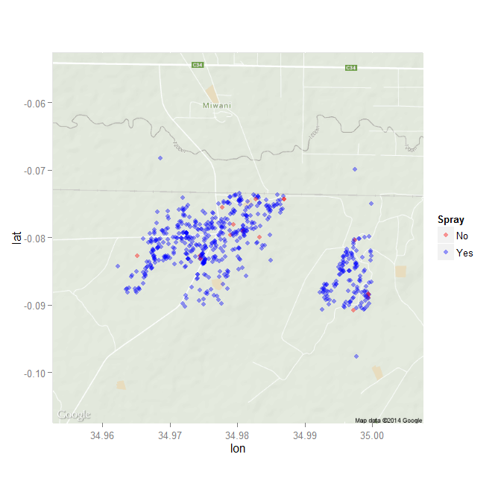

Figure 4. Households with and without spraying at the low site.