Lung Cancer Treatment and Quality of Life

Dominic LaRoche, Elinora Price

Tuesday, October 28, 2014

|  |  |
| --- | --- |
|  | N |
| **1** | 5 |
| **1 2 3** | 1 |
| **1 2 3 4** | 6 |
| **1 2 4** | 1 |
| **1 3** | 1 |
| **1 3 4** | 11 |
| **1 4** | 5 |
| **2** | 10 |
| **2 3** | 10 |
| **2 3 4** | 126 |
| **2 4** | 20 |
| **3** | 15 |
| **3 4** | 86 |
| **4** | 92 |
| **None Missing** | 136 |

Among period missingness patterns

|  |  |
| --- | --- |
|  | N |
| **1 2 3 4 5 6** | 15 |
| **1 3 4 5 6** | 1 |
| **1 4 5 6** | 2 |
| **1 5 6** | 1 |
| **1 6** | 2 |
| **2 5 6** | 1 |
| **2 6** | 1 |
| **3** | 2 |
| **3 4 6** | 1 |
| **4 6** | 1 |
| **5** | 3 |
| **None Missing** | 495 |

Within period 1 missingness patterns

|  |  |
| --- | --- |
|  | N |
| **1 2 3 4 5 6** | 168 |
| **1 6** | 1 |
| **2 3 6** | 1 |
| **3** | 2 |
| **3 5** | 1 |
| **4 5 6** | 1 |
| **None Missing** | 351 |

Within period 2 missingness patterns

|  |  |
| --- | --- |
|  | N |
| **1 2 3 4 5 6** | 249 |
| **1 4 5 6** | 2 |
| **1 5 6** | 1 |
| **2 3 4 5 6** | 1 |
| **2 6** | 2 |
| **5** | 1 |
| **None Missing** | 269 |

Within period 3 missingness patterns

|  |  |
| --- | --- |
|  | N |
| **1 2 3 4 5 6** | 341 |
| **1 4 5 6** | 1 |
| **4 6** | 1 |
| **5** | 4 |
| **None Missing** | 178 |

Within period 4 missingness patterns

|  |  |  |  |
| --- | --- | --- | --- |
|  | Estimate | Std. Error | t value |
| **(Intercept)** | 64.86 | 1.246 | 52.04 |
| **ExpTx1** | 1.099 | 1.529 | 0.7188 |
| **FUNO2** | -2.493 | 1.509 | -1.652 |
| **FUNO3** | -1.97 | 1.651 | -1.193 |
| **FUNO4** | -4.77 | 1.948 | -2.448 |
| **ExpTx1:FUNO2** | 1.167 | 1.804 | 0.6471 |
| **ExpTx1:FUNO3** | -1.194 | 1.978 | -0.6035 |
| **ExpTx1:FUNO4** | -0.3507 | 2.321 | -0.1511 |

Estimated parameters from unadjusted mixed model

cct1t<-contrast::contrast(m0,a=list(ExpTx="1",FUNO="1"),b=list(ExpTx="0",FUNO="1"))  
cct2t<-contrast::contrast(m0,a=list(ExpTx="1",FUNO="2"),b=list(ExpTx="0",FUNO="2"))  
cct3t<-contrast::contrast(m0,a=list(ExpTx="1",FUNO="3"),b=list(ExpTx="0",FUNO="3"))  
cct4t<-contrast::contrast(m0,a=list(ExpTx="1",FUNO="4"),b=list(ExpTx="0",FUNO="4"))  
  
#Test difference at time 1  
dt1<-summary(glht(m1,linfct=cct1t$X))$test  
#Test difference at time 2  
dt2<-summary(glht(m1,linfct=cct2t$X))$test  
#Test difference at time 3  
dt3<-summary(glht(m1,linfct=cct3t$X))$test  
#Test difference at time 4  
dt4<-summary(glht(m1,linfct=cct4t$X))$test

## Warning: Removed 794 rows containing non-finite values (stat_boxplot).

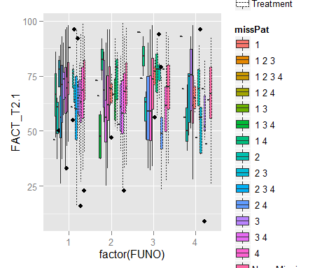 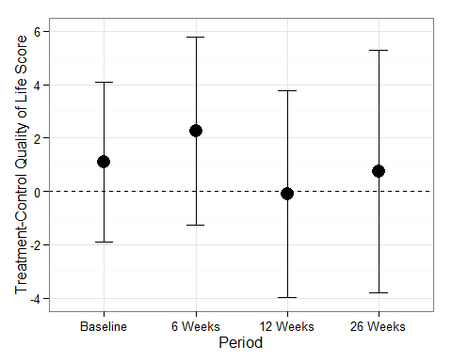

|  |  |  |  |  |  |  |  |
| --- | --- | --- | --- | --- | --- | --- | --- |
|  |  | Control | Control % | Treatment | Treatment % | Total | Total % |
| Variable | Categories | N | % | N | % | N | % |
| ECOGPS | 0 | 59 | 33.7% | 111 | 31.7% | 170 | 32.4% |
|  | 1 | 116 | 66.3% | 238 | 68% | 354 | 67.4% |
|  | 2 | 0 | 0% | 1 | 0.3% | 1 | 0.2% |
|  |  |  |  |  |  |  |  |
| SX_SYS | 2 | 76 | 43.4% | 138 | 39.4% | 214 | 40.8% |
|  | Yes | 99 | 56.6% | 212 | 60.6% | 311 | 59.2% |
|  |  |  |  |  |  |  |  |
| PD_LT6 | No | 96 | 54.9% | 236 | 67.4% | 332 | 63.2% |
|  | Yes | 79 | 45.1% | 114 | 32.6% | 193 | 36.8% |
|  |  |  |  |  |  |  |  |
| CYCLES |  | 4.2 (2.6) |  | 4.8 (2.9) |  | 4.6 (2.8) |  |
| SURV_DUR |  | 297.6 (223.8) |  | 342.1 (226.1) |  | 327.3 (226.1) |  |
| Total |  | 175 | 33.3% | 350 | 66.7% | 525 |  |