Malaria Prevention: Are high-risk households in Kenya receiving treatments?

Dominic D. LaRoche*
Melanie L. Bell¹
Kacey C. Ernst¹

¹Mel & Enid Zuckerman College of Public Health, University of Arizona

Key Words: Malaria, Long lasting insecticidal nets, indoor residual spray, prevention, policy evaluation, spatial risk mapping, topography

Abstract Word Count: 141
Text Word Count: 1498

Abstract
Malaria is a significant threat to public health in countries where the disease is either endemic or epidemic. Concerted efforts have been made in the past decade to reduce and in some cases eliminate malaria with the use of prophylactic interventions. The World Health Organization recommends preferential administration of interventions to pregnant women and infants because of the high disease burden borne by this group. However, previous research has identified the benefit of additionally targeting interventions at those with the highest risk of infections. We use a topographic wetness index, combined with a household census of intervention use, at two sites in Kenya to assess intervention administration. We find preferential administration of interventions at the high-elevation epidemic-prone site but not at the low-elevation endemic site. Our results have important implications for assessing the administration of interventions in the battle against malaria.

Malaria is considered a significant threat to public health and a socio-economic burden in countries where the disease is either endemic or epidemic.¹ Concerted efforts have been made in the past decade to reduce and in some cases eliminate malaria. Many national strategic plans to reduce or eliminate malaria are in their third generation. Spatial targeting of high risk areas is a strategy that has been recommended but few studies have assessed if government programs are achieving differential coverage in high risk areas.²
The government of Kenya developed the “National Malaria Strategy 2009-2017” in response to the ongoing threat of malaria.³ This strategy outlined 6 objectives, the first of which is “to have at least 80% of people living in malaria risk areas using appropriate malaria preventive interventions.” The two primary non-pharmaceutical interventions identified in the plan are Indoor Residual Spraying (IRS) and Long Lasting Insecticidal Nets (LLINs). The strategy outlined for achieving the intervention objective included the initial mass distribution of LLINs where malaria is either endemic (western lowlands) or epidemic-prone (western highlands); followed by routine distribution of LLINs to pregnant women and children under 1 year of age and a subsidized sale of LLINs. The strategy also outlined the use of widespread IRS followed by focal treatments in epidemic-prone areas.
The World Health Organization recommends prioritizing the administration of interventions to pregnant women and children followed by progressively achieving intervention coverage of all community members. The preferential administration of interventions to pregnant women and young children reflects the disproportionate disease burden borne by this group.⁴ However, previous research has identified the benefit of additionally targeting interventions at those with the highest risk of infections.² Moreover, remotely-sensed topographic data has been previously validated as a tool for assessing risk of malaria infection by identifying areas where water is likely to pool and Anopheles densities are likely to be higher.^{5,6} Our primary objective was to use topographic data, combined with a household census of intervention use, to determine if existing protocols of intervention administration simultaneously targeted households with high risk members and high infection risk. Since policies for intervention administration differed between the epidemic-prone and endemic regions we also sought to compare the distribution of interventions between these two regions.
Prior to the initiation of a community-based research program, two study sites in western Kenya were mapped and a census was taken. These two sites represent the western highland (hereafter “epidemic-prone”, N=3380) and lowland (hereafter “endemic”, N=604) populations. We collected demographic information for each occupant including age and sex. Both sites have had partial treatment with both LLINs and IRS and household heads provided initial information about LLIN ownership and government administration of household IRS in the previous six months. Research was approved by the University of Arizona and the Kenyan Medical Research Institute. We summarized information into household attributes. If any individual in the household owned a bednet, the household was considered a bednet owning household and households were considered treated with IRS even if some occupants slept in adjacent buildings that had not been treated. For each unique house we calculated the number of individuals under 1, the number of individuals over 1 and under 5. We assigned an age-based health risk score (age-based risk hereafter) to each household with the following formula:
Risk Score=(2×Children≤1)+(1<Children≤5)
We assigned twice the weight to children under 1 since they have the higher risk of the two categories.^{7,8}
We assigned each household a risk for exposure to mosquitoes (infection risk hereafter) by deriving a continuous risk surface over the study area. We used a Topographical Wetness Index (TWI) derived from the digital elevation data to determine areas likely to provide breeding habitat for mosquitoes. The TWI combines the total basin area (the area from which water will flow to a particular point) with the slope at that point to determine the amount of water likely to accumulate and provide breeding habitat for mosquitoes. To derive the risk surface, we utilized 90 meter resolution elevation data from the National Aeronautics and Space Administration Shuttle Radar Topography Mission .⁹ We used the statistical programming language R with the packages “SDMTools” and “raster” to calculate TWI using a multi-directional flow model.^{10,11,12} We restricted our TWI measurements to identify areas with low water out-flow by including a measure of local aspect variance. We assumed the infection risk of a household was inversely related to the distance to one or more of these high-wetness areas. Therefore, we applied a Gaussian filter with σ=10 to create a weighted average of mosquito risk for each cell in the study area. We then assigned each house the risk score of the cell in which it was located.
To determine if current administration protocols targeted households with both high infection risk and high health risk we standardized each risk measure and added them to create a combined risk score (measured in standard deviations from the sample population). We used a logistic model to evaluate whether households with high risk were more likely to receive an intervention. We also modelled each risk separately to determine if existing protocols of intervention administration were adequately addressing either risk. We used restricted cubic splines to assess violations of the linearity assumption. If we found evidence of a non-linear relationship in any model we categorized the risk score into quartiles and re-fit with a means model.
Figure 1 shows the estimated risk surface for both sites. The odds of receiving either an LLIN or IRS were higher for households with higher combined risk, but only at the epidemic-prone site (table 1, figure 2). For each 1 standard deviation increase in combined-risk at the epidemic-prone site the odds of receiving an LLIN increased 45% (Odds Ratio (OR): 1.45, 95% CI: 1.33, 1.59) and the odds of IRS increased 22% (OR: 1.22, 95% CI: 1.05, 1.42). At the endemic site, we found no statistically significant preferential administration of either intervention to high combined-risk households. We found some evidence of a non-linear relationship between the log-odds of net use and combined risk at the endemic site. However, modelling the mean risk for each risk quartile did not change the interpretation of our results.
The odds of LLIN use at the epidemic-prone site was more strongly associated with age-based risk than infection risk, whereas the probability of IRS at the epidemic-prone site was more strongly associated with infection risk. However, we did not find the same pattern at the endemic site where we found households with high infection risk were significantly less likely to receive IRS (OR: 0.34, 95% CI: 0.14, 0.83).
The two sites had very different rates of use for both LLINs and IRS. The endemic site had recently received 3 consecutive years of IRS (as prescribed by the National MALARIA Strategy) resulting in 97.4% of all households reporting IRS. However, only 7.6% of households in the endemic site reported LLIN use. Conversely, 34.6% of households in the epidemic-prone site reported LLIN use but only 7.6% of households reported IRS in the previous six months. The widespread use of IRS in the endemic site makes it difficult to determine whether high risk households preferentially received the intervention but we found no evidence that spraying was targeted at high risk households. This result is in contrast to the epidemic-prone site where we found evidence of preferential administration of both LLINs and IRS (despite the relatively low occurrence of IRS).
Our study has some limitations. Our measure of infection risk may be more suitable to the epidemic-prone site which has more pronounced topographical features. Previous research on the use of TWI for prediction of malaria has been performed at sites similar to our epidemic-prone site but not our endemic site.⁴ Moreover, TWI algorithms are known to be sensitive to the general terrain to which they are applied.¹³ However, since our method only relies on identifying the relative risk of infection among households within a community we believe the potential problems are minimal since effective targeting of interventions only relies on relative risk. For large scale applications of TWI comparing households in different topographical regions care should be taken to account for terrain differences.
We found significant evidence of targeted interventions at the epidemic-prone site but not at the endemic site. This likely reflects the differential administration of interventions at these two sites. A mass distribution campaign took place at the endemic site 1 year prior to our survey. Despite this, roughly half of the un-sprayed households had higher than average risk with half of these in the upper-most quartile of risk (Figure 2). The incorporation of a targeted administration could have potentially left only very low-risk households without an intervention. Given the additional benefit achieved by targeting interventions to households with the highest risk, and the widespread availability of elevation data provided by the USGS, we believe the incorporation of TWI for identifying households with high infection risk can be used in conjunction with on-the-ground assessments to evaluate and improve current protocols of intervention administration.¹⁴

Literature Cited
- Ministry of Health, 2005. Reversing the Trends – The Second National Health Sector Strategic Plan of Kenya: NHSSP II – 2005–2010. Ministry of Health, Nairobi, Kenya.
- Schantz-Dunn J, Nour NM, 2009. Malaria and Pregnancy: A Global Health Perspective. Reviews in Obstetrics and Gynecology;2(3):186-192.
- Ministry of Public Health and Sanitation, 2009. National Malaria Strategy 2009-2017. Division of Malaria Control, Nairobi, Kenya. http://www .nmcp.or .ke
- Bousema T, Griffin JT, Sauerwein RW, Smith DL, Churcher TS, et al. 2012. Hitting Hotspots: Spatial Targeting of Malaria for Control and Elimination. PLoS Med 9(1): e1001165. doi:10.1371/journal.pmed.1001165
- Cohen JM, Ernst KC, Linblade KA, Vulule JM, John CC, and Wilson M, 2008. Topography-derived wetness indices are associated with household-level malaria risk in two communities in the western Kenyan highlands. Malaria Journal 7: 40.
- Cohen JM, Ernst KC, Linblade KA, Vulule JM, John CC, and Wilson M, 2010. Local topographic wetness indices predict household malaria risk better than land-use and land-cover in the western Kenya highlands. Malaria Journal 9: 328.
- Gupta S, Snow RW, Donnelly CA, Marsh K, and Newbold C, 1999. Immunity to non-cerebral severe malaria is acquired after one or two infections. Nature Medicine 5: 340-343.
- Snow RW, Craig M, Deichmann U, Marsh K, 1999. Estimating mortality, morbidity and disability due to malaria among Africa's non-pregnant population. Bull. World Health Organ. 77(8): 624-640.
- These data are distributed by the Land Processes Distributed Active Archive Center (LP DAAC), located at USGS/EROS, Sioux Falls, SD. http://lpdaac.usgs.gov
- R Core Team, 2014. R: A language and environment for statistical computing. R Foundation for Statistical Computing, Vienna, Austria. URL http://www.R-project.org/.
- VanDerWal J, Lorena F, Januchowski S, Shoo L, Storlie C, 2014. SDMTools: Species Distribution Modelling Tools: Tools for processing data associated with species distribution modelling exercises. R package version 1.1-221. http://CRAN.R-project.org/package=SDMTools
- Hijmans RJ, 2015. raster: Geographic data analysis and modeling. R package version 2.3-24. http://CRAN.R-project.org/package=raster
- Sorensen R, Zinko U, Seibert J, 2006. On the calculation of the topographic wetness index: evaluation of different methods based on field observations. Hydrology and Earth System Sciences Discussions, Copernicus Publications 10 (1), pp.101-112.
- Cox J, Sovannaroth S, Dy Soley L, Ngor P, Mellor S, Roca-Feltrer A, 2014. Novel approaches to risk stratification to support malaria elimination: an example from Cambodia. Malar J. 13:371. doi: 10.1186/1475-2875-13-371.

Table 1. Odds of receiving a treatment as a function of risk. Odds ratios represent the effect of an increase of 1 standard deviation in the risk measure.
 |  | Long lasting insecticidal nets |  | Indoor residual spraying
Site | Risk Measure | Odds Ratio (95% CI) |  | Odds Ratio (95% CI)
Endemic | Combined Risk | 1.33 (0.93, 1.90) |  | 1.10 (0.59, 2.03)
N*=604 | Infection Risk | 0.58 (0.31, 1.10) |  | 0.34 (0.15, 0.79)
 | Age-based Risk | 1.21 (0.94, 1.55) |  | 1.08 (0.67, 1.74)
Epidemic-prone | Combined Risk | 1.45 (1.33, 1.59) |  | 1.22 (1.05, 1.42)
N*=3380 | Infection Risk | 1.01 (0.93, 1.10) |  | 1.32 (1.14, 1.53)
 | Age-based Risk | 1.36 (1.27, 1.45) |  | 1.08 (0.96, 1.22)
* Number of households

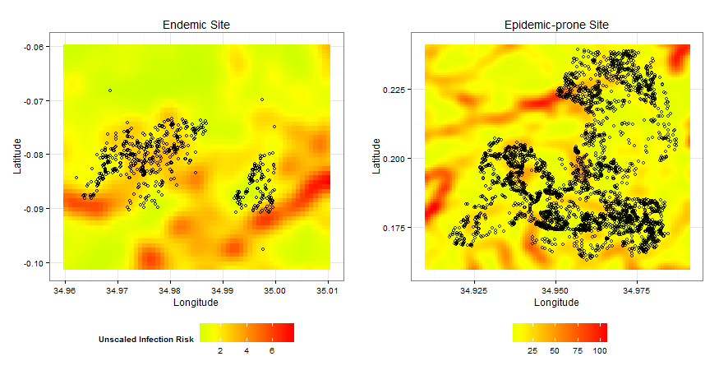
Figure1. Gaussian smoothed (σ=10) infection risk at the endemic and epidemic-prone sites. Dots represent household locations within each site.

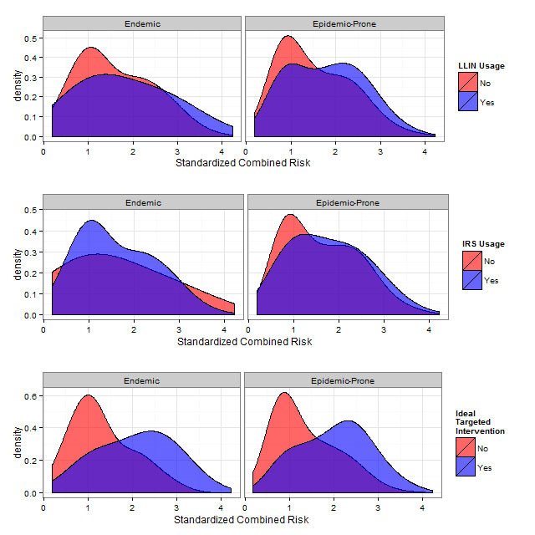
Figure 2. The distributions of combined risk of each household at the endemic and epidemic-prone sites by LLIN and IRS usage. Combined risk is the combination of infection risk and age-based risk and is standardized within a site so that the unit is in standard deviations. Interventions targeted at high-risk households would result in good separation between the two densities as we simulated in the bottom panel. The epidemic-prone site shows better targeting of interventions than the endemic site for both interventions.

* 104 BSE University of Arizona, Tucson, AZ 85721, 520-626-8293, dlaroche@email.arizona.edu

