Audrey Dissertation Analysis

Audrey Nelson

May 12, 2016

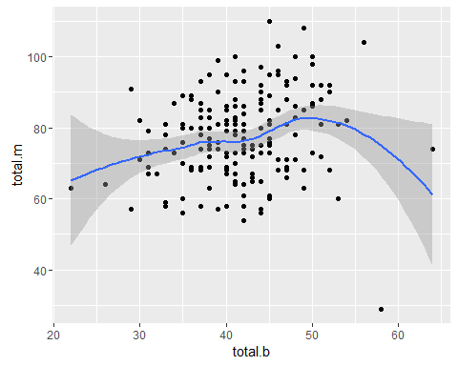

Figure 1. The relationship between the sum of b and the sum of m appears to be linear and positive.

The correlation between the sum of b and the sum of m for each participant is 0.205272.

Table 1: The results of a linear model predicting the sum of m from the sum of b showing a significant positive relationship.

##   
## Call:  
## lm(formula = total.m ~ total.b, data = df.bm.w)  
##   
## Residuals:  
## Min 1Q Median 3Q Max   
## -54.708 -7.348 -0.718 7.652 31.467   
##   
## Coefficients:  
## Estimate Std. Error t value Pr(>|t|)   
## (Intercept) 60.6169 5.6409 10.746 < 2e-16 ***  
## total.b 0.3981 0.1346 2.959 0.00346 **   
## ---  
## Signif. codes: 0 '***' 0.001 '**' 0.01 '*' 0.05 '.' 0.1 ' ' 1  
##   
## Residual standard error: 11.79 on 199 degrees of freedom  
## (1 observation deleted due to missingness)  
## Multiple R-squared: 0.04214, Adjusted R-squared: 0.03732   
## F-statistic: 8.754 on 1 and 199 DF, p-value: 0.003464

```