**Homework 2, CPH 675 Clinical Trials Dominic D LaRoche**

**Due: 6 March 2015**

Data can be downloaded from D2L. For problems which require data analysis, include code only when asked to, and only include relevant output. Excessive output will result in a reduction of points.

1.a) A and B are binary explanatory variables for a continuous outcome y. Use the following linear regression output to fill in the table of means. Write your answers to 1 decimal place.

|  |
| --- |
| Standard  Parameter Estimate Error t Value Pr > |t| 95% Confidence Limits  Intercept 9.883207038 0.28935831 34.16 <.0001 9.314336517 10.452077559  A 6.229226766 0.40921445 15.22 <.0001 5.424722360 7.033731172  B 2.966622263 0.40921445 7.25 <.0001 2.162117857 3.771126669  A*B 1.860241058 0.57871663 3.21 0.0014 0.722500016 2.997982100 |

|  |  |  |  |
| --- | --- | --- | --- |
|  |  | A | |
|  |  | 1 | 0 |
| B | 1 | 17.96 | 12.84 |
| 0 | 16.10 | 9.88 |

b) Consider a two arm RCT with a binary outcome of “positive response”, with output from a logistic regression shown below (on the logit scale). Assume that sex = 0 for males, and sex = 1 for females.

|  |
| --- |
| Analysis of Maximum Likelihood Estimates  Standard Wald  Parameter DF Estimate Error Chi-Square Pr > ChiSq  Intercept 1 -1.2584 0.5198 5.8613 0.0155  sex 1 0.0363 0.0129 7.9379 0.0048  treat 1 2.8267 0.7345 14.8095 0.0001  treat*sex 1 -0.0657 0.0182 13.0749 0.0003 |

i) Is there a heterogeneous treatment effect? Explain briefly.

Yes, there is a significant treatment by sex interaction so the mean treatment effect differs between sexes.

ii) compute the odds ratio treatment effect for men and for women.

The treatment effect for men is 2.8267. Since this is the raw (logit scale) effect from the linear model then the HR is e2.8267=16.9. For women the logit scale treatment effect is 2.8267-0.0657=2.761 and the HR is e2.761=15.8.

2. Use the renal cancer data set and data dictionary, which was taken from Fairclough, 2010. These data are derived from a multicenter phase III trial of 284 advanced renal-cell carcinoma patients, details of which are discussed elsewhere.6 The dataset used here is a random sample of 197 of the 230 patients who were invited to join the QoL sub-study. In addition to survival and disease progression outcomes, quality of life, as measured by the FACT-G (Functional Assessment of Cancer Therapy – General) was assessed. The FACT-G contains sub-scales for physical, emotional, functional and social well-being. We will be considering the Trial Outcome Index (TOI), which is the sum of the physical, functional and symptom scores, scaled to 0-100, with higher values indicating better quality of life. Quality of life was assessed at baseline (time 1) and at three timepoints after baseline.

1. Use t-test to test the difference in the TOI between the two arms at the third time point.

load("renal.Rdata")

t.test(toi~treat,data=renal[which(renal$time==3),])

We get a significant difference (p=0.007) with the control (treat=0) group having higher mean TOI (66.06 vs 58.44)

1. Perform the same tests using an ANCOVA model.

#reshape to wide format to do ANCOVA

renalw<-reshape(renal,v.names="toi",idvar="id",times="time",direction="wide")

m1<-lm(toi.3~toi.1+treat,data=renalw)

summary(m1)

The mean TOI for the treatment group is still estimated to be 7.52 points lower than the control. However, the significance of the difference is now greater (0.004) (even though it is still biased.

1. Summarize your results from a and b in a table and in words.

The (biased) estimates of the difference between the two treatment arms remains unchanged between the simple linear model (t-test) and the ANCOVA including the baseline measurement. However, the precision of the ANCOVA estimate is increased as demonstrated by the lower standard error.

|  |  |  |  |  |  |
| --- | --- | --- | --- | --- | --- |
| Model | Estimated Difference (Treatment - Control) | | SE | 95% Confidence Interval | |
| Univariate | | -7.52 | 2.76 | -2.07 | -13.16 |
| ANCOVA | | -7.52 | 2.54 | -2.49 | -12.54 |

1. Create an informative table of missing data rates of the outcome TOI.

library(BDSS)#my home built package let me know if you would like a copy to reproduce my results

renalw$Treatment<-factor(ifelse(renalw$treat==0,"Control","Treatment"))

renalw$OffReas<-factor(renalw$offreas)

renalw$toimiss.1<-factor(ifelse(is.na(renalw$toi.1),"Yes","No"))

renalw$toimiss.2<-factor(ifelse(is.na(renalw$toi.2),"Yes","No"))

renalw$toimiss.3<-factor(ifelse(is.na(renalw$toi.3),"Yes","No"))

renalw$toimiss.4<-factor(ifelse(is.na(renalw$toi.4),"Yes","No"))

outtab<-SummaryTable(data=renalw,rowvars=c("OffReas",paste("toimiss",1:4,sep=".")),colvar="Treatment",cont.vars=c("toi.1","toi.2","toi.3","toi.4"),output="matrix")

Table1. Number of missing TOI assessments at each time point in the study and the mean TOI at each time point by treatment arm.

|  |  |  |  |  |  |  |  |
| --- | --- | --- | --- | --- | --- | --- | --- |
|  |  | Control | | Treatment | | Total | |
|  |  | N | % | N | % | N | % |
| Missing TOI 1 | No | 97 | 100% | 100 | 100% | 197 | 100% |
|  |  |  |  |  |  |  |  |
| Missing TOI 2 | No | 92 | 94.80% | 86 | 86% | 178 | 90.40% |
|  | Yes | 5 | 5.20% | 14 | 14% | 19 | 9.60% |
|  |  |  |  |  |  |  |  |
| Missing TOI 3 | No | 70 | 72.20% | 61 | 61% | 131 | 66.50% |
|  | Yes | 27 | 27.80% | 39 | 39% | 66 | 33.50% |
|  |  |  |  |  |  |  |  |
| Missing TOI 4 | No | 35 | 36.10% | 30 | 30% | 65 | 33% |
|  | Yes | 62 | 63.90% | 70 | 70% | 132 | 67% |
|  |  |  |  |  |  |  |  |
| TOI 1 Mean (sd) | | 77.4 (13.2) | | 73.6 (14) | | 75.5 (13.7) | |
| TOI 2 Mean (sd) | | 65.8 (14.1) | | 62.2 (17) | | 64.1 (15.6) | |
| TOI 3 Mean (sd) | | 66.1 (14.3) | | 58.4 (17.3) | | 62.5 (16.2) | |
| TOI 4 Mean (sd) | | 66.2 (18) | | 65.9 (16.1) | | 66.1 (17) | |
|  |  |  |  |  |  |  |  |
| Total |  | 97 | 49.20% | 100 | 50.80% | 197 |  |

1. Create a good graph of the mean TOI at each time, by arm, with 95% CI error bars. It is best to use statistical software for this.

for(i in 1:dim(renalw)[1]){

renalw$nmiss[i]<-with(renalw[i,],sum(c(toimiss.1=="Yes",toimiss.2=="Yes",toimiss.3=="Yes",toimiss.4=="Yes")))

}

renall<-reshape(renalw,direction="long")

library(ggplot2)

base<-ggplot(data=renall,aes(x=factor(time),y=toi,group=nmiss))+geom_point(aes(color=factor(nmiss)))+ylab("Mean TOI")+xlab("Time Point")+theme_bw()+scale_colour_manual("Number Missing\nObservations",values=c("purple","blue","red","black"))+geom_jitter(position=position_jitter(width=.1))

base+stat_summary(fun.data = "mean_cl_normal",geom="line")+aes(color=factor(nmiss))

C:\Classes\ClinicalTrials\MissingPlotHW2.emf

3. Use the asthma dataset. This data comes from a crossover study of 13 children with moderate to severe asthma and aims to compare formoterol and salbutamol. The primary outcome is peak expiratory flow (PEF). There was a one day washout between treatments. Is there a difference in PEF between the two medications? Show your code and relevant output. Write your results in a few sentences that would be suitable for a journal.

Code:

library(lme4)#for mixed effect model

#random intercept model for patients

m2<-lmer(pef~trt+(1|pat),data=asm)

summary(m2)

#get conservative p-value since proper df are disputed in mixed effects models

1-pt(q=4.031,df=13)#of course I know you just want the 95% CI

#95% CI on the difference

t95<-qt(p=0.975,df=13)

lower<-m2@beta[2]-(t95*(coef(summary(m2))[, "Std. Error"][2]))

upper<-m2@beta[2]+(t95*(coef(summary(m2))[, "Std. Error"][2]))

Linear mixed model fit by REML ['lmerMod']

m3<-lmer(pef~trt*group+(1|pat),data=asm)

summary(m3)

Output:

Formula: pef ~ trt + (1 | pat)

Data: asm

REML criterion at convergence: 263.8

Scaled residuals:

Min 1Q Median 3Q Max

-1.96265 -0.34165 -0.08402 0.49217 1.48708

Random effects:

Groups Name Variance Std.Dev.

pat (Intercept) 4388.6 66.25

Residual 823.9 28.70

Number of obs: 26, groups: pat, 13

Fixed effects:

Estimate Std. Error t value

(Intercept) 341.15 20.02 17.037

trtsal -45.38 11.26 -4.031

Correlation of Fixed Effects:

(Intr)

trtsal -0.281

Results:

We found a significant difference in PEF between the two treatments (p-value < 0.001). Mean PEF after treatment with salbutamol was 45.4 points lower than after receiving formoterol (95% CI 21.1, 69.7). This represents a clinically meaningful 15% increase in PEF for patients when treated with formoterol versus salbutamol. We did not find any evidence for an effect from the order treatments were administered.

4. Consider the variance for each analytical approach to analyzing a trial with 1 pre-randomization measurement and r post randomization measurements, where  = correlation between pre and post. Assume that allocation is 1:1, so that nA = nB and assume that there is just one post measurement.

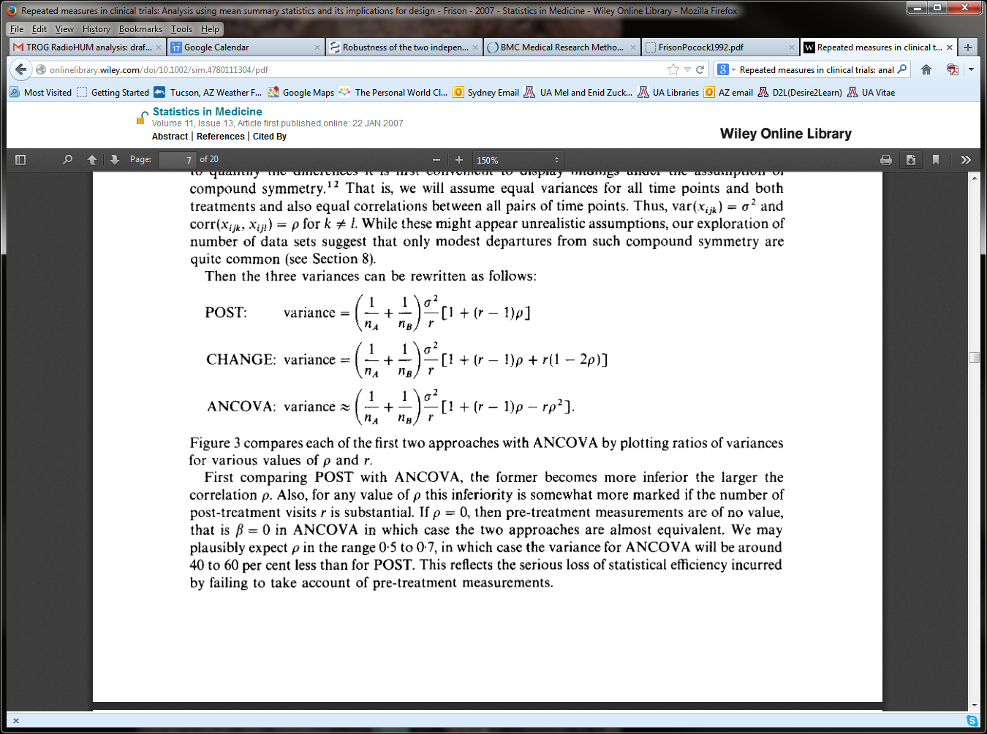

a. When will post be more powerful than change?

The change design will have lower variance than post if the last term is negative, this will occur for any rho > 0.5. Therefore the post design will have smaller variance when rho < 0.5.

b. When will post be more powerful than ANCOVA?

Post will only have lower variance than ANCOVA when rho=0, i.e. when there is absolutely no within subject correlation.

C. Suppose that the correlation between pre and post is 0.6. Compute the relative efficiency (the ratio of sample sizes for a given power) for all pairwise combinations.

For a given power and alternative hypothesis the sample size is entirely, and inversely, dependent on the variance. For Change vs Post we have [1+(1-2*.6)]/1 = 0.8, for ANCOVA vs post we have (1-.62)/1 = 0.64, for Change vs ANCOVA we have [1+(1-2*.6)]/ (1-.62) = 0.8/0.64 = 1.25. From this we can see that ANOCOVA is clearly best when rho=0.6.