A. Spring/Summer

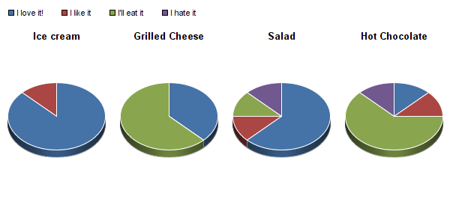

B. Fall/Winter

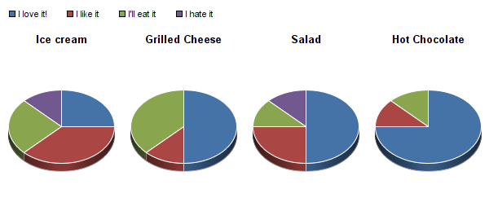

Figure 1. Preferences for 4 food items in either (A) spring and summer or (B) fall and winter. Individuals were asked to give their preferences for each food type in either the spring and summer or fall and winter. Cool foods such as ice cream and salad were generally preferred in the spring and summer whereas warm foods such as grilled cheese and hot chocolate were more preferred in the fall and winter.\*

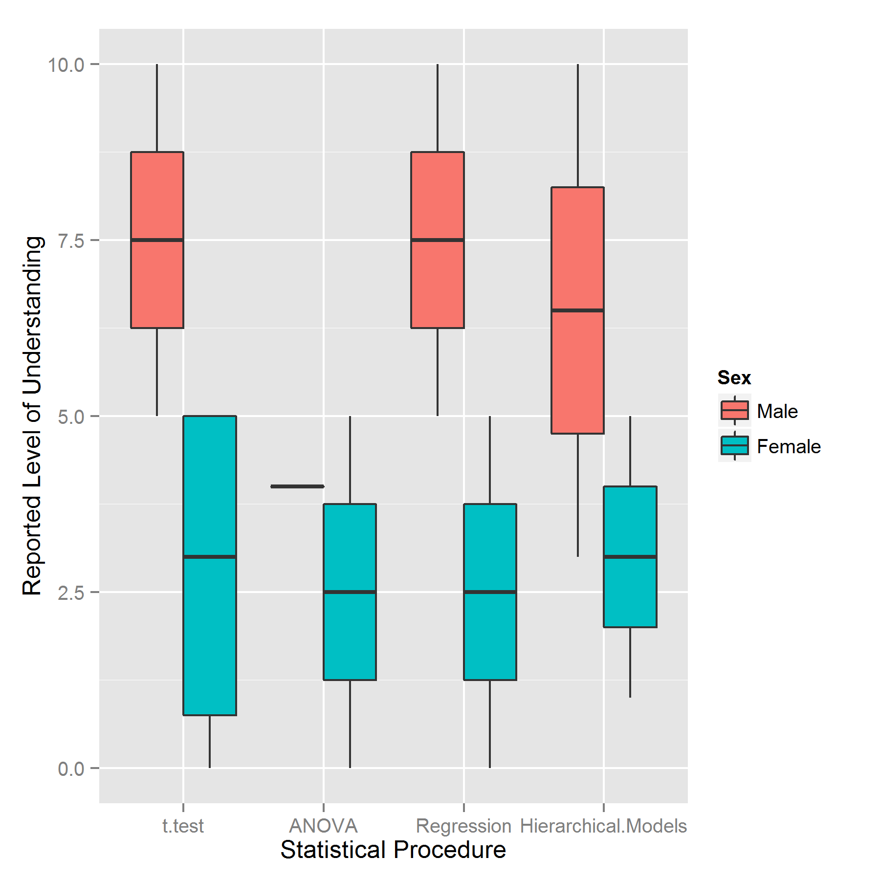

Figure 2. Reported level of understanding of 4 statistical procedures by sex. Individuals were asked to self-report their perceived level of understanding of 4 statistical procedures of varying complexity: 1) t-test, 2) ANOVA, 3) Regression, and 4) Hierarchical models. Males generally reported greater understanding of all four topics.\*

\*No reported differences are statistically significant and should not be treated as representative of the sampled population due to the very small sample size of completed surveys (9).