Lab 5

Dominic LaRoche

Tuesday, October 07, 2014

rm(list=ls())  
library(sp)  
data(meuse)  
coords<-cbind(meuse$x, meuse$y)  
meuse.df<-SpatialPointsDataFrame(coords,meuse)  
bubble(meuse.df,"zinc")

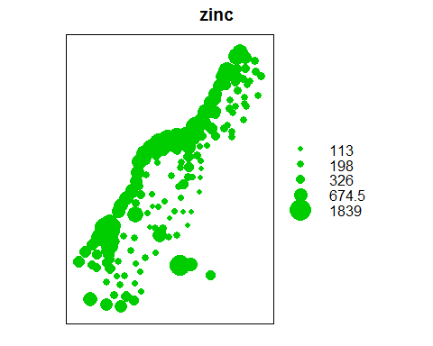

data(meuse.grid)  
meuse.grid$ffreq<-as.factor(meuse.grid$ffreq)  
m.grid.df<-SpatialPixelsDataFrame(points=meuse.grid[c("x","y")],data=meuse.grid)  
pts<-list("sp.points",meuse.df,pch=4,col="white")  
spplot(m.grid.df,"ffreq",col.regions=1:3,sp.layout=list(pts),main="Flooding Frequency and Sampling Points")

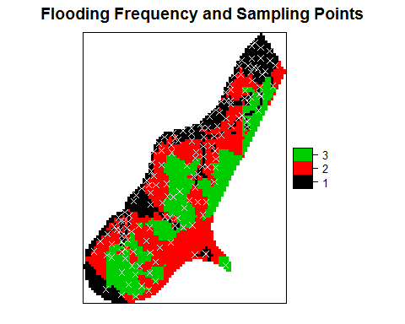

library(gstat)  
#variogram cloud  
cvgm<-variogram(zinc~1,data=meuse.df, width=100, cutoff=1000, cloud=T)  
plot(cvgm,main="Variogram cloud of semivariance in zinc")

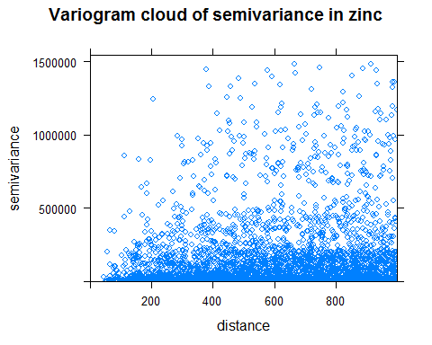

#agregated  
cvgm<-variogram(zinc ~ 1, data=meuse.df, width=100, cutoff=1000)   
plot(cvgm,main="Aggregated variogram of zinc concentrations")

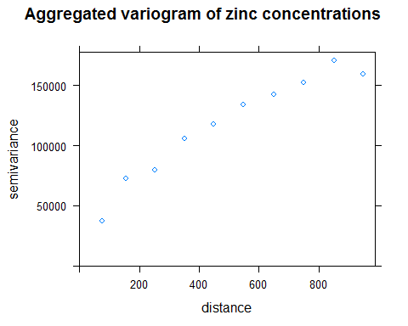

#fit the observation to the theoretical model  
#Use exponential model   
vgm.md<-vgm(psill=1, model='Exp', range =100, nugget=1)   
efitted<-fit.variogram(cvgm, model=vgm.md)   
efitted

## model psill range  
## 1 Nug 15620 0.0  
## 2 Exp 168493 455.9

plot(cvgm, model=efitted)

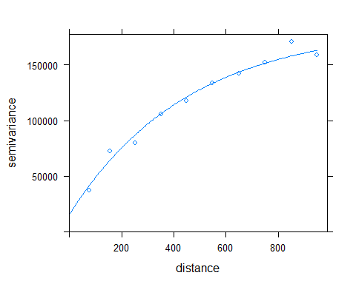

#Using the fitted variogram conduct ordinary Kriging   
#fit ordinary kriging   
OK_fit<-gstat(id='OK_fit', formula=zinc ~ 1, data=meuse.df, model=efitted)   
#cross-validation   
pe<-gstat.cv(OK_fit, nfold=155, debug.level=0, random=FALSE)$residual   
round(sqrt(mean(pe^2)),2)

## [1] 225.9

z<-predict(OK_fit, newdata=m.grid.df, debug.level=0)   
m.grid.df$OK_pred <-z$OK_fit.pred #Kriging prediction   
m.grid.df$OK_se<-sqrt(z$OK_fit.var) #Kriging standard error

#set up the plotting environment  
library(maptools)

## Checking rgeos availability: TRUE

bluepal<-colorRampPalette(c('azure1','steelblue4'))   
brks<-c(0, 130, 155, 195, 250, 330, 450, 630, 890, 1270, 1850)   
cols<-bluepal(length(brks)-1)   
sepal<-colorRampPalette(c('peachpuff1', 'tomato3'))   
brks.se<-c(0, 240, 250, 260, 270, 280, 290, 300, 350, 400, 1000)   
cols.se<-sepal(length(brks.se)-1)   
scols<-c('green', 'red')

The predictions are plotted in the following figure. The kriging predictions appear to capture the pattern of zinc deposition in the floodplain indicated by the bubble plot.

#Plot the Kriging prediction   
image (m.grid.df, 'OK_pred', breaks=brks, col=cols)   
symbols(coordinates(meuse.df), circles=sqrt(abs(pe)), fg='black',   
 bg=scols[(pe<0)+1], inches=FALSE, add=TRUE)   
legend('topleft',fill=cols, legend=leglabs(brks), bty ='n', cex=0.8)

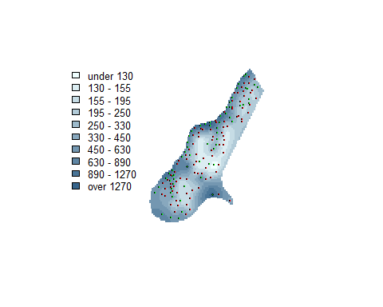

The kriging standard errors increase rapidly with increasing distance from a sample point which produces relatively large areas with very incertain predictions.

#Plot the Kriging standard errors   
image (m.grid.df, 'OK_se', breaks=brks.se, col=cols.se)   
symbols(coordinates(meuse.df), circles=sqrt(abs(pe)), fg='black',   
 bg=scols[(pe<0)+1], inches=FALSE, add=TRUE)   
legend('topleft', fill=cols.se, legend=leglabs(brks.se), bty='n', cex=0.8)

