Quantifying Uncertainty

Quantifying the uncertainty associated with the suite of HSI models that we have developed will be very important as land managers attempt to improve masked bobwhite habitat or find new potential release sites. Multiple sources of uncertainty are associated with each HSI model:

1. Variable selection uncertainty
2. Uncertainty of the suitability functions
3. The structure of the model
   1. Relationships between variables
   2. Importance of variables relative to one another
   3. Latent variables (Food, Reproduction, etc.)
   4. Synergistic effects (interactions among variables)
4. Measurement error of model inputs

We will focus our efforts on the quantification of uncertainty associated with (2) and (3). Understanding this uncertainty will not just help land managers make decisions about habitat management, but will also identify the habitat variables which contain the greatest degree of uncertainty. Understanding the greatest sources of uncertainty will be important for directing future research efforts as well as identifying a suite of alternative release sites that incorporate the range of uncertainty.

Uncertainty of Suitability Relationships

Past efforts to quantify uncertainty in expert opinions typically require the expert to explicitly specify their confidence. Unfortunately, an expert’s confidence in their own knowledge is likely to be a function of many factors, only one of which relates to the precision of their knowledge about the species habitat requirements. We are instead using the complete set of expert opinions to quantify uncertainty in the species habitat models (Fig. 3). Our current method assumes the “true” relationship is spanned by the variation in opinions among our 6 species experts. Therefore, the degree of uncertainty surrounding any suitability function is defined by the entire set of functions across all species experts. We created graphical representations of this uncertainty for each habitat suitability relationship identified by experts. Figure 1 shows the utility of these graphs for identifying habitat variables with considerable uncertainty. The uncertainty represented in these graphs can be measured by integrating over the domain of the relationship to determine the area of each uncertainty estimate. This method allows direct comparison of uncertainty among all habitat-suitability relationships identified by the experts (i.e., it allows us to validly compare different habitat variables with different units of measurement). Table 3 contains an ordered list of the habitat-suitability uncertainties.

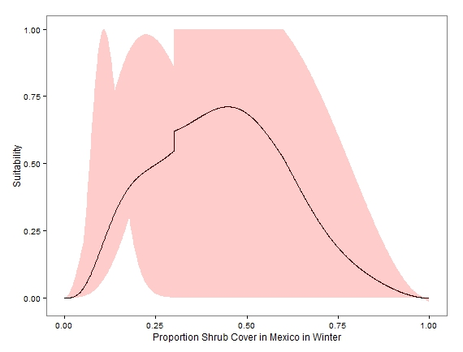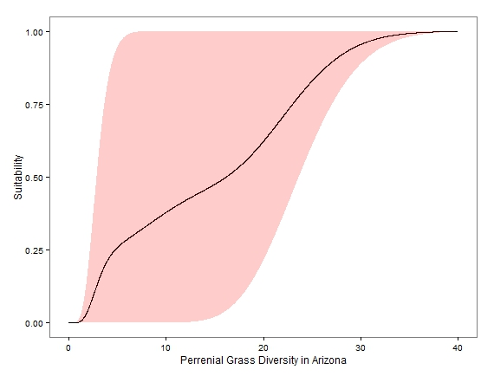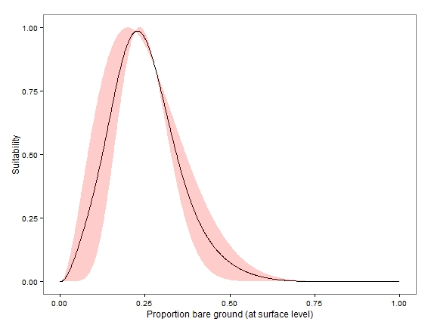

Figure 1. Examples of three habitat-suitability plots with estimates of uncertainty. The black curve represents the mean suitability relationship among all experts and the red band represents the uncertainty associated with the suitability relationship. Uncertainty is measured by the diversity of opinion among experts. The graph on the left shows a great deal of uncertainty whereas the graph on the right shows only a small amount of uncertainty. The middle graph contains a moderate amount of uncertainty but does contain a consensus on an optimal level of grass diversity.

|  |  |  |  |
| --- | --- | --- | --- |
| Habitat Variable | Uncertainty | Habitat Variable | Uncertainty |
| Forb Diversity | 751.4589 |  |  |
| Shrub Cover: MX, Summer | 681.4633 | Annual Grass Diversity, MX | 549.9952 |
| Shrub Cover: MX, Winter | 681.4633 | Annual Grass Diversity, AZ | 549.8661 |
| Forb Height in the Fall | 680.5916 | Forb Height in the Spring | 530.6362 |
| Shrub Cover: AZ, Summer | 669.5275 | Tree Cover: MX, Arroyos, Summer | 527.6743 |
| Tree Cover: MX, Uplands, Winter | 649.679 | Perennial Grass Diversity, MX | 527.2701 |
| Shrub Cover: AZ, Winter | 635.0047 | Perennial Grass Diversity, AZ | 524.865 |
| Tree Cover: AZ, Arroyos, Winter | 632.0208 | Tree Cover: MX, Uplands, Summer | 523.689 |
| Tree Cover: AZ, Uplands, Winter | 603.743 | Tree Cover: AZ, Arroyos, Summer | 522.2229 |
| Perennial Grass Cover, MX | 602.9204 | Grass Height for Nesting | 511.7814 |
| Annual Grass Cover, MX | 601.5158 | Forb Cover: AZ, Winter | 500.3264 |
| Annual Grass Cover, AZ | 592.9706 | Tree Cover: AZ, Uplands, Summer | 480.8542 |
| Perennial Grass Cover, AZ | 587.2909 | Forb Cover: MX, Winter | 466.7073 |
| Tree Cover: MX, Arroyos, Winter | 586.0451 | Forb Cover: MX, Summer | 425.4503 |
| Grass Height for Cover | 557.5849 | Shrub Height | 127.2489 |
| Forb Cover: AZ, Summer | 552.1541 | Proportion of Bare Ground | 125.2965 |

Table 3. Estimates of uncertainty associated with each habitat-suitability relationship. Estimates are ordered from highest (most uncertainty) to lowest (least uncertainty). Estimates are obtained by calculating the area of the uncertainty bands associated with each habitat-suitability relationship (Figure 1). Uncertainty estimates are standardized for all variables to control for differences among variables in measurements units and scale.