Dominic LaRoche

10/27/14

CPH576D- Assignment 7

**Introduction**

This report summarizes data on 36,296 emergency room visits in 2004. The primary objectives of this report are to determine:

1. if there are monthly, or quarterly, differences in the number of ER visits,
2. if there are differences in the number of visits for the days of the week,
3. if female patients wait longer than male patients,
4. if non-white patients wait longer than white patients,
5. if Medicare or Medicaid patients wait longer than privately insured patients,
6. the number of visits for different times of the day and modes of arrival,
7. if the pain level of night arriving patients is different than those that arrive in the day,
8. and to determine the distribution of ER patient temperatures.

**Results**

I found a significant difference in the number of ER visits by quarter (p-value < 0.001), by month (p-value <0.001), and by day of the week (p-value < 0.001). Quarter 2 received a higher proportion of visits than quarters 1, 3, and 4 (fig. 1). This corresponded to a higher than expected number of ER visits in the spring months (fig. 2). There was also a higher number of expected visits in the late fall months. As might be expected, the number of ER visits was higher on Saturday and Sunday (fig. 3). Monday also received a higher than expected number of visits and this may be due to early morning ER visits carrying over from the weekend.

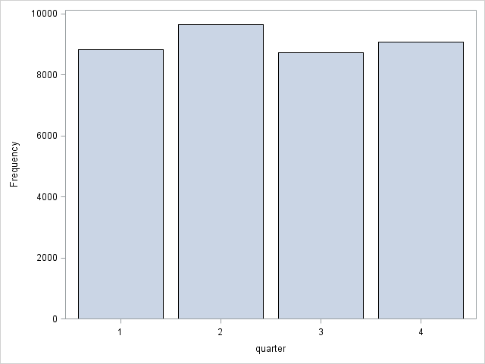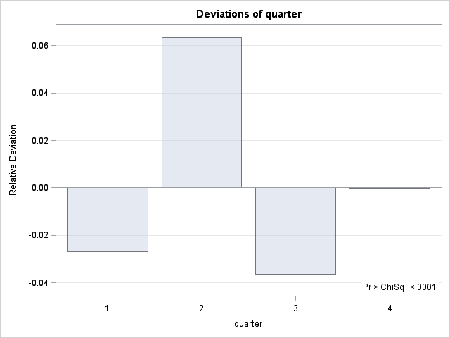

Figure 1. Frequencies and relative deviations from the expected number of ER visits for each quarter.

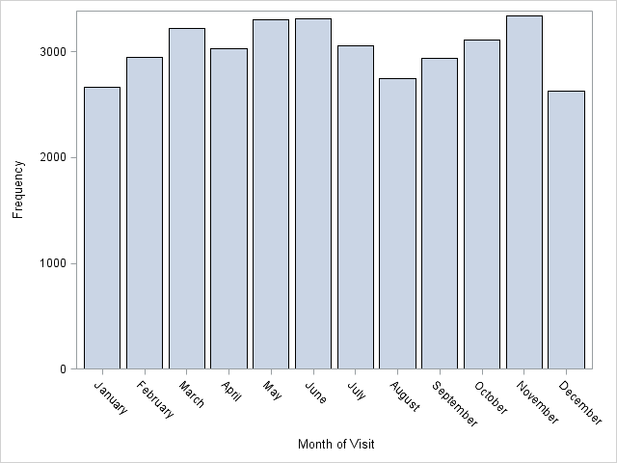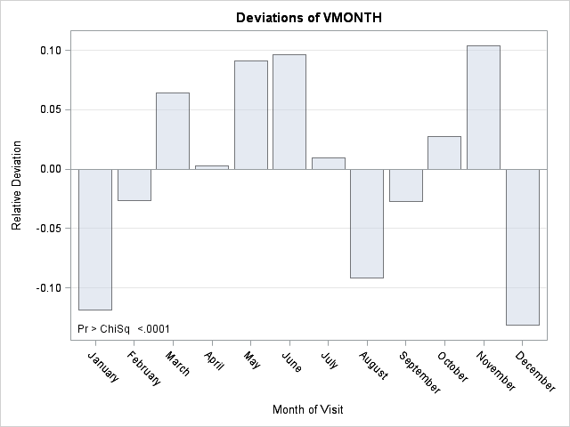

Figure 2. frequencies and relative deviations in the expected number of ER visits by month.

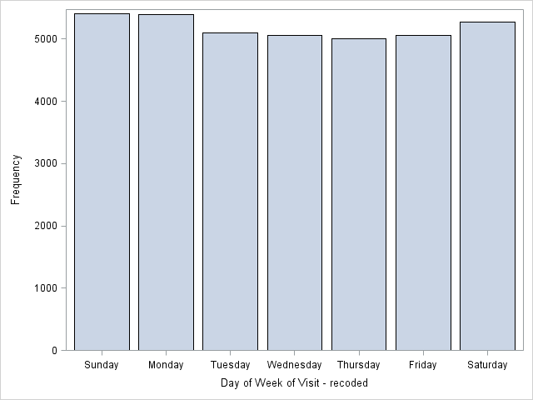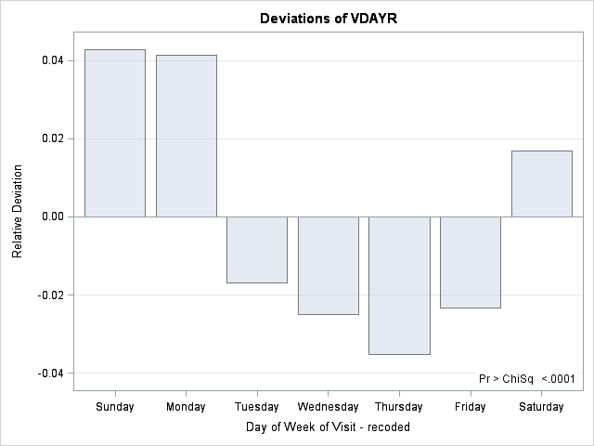

Figure 3. Relative deviations from the expected number of ER visits by day of the week.

Waiting times had a strong right skew so I made all comparisons of waiting times on the log-transformed variable. Data were not strictly normal after transformation but large sample theory applies for this data set so p-values considered accurate. Females waited 2.83 minutes longer than males (p-value < 0.001) and non-whites waited 8.98 minutes longer than whites (p-value < 0.001). Patients with Medicare or Medicaid waited 2.35 minutes longer than those with private insurance (p-value < 0.001).

The number of visits at different times of the day are shown in table 1. The mode arrival for the different times of the day is given in table 2.

| **10pm to 6am** | | | | |
| --- | --- | --- | --- | --- |
| **Arrival Time** | **Frequency** | **Percent** | **Cumulative Frequency** | **Cumulative Percent** |
| **10pm to 6am** | 6830 | 18.82 | 6830 | 18.82 |
| **Other Times** | 29038 | 80.00 | 35868 | 98.82 |
| **Missing** | 428 | 1.18 | 36296 | 100.00 |

Table 1. Number of visits at night and during the day.

| **arr2(Arrival Time)** | **ARRIVE(Mode of Arrival)** | | | | | |
| --- | --- | --- | --- | --- | --- | --- |
| **Blank** | **Ambulance** | **Public service** | **Walk-in** | **Unknown** | **Total** |
| **midnight to 6am** | |  | | --- | | 56 | | 0.15 | | 1.44 | | 7.32 | | |  | | --- | | 783 | | 2.16 | | 20.15 | | 13.73 | | |  | | --- | | 119 | | 0.33 | | 3.06 | | 16.39 | | |  | | --- | | 2851 | | 7.85 | | 73.37 | | 10.05 | | |  | | --- | | 77 | | 0.21 | | 1.98 | | 10.35 | | |  | | --- | | 3886 | | 10.71 | |  | |  | |
| **6am to midnight** | |  | | --- | | 140 | | 0.39 | | 1.58 | | 18.30 | | |  | | --- | | 1398 | | 3.85 | | 15.80 | | 24.52 | | |  | | --- | | 164 | | 0.45 | | 1.85 | | 22.59 | | |  | | --- | | 6970 | | 19.20 | | 78.77 | | 24.58 | | |  | | --- | | 176 | | 0.48 | | 1.99 | | 23.66 | | |  | | --- | | 8848 | | 24.38 | |  | |  | |
| **noon to 6pm** | |  | | --- | | 195 | | 0.54 | | 1.60 | | 25.49 | | |  | | --- | | 1840 | | 5.07 | | 15.08 | | 32.28 | | |  | | --- | | 226 | | 0.62 | | 1.85 | | 31.13 | | |  | | --- | | 9667 | | 26.63 | | 79.24 | | 34.09 | | |  | | --- | | 271 | | 0.75 | | 2.22 | | 36.42 | | |  | | --- | | 12199 | | 33.61 | |  | |  | |
| **6pm to midnight** | |  | | --- | | 159 | | 0.44 | | 1.45 | | 20.78 | | |  | | --- | | 1653 | | 4.55 | | 15.12 | | 28.99 | | |  | | --- | | 215 | | 0.59 | | 1.97 | | 29.61 | | |  | | --- | | 8700 | | 23.97 | | 79.56 | | 30.68 | | |  | | --- | | 208 | | 0.57 | | 1.90 | | 27.96 | | |  | | --- | | 10935 | | 30.13 | |  | |  | |
| **Missing** | |  | | --- | | 215 | | 0.59 | | 50.23 | | 28.10 | | |  | | --- | | 27 | | 0.07 | | 6.31 | | 0.47 | | |  | | --- | | 2 | | 0.01 | | 0.47 | | 0.28 | | |  | | --- | | 172 | | 0.47 | | 40.19 | | 0.61 | | |  | | --- | | 12 | | 0.03 | | 2.80 | | 1.61 | | |  | | --- | | 428 | | 1.18 | |  | |  | |
| **Total** | |  | | --- | | 765 | | 2.11 | | |  | | --- | | 5701 | | 15.71 | | |  | | --- | | 726 | | 2.00 | | |  | | --- | | 28360 | | 78.14 | | |  | | --- | | 744 | | 2.05 | | |  | | --- | | 36296 | | 100.00 | |

Table 2. Comparison of modes of arrival for each time period in the day. Numbers given vertically for each cell are ( in descent) frequency, percent, row percent, and column percent.

Pain level of patients entering the ER is given as a 5 point scale with only 4 points representing non-missing data. Therefore, I used a nonparametric test (namely the Wilcoxon rank sum test) to determine a difference in pain levels among patients arriving by day or by night. There was no difference pain between day-arriving vs night-arriving patients (p-value = 0.347).

The distribution of patient temperatures is shown in figure 4. One case with an exceptionally low temperature was removed prior to plotting.

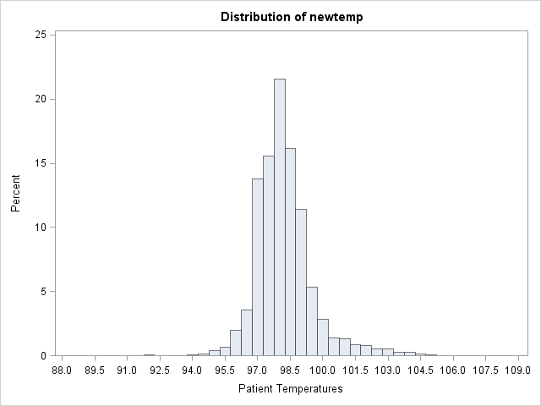

Figure 4. Distribution of patient temperatures.

**Discussion**

Although there are several significant differences among patient populations the effects sizes are relatively small and may represent clinically relevant differences.

**SAS Code:**

**proc** **format**;

value mnth_fmt

**01** = 'January'

**02** = 'February'

**03** = 'March'

**04** = 'April'

**05** = 'May'

**06** = 'June'

**07** = 'July'

**08** = 'August'

**09** = 'September'

**10** = 'October'

**11** = 'November'

**12** = 'December';

value day_fmt

**1**='Sunday'

**2**='Monday'

**3**='Tuesday'

**4**='Wednesday'

**5**='Thursday'

**6**='Friday'

**7**='Saturday';

value wait_fmt

**999** ='Unknown';

value lov_fmt

**9999**='Unknown';

value by_fmt

**0** = 'Blank'

**1** = 'Yes'

**2** = 'No'

**3** = 'Unknown';

value sex_fmt

**1** = 'Female'

**2** = 'Male';

value eth_fmt

**0** = 'Blank'

**1** = 'Hispanic or Latino'

**2** = 'Not Hispanic or Latino';

value arrive_fmt

**0** = 'Blank'

**1** = 'Ambulance'

**2** ='Public service'

**3** ='Walk-in'

**4** ='Unknown';

value race_fmt

**1** ='White only'

**2** ='Black/African American only'

**3** ='Asian only'

**4** ='Native Hawaiian/Oth Pac Isl only'

**5** ='American Indian/Alaska Native only'

**6** ='More than one race reported';

value pay_fmt

**0** ='Blank'

**1** ='Private insurance'

**2** ='Medicare'

**3** ='Medicaid'

**4** ="Worker's compensation"

**5** ='Self-pay'

**6** ='No charge'

**7** ='Other'

**8** ='Unknown';

value pain_fmt

**0** ='No box is marked'

**1** ='Unknown'

**2** ='None'

**3** ='Mild'

**4** ='Moderate'

**5** ='Severe';

value atime_fmt

**9999** = ''

**1800** - < **2400** = '6pm to midnight'

**0000** - < **600** = 'midnight to 6am'

**600** - < **1200** = '6am to midnight'

**1200** - < **1800** = 'noon to 6pm';

**run**;

**data** er;

set class.test_er;

label vmonth = 'Month of Visit'

VYEAR ='Year of Visit'

vdayr = 'Day of Week of Visit - recoded'

age = 'Patient age in years'

arrtime = 'Arrival time (military time)'

waittime = 'Waiting time to see physician (minutes)'

lov = 'Length of visit (minutes)'

reside = 'Does patient reside in nursing home?'

sex = 'Patient Sex'

ethnic = 'Patient Ethnicity'

arrive = 'Mode of Arrival'

race = 'Patient Race'

paytype = 'Expected source of payment for this visit'

tempf = 'Initial temperature (F)'

pulse = 'Pulse (beats/min)'

pain = 'Pain at admission';

format vmonth mnth_fmt.

vdayr day_fmt.

waittime wait_fmt.

lov lov_fmt.

reside by_fmt.

sex sex_fmt.

ethnic eth_fmt.

arrive arrive_fmt.

race race_fmt.

paytype pay_fmt.

pain pain_fmt.;

run;

**data** er;

set er;

if vyear ne **2004** then delete;

if vmonth in(**1**, **2**, **3**) then quarter = **1**;

if vmonth in(**4**, **5**, **6**) then quarter = **2**;

if vmonth in(**7**, **8**, **9**) then quarter = **3**;

if vmonth in(**10**, **11**, **12**) then quarter = **4**;

run;

**proc** **freq** data = er;

table vmonth quarter /nocum chisq;

**run**;

**proc** **freq** data = er;

table vdayr/ nocum chisq;

**run**;

**proc** **sgplot** data = er;

vbar vmonth ;

**run**;

**proc** **sgplot** data = er;

vbar quarter;

**run**;

/* there does not appear to be a difference in visits by month or quarter*/

**proc** **sgplot** data = er;

vbar vdayr;

**run**;

/* check distribution of waiting times */

**proc** **univariate** data =er;

var waittime;

histogram;

**run**;

/* Strong right skew so make new transformed variable */

**data** er;

set er;

/*change arrival time to numeric*/

arr2 = input(arrtime,**4.**);

/*set up 10-6 variable*/

ten_to_six = **0**;

if waittime ne **999** then lwait = log(waittime+**1**);

if paytype in(**2**,**3**) then medic = **1**;

if paytype in(**1**,**4**,**5**,**6**,**7**) then medic = **0**;

if (**2159** < arr2 <= **2400**)or(**0** <= arr2 < **601**) then ten_to_six = **1**;

run;

/*Check transformation*/

**proc** **univariate** data =er;

var lwait;

histogram;

**run**;

/*Looks OK but not perfect*/

**proc** **ttest** data =er;

var lwait;

class sex;

**run**;

/* QQplots not great but we can rely on CLT for test validity*/

**proc** **format**;

value race2_fmt

**1** = 'White'

**2**-**6** = 'Non-White';

**run**;

/*Test white vs Non-white*/

**proc** **ttest** data =er;

label lwait = 'Log Waiting Time';

label race = 'White vs Non-White';

format race race2_fmt.;

var lwait;

class race;

**run**;

**proc** **format**;

value paytype2_fmt

**0** - **1** = 'Other'

**2** - **3** = 'Medicare/Medicaid'

**4** - **7** = 'Other';

**run**;

**data** ernew;

set er;

if paytype = **8** then delete;

run;

/*Test medicare/medicaid vs other */

**proc** **ttest** data =ernew;

label lwait = 'Log Waiting Time';

label paytype = 'Medicare/Medicare vs Other Pay Types';

format paytype paytype2_fmt.;

var lwait;

class paytype;

**run**;

**proc** **format**;

value atime2_fmt

**600** - <**2200** = 'Other Times'

**2200** - **2400** = '10pm to 6am'

**0** - <**600** = '10pm to 6am'

**9999** = 'Missing';

**run**;

**proc** **freq** data = er;

label arr2 = '10pm to 6am';

format arr2 atime2_fmt.;

table arr2;

**run**;

/*Use format included above for continuous arrival time variable*/

**proc** **freq** data=er;

label arr2 = 'Arrival Time';

format arr2 atime_fmt.;

table arr2*arrive;

**run**;

**proc** **univariate** data=er;

var pain;

histogram;

**run**;

**proc** **sgplot** data=er;

vbar pain;

**run**;

**proc** **format**;

value atime3_fmt

**600** - <**1800** = 'Day'

**1800** - **2400** = 'Night'

**0** - <**600** = 'Night'

**9999** = '';

**run**;

/*Remove missing arrival time records for Wilcoxon test*/

**data** erpain;

set er;

if arr2 = **9999** then delete;

run;

/*Since the pain variable is ordinal I will use a wilcoxon test for the difference*/

**proc** **npar1way** wilcoxon data=erpain;

where pain > **1**;

label arr2 = 'Night vs Day';

label pain = 'Reported Pain';

format arr2 atime3_fmt.;

class arr2;

var pain;

**run**;

/*Distribution of temperature for patients entering ER*/

**proc** **univariate** data = er;

var tempf;

histogram;

**run**;

/*Outlier needs to be removed and temp needs to be divided by 10*/

**data** er;

set er;

/*set 0 to missing and remove outlier*/

if tempf > **100** then newtemp = tempf/**10**;

run;

**proc** **univariate** data = er;

label newtemp = 'Patient Temperatures';

var newtemp;

histogram;

**run**;

**proc** **means** data = er;

format race race2_fmt.;

where waittime ne **999**;

var waittime;

class race;

**run**;

**proc** **means** data = er;

where waittime ne **999**;

var waittime;

class sex;

**run**;

**proc** **means** data =ernew;

where waittime ne **999**;

label lwait = 'Log Waiting Time';

label paytype = 'Medicare/Medicare vs Other Pay Types';

format paytype paytype2_fmt.;

var waittime;

class paytype;

**run**;

**SAS Log:**

943 proc format;

944 value mnth_fmt

945 01 = 'January'

946 02 = 'February'

947 03 = 'March'

948 04 = 'April'

949 05 = 'May'

950 06 = 'June'

951 07 = 'July'

952 08 = 'August'

953 09 = 'September'

954 10 = 'October'

955 11 = 'November'

956 12 = 'December';

NOTE: Format MNTH_FMT is already on the library.

NOTE: Format MNTH_FMT has been output.

957 value day_fmt

958 1='Sunday'

959 2='Monday'

960 3='Tuesday'

961 4='Wednesday'

962 5='Thursday'

963 6='Friday'

964 7='Saturday';

NOTE: Format DAY_FMT is already on the library.

NOTE: Format DAY_FMT has been output.

965 value wait_fmt

966 999 ='Unknown';

NOTE: Format WAIT_FMT is already on the library.

NOTE: Format WAIT_FMT has been output.

967 value lov_fmt

968 9999='Unknown';

NOTE: Format LOV_FMT is already on the library.

NOTE: Format LOV_FMT has been output.

969 value by_fmt

970 0 = 'Blank'

971 1 = 'Yes'

972 2 = 'No'

973 3 = 'Unknown';

NOTE: Format BY_FMT is already on the library.

NOTE: Format BY_FMT has been output.

974 value sex_fmt

975 1 = 'Female'

976 2 = 'Male';

NOTE: Format SEX_FMT is already on the library.

NOTE: Format SEX_FMT has been output.

977 value eth_fmt

978 0 = 'Blank'

979 1 = 'Hispanic or Latino'

980 2 = 'Not Hispanic or Latino';

NOTE: Format ETH_FMT is already on the library.

NOTE: Format ETH_FMT has been output.

981 value arrive_fmt

982 0 = 'Blank'

983 1 = 'Ambulance'

984 2 ='Public service'

985 3 ='Walk-in'

986 4 ='Unknown';

NOTE: Format ARRIVE_FMT is already on the library.

NOTE: Format ARRIVE_FMT has been output.

987 value race_fmt

988 1 ='White only'

989 2 ='Black/African American only'

990 3 ='Asian only'

991 4 ='Native Hawaiian/Oth Pac Isl only'

992 5 ='American Indian/Alaska Native only'

993 6 ='More than one race reported';

NOTE: Format RACE_FMT is already on the library.

NOTE: Format RACE_FMT has been output.

994 value pay_fmt

995 0 ='Blank'

996 1 ='Private insurance'

997 2 ='Medicare'

998 3 ='Medicaid'

999 4 ="Worker's compensation"

1000 5 ='Self-pay'

1001 6 ='No charge'

1002 7 ='Other'

1003 8 ='Unknown';

NOTE: Format PAY_FMT is already on the library.

NOTE: Format PAY_FMT has been output.

1004 value pain_fmt

1005 0 ='No box is marked'

1006 1 ='Unknown'

1007 2 ='None'

1008 3 ='Mild'

1009 4 ='Moderate'

1010 5 ='Severe';

NOTE: Format PAIN_FMT is already on the library.

NOTE: Format PAIN_FMT has been output.

1011 value atime_fmt

1012 9999 = ''

1013 1800 - < 2400 = '6pm to midnight'

1014 0000 - < 600 = 'midnight to 6am'

1015 600 - < 1200 = '6am to midnight'

1016 1200 - < 1800 = 'noon to 6pm';

NOTE: Format ATIME_FMT is already on the library.

NOTE: Format ATIME_FMT has been output.

1017 run;

NOTE: PROCEDURE FORMAT used (Total process time):

real time 0.05 seconds

cpu time 0.04 seconds

1018

1019 data er;

1020 set class.test_er;

1021 label vmonth = 'Month of Visit'

1022 VYEAR ='Year of Visit'

1023 vdayr = 'Day of Week of Visit - recoded'

1024 age = 'Patient age in years'

1025 arrtime = 'Arrival time (military time)'

1026 waittime = 'Waiting time to see physician (minutes)'

1027 lov = 'Length of visit (minutes)'

1028 reside = 'Does patient reside in nursing home?'

1029 sex = 'Patient Sex'

1030 ethnic = 'Patient Ethnicity'

1031 arrive = 'Mode of Arrival'

1032 race = 'Patient Race'

1033 paytype = 'Expected source of payment for this visit'

1034 tempf = 'Initial temperature (F)'

1035 pulse = 'Pulse (beats/min)'

1036 pain = 'Pain at admission';

1037 format vmonth mnth_fmt.

1038 vdayr day_fmt.

1039 waittime wait_fmt.

1040 lov lov_fmt.

1041 reside by_fmt.

1042 sex sex_fmt.

1043 ethnic eth_fmt.

1044 arrive arrive_fmt.

1045 race race_fmt.

1046 paytype pay_fmt.

1047 pain pain_fmt.;

1048 run;

NOTE: There were 36589 observations read from the data set CLASS.TEST_ER.

NOTE: The data set WORK.ER has 36589 observations and 20 variables.

NOTE: DATA statement used (Total process time):

real time 0.05 seconds

cpu time 0.06 seconds

1049

1050 data er;

1051 set er;

1052 if vyear ne 2004 then delete;

1053 if vmonth in(1, 2, 3) then quarter = 1;

1054 if vmonth in(4, 5, 6) then quarter = 2;

1055 if vmonth in(7, 8, 9) then quarter = 3;

1056 if vmonth in(10, 11, 12) then quarter = 4;

1057 run;

NOTE: There were 36589 observations read from the data set WORK.ER.

NOTE: The data set WORK.ER has 36296 observations and 21 variables.

NOTE: DATA statement used (Total process time):

real time 0.03 seconds

cpu time 0.03 seconds

1058

1059 proc freq data = er;

1060 table vmonth quarter /nocum chisq;

1061 run;

NOTE: Writing HTML Body file: sashtml3.htm

NOTE: There were 36296 observations read from the data set WORK.ER.

NOTE: PROCEDURE FREQ used (Total process time):

real time 1.67 seconds

cpu time 1.23 seconds

1062 proc freq data = er;

1063 table vdayr/ nocum chisq;

1064 run;

NOTE: There were 36296 observations read from the data set WORK.ER.

NOTE: PROCEDURE FREQ used (Total process time):

real time 0.14 seconds

cpu time 0.06 seconds

1065

1066 proc sgplot data = er;

1067 vbar vmonth ;

1068 run;

WARNING: SASUSER.TEMPLAT is not a template store! It will be ignored.

NOTE: PROCEDURE SGPLOT used (Total process time):

real time 0.14 seconds

cpu time 0.06 seconds

NOTE: There were 36296 observations read from the data set WORK.ER.

1069 proc sgplot data = er;

1070 vbar quarter;

1071 run;

NOTE: Since no format is assigned, the numeric category variable will use the default of BEST6.

WARNING: SASUSER.TEMPLAT is not a template store! It will be ignored.

NOTE: PROCEDURE SGPLOT used (Total process time):

real time 0.14 seconds

cpu time 0.06 seconds

NOTE: There were 36296 observations read from the data set WORK.ER.

1072 /* there does not appear to be a difference in visits by month or quarter*/

1073

1074 proc sgplot data = er;

1075 vbar vdayr;

1076 run;

WARNING: SASUSER.TEMPLAT is not a template store! It will be ignored.

NOTE: PROCEDURE SGPLOT used (Total process time):

real time 0.15 seconds

cpu time 0.06 seconds

NOTE: There were 36296 observations read from the data set WORK.ER.

1077

1078 /* check distribution of waiting times */

1079 proc univariate data =er;

1080 var waittime;

1081 histogram;

1082 run;

NOTE: PROCEDURE UNIVARIATE used (Total process time):

real time 0.18 seconds

cpu time 0.11 seconds

1083 /* Strong right skew so make new transformed variable */

1084 data er;

1085 set er;

1086 /*change arrival time to numeric*/

1087 arr2 = input(arrtime,4.);

1088 /*set up 10-6 variable*/

1089 ten_to_six = 0;

1090 if waittime ne 999 then lwait = log(waittime+1);

1091 if paytype in(2,3) then medic = 1;

1092 if paytype in(1,4,5,6,7) then medic = 0;

1093 if (2159 < arr2 <= 2400)or(0 <= arr2 < 601) then ten_to_six = 1;

1094 run;

NOTE: There were 36296 observations read from the data set WORK.ER.

NOTE: The data set WORK.ER has 36296 observations and 25 variables.

NOTE: DATA statement used (Total process time):

real time 0.03 seconds

cpu time 0.03 seconds

1095

1096 /*Check transformation*/

1097 proc univariate data =er;

1098 var lwait;

1099 histogram;

1100 run;

NOTE: PROCEDURE UNIVARIATE used (Total process time):

real time 0.18 seconds

cpu time 0.07 seconds

1101 /*Looks OK but not perfect*/

1102 proc ttest data =er;

1103 var lwait;

1104 class sex;

1105 run;

NOTE: PROCEDURE TTEST used (Total process time):

real time 1.28 seconds

cpu time 0.98 seconds

1106 /* QQplots not great but we can rely on CLT for test validity*/

1107 proc format;

1108 value race2_fmt

1109 1 = 'White'

1110 2-6 = 'Non-White';

NOTE: Format RACE2_FMT is already on the library.

NOTE: Format RACE2_FMT has been output.

1111 run;

NOTE: PROCEDURE FORMAT used (Total process time):

real time 0.00 seconds

cpu time 0.00 seconds

1112 /*Test white vs Non-white*/

1113 proc ttest data =er;

1114 label lwait = 'Log Waiting Time';

1115 label race = 'White vs Non-White';

1116 format race race2_fmt.;

1117 var lwait;

1118 class race;

1119 run;

NOTE: PROCEDURE TTEST used (Total process time):

real time 1.49 seconds

cpu time 1.04 seconds

1120

1121 proc format;

1122 value paytype2_fmt

1123 0 - 1 = 'Other'

1124 2 - 3 = 'Medicare/Medicaid'

1125 4 - 7 = 'Other';

NOTE: Format PAYTYPE2_FMT is already on the library.

NOTE: Format PAYTYPE2_FMT has been output.

1126 run;

NOTE: PROCEDURE FORMAT used (Total process time):

real time 0.00 seconds

cpu time 0.01 seconds

1127

1128 data ernew;

1129 set er;

1130 if paytype = 8 then delete;

1131 run;

NOTE: There were 36296 observations read from the data set WORK.ER.

NOTE: The data set WORK.ERNEW has 34635 observations and 25 variables.

NOTE: DATA statement used (Total process time):

real time 0.03 seconds

cpu time 0.03 seconds

1132 /*Test medicare/medicaid vs other */

1133 proc ttest data =ernew;

1134 label lwait = 'Log Waiting Time';

1135 label paytype = 'Medicare/Medicare vs Other Pay Types';

1136 format paytype paytype2_fmt.;

1137 var lwait;

1138 class paytype;

1139 run;

NOTE: PROCEDURE TTEST used (Total process time):

real time 1.24 seconds

cpu time 0.95 seconds

1140

1141 proc format;

1142 value atime2_fmt

1143 600 - <2200 = 'Other Times'

1144 2200 - 2400 = '10pm to 6am'

1145 0 - <600 = '10pm to 6am'

1146 9999 = 'Missing';

NOTE: Format ATIME2_FMT is already on the library.

NOTE: Format ATIME2_FMT has been output.

1147 run;

NOTE: PROCEDURE FORMAT used (Total process time):

real time 0.00 seconds

cpu time 0.00 seconds

1148

1149 proc freq data = er;

1150 label arr2 = '10pm to 6am';

1151 format arr2 atime2_fmt.;

1152 table arr2;

1153 run;

NOTE: There were 36296 observations read from the data set WORK.ER.

NOTE: PROCEDURE FREQ used (Total process time):

real time 0.02 seconds

cpu time 0.01 seconds

1154

1155 /*Use format included above for continuous arrival time variable*/

1156 proc freq data=er;

1157 label arr2 = 'Arrival Time';

1158 format arr2 atime_fmt.;

1159 table arr2*arrive;

1160 run;

NOTE: There were 36296 observations read from the data set WORK.ER.

NOTE: PROCEDURE FREQ used (Total process time):

real time 0.03 seconds

cpu time 0.03 seconds

1161

1162 proc univariate data=er;

1163 var pain;

1164 histogram;

1165 run;

NOTE: PROCEDURE UNIVARIATE used (Total process time):

real time 0.19 seconds

cpu time 0.07 seconds

1166

1167 proc sgplot data=er;

1168 vbar pain;

1169 run;

WARNING: SASUSER.TEMPLAT is not a template store! It will be ignored.

NOTE: PROCEDURE SGPLOT used (Total process time):

real time 0.14 seconds

cpu time 0.03 seconds

NOTE: There were 36296 observations read from the data set WORK.ER.

1170

1171 proc format;

1172 value atime3_fmt

1173 600 - <1800 = 'Day'

1174 1800 - 2400 = 'Night'

1175 0 - <600 = 'Night'

1176 9999 = '';

NOTE: Format ATIME3_FMT is already on the library.

NOTE: Format ATIME3_FMT has been output.

1177 run;

NOTE: PROCEDURE FORMAT used (Total process time):

real time 0.00 seconds

cpu time 0.00 seconds

1178 /*Remove missing arrival time records for Wilcoxon test*/

1179 data erpain;

1180 set er;

1181 if arr2 = 9999 then delete;

1182 run;

NOTE: There were 36296 observations read from the data set WORK.ER.

NOTE: The data set WORK.ERPAIN has 35868 observations and 25 variables.

NOTE: DATA statement used (Total process time):

real time 0.04 seconds

cpu time 0.04 seconds

1183

1184 /*Since the pain variable is ordinal I will use a wilcoxon test for the difference*/

1185 proc npar1way wilcoxon data=erpain;

1186 where pain > 1;

1187 label arr2 = 'Night vs Day';

1188 label pain = 'Reported Pain';

1189 format arr2 atime3_fmt.;

1190 class arr2;

1191 var pain;

1192 run;

NOTE: There were 25458 observations read from the data set WORK.ERPAIN.

WHERE pain>1;

NOTE: PROCEDURE NPAR1WAY used (Total process time):

real time 0.17 seconds

cpu time 0.06 seconds

1193

1194

1195 /*Distribution of temperature for patients entering ER*/

1196 proc univariate data = er;

1197 var tempf;

1198 histogram;

1199 run;

NOTE: PROCEDURE UNIVARIATE used (Total process time):

real time 0.21 seconds

cpu time 0.11 seconds

1200

1201 /*Outlier needs to be removed and temp needs to be divided by 10*/

1202 data er;

1203 set er;

1204 /*set 0 to missing and remove outlier*/

1205 if tempf > 100 then newtemp = tempf/10;

1206 run;

NOTE: There were 36296 observations read from the data set WORK.ER.

NOTE: The data set WORK.ER has 36296 observations and 26 variables.

NOTE: DATA statement used (Total process time):

real time 0.03 seconds

cpu time 0.03 seconds

1207

1208 proc univariate data = er;

1209 label newtemp = 'Patient Temperatures';

1210 var newtemp;

1211 histogram;

1212 run;

NOTE: PROCEDURE UNIVARIATE used (Total process time):

real time 0.18 seconds

cpu time 0.09 seconds

1213

1214

1215 proc means data = er;

1216 format race race2_fmt.;

1217 where waittime ne 999;

1218 var waittime;

1219 class race;

1220 run;

NOTE: There were 28853 observations read from the data set WORK.ER.

WHERE waittime not = 999;

NOTE: PROCEDURE MEANS used (Total process time):

real time 0.03 seconds

cpu time 0.03 seconds

1221

1222 proc means data = er;

1223 where waittime ne 999;

1224 var waittime;

1225 class sex;

1226 run;

NOTE: There were 28853 observations read from the data set WORK.ER.

WHERE waittime not = 999;

NOTE: PROCEDURE MEANS used (Total process time):

real time 0.03 seconds

cpu time 0.01 seconds

1227

1228 proc means data =ernew;

1229 where waittime ne 999;

1230 label lwait = 'Log Waiting Time';

1231 label paytype = 'Medicare/Medicare vs Other Pay Types';

1232 format paytype paytype2_fmt.;

1233 var waittime;

1234 class paytype;

1235 run;

NOTE: There were 27681 observations read from the data set WORK.ERNEW.

WHERE waittime not = 999;

NOTE: PROCEDURE MEANS used (Total process time):

real time 0.03 seconds

cpu time 0.03 seconds