Introduction to ARRAYS

Use data set Test_Sample_3b.sas7bdat

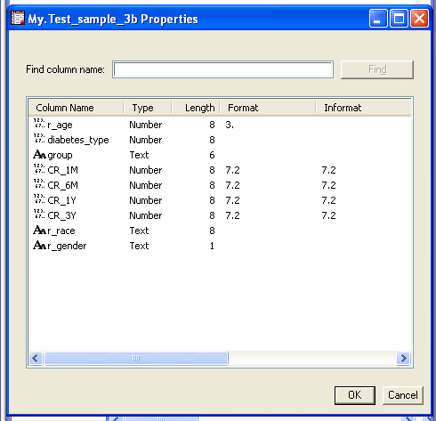

1. Create frequencies for race, age and gender (use PROC FREQ)
2. Compute eGFR for all time points 1M, 6M, 1Y, and 3Y.by using the MDRD formula with arrays.
3. Classify patients’ kidney function (eGFR) according criteria into below normal and normal and above (only 2 categories) for all time points, Assume a cutpoint for normal to be 70 for females and 68 for males.
4. (optional) Create a contingency table (PROC FREQ) for eGFR categories of time point 1M and 3Y.