EE 371 Project 1 Report

Minh Khuu

Ruchira Kulkarni

Denny Ly

**Table of Contents**

1. <<Replace with section heading>>

1.1 <<Section topic 1>>

1.2 <<Section topic 2>>

**Table of Figures**

**Figure 1.** Right click the figure and select change picture to make the figure.

**Figure 1.** Right click the figure and select change picture to make the figure.

# <<Replace with section heading>>

Overview of section. Maecenas porttitor congue massa. Fusce posuere, magna sed pulvinar ultricies, purus lectus malesuada libero, sit amet commodo magna eros quis urna. Nunc viverra imperdiet enim. Fusce est. Vivamus a tellus. Pellentesque habitant morbi tristique senectus et netus et malesuada fames ac turpis egestas. Proin pharetra nonummy pede. Mauris et orci. Aenean nec lorem.

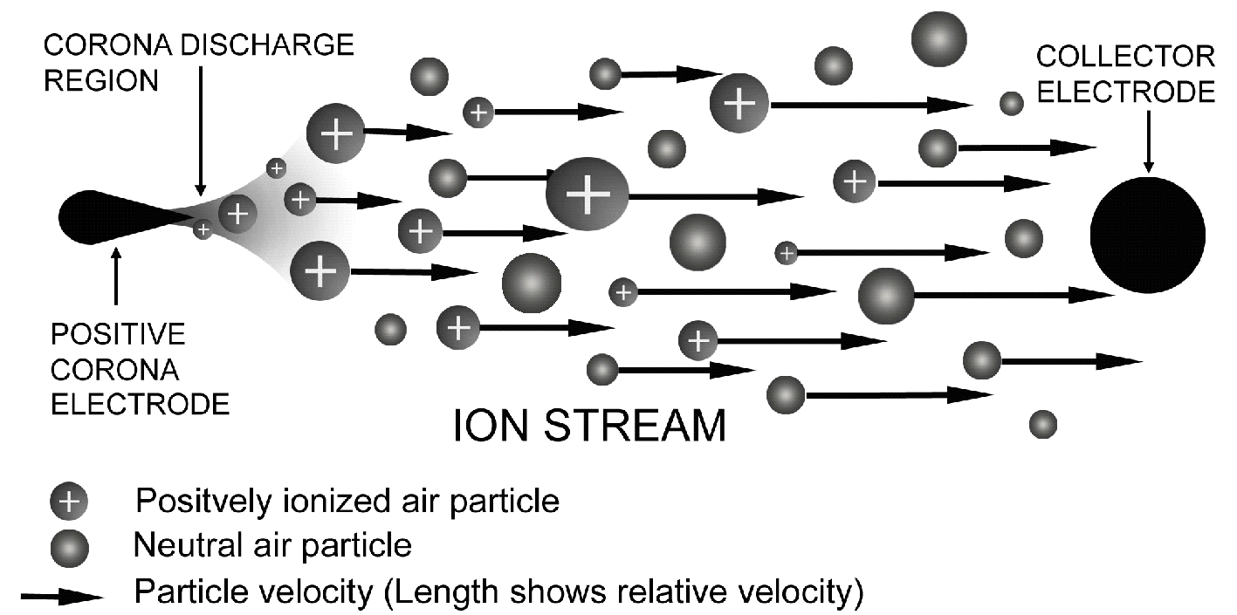

**Figure 1.** Right click the figure and select change picture to make the figure.

## <<Section topic 1>>

Lorem ipsum dolor sit amet, consectetuer adipiscing elit. Maecenas porttitor congue massa. Fusce posuere, magna sed pulvinar ultricies, purus lectus malesuada libero, sit amet commodo magna eros quis urna. Nunc viverra imperdiet enim. Fusce est. Vivamus a tellus. Pellentesque habitant morbi tristique senectus et netus et malesuada fames ac turpis egestas. Proin pharetra nonummy pede. Mauris et orci. Aenean nec lorem.



**Figure 2.** Right click the figure and select change picture to make the figure.

## <<Section topic 2>>

Lorem ipsum dolor sit amet, consectetuer adipiscing elit. Maecenas porttitor congue massa. Fusce posuere, magna sed pulvinar ultricies, purus lectus malesuada libero, sit amet commodo magna eros quis urna. Nunc viverra imperdiet enim. Fusce est. Vivamus a tellus. Pellentesque habitant morbi tristique senectus et netus et malesuada fames ac turpis egestas. Proin pharetra nonummy pede. Mauris et orci. Aenean nec lorem.