Livy – Delegation Token Renewal (RPC)
Generated: 2026-07-09
This document describes delegation token handling for Apache Livy proxy-user (impersonation) sessions. Renewed tokens are pushed to the Spark driver entirely over encrypted RSC RPC. There is no HDFS credentials file, no file polling, and no staging directory for tokens.

1. Summary
- Activation: proxyUser + Kerberos + livy.impersonation.enabled + renewal.enabled
- Initial tokens: Spark --proxy-user at launch
- Renewal: Livy server (real user) → RPC push to driver
- Supported services: hdfs, hive, hbase, kafka (+ ofs:// Ozone auto-discovery)
- Provider registry: built-in + SPI + livy.impersonation.delegation-token.providers
- Filesystem auto-discovery: hdfs://, ofs://, o3fs://, s3a, … from jars/files/conf
- Session types: interactive and batch, client and cluster deploy mode

2. Architecture
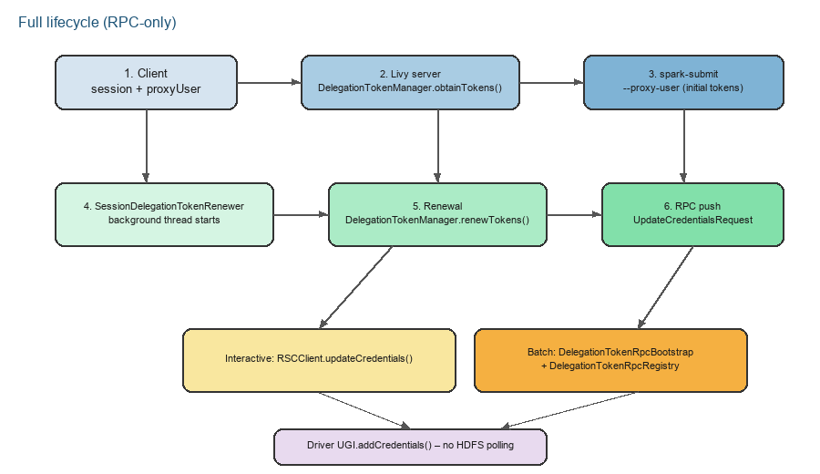
Figure 1 – Full delegation token lifecycle (RPC-only)

3. Launch flow
- Client creates a session with proxyUser (impersonation).
- BatchSession / InteractiveSession calls SessionDelegationTokenRenewer.prepareForLaunch().
- DelegationTokenManager.obtainTokens() acquires tokens as the Livy login user.
- Spark starts with --proxy-user; initial delegation tokens arrive during launch.
- In batch mode, DelegationTokenRpcRegistry sets spark conf (launcher address, client id/secret, extraListeners, spark.jars).
- In interactive mode, token push uses the existing RSC connection.

4. Renewal flow
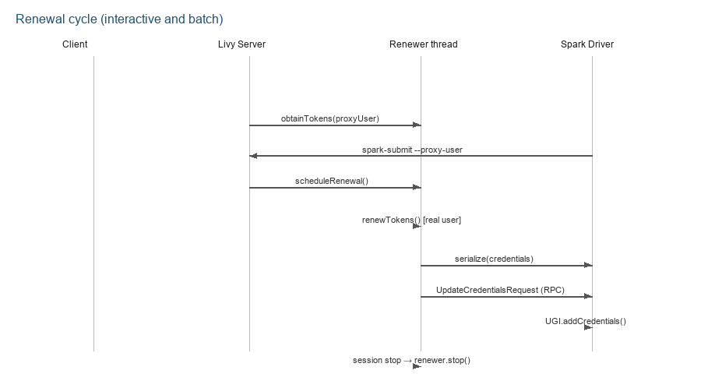
Figure 2 – Renewal cycle
- SessionDelegationTokenRenewer schedules renewal on a background thread.
- Interval: min(token_max_lifetime / 2, livy.impersonation.delegation-token.renewal.interval)
- DelegationTokenManager.renewTokens() – real Livy user, Hadoop TokenRenewer SPI.
- Credentials serialized → UpdateCredentialsRequest RPC message.
- On the driver, DelegationTokenRpcBootstrap.applyCredentials() → UGI.addCredentials().
- On session stop: renewer.stop() and RPC connections closed.

5. Interactive vs. Batch
Aspect | Interactive session | Batch session
RPC channel | Existing RSCClient.updateCredentials() | DelegationTokenRpcRegistry ↔ DelegationTokenRpcBootstrap
Driver listener | RSCDriver (existing) | spark.extraListeners → DelegationTokenRpcBootstrap
Batch registry | Not required | Livy-side RpcServer waits for driver registration
Deploy mode | Client and cluster | Client and cluster (K8s/cluster: spark.driver.host)
HDFS polling | None | None

6. Main components
Component | File | Role
DelegationTokenManager | server/.../DelegationTokenManager.scala | Token obtain, renew, serialize, max-lifetime config lookup
DelegationTokenProviderRegistry | server/.../DelegationTokenProviderRegistry.scala | Built-in + SPI + config provider resolution
BuiltInDelegationTokenProviders | server/.../BuiltInDelegationTokenProviders.scala | Built-in hdfs, hive, hbase, kafka providers
SessionFilesystemUriCollector | server/.../SessionFilesystemUriCollector.scala | Filesystem URI auto-discovery from session inputs
SessionDelegationTokenRenewer | server/.../SessionDelegationTokenRenewer.scala | Per-session background thread, scheduled renewal and push
DelegationTokenRpcRegistry | server/.../DelegationTokenRpcRegistry.scala | Batch driver registration and RPC push from Livy server
DelegationTokenRpcBootstrap | rsc/.../DelegationTokenRpcBootstrap.java | Batch driver-side RPC server and Livy registration
RSCDriver | rsc/.../RSCDriver.java | Interactive: receives UpdateCredentialsRequest

7. Configuration
# Impersonation (prerequisite)
livy.impersonation.enabled = true
# Delegation token renewal (default: enabled)
livy.impersonation.delegation-token.renewal.enabled = true
livy.impersonation.delegation-token.renewal.interval = 1h
livy.impersonation.delegation-token.renewer.principal = livy/hostname@REALM
livy.impersonation.delegation-token.extra.filesystems = hdfs://ns2
livy.impersonation.delegation-token.services = hdfs,hive,hbase,kafka
livy.impersonation.delegation-token.auto-discover.filesystems = true
livy.impersonation.delegation-token.providers = mycloud=com.example.MyTokenProvider
# Set automatically in batch mode:
# spark.extraListeners = org.apache.livy.rsc.driver.DelegationTokenRpcBootstrap
# spark.__livy__.livy.rsc.launcher-address / launcher-port / client-id / client-secret
# spark.jars += livy-rsc.jar (if needed)
Service-specific delegation token lifetime keys (DelegationTokenManager.getMaxLifetime):
Service | Config key(s) | IT mini cluster value
HDFS | dfs.namenode.delegation.token.max-lifetime | 15s
Hive | hive.cluster.delegation.token.max-lifetime | 15s
Hive | hive.cluster.delegation.token.renew-interval | 8s
Hive | hive.cluster.delegation.token.gc-interval | 5s
HBase | hbase.auth.token.max.lifetime | 15s
HBase | hbase.auth.key.update.interval | 8s
Kafka | delegation.token.max.lifetime.ms | 15000
Kafka | delegation.token.expiry.time.ms | 7500
Ozone | ozone.manager.delegation.token.max-lifetime | 15s
Ozone | ozone.manager.delegation.token.renew-interval | 8s
Ozone | ozone.manager.delegation.remover.scan.interval | 5s

Notes:
- Renewal is active only for proxy-user sessions (DelegationTokenManager.isEnabled).
- HBase and Kafka tokens require the corresponding client libraries on the Livy classpath.
- No livy.rsc.delegation.tokens.path and no poll-interval – purely RPC-based.
- Ozone ofs:// URIs are auto-discovered via SessionFilesystemUriCollector.

8. Test environment (integration-test mini cluster)
The integration-test module starts an embedded KerberosMiniCluster by default (cluster.type=mini, kerberos.enabled=true). Tests run with Maven test-scope dependencies; no external HDFS/YARN/Livy installation is required.

8.1. Mini cluster architecture
Layer | Component | Startup | Maven artifact (test scope)
Base | MiniDFSCluster + MiniYARNCluster + LivyServer | subprocess (MiniHdfsMain, MiniYarnMain, MiniLivyMain) | hadoop-hdfs, hadoop-yarn-server-tests
Security | MiniKdc (Kerberos) | in-process | hadoop-minikdc
Embedded services | MiniOzoneCluster | in-process (reflection) | ozone-mini-cluster 2.1.1
Embedded services | Hive Metastore (Derby + Thrift) | in-process daemon thread | hive-service 3.0.0
Embedded services | HBase mini cluster | in-process (HBaseTestingUtility) | hbase-server 2.4.17 (tests)
Embedded services | Kafka broker | in-process (KafkaServer + Curator ZK) | kafka_2.12 2.8.2, curator-test

Startup order (KerberosMiniCluster.configureClusterConfig):
- MiniKdc + secure core-site.xml / hdfs-site.xml / yarn-site.xml (short token lifetimes).
- MiniOzoneCluster (ozone.enabled=true by default).
- Hive Metastore (hive.enabled=true).
- HBase mini cluster (hbase.enabled=true).
- Kafka broker (kafka.enabled=true).
- HDFS / YARN / Livy subprocesses (shared HADOOP_CONF_DIR).

8.2. KDC principals and proxy user
- Principals: hdfs, HTTP, yarn, livy, proxy, om, scm, hive, hbase, kafka
- Livy login: livy/localhost@REALM (keytab)
- Proxy user for tests: proxy/localhost@REALM → livy.test.proxyUser=proxy
- hadoop.proxyuser.livy.users=* and hosts=* in core-site.xml

8.3. Short token lifetimes (renewal IT)
Setting | Value | Purpose
Token max lifetime (HDFS/Hive/HBase/Kafka/Ozone) | 15s | Token expires for renewal tests
Token renew interval | 8s | Service-side renewal window
Livy renewal interval | 5s | livy.impersonation.delegation-token.renewal.interval
Renewal job sleep | 45s | spark.livy.test.renewal.sleep.seconds
Renewal check interval | 8s | spark.livy.test.renewal.check.interval.seconds

8.4. Auto-populated cluster properties
Key | Source | Example
hive.metastore.uris | HiveMiniClusterSupport | thrift://localhost:PORT
hbase.zookeeper.quorum | HBaseMiniClusterSupport | localhost
kafka.bootstrap.servers | KafkaMiniClusterSupport | 127.0.0.1:PORT
livy.test.ozone.path | OzoneMiniClusterSupport | ofs://omService/livy-it/bucket1
hive.started / hbase.started / kafka.started | Mini cluster support | true
ozone.started | OzoneMiniClusterSupport | true

8.5. External cluster (cluster.spec)
In external mode (cluster.type=external), a real cluster is configured from cluster.spec.template. Instead of embedded mini-cluster services, tests use endpoints from the spec (hive.metastore.uris, hbase.zookeeper.quorum, kafka.bootstrap.servers).
# Example: external cluster
cluster.type=external
authScheme=kerberos
configDir=/etc/hadoop/conf
livyEndpoint=https://livy.example.com
principal=livy/host@REALM
keytabPath=/etc/security/keytabs/livy.keytab
delegation.token.services=hdfs,hive,hbase,kafka

8.6. Maven dependencies (test scope, parent pom.xml)
Artifact | Version | Purpose
ozone-mini-cluster, ozone-client, ozone-filesystem-hadoop3 | 2.1.1 | MiniOzoneCluster
hive-service | 3.0.0 | Hive Metastore Thrift server
hbase-server (classifier: tests) | 2.4.17 | HBaseTestingUtility
kafka_2.12 | 2.8.2 | Embedded Kafka broker
curator-test | 5.9.0 | ZK for Kafka broker
hadoop-minikdc | ${hadoop.version} | MiniKdc

9. Test cases

9.1. Unit tests (server module)
Class | Coverage
DelegationTokenManagerSpec | isEnabled, serialize/deserialize, RPC bootstrap class
DelegationTokenProviderRegistrySpec | Built-in providers, custom provider config, SPI
DelegationTokenKerberosSpec | MiniKdc, HBase/Kafka stub tokens, renewer startup
SessionFilesystemUriCollectorSpec | hdfs://, ofs://, o3fs:// URI extraction from session inputs

9.2. Integration tests – DelegationTokenIT matrix
Dimensions:
- Deploy mode: client, cluster
- Session type: interactive, batch
- Impersonation: no-impersonation, impersonation (proxy-user, Kerberos only)
- Services: hdfs, hive, hbase, kafka (+ ozone when started)

9.2.1. Mini cluster regression (non-Kerberos HDFS)
Test ID | Description
IT-DT-mini-interactive-{client|cluster}-no-impersonation-hdfs | Interactive: no polling path, HDFS mkdir/exists
IT-DT-mini-batch-{client|cluster}-no-impersonation-hdfs | Batch: batch-dt-services.py succeeds

9.2.2. Kerberos service access
Test ID | Description
IT-DT-krb-interactive-{client|cluster}-{no-impersonation|impersonation}-{service} | Interactive: verifyNoFilesystemTokenPolling + verifyServiceAccessInteractive
IT-DT-krb-batch-{client|cluster}-{no-impersonation|impersonation}-{service} | Batch: batch-dt-services.py narrowed to one service

service ∈ {hdfs, hive, hbase, kafka} – only when the embedded service started (hive.started, hbase.started, kafka.started).

9.2.3. Delegation token renewal (short lifetime + long job)
Test ID | Description
IT-DT-renewal-batch-{client|cluster}-impersonation-{service} | Batch: batch-dt-renewal.py, 45s sleep, service access every 8s
IT-DT-renewal-interactive-{client|cluster}-impersonation-hdfs | Interactive: 45s HDFS mkdir loop, at least 2 successful checks
IT-DT-renewal-interactive-{client|cluster}-impersonation-ozone | Interactive: 45s ofs:// mkdir loop (when ozone.started=true)

renewal batch service ∈ testServices + ozone (when configured).

9.2.4. Ozone auto-discovery (ofs://)
Test ID | Description
IT-DT-O01 | Interactive cluster: spark.files ofs:// path → Ozone mkdir/exists
IT-DT-O02 | Batch cluster: auto-discovered ofs:// token + batch-dt-services.py

9.2.5. Legacy smoke tests
Test ID | Description
IT-DT-01 | Interactive cluster: no filesystem token polling, 1+1
IT-DT-02 | Batch cluster: batch-dt-test.py succeeds
IT-DT-K01 | Interactive cluster + proxy: HDFS access
IT-DT-K03 | Batch cluster + proxy: batch-dt-krb.py

9.3. Test scripts (integration-test resources)
File | Role
batch-dt-services.py | Service-specific access (hdfs/hive/hbase/kafka)
batch-dt-renewal.py | Long sleep + periodic service access for renewal IT
batch-dt-krb.py | Kerberos batch smoke
batch-dt-test.py | Basic batch smoke

Verifications:
- verifyNoFilesystemTokenPolling: sc.hadoopConfiguration.get("livy.rsc.delegation.tokens.path") == null
- verifyHdfsAccessInteractive: fs.mkdirs + fs.exists
- verifyHiveAccessInteractive: spark.sql("SHOW DATABASES").count() > 0
- verifyHbaseAccessInteractive: ConnectionFactory + admin.listNamespaceDescriptors
- verifyKafkaAccessInteractive: KafkaConsumer bootstrap connect + close
- verifyOzoneAccessInteractive: ofs:// path mkdir/exists

10. Running tests
# Build
mvn -pl server,integration-test -am -Pscala-2.12 -Pspark3 clean install \
-DskipTests -DskipITs -Drat.skip=true -Dcheckstyle.skip=true -Dscalastyle.skip=true
# Delegation token tests (unit + integration)
mvn -pl server,integration-test -Pscala-2.12 -Pspark3 test integration-test \
-DskipITs=false -Drat.skip=true -Dcheckstyle.skip=true \
-DwildcardSuites=org.apache.livy.utils.DelegationTokenManagerSpec,\
org.apache.livy.utils.DelegationTokenProviderRegistrySpec,\
org.apache.livy.utils.DelegationTokenKerberosSpec,\
org.apache.livy.utils.SessionFilesystemUriCollectorSpec,\
org.apache.livy.test.DelegationTokenIT
# Integration tests only (embedded mini cluster)
mvn -pl integration-test -Pscala-2.12 -Pspark3 integration-test \
-DskipITs=false -Drat.skip=true \
-DwildcardSuites=org.apache.livy.test.DelegationTokenIT
# Against external cluster (custom cluster.spec)
mvn -pl integration-test -Pscala-2.12 -Pspark3 integration-test \
-DskipITs=false -Dcluster.spec=/path/to/cluster.spec \
-DwildcardSuites=org.apache.livy.test.DelegationTokenIT

11. Log messages (troubleshooting)
Component | Message | Meaning
Livy | Delegation token RPC registry listening on ... | Batch RPC registry started
Livy | Batch session N connected for delegation token RPC | Batch driver registered
Livy | Renewed delegation tokens for session N | Successful renewal and push
Driver | Starting delegation token RPC server for batch driver | DelegationTokenRpcBootstrap active
Driver | Applied delegation tokens from Livy RPC to driver UGI | Tokens applied

