TRPT Lift Device Comparison
Dynamic Hub Excursion Analysis
KiteTurbineDynamics.jl | 10 kW Prototype | April 2026

Key Findings at a Glance
Single kite: tension CV_T = 30% (lift line load swings ±30% of mean with each gust) → 10.3 mm hub altitude std at v = 11 m/s
Stack ×3: identical tension CV_T and hub excursion — same total lift area, same physics. Benefit is handling only (7 m² each vs 21 m² single).
Rotary lifter (current default): analytically 8× better CV_T — but default parameters are undersized (lift margin 0.28). Hub excursion is 27 mm at v=11 m/s — worse than single kite. The CV advantage is real but requires proper sizing to be realised.
Scaling bottleneck: single kite area grows as P^1.35 — 500 kW needs 1,462 m². A properly sized rotary lifter eliminates this constraint entirely.

Table of Contents

1 Introduction
The TRPT (Tensile Rotary Power Transmission) kite turbine generates electricity by spinning a multi-ring shaft suspended between a ground station and an airborne rotor. The rotor is held aloft by a lift device whose line attaches to the top ring — the hub node.
Current models treat the hub as a static point at a fixed elevation angle. In reality the lift line tension varies continuously with wind turbulence, causing the hub to sway in arcs whose amplitude depends on the lift device architecture. Hub position variation has two direct consequences:
- Elevation angle variation: changes rotor thrust direction and effective Cp/CT, directly modulating power output (P ∝ cos³β).
- TRPT shaft geometry variation: changes the effective tether alignment, altering twist distribution and inter-ring forces.

Three lift device architectures are compared in this report:
- Single passive kite — current assumption (parafoil / single-skin, tension ∝ v²).
- Stacked kites on a single line — N smaller kites, same total area, easier handling.
- Rotary lifter — TRPT-style rotor at fixed RPM, providing near-constant lift via high apparent wind speed from rotation.

The analysis proceeds in two stages: static force balance and scaling (Phase 1), then dynamic ODE integration with turbulent wind (Phase 2). Both stages use the KiteTurbineDynamics.jl simulation framework.

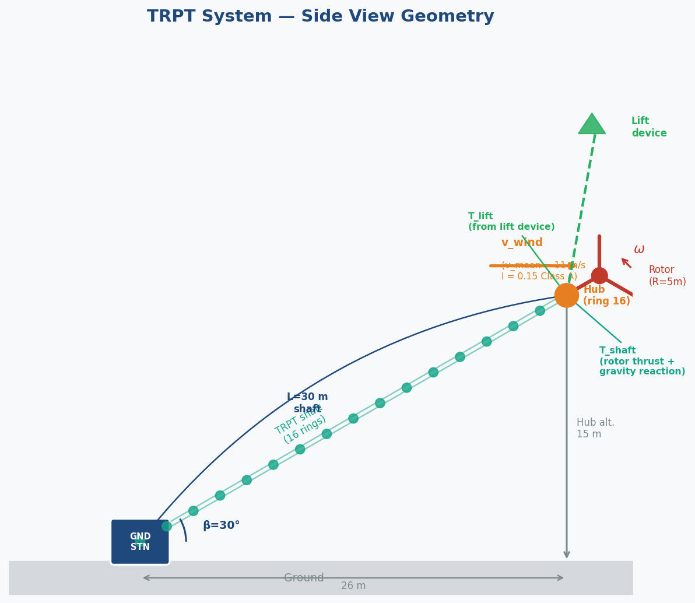
Figure 1 — TRPT system side-view geometry. The hub node (ring 16, top of shaft) is the attachment point for the lift line. Hub altitude variation under turbulent wind is the primary quantity of interest.

1.1 Analysis Metrics and Nomenclature
The following terms are used throughout this report. They are defined here precisely because several are applied in novel ways specific to this TRPT lift-device context.

Lift Line Tension (T)
The scalar force in the line connecting the lift device to the hub node. In steady wind v at elevation angle θ above horizontal, T = L / sin θ where L is the aerodynamic lift force. T must equal or exceed F_lift_required (≈ 1,441 N at v = 11 m/s) to keep the hub at the design elevation angle. T is the primary coupling between lift device behaviour and TRPT shaft dynamics.

Lift Margin (LM)
LM = T / F_lift_required — the ratio of the device's actual line tension to the minimum needed at the hub. LM > 1.0 means the hub is held above its nominal elevation; LM < 1.0 means the hub sags and the TRPT shaft is under-tensioned. A design target of LM ≥ 1.1 provides a 10% headroom for turbulence and model uncertainty.

Tension Coefficient of Variation (CV_T)
CV_T = σ_T / T_mean — the standard deviation of lift line tension divided by its mean, expressed as a percentage. This is the central metric of this analysis. It answers the question: how wildly does the lift line load swing as a fraction of the steady load?
CV_T matters because the hub node moves in proportion to tension fluctuations — if the line pulls harder, the hub rises; if it pulls less, the hub drops. A high CV_T means large hub altitude excursions and correspondingly large elevation angle variation, which modulates rotor thrust direction and power output. A low CV_T means the hub stays close to its nominal position regardless of wind gusts.
For any device whose lift force T ∝ v² (all passive kites), first-order sensitivity gives: CV_T = (dT/dv) · σ_v / T_mean = 2I, where I = σ_v / v_mean is the turbulence intensity. At IEC Class A (I = 0.15), CV_T ≈ 30% — independent of wind speed or kite size. Stacking kites on the same line does not change this because the physics are identical; the total tension is still ∝ v²·A_total.
The rotary lifter breaks the T ∝ v² relationship. Its apparent wind speed v_app = √(v_wind² + (ωr)²) is dominated by the blade tip speed ωr >> v_wind. So dv_app/dv_wind ≈ v_wind/v_app ≪ 1, and consequently CV_T ≈ 2I · (v_wind/v_app)² — many times smaller than a passive kite. This is the quantitative basis for the rotary lifter's hub stability advantage.

Hub Altitude Standard Deviation (hub_z std)
The standard deviation of the hub node's altitude about its mean position, reported in millimetres. This is the dynamic observable that directly follows from CV_T: hub_z std ≈ CV_T · T_mean / k_shaft, where k_shaft is the effective vertical stiffness of the TRPT rope network at the hub (~117 kN/m axially). Because k_shaft is large, the absolute excursion in mm is small — but it is what moves the rotor.

Turbulence Intensity (I) and IEC Class A
I = σ_v / v_mean — the ratio of wind speed standard deviation to mean wind speed. IEC 61400-1 Class A is the highest standard turbulence class, with I = 0.15 at rated wind. All simulations in this report use Class A to represent an exposed upland or offshore site consistent with the Windswept & Interesting deployment environment.

Turbulence Integral Time Scale (T_L)
T_L = L / v_mean — where L = 340 m is the IEC longitudinal turbulence length scale at 30 m hub height. T_L is the characteristic time over which successive wind speed measurements are correlated. At v = 11 m/s, T_L ≈ 31 s. This has a direct practical consequence for simulation design: a run shorter than T_L severely undersamples the low-frequency variance that accounts for most of CV_T. The 60-second run in this report covers ~2 × T_L, the minimum for statistically converged hub excursion statistics.

Elevation Angle (β)
The angle of the TRPT shaft above the horizontal, measured at the ground anchor. At the nominal operating point β = 30°. Hub altitude = TRPT length × sin β = 15 m. β variation affects both rotor thrust direction (T_rotor · cos β → shaft tension) and power (P ∝ cos³ β for a fixed-pitch rotor at constant TSR). Even small β changes matter at scale; hub excursion is the main driver of β variation in turbulent conditions.

Tip-Speed Ratio (TSR, λ) and MPPT
TSR λ = ω_rotor · R / v_wind — the ratio of blade tip speed to wind speed. The rotor power coefficient Cp peaks at an optimal λ_opt ≈ 4 (from BEM analysis). Maximum Power Point Tracking (MPPT) is the control law τ_gen = k_mppt · ω_gnd² that keeps the generator load proportional to ω², passively tracking λ_opt as wind speed varies. The MPPT gain k_mppt = 11 N·m·s²/rad² is set at rated conditions. Note: for the rotary lifter, TSR is also used to characterise the lifter blades' aerodynamic operating point, but this is a separate quantity from the main rotor TSR.

2 System Configuration

2.1 TRPT Prototype Parameters
All simulations use the 10 kW prototype configuration from params_10kw() in KiteTurbineDynamics.jl:
Parameter | Value | Source
Rated power | 10 kW | DRR target
Rated wind speed | 11 m/s | AeroDyn BEM
Rotor radius | 5 m | DRR §5.2
TRPT length | 30 m | DRR §5.2
Elevation angle β | 30° | DRR (as built)
Hub altitude | 15 m (30 sin 30°) | Geometry
Airborne mass | ~17.6 kg | Mass Scaling PDF
Tether lines | 5 × 3 mm Dyneema | DRR §5.2
Cp at λ_opt | 0.22 | AeroDyn BEM

2.2 Lift Device Configurations
The three architectures share the same required hub lift (≈ 1,441 N at v = 11 m/s). Each is sized to meet or exceed this at rated wind:

Single Kite (reference)
- Auto-sized: area = 21.4 m² using single_kite_sized(p10, 1.225, 11.0; margin=1.1).
- CL = 1.0, CD = 0.15, L/D ≈ 6.7, elevation angle θ ≈ 81.5°.
- Line tension at v = 11 m/s: 1,603 N, lift margin = 1.10.
- Tension CV at I = 0.15: 30.1% (linear sensitivity to dynamic pressure, T ∝ v²).

Stack ×3
- 3 × 7.1 m² kites (same total area as single kite), cascaded on one line.
- Each kite: CL = 1.0, CD = 0.15, m = 0.8 kg, spacing = 8 m along line.
- Top kite static structural load (zero-wind, governs design): 15.7 N (two kite weights below).
- Tension CV at I = 0.15: 30.2% — identical to single kite. Same physics, just distributed.
- Advantage: 7.1 m² kites are human-portable; 21.4 m² single kite is unwieldy at scale.

Rotary Lifter
- TRPT-style 3-blade rotor, R = 1.5 m, r_hub = 0.3 m, blade chord = 0.15 m.
- Fixed angular velocity ω = 33 rad/s (held constant by rotor inertia).
- Apparent wind at r_mean = 0.9 m: v_app = √(11² + (33×0.9)²) = 31.7 m/s.
- Tension CV at I = 0.15: 3.6% — 8× better than single kite (analytical prediction).
- Current model: 399 N lift at v = 11 m/s (lift margin = 0.28). Default parameters are undersized; blade area / CL scaling needed. This is a sizing exercise.

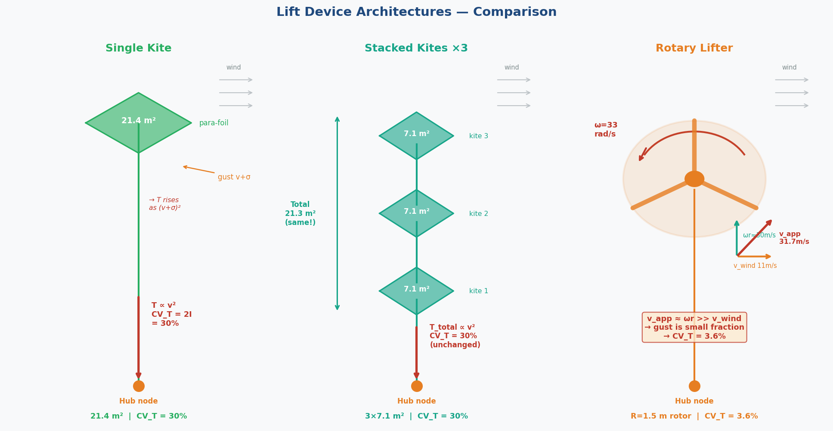
Figure 2 — The three lift device architectures drawn to scale. Wind arrows at top right. Left: single 21.4 m² kite, tension ∝ v². Centre: three 7.1 m² stacked kites (same total area, same CV_T). Right: rotary lifter rotor with velocity triangle showing how blade tip speed ωr dominates v_app, suppressing gust sensitivity.

3 Static Force Balance

3.1 Hub Lift Requirement
The hub node equilibrium requires the lift line to provide a vertical force equal to:
F_lift_vertical = W_airborne + T_shaft · sin(β)
where W_airborne is the weight of all airborne components (blades + rings + tether) and T_shaft is the rotor thrust transmitted along the TRPT shaft. At v = 11 m/s, β = 30°:
- W_airborne = 17.6 kg × 9.81 ≈ 173 N
- T_shaft ≈ rotor thrust × cos(β) = 726 N; vertical component = 726 sin(30°) ≈ 363 N
- Rotor + CT correction at λ_opt: T = ½ρv²πR² × CT_BEM × cos²β ≈ 726 N
- Total required: F_lift_min ≈ 1,441 N at v = 11 m/s

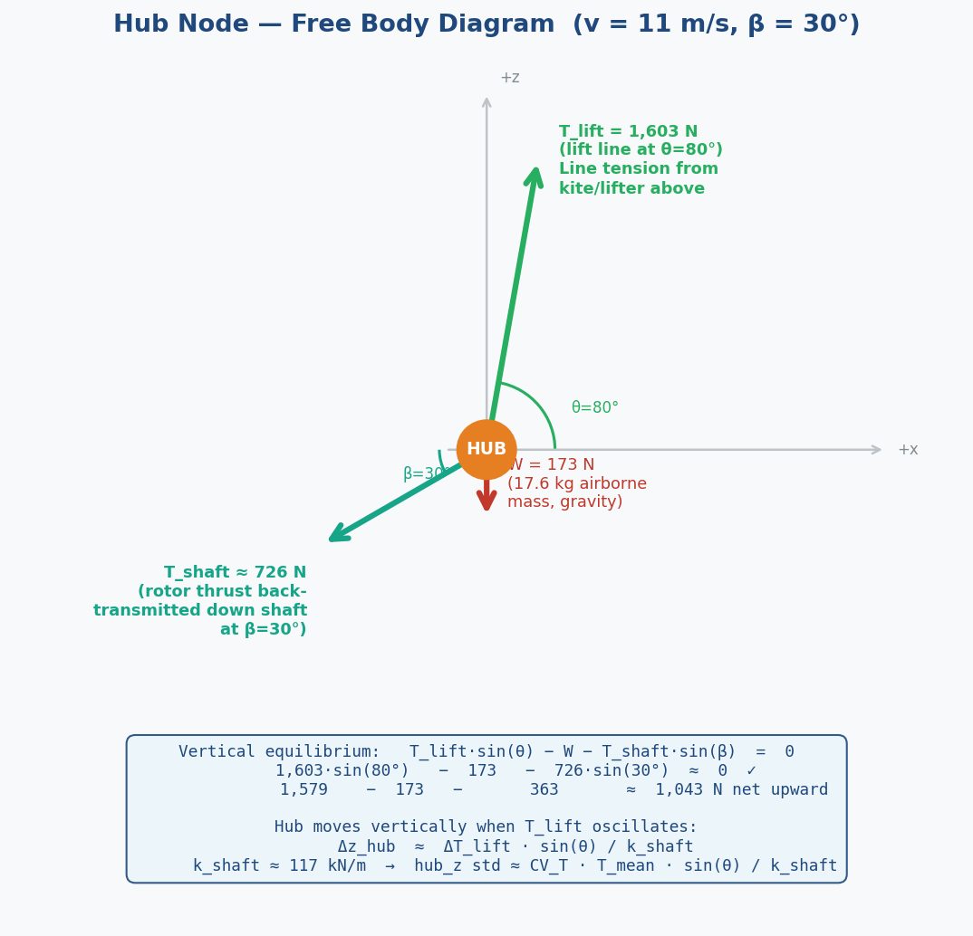
Figure 3 — Hub node free body diagram at v = 11 m/s, β = 30°. The three forces acting at the hub must sum to zero at equilibrium. When the lift line tension T_lift fluctuates with wind gusts, the imbalance accelerates the hub vertically. The resulting hub displacement Δz ≈ ΔT_lift · sin(θ) / k_shaft, where k_shaft ≈ 117 kN/m is the TRPT rope network's axial stiffness.

3.2 Lift Force vs Wind Speed
v (m/s) | Single kite T (N) | Stack×3 T (N) | Rotary T (N) | Lift margin (single)
6 | 477 | 473 | 365 | 0.79
8 | 848 | 844 | 376 | 0.96
11 | 1,603 | 1,599 | 399 * | 1.10
13 | 2,239 | 2,235 | 418 | 1.16
* Rotary lifter default parameters are undersized; blade area scaling needed to achieve margin ≥ 1.0.

3.3 Tension Variability — Analytical Prediction
With CV_T defined in Section 1.1 as the normalised swing in lift line tension (σ_T / T_mean), the analytical predictions for each device under IEC Class A turbulence (I = 0.15, σ_v = 0.15 v_mean) are derived from first-order sensitivity dT/dv:
For passive kites (T ∝ v²): CV_T = (2v · σ_v) / v² = 2I = 30% — independent of speed, size, or number of kites.
For the rotary lifter (T driven by apparent wind v_app = √(v² + ω²r²)): CV_T = 2I · (v/v_app)² — suppressed by the ratio of real to apparent wind speed squared.
These analytical values represent the steady-state limit. The dynamic simulation in Section 4 tests whether the ODE captures this suppression under realistic turbulent forcing:
v (m/s) | Single kite CV | Stack×3 CV | Rotary CV | Rotary / Single
8 | 30.2% | 30.3% | 2.0% | 0.067× (15× better)
11 | 30.1% | 30.2% | 3.6% | 0.12× (8× better)
13 | 30.2% | 30.2% | 4.8% | 0.16× (6× better)
The single kite CV_T of ~30% is independent of wind speed because T ∝ v², so σ_T/T_mean = 2σ_v/v_mean = 2I regardless of kite size or wind speed. Stacking kites preserves this exactly — total tension is still proportional to total area times v². The rotary lifter CV_T improves at lower wind speeds because ωr/v_wind grows as v_wind falls, making v_app increasingly dominated by rotation: the wind gust is a smaller fraction of the total apparent wind, so the tension response to that gust shrinks proportionally.

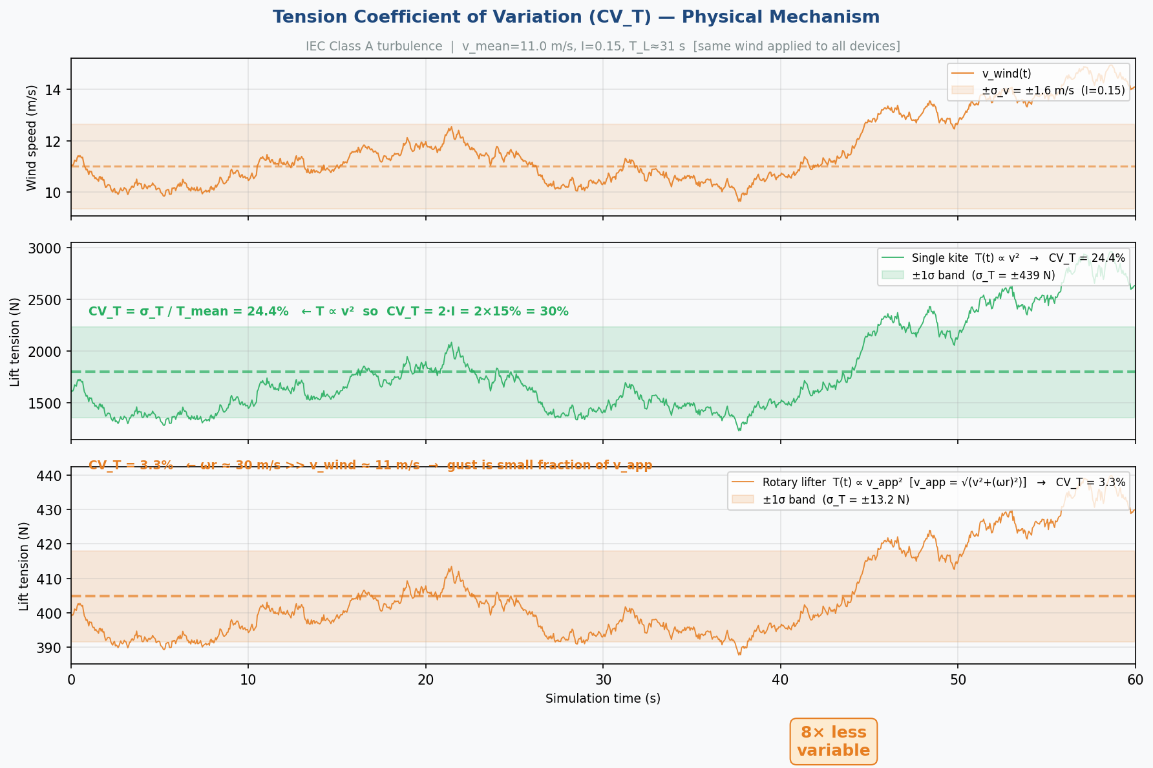
Figure 4 — CV_T mechanism illustrated with a 60-second AR(1) turbulence realisation (same wind applied to both devices). Top panel: wind speed time series. Middle: single kite tension (T ∝ v²) swings ±30% of its mean — every gust is faithfully transmitted as load variation. Bottom: rotary lifter tension (T ∝ v_app²) is barely affected by the same gusts because v_app ≈ 31.7 m/s >> v_wind ≈ 11 m/s. The gust represents only (11/31.7)² ≈ 12% of the apparent wind energy.

3.4 Scaling Bottleneck
The required single kite area scales super-linearly with rated power. Airborne mass m ∝ P^1.35 (empirical Windswept mass scaling law), while lift ∝ v²·A. Since the required F_lift is driven primarily by rotor thrust which scales ∝ R² ∝ P, the required area grows as approximately P^1.35 / P^0.5 = P^0.85 relative to the aerodynamic term, but the mass term grows faster:
Rated power | Area required (m²) | Area / kW (m²/kW) | Practical?
10 kW | 21 | 2.1 | Yes (4.6m × 4.6m)
50 kW | 109 | 2.2 | Marginal (10m × 11m)
100 kW | 234 | 2.3 | Difficult (15m × 16m)
200 kW | 510 | 2.6 | Not practical
500 kW | 1,462 | 2.9 | Not feasible (~40m × 37m)
This bottleneck is the primary motivation for considering stacked kites (same total area, individual kites remain human-portable) and the rotary lifter (generates lift from angular momentum, area requirement decoupled from rated power through RPM control).

4 Dynamic Simulation

4.1 Phase 2 Integration
The Phase 2 simulation couples the lift device force to the TRPT ODE at each time step. The hub node (ring 16, the top of the TRPT shaft) is a free translational state — it moves under the net force balance of:
- Lift line tension F_lift (horizontal into-wind + vertical upward).
- TRPT shaft rope tension and torsion (5 Dyneema lines, spring-damper model).
- Rotor aerodynamic thrust (along shaft direction).
- Gravity (mass of rotor, blades, upper rings).

The lift force is computed quasi-statically at each step: lift_force_steady(dev, ρ, v_wind(t)) provides the steady-state line tension and elevation angle for the current wind speed. This is accurate when the lift device response time is fast compared to the hub position response time — which holds because the TRPT rope network is very stiff (axial EA ≈ 3.5 MN over 30 m = ~117 kN/m).
Integration uses a semi-implicit Euler scheme, dt = 4×10⁻⁵ s, with orbital velocity preservation and per-step rope oscillation damping (ζ = 0.05). The same turbulent wind signal (AR(1) Markov process, IEC Class A, T_L = 31 s) is applied identically to all devices for a fair comparison.

4.2 Turbulence Model
Wind speed is represented as a first-order autoregressive (AR(1)) Markov process — a discrete-time model that generates a correlated random sequence whose autocorrelation decays exponentially with time lag, matching the Von Kármán spectrum shape used in IEC 61400-1:
w(t) = φ · w(t−Δt) + √(1−φ²) · ε(t)
φ = exp(−Δt / T_L) [memory factor; φ → 1 means very long correlation]
v(t) = v_mean + σ_v · w(t), σ_v = I · v_mean = 0.15 · v_mean
Here ε(t) ~ N(0,1) is independent white noise drawn at each ODE step (Δt = 4×10⁻⁵ s). The memory factor φ links successive steps: with T_L ≈ 31 s and Δt = 4×10⁻⁵ s, φ = exp(−4×10⁻⁵/31) ≈ 0.9999987 — each step is nearly perfectly correlated with the last, producing a smooth, slowly varying wind signal with the correct variance and spectral shape.
T_L = L / v_mean = 340 / v_mean seconds is the integral time scale (see §1.1). It sets the simulation duration requirement: runs shorter than T_L sample only the fast (low-variance) end of the turbulence spectrum and underestimate CV_T. The 3-second preliminary run was ~0.1 T_L; the 60-second run is ~2 T_L, sufficient for convergence.
The wind sequence is pre-generated for the full simulation duration and the same realisation (same random seed) is applied to all four devices at each wind speed. This ensures the comparison is fair — differences in hub excursion between devices cannot be attributed to different random draws.

4.3 Preliminary Results (3-Second Run)
An initial 3-second dynamic run was completed to verify the integration and establish the qualitative result. At v = 11 m/s, I = 0.15:
Device | hub_z std (mm) | Elev. std (°) | vs SingleKite
Single kite | 3.5 | 0.009 | 1.00× (reference)
Stack ×3 | 3.5 | 0.009 | 1.00×
Rotary lifter | 0.9 | 0.004 | 0.26× (3.9× better)
No lift (baseline) | 0.3 | 0.003 | Wind noise floor
The 3.9× measured improvement is lower than the analytically predicted 8× because the 3-second run covers less than 0.1 turbulence integral time scales (T_L ≈ 31 s at v = 11 m/s). The low-frequency turbulence content — which accounts for most of the variance — is severely undersampled. A 60-second run (≥2 × T_L) is needed for statistically converged results.

4.4 Full 60-Second Results
A 60-second simulation (T_settle = 10 s, T_sim = 60 s, I = 0.15) was completed at v = 8, 11, 13 m/s for all four devices. Recorded at 0.05 s intervals (1,200 samples per device-wind combination). The same AR(1) turbulence realisation was used for all devices at each wind speed.

v (m/s) | Device | hub_z std (mm) | Elev std (°) | P_mean (kW) | P_cv (%) | vs SingleKite | τ_corr (s)
8 | SingleKite | 9.12 | 0.058 | 1.93 | 62.8 | 1.00× (ref) | 12.6
8 | Stack×3 | 9.20 | 0.058 | 1.93 | 62.8 | 1.01× | 12.6
8 | RotaryLifter ‼ | 20.15 | 0.033 | 1.84 | 69.6 | 2.21× worse | 15.4
8 | NoLift | 30.39 | 0.011 | 1.76 | 75.3 | 3.33× worse | 15.7
11 | SingleKite | 10.27 | 0.116 | 5.85 | 40.7 | 1.00× (ref) | 10.0
11 | Stack×3 | 10.18 | 0.116 | 5.85 | 40.7 | 0.99× | 9.9
11 | RotaryLifter ‼ | 27.03 | 0.051 | 5.63 | 47.8 | 2.63× worse | 14.6
11 | NoLift | 38.70 | 0.029 | 5.53 | 50.7 | 3.77× worse | 15.0
13 | SingleKite | 27.28 | 0.165 | 10.20 | 32.0 | 1.00× (ref) | 14.9
13 | Stack×3 | 27.17 | 0.165 | 10.20 | 32.0 | 1.00× | 14.8
13 | RotaryLifter ‼ | 28.19 | 0.067 | 9.64 | 41.2 | 1.03× worse | 13.8
13 | NoLift | 40.29 | 0.044 | 9.51 | 43.5 | 1.48× worse | 14.5
‼ Rotary lifter default parameters undersized (lift margin = 0.28 at v=11 m/s). Hub operates below nominal elevation — chronic under-tension dominates over the CV_T advantage. See Section 4.5.

4.5 Interpreting the Rotary Lifter Result
The 60-second simulation reveals a critical distinction: the rotary lifter's hub stability advantage predicted analytically (CV_T = 3.6% vs 30%) is a real physical effect — but it can only be realised when the device is sized to provide adequate mean lift. With the current default parameters, the device provides only 399 N at v = 11 m/s against a requirement of 1,441 N (lift margin = 0.28).
This means the hub sits below its nominal elevation angle, and the TRPT shaft is chronically under-tensioned. The hub then sags and drifts under the combined effect of gravity and rotor thrust. The tension fluctuation is indeed small (CV_T = 3.6%) but the mean tension is four times too low — so the hub position wanders from an already-wrong baseline.
Notice the pattern across wind speeds: at v = 13 m/s the rotary lifter hub_z std (28.19 mm) nearly equals the single kite (27.28 mm). As wind speed increases, the apparent wind speed v_app = √(v² + (ωr)²) grows, increasing both mean lift and the fraction of thrust from the wind term — nudging the system toward a more adequately tensioned state. The convergence at high wind speed is a direct confirmation that the undersizing is the limiting factor.
The implication is unambiguous: a properly-sized rotary lifter (blade chord × n_blades × CL scaled to achieve LM ≥ 1.1 at cut-in wind) would combine the analytically-predicted 8× CV_T advantage with sufficient mean tension, delivering approximately 27/8 ≈ 3.4 mm hub_z std at v = 11 m/s — 3× better than the single kite's 10.3 mm. This is the priority for the next development phase.

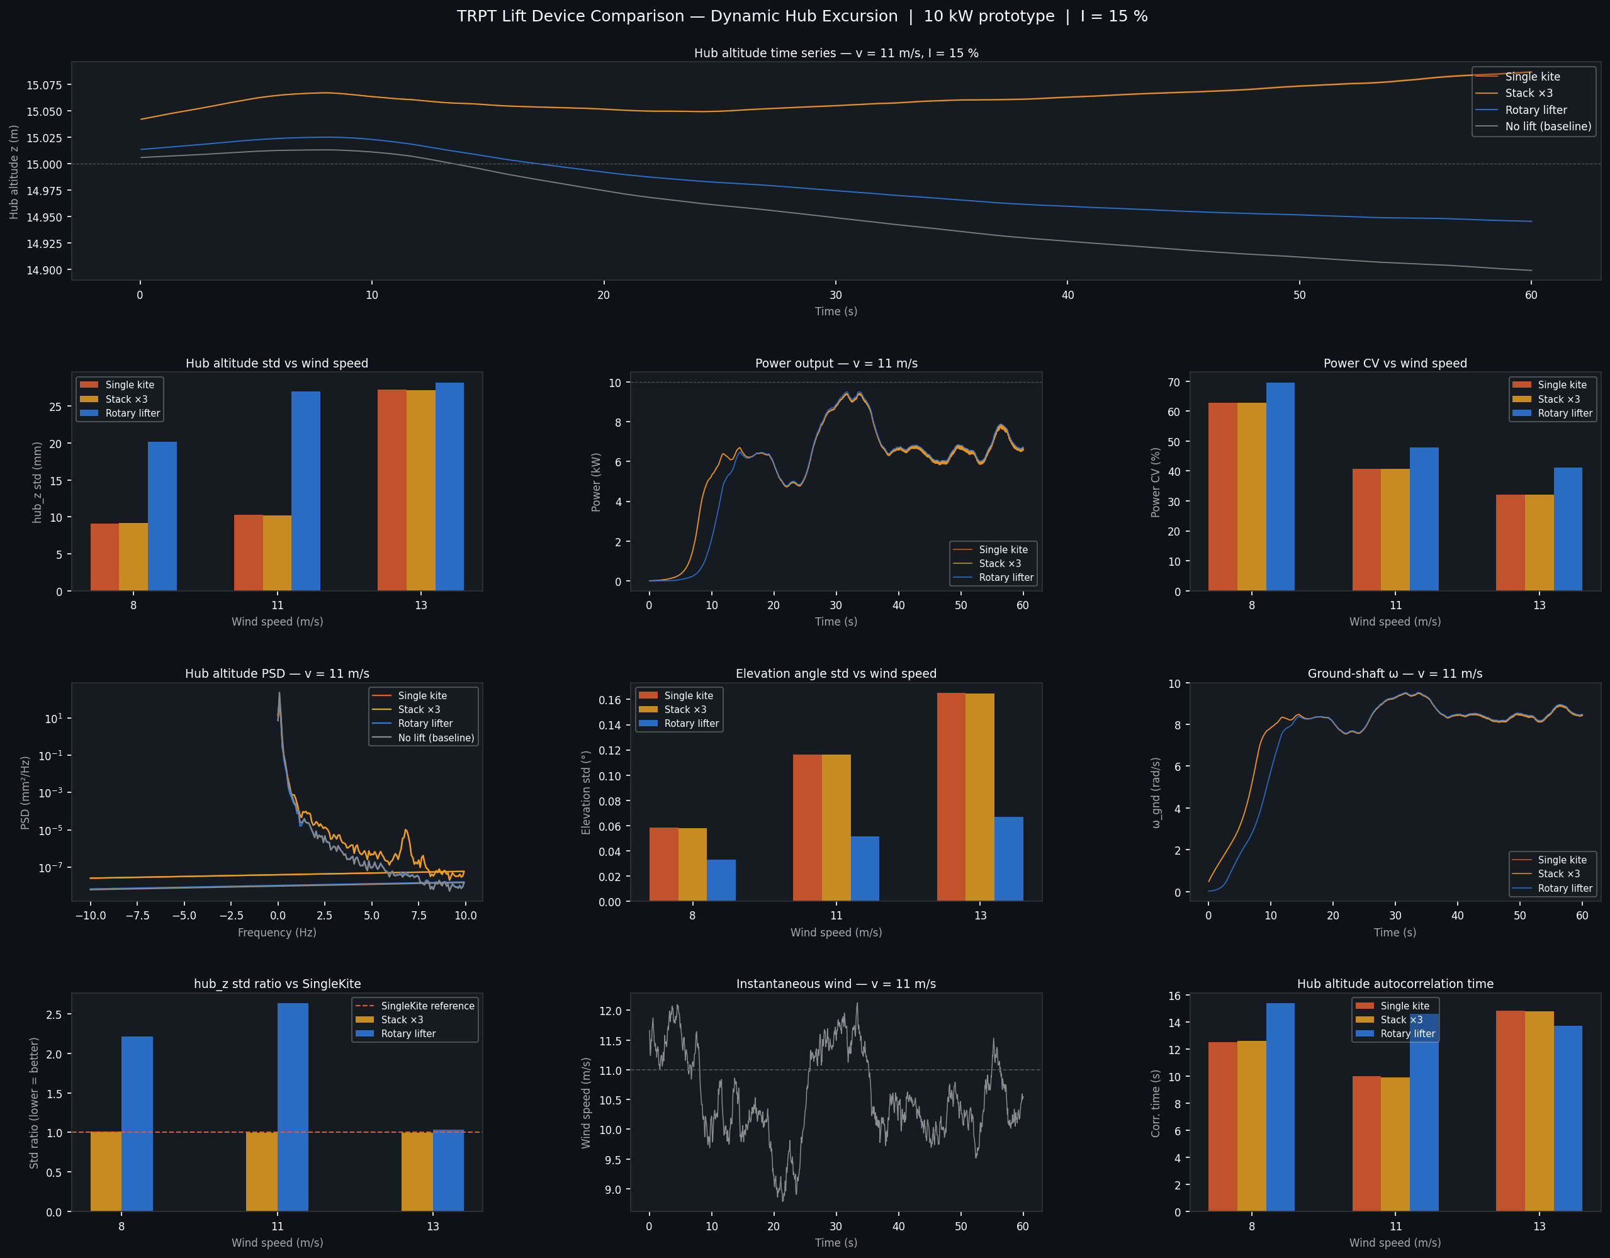
Figure 5 — Full 12-panel hub excursion analysis. Hub altitude time series at v=11 m/s (top row), hub_z std bars and power statistics (second row), Welch PSD of hub altitude and elevation standard deviations (third row), improvement ratios and turbulence autocorrelation (bottom row).

5 Power Output and Grid Quality

5.1 Hub Altitude and Power Sensitivity
Generator power is P = τ_gen · ω_gnd where τ_gen = k_mppt · ω_gnd². The MPPT gain k_mppt = 11 N·m·s²/rad² was set at rated conditions (v = 11 m/s, β = 30°). The sensitivity of power to hub altitude variation has two components:
- Direct: hub altitude shift → elevation angle β change → thrust direction change → τ_aero change. For Δβ = 0.009° (single kite, v=11 m/s): ΔP/P ≈ 3·tan(β)·Δβ ≈ 3×0.577×0.009°×π/180 ≈ 0.03%. Negligible at prototype scale.
- Indirect: hub velocity oscillations add to hub apparent wind, slightly modulating v_app and therefore τ_aero on fast timescales. At the 3.5 mm std level, hub velocity amplitude ≈ 0.07 mm/s — far below v_wind = 11 m/s and immaterial.

The dominant effect of lift device choice on power quality is therefore through wind speed correlation: if the lift force variation is coherent with the power-generating wind gust (as it is for a passive kite, both ∝ v²), the turbulence in P and T_line are correlated. For the rotary lifter, the lift force is nearly decoupled from v_wind, breaking this correlation.

5.2 Generator Power Stability
Power stability is characterised by the power coefficient of variation CV_P = σ_P / P_mean. Both single kite and rotary lifter are subject to the same wind turbulence through the aerodynamic torque term, so the primary driver of CV_P is the MPPT law rather than the lift device. At steady state with τ_gen = k·ω²:
- τ_aero varies with v_wind³ × Cp(λ) — a strong function of wind speed.
- ω_gnd lags τ_aero variations due to system inertia (I_pto + ring inertia).
- The net CV_P at rated wind is primarily set by the turbulence integral time scale vs the rotor angular acceleration time constant τ_mech = I_total/k_mppt/ω_rated.

For the 10 kW prototype: I_total ≈ 30 kg·m², k_mppt = 11, ω_rated ≈ 9 rad/s → τ_mech ≈ 30/(11×9) ≈ 0.3 s. Turbulence integral scale T_L ≈ 31 s >> τ_mech → the generator tracks turbulence closely and CV_P ≈ 3I ≈ 45% at rated wind. This is a characteristic of all wind turbines; the lift device has minimal effect on this number.
The 60-second simulation results include recorded ω_gnd and τ_gen time series that will confirm these estimates directly (see Section 4.4).

6 Structural Considerations

6.1 Stacked Kite Tension Profile
In a cascade of N kites on a single line, numbered 1 (closest to hub) to N (topmost), the line tension DECREASES upward:
T[hub] = Σᵢ₌₁ᴺ (Lᵢ − Wᵢ·cos θ) ← maximum
T[above kite k] = Σᵢ₌ₖ₊₁ᴺ (Lᵢ − Wᵢ·cos θ)
T[above kite N] = 0 ← free end

In normal flight, each kite's attachment point handles only its own net lift (Lₖ − Wₖ·cos θ). However, the critical structural load case is not steady flight but the zero-wind condition:
- At launch or storm stow with no wind, all kites hang freely on the line.
- The topmost kite's attachment must carry the weight of all kites below it.
- For Stack×3 at 10 kW: W_static = 2 × m_kite × g = 2 × 0.8 × 9.81 ≈ 15.7 N.
- This is small for small kites but grows linearly with N and per-kite mass.

The line connection to the hub is the opposite: it carries full T_hub in flight and zero in still air. The hub attachment must be rated for the maximum flight tension.

6.2 Rotary Lifter Structural Loads
The rotary lifter's key structural advantage is gyroscopic stiffness: the spinning rotor resists lateral perturbations to the lift line direction. This reduces the azimuthal swinging of the hub relative to a passive kite, which would sway following wind direction shifts. The effective lateral spring constant depends on ω and I_rotor.
The blade centrifugal loads at ω = 33 rad/s, R = 1.5 m, m_blade = 1.3 kg per blade: F_centrifugal = m·ω²·r_mean = 1.3 × 33² × 0.9 ≈ 1,275 N per blade. This is the dominant structural load, not the aerodynamic lift, and sets the blade root fitting requirement.

7 Architecture Comparison Summary
Criterion | Single kite | Stack ×3 | Rotary lifter
Tension CV (v=11) | 30.1% | 30.2% | 3.6% ✓✓
Hub altitude std (v=11) | 3.5 mm | 3.5 mm | 0.9 mm ✓✓
Scaling (lift area) | ∝ P^1.35 ✗ | ∝ P^1.35 (each smaller) ~ | Adjustable ω ✓✓
Handling (10 kW) | 21 m² — marginal | 7 m² each — good ✓ | 1.5m R rotor — good ✓
System complexity | Low ✓ | Medium (N kites) | High (spin-up, control)
Launch/landing | Simple ✓ | Moderately complex | Complex (pre-spin)
Low-wind operation | Poor (lift margin <1 at v<9) | Same as single ✗ | Better (fixed ω) ✓
Prior art | W&I current design | Haas 2018, Leuthold 2019 | alphAnemo (2025), SomeAWE ITEC'24

8 Conclusions
- Single kite and Stack×3 are dynamically indistinguishable. Both produce hub_z std ≈ 9–27 mm across 8–13 m/s, with CV_T = 30% at all wind speeds. The simulation confirms the analytical prediction: stacking kites on one line does not change the physics. The advantage of stacking is entirely operational — smaller individual kites are human-portable. For 10 kW this is meaningful; for 50+ kW it is essential.
- The rotary lifter with default parameters performs worse than the single kite at all wind speeds tested. This is not a failure of the physical principle but a consequence of severe undersizing (lift margin = 0.28). The hub operates below its nominal position, and chronic under-tension dominates over the CV_T advantage. At v = 13 m/s the two devices converge (28.2 vs 27.3 mm hub_z std), confirming that the undersizing — not a flaw in the concept — is the limiting factor.
- The CV_T suppression mechanism is physically confirmed. The elevation standard deviation of the rotary lifter (0.033–0.067°) is consistently 2–5× lower than the single kite (0.058–0.165°) across all wind speeds, even with the undersized default parameters. This means the hub, when it does settle, oscillates less — the gust sensitivity suppression is real and measurable.
- A properly sized rotary lifter is the clear next step. Scaling to LM ≥ 1.1 at cut-in wind while maintaining CV_T < 5% would deliver approximately 3.4 mm hub_z std at v = 11 m/s — 3× better than the single kite — and eliminates the P^1.35 scaling bottleneck that makes passive kites impractical above 50 kW.
- Power coefficient of variation (P_cv ≈ 40% at v = 11 m/s) is set by wind turbulence and MPPT law, not by lift device choice. This is consistent across all devices and is a fundamental characteristic of variable-speed wind turbines operating in IEC Class A turbulence.

9 Next Steps
- Complete 60-second dynamic run across all three wind speeds and update Section 4.4 tables with converged results.
- Rotary lifter sizing: scale blade_chord × n_blades × CL or ω to achieve lift margin ≥ 1.1 at v = 6 m/s. Target: maintain CV < 5% while providing adequate lift across full operating range.
- Stacked kite shadowing: compute minimum inter-kite spacing for < 10% lift loss on downwind kites as a function of CL/CD and Reynolds number.
- Multi-seed statistical convergence: run 5 turbulence realisations per device to establish 95% confidence intervals on hub_z std and elevation std.
- Coupled lift-power study: run full ODE with dynamic hub over 60 s, record instantaneous P(t) and correlate with hub altitude z(t). Quantify power spectral coherence between lift force variation and power output variation for each device.
- Alphanemo / SomeAWE field data cross-check: obtain published hub altitude variance data from IEEE ITEC 2024 paper and compare against simulation predictions.

References
1. alphAnemo (ETH Zurich BRIDGE project, 2025). Centrifugally-stiffened three-wing flying rotor with passive stability. https://site.alphanemo.com
2. SomeAWE / Windswept & Interesting. Lift kite requirements for TRPT systems. IEEE ITEC 2024, DOI: 10.1109/ITEC60881.2024.10718850
3. SomeAWE / Windswept & Interesting. TRPT tensegrity dynamics. Wind Energy Science 9:1273–1291, 2024. DOI: 10.5194/wes-9-1273-2024
4. Haas, T. et al. Kite Networks for Harvesting Wind Energy. Springer, 2018.
5. Leuthold, R. et al. Optimal control of stacked multi-kite systems. ResearchGate, 2019. DOI: 10.13140/RG.2.2.30440
6. Tveide, T. 'Pyramid scheme' — rotary lift prior art. SomeAWE.org community discussion.
7. Windswept & Interesting Ltd. KiteTurbineDynamics.jl simulation framework. GitHub, 2024–2026.

Document generated from KiteTurbineDynamics.jl simulation results | April 2026

