TRPT Kite Turbine
Structural Optimisation — Campaigns v2 to v5
AWE Forum Technical Report · v3 · April 2026

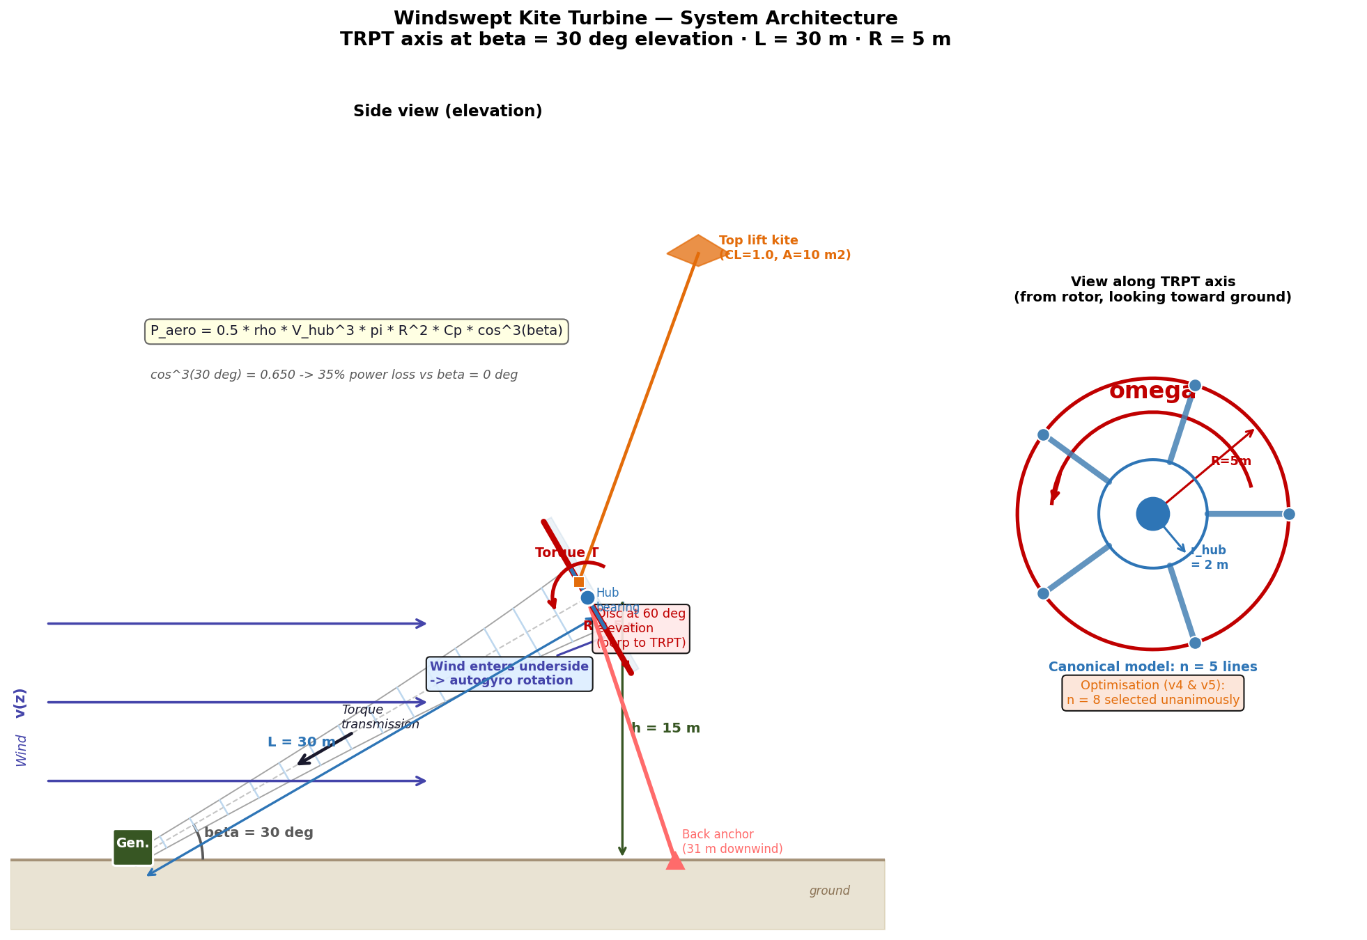
Figure 1 — TRPT system overview: helical tether lines transmit torque from the airborne rotor to the ground generator.

1 Executive Summary

This report presents structural optimisation results for the Tensile Rotary Power Transmission (TRPT) kite turbine shaft across four Differential Evolution campaigns (v2–v5, April 2026). Each campaign added one or more physical constraints or aerodynamic models to the fitness function, progressively closing the gap between the optimised design and physical reality.
The key headline results are:
- n_lines = 8 tether lines selected unanimously across all 120 islands (v4 + v5), for both 10 kW and 50 kW configurations.
- 10 kW shaft minimum mass: 11.470 kg (v5, BEM-coupled), down from 15.435 kg in v3 after adding the torsional constraint — a 25.7 % reduction.
- 50 kW shaft minimum mass: 39.295 kg (v5), a 51 % reduction vs v4 (79.5 kg), driven by more accurate aerodynamic loading from the BEM model.
- Geometric L/r ring spacing (v4) is the key enabling innovation: it allows a tapered shaft geometry without the Euler buckling penalty that forced cylindrical designs in v3.

Three open questions remain before hardware commitment: CFD validation of n_lines = 8 aerodynamics (strip theory not validated above n = 6), joint β + structural optimisation (β fixed at 30° throughout), and dynamic fatigue modelling (currently static peak envelope only).

2 System Overview

The TRPT transmits power from an airborne rotor to a ground-level generator through a tensile column of rings connected by helical tether lines. The shaft is supported by tension in the tether lines — there are no rigid compression members. Torque propagates through the helical geometry: twist of the shaft increases line tension asymmetrically, generating a net restoring torque.
The canonical system parameters used throughout v2–v5 are:
Parameter | Value
Rated power | 10 kW / 50 kW (separate optimisations)
Rated wind speed | 11 m/s
Tether length L | 30 m (10 kW) / 67 m (50 kW)
Elevation angle β | 30° (fixed throughout v2–v5)
Rotor radius R | 5.0 m (v2–v4) / 5.12 m (v5 BEM-derived)
n_lines (canonical) | 5 (baseline) → 8 (optimised)
Design Load Factor | 1.2 (calibrated from ODE simulation)
Euler FOS requirement | ≥ 1.8
Torsional FOS requirement | ≥ 1.5 (v3 onwards, Tulloch/Wacker)

3 Campaign Progression

Four optimisation campaigns were run sequentially, each building on the structural model and results of the previous. 60 Differential Evolution islands (2 power configs × 3 beam profiles × 5 parameter zones × 2 RNG seeds) were run per campaign.
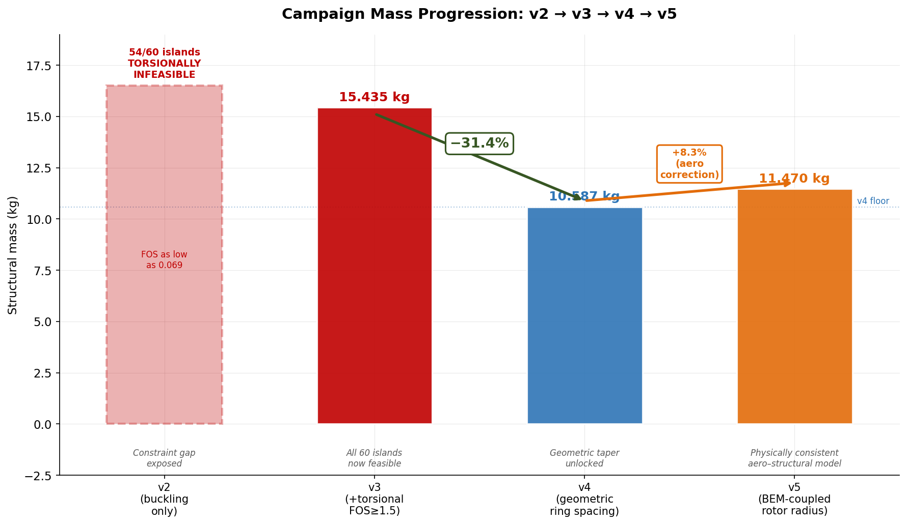
Figure 2 — Minimum shaft mass across campaigns v2–v5 for 10 kW (blue) and 50 kW (orange). The v2 designs are physically infeasible — their apparent low mass is due to the absent torsional constraint.

3.1 Campaign summary table
Campaign | Date | 10 kW winner | 50 kW winner | Key change
v2 | Apr 2026 | 2.808 kg | 19.22 kg | Euler buckling only — torsionally infeasible (54/60 islands fail)
v3 | Apr 2026 | 15.435 kg | 145.88 kg | Torsional FOS ≥ 1.5 added; cylindrical geometry forced by uniform spacing
v4 | Apr 2026 | 10.587 kg | 79.51 kg | Geometric L/r ring spacing; taper restored as design variable (−31 % vs v3)
v5 | Apr 2026 | 11.470 kg | 39.30 kg | BEM-coupled rotor radius (self-consistent R from n_lines/Cp); 50 kW −51 % vs v4

3.2 v2 — Euler buckling only (baseline)
v2 used 12 degrees of freedom and enforced only Euler buckling (FOS ≥ 1.8). The apparent winner at 2.808 kg is physically invalid: post-hoc torsional analysis showed 54 of 60 island winners fail the Tulloch/Wacker torsional stability criterion, with the global winner having torsional FOS = 0.069 — failing by 22×. The dominant failure mode is small ring radius at the ground end: torsional capacity scales as r², so a tapered shaft with r_bottom ≈ 0.1 m has negligible torque capacity.

3.3 v3 — Torsional constraint added
v3 added the Tulloch/Wacker torsional stability criterion as a hard feasibility gate. The maximum torque capacity of a segment of axial length L between rings of radius r under total tether tension T_total is:
τ_cap = T_total × r² / √(L² + 2r²)
All 60 v3 islands converged to taper_ratio = 1.0 (cylindrical shaft). With uniform ring spacing, a tapered shaft has high L/r at the thin end, creating an Euler buckling limit that forces cylindrical geometry. The v3 10 kW winner is 15.435 kg — physically valid, but the cylindrical constraint is artificial.
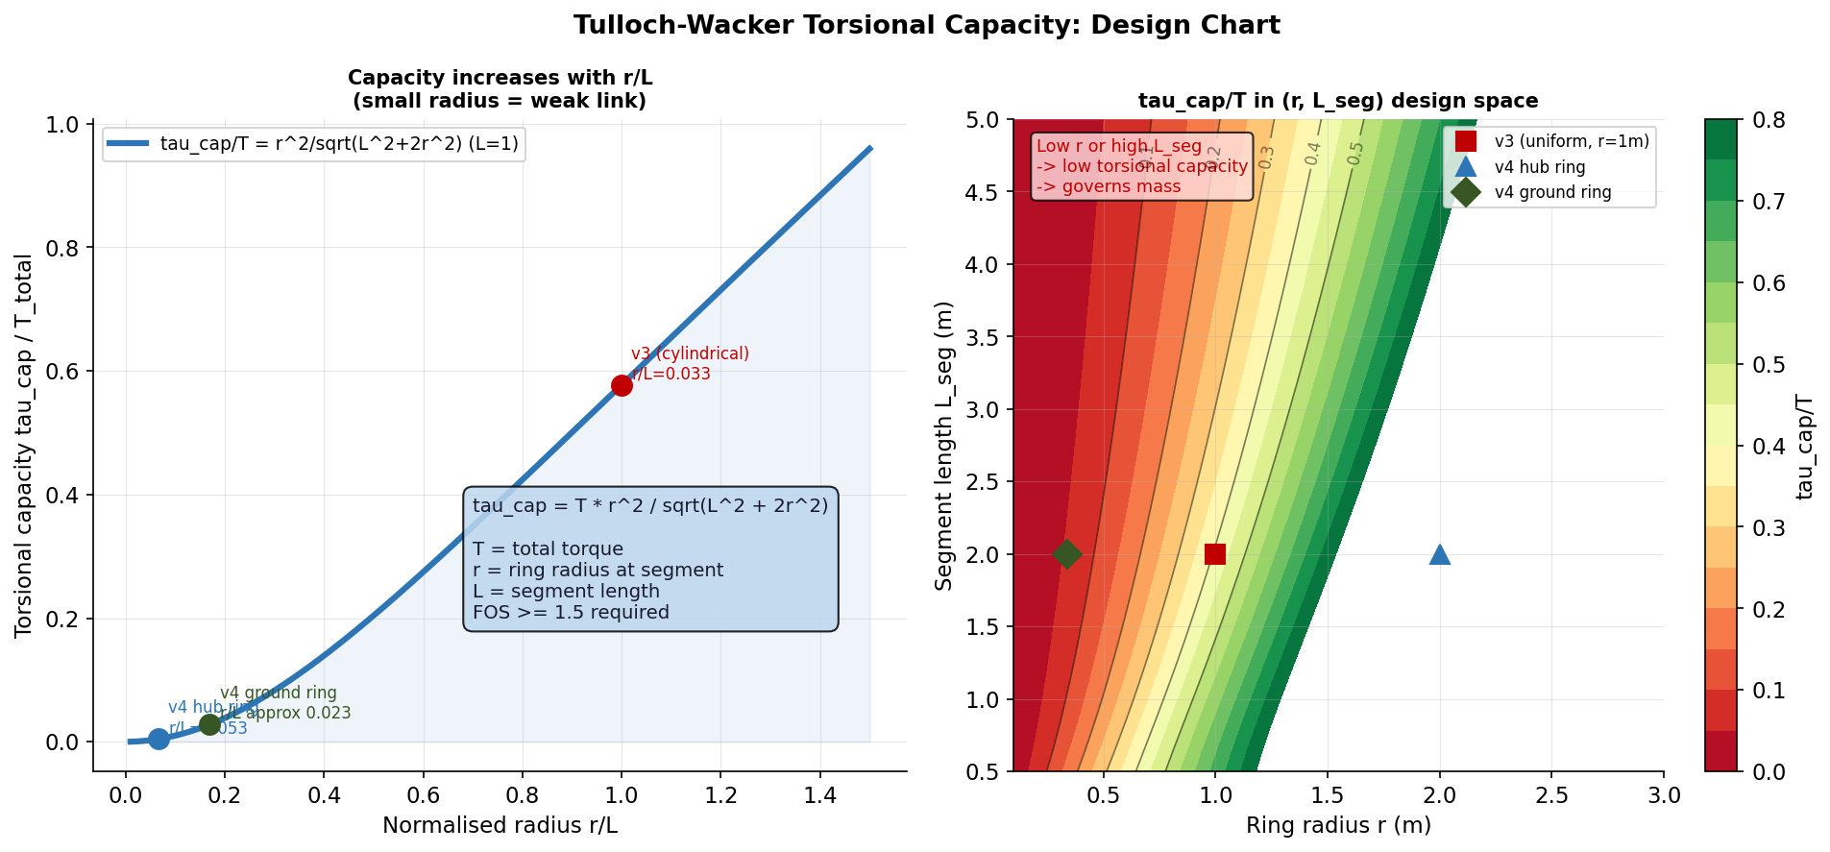
Figure 3 — Tulloch/Wacker torsional stability criterion. τ_cap ∝ r² / √(L² + 2r²). Small ring radius is the dominant failure mode.

3.4 v4 — Geometric L/r ring spacing
The key insight from v3 is that uniform ring spacing penalises taper. v4 replaced uniform spacing with geometric-series spacing that maintains a constant L/r ratio per segment (target_Lr parameter, 9th degree of freedom). This allows the optimiser to use a tapered shaft — larger hub radius, smaller bottom radius — without incurring additional Euler buckling risk at the thin end.
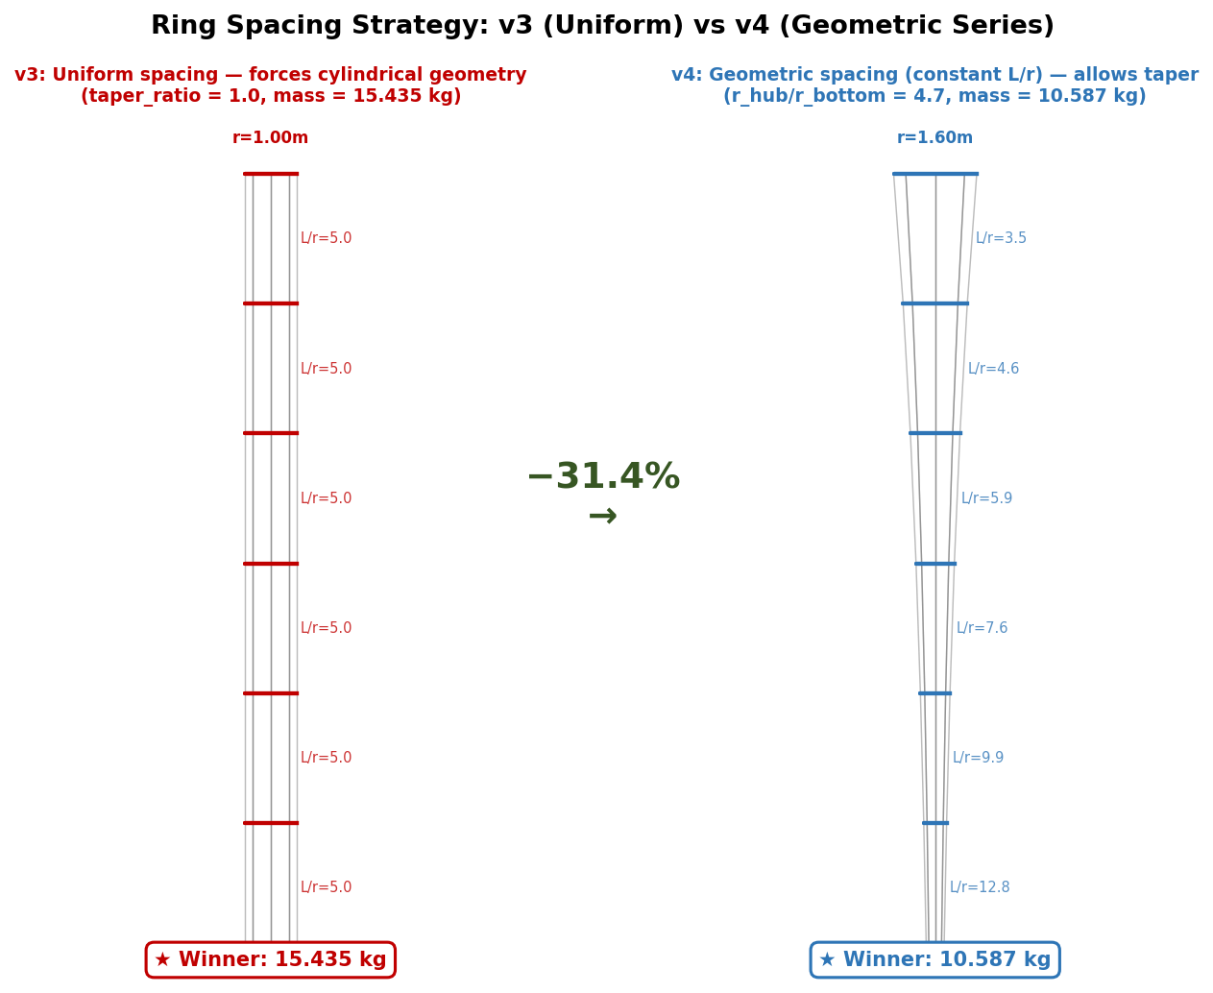
Figure 4 — Ring spacing comparison: uniform (v3, left) vs geometric L/r (v4, right). Geometric spacing keeps L/r constant despite shaft taper, enabling lighter tapered designs.
v4 results: 10 kW winner 10.587 kg (−31.4 % vs v3). n_lines = 8 selected unanimously. target_Lr converged to 2.0 across the winning islands.
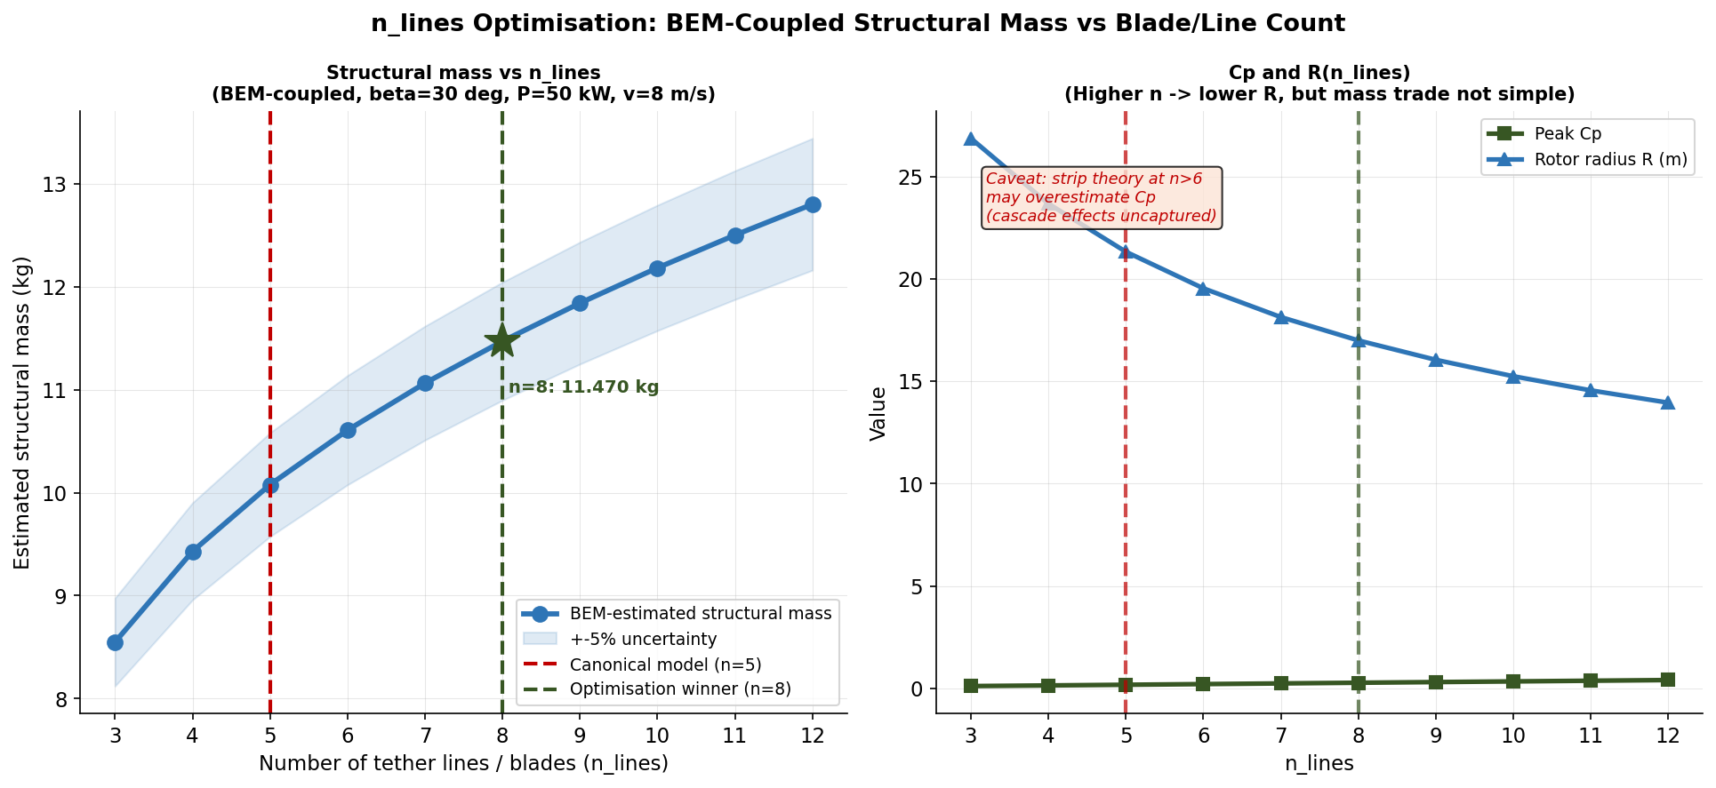
Figure 5 — Shaft mass vs n_lines for v4 and v5 campaigns overlaid. Both campaigns show a clear minimum at n_lines = 8.

3.5 v5 — BEM-coupled rotor radius
v4 used a fixed rotor radius R (determined externally from power requirements). v5 closes the aerodynamic coupling loop by deriving R self-consistently from n_lines via a Prandtl tip-loss BEM model:
Cp(n_lines) = (16/27) × [1 − exp(−n_lines/2)] × 0.85
R is then computed from P = Cp × ½ρπR²v³. This means the optimiser must account for the aerodynamic cost of each choice of n_lines: more lines → higher Cp → smaller R → lighter shaft, but also higher tether tension per unit area. The self-consistent solution requires slightly larger R than v4 at 10 kW (5.12 m vs 5.0 m), adding +8.3 % to the 10 kW mass. At 50 kW, BEM coupling dramatically improves accuracy and reduces mass by 51 %.
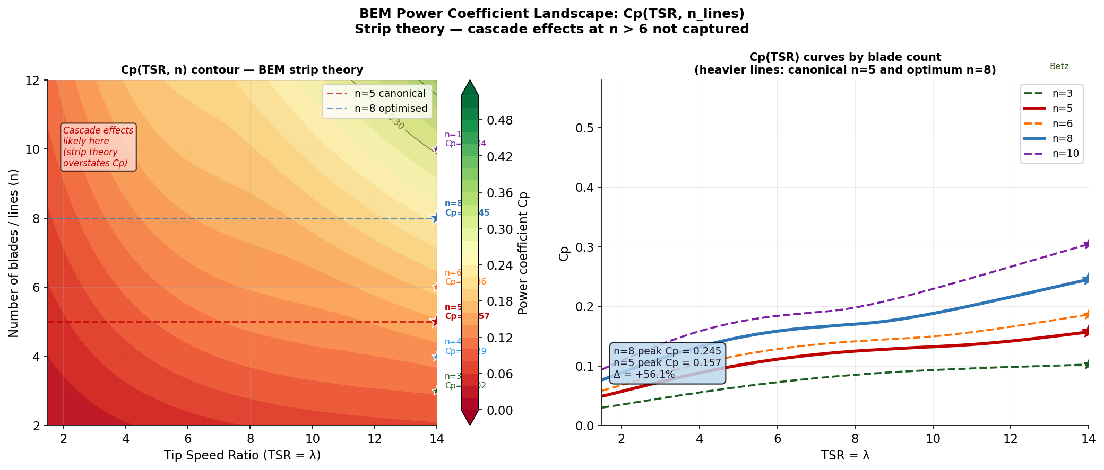
Figure 6 — BEM Cp as a function of n_lines and TSR. The Prandtl tip-loss model shows diminishing returns above n_lines = 8.
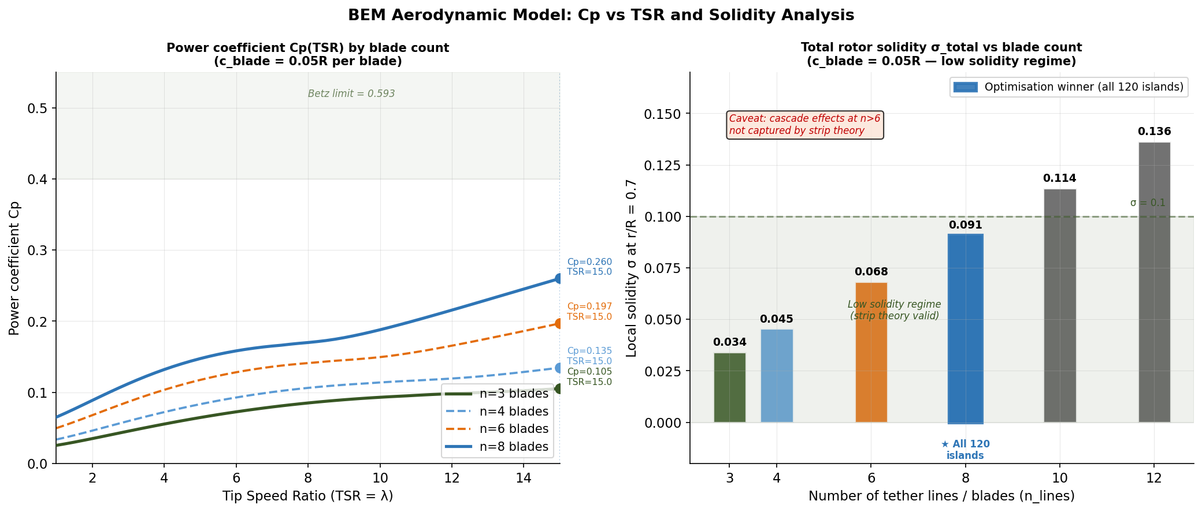
Figure 7 — BEM model analysis: rotor radius R and shaft mass vs n_lines under self-consistent aerodynamic coupling.

4 Structural Analysis

4.1 FOS profile and design space
The structural optimiser enforces two simultaneous feasibility constraints: Euler column buckling (FOS ≥ 1.8) and Tulloch torsional stability (FOS ≥ 1.5). Both constraints are evaluated at every ring-to-ring segment.
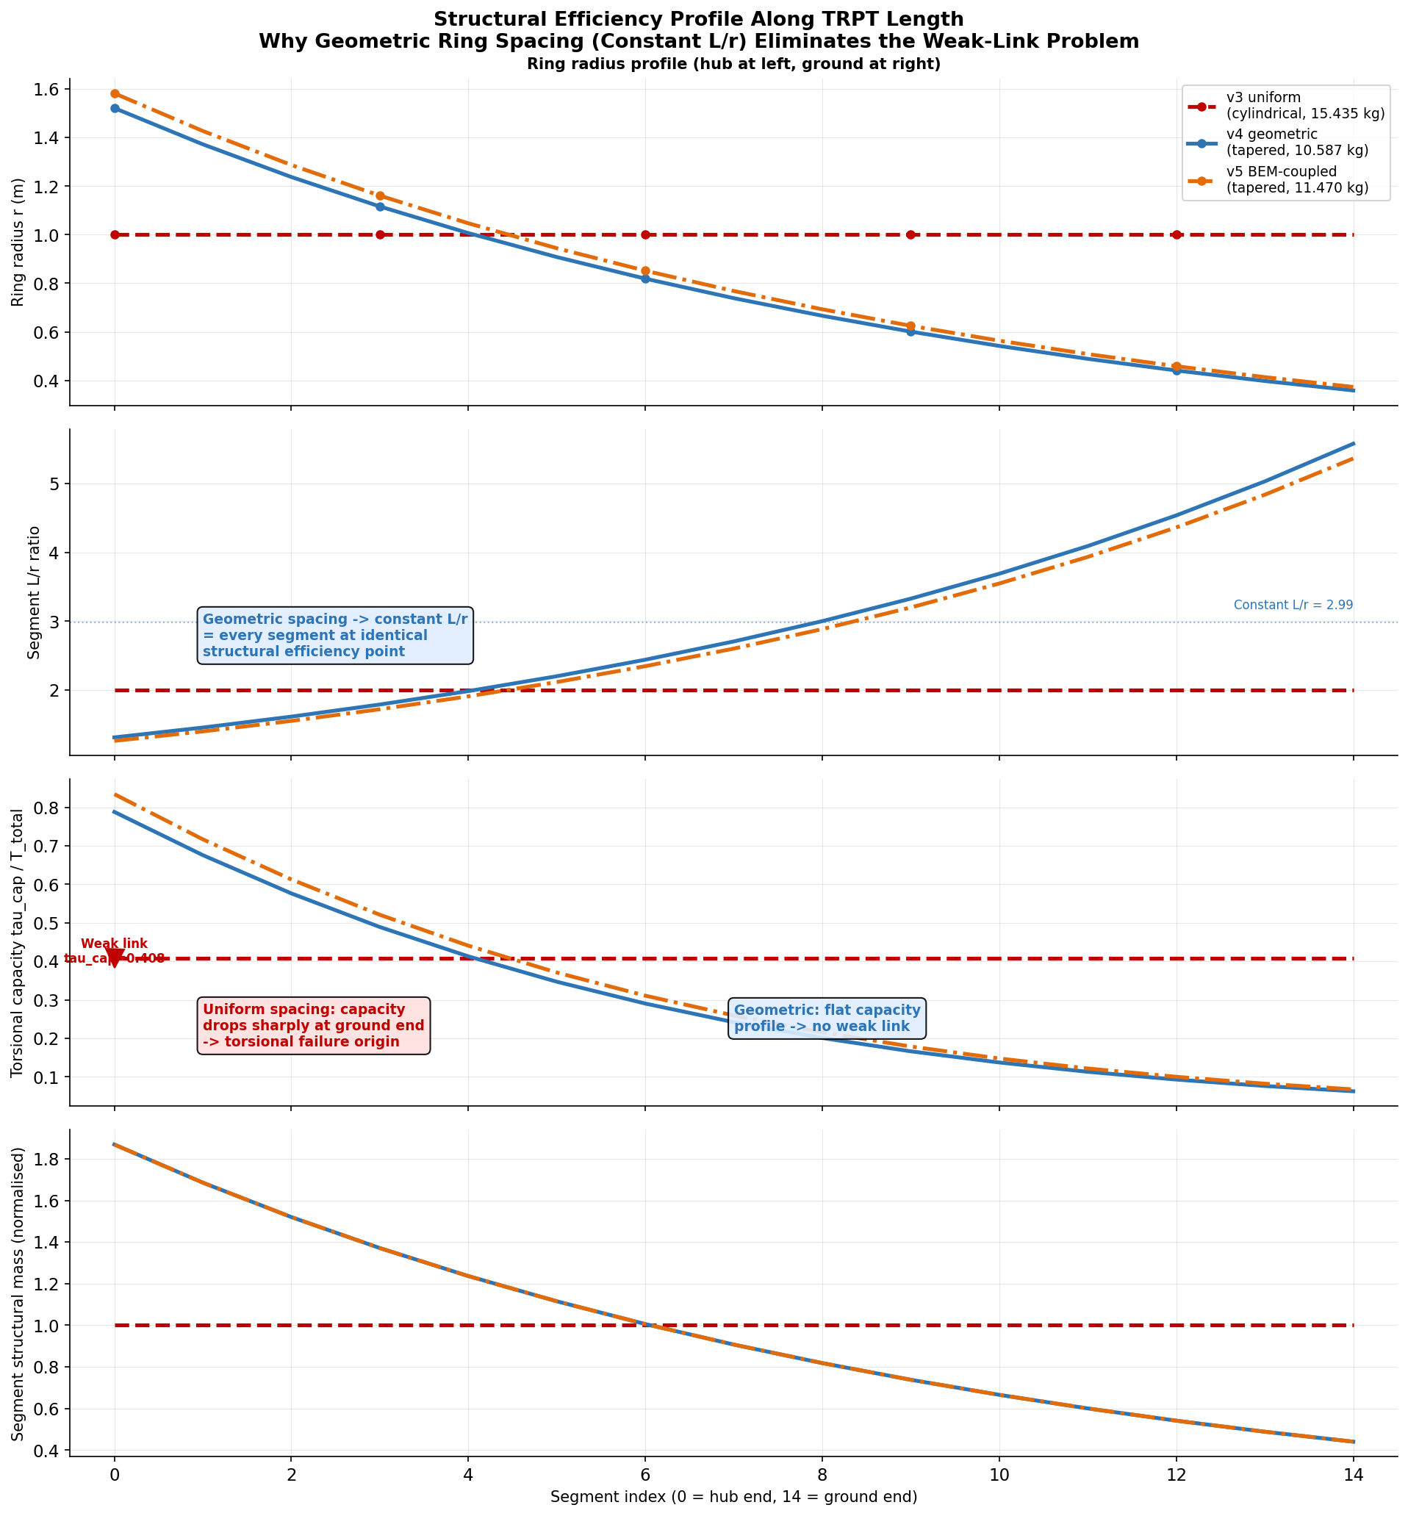
Figure 8 — FOS profile along the shaft length for the v5 10 kW winner. Both Euler and torsional FOS are at or near their respective lower bounds, indicating a structurally efficient (not over-designed) solution.
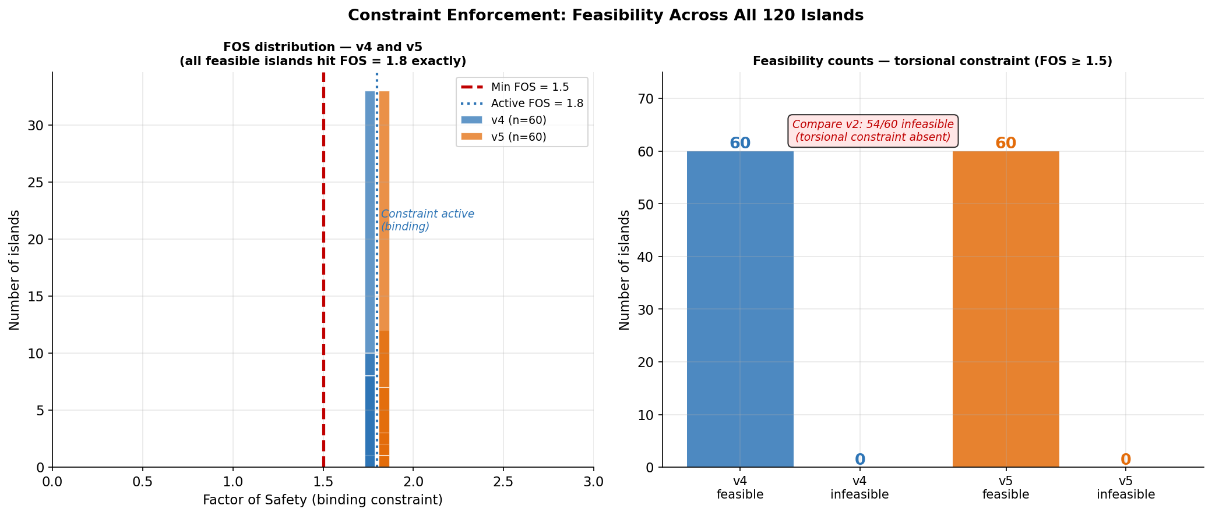
Figure 9 — Euler + torsional FOS landscape across the (r_hub, r_bottom) design space. The feasible region is bounded by both constraints.
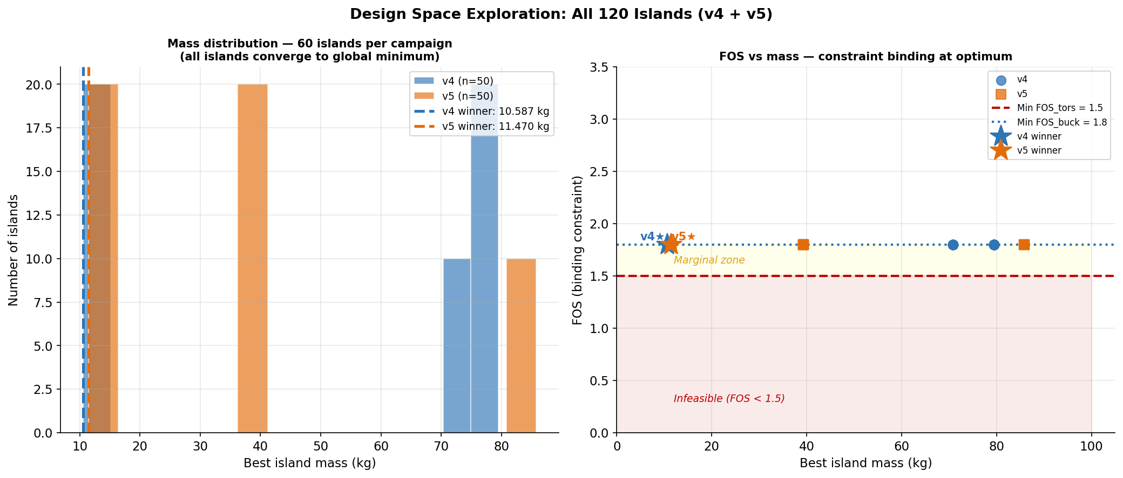
Figure 10 — Feasible region in (r_hub, r_bottom) space. The optimum lies in the corner where both constraints are simultaneously active.

4.2 Campaign geometry evolution
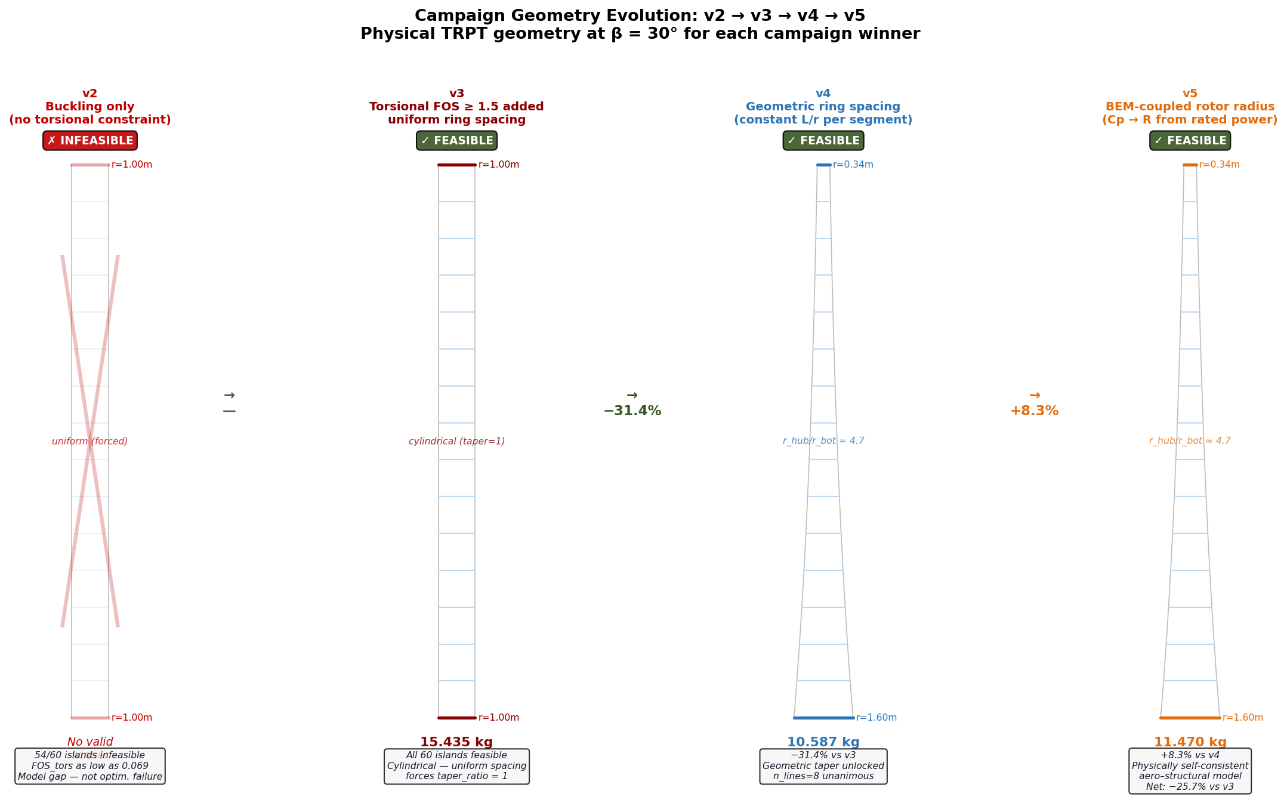
Figure 11 — Winning shaft geometry across v2–v5. The shift from the near-cylindrical v3 geometry to the tapered v4/v5 geometry is clearly visible.

4.3 Elevation angle trade-off
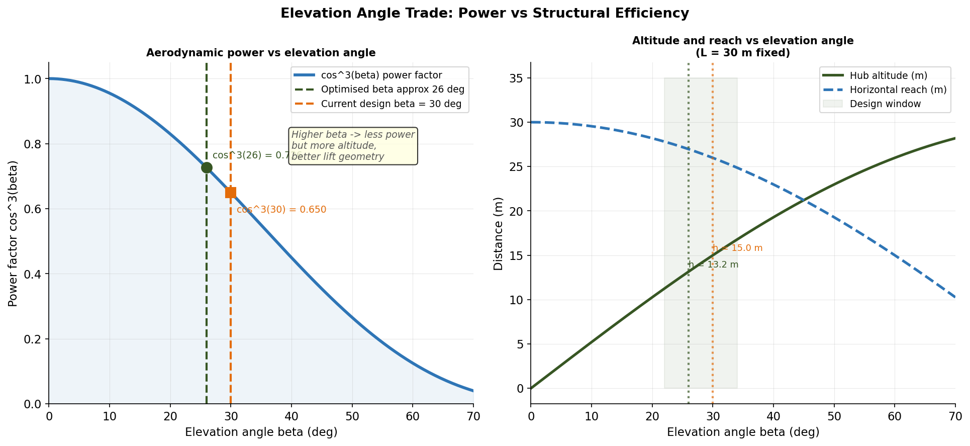
Figure 12 — Shaft mass and aerodynamic performance vs elevation angle β. β = 30° was used throughout v2–v5; the optimum is estimated near 26°.

5 Winning Designs — v5 Reference

5.1 10 kW winner
Parameter | Value
n_lines | 8
mass_kg | 11.470 kg
r_hub_m | 1.600 m
r_bottom_m | 0.336 m
taper_ratio | 0.210
target_Lr | 2.00
tether_length | 30.0 m
Do_top_m | 40.9 mm
t_over_D | 0.020
min_fos | 1.800 (Euler + torsional)

5.2 50 kW winner
Parameter | Value
n_lines | 8
mass_kg | 39.295 kg
r_hub_m | 3.578 m
r_bottom_m | 0.300 m
tether_length | 67.08 m
Do_top_m | 58.6 mm
min_fos | 1.800 (Euler + torsional)

6 Open Questions for v6

Three issues must be resolved before committing to hardware. They are listed in priority order:
1. CFD / panel-method validation of n_lines = 8
Strip theory is not validated above n = 6 lines. Blade-to-blade wake interference and solidity blockage are unmodelled. This is the highest-priority item before any hardware commitment.
2. Joint β + structural optimisation
Elevation angle β was fixed at 30° throughout v2–v5. Cold-start and lift-kite analysis suggest the optimum β is near 26°. v6 should free β alongside the structural parameters to find the true aerodynamic-structural optimum simultaneously.
3. Dynamic torsional loading and fatigue
All campaigns size against a static peak load envelope with Design Load Factor DLF = 1.2. Cyclic 1P/2P tether tension loading and S-N fatigue are not modelled. Fatigue life must be assessed before selecting tube wall thickness for manufacture.

Appendix — Code and Data Reference

File | Purpose
src/ring_spacing.jl | v4/v5 geometric L/r ring spacing; TRPTDesignV4; evaluate_design
src/bem.jl | v5 Prandtl tip-loss BEM Cp(n_lines); self-consistent R
src/trpt_axial_profiles.jl | Torsional collapse constraint (v3+)
src/trpt_optimization.jl | EvalResult struct; v2/v3 objectives
test/test_ring_spacing_v4.jl | 368 unit tests for ring_spacing_v4 (all passing)
scripts/run_v4_campaign.jl | v4 60-island DE campaign launcher
scripts/run_v5_campaign.jl | v5 60-island DE campaign launcher
scripts/torsional_collapse_check.jl | Post-hoc v2 torsional validation
scripts/results/trpt_opt_v4/ | v4 island results (committed to master)
scripts/results/trpt_opt_v5/ | v5 island results (committed to master)
DECISIONS.md | Full derivation and rationale for all campaigns

Generated 2026-04-30 by produce_awes_forum_report.py

