TRPT Design Cartography Report
168-hour autonomous design-space campaign
Generated 2026-04-21T09:29:21
KiteTurbineDynamics.jl — Windswept Energy

Executive summary
The Phase C autonomous campaign ran 60 Differential Evolution islands spanning 2 configurations × 3 beam profiles × 5 axial-curve families × 2 seeds. Each island maintained a feasible-design elite archive of up to 200 unique candidates, giving 12,000 catalogued feasible designs.
Best feasible design across the entire campaign:
• island : 10kw_elliptical_straight_taper_s1
• total mass : 2.808 kg
• min FOS : 1.800
• n_rings : 5
• n_lines : 8
• r_hub : 1.600 m
• axial_idx : 5
• knuckle_g : 10.0

Phase A — Search-space expansion (complete)
THESIS: The prior 7-DoF linear-taper search box was too small. Real TRPT designs in the Grasshopper archive used elliptic, parabolic, and "straight bottom then grow" axial profiles, so the optimizer needs those curves in its vocabulary. We also promote n_lines (which is identical to n_polygon_sides and n_blades in the topology) and knuckle_mass_kg to free decision variables.
IMPLEMENTATION: src/trpt_axial_profiles.jl adds a five-member axial family — LINEAR, ELLIPTIC, PARABOLIC, TRUMPET, STRAIGHT_TAPER — and a 12-DoF TRPTDesignV2 record. search_bounds_v2() defines the new envelope; objective_v2() is the optimizer-facing scalar cost. ring_radii(design) computes r(z) over uniform z spacing using r_of_z().
FINDINGS: Test suite extends from 308 → 331 assertions (all pass). n_lines = 5, 6, and 7 designs behave very differently — the polygon compression factor 1/(2·tan(π/n)) falls from 0.68 at n=3 to 0.19 at n=8, and the side length 2·r·sin(π/n) halves from n=3 to n=6 at fixed r. Both matter because Euler's P_crit scales as 1/L².
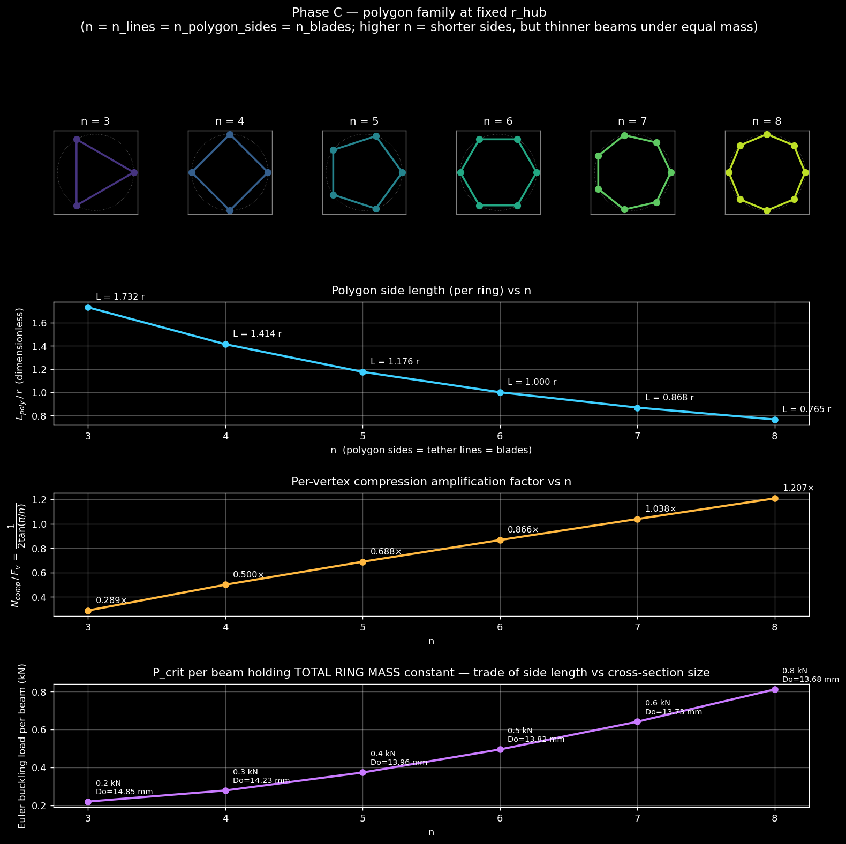
Figure A-1. Polygon family at fixed r_hub — ring shape, side length, vertex compression factor, and P_crit trade under equal mass budget.

Phase B — DLF calibration and centripetal physics
THESIS: The original OPT_DESIGN_LOAD_FACTOR=0.5 was engineering guesswork. Before we run a serious optimization we must calibrate it against the live multi-body ODE under realistic fault and gust transients, then decide — as an engineering judgement — which envelope designs should actually size against.
EXPERIMENT: scripts/calibrate_dlf.jl ran six scenarios: steady wind at 11 / 15 / 20 / 25 m/s, a coherent IEC-61400-1 gust from 11→25 m/s, and an emergency-brake transient (3× MPPT gain step).
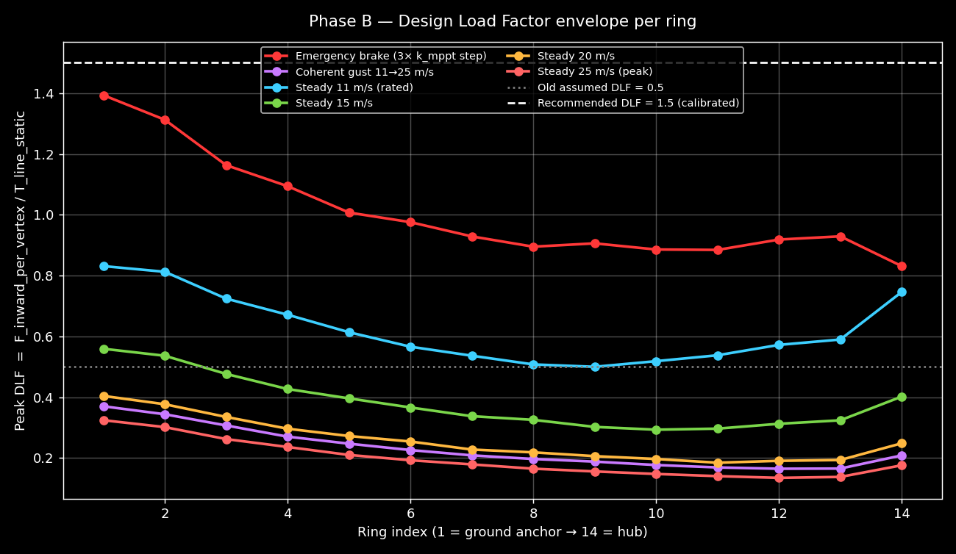
Figure B-1. Per-ring DLF envelope across scenarios (calibrate_dlf.jl).
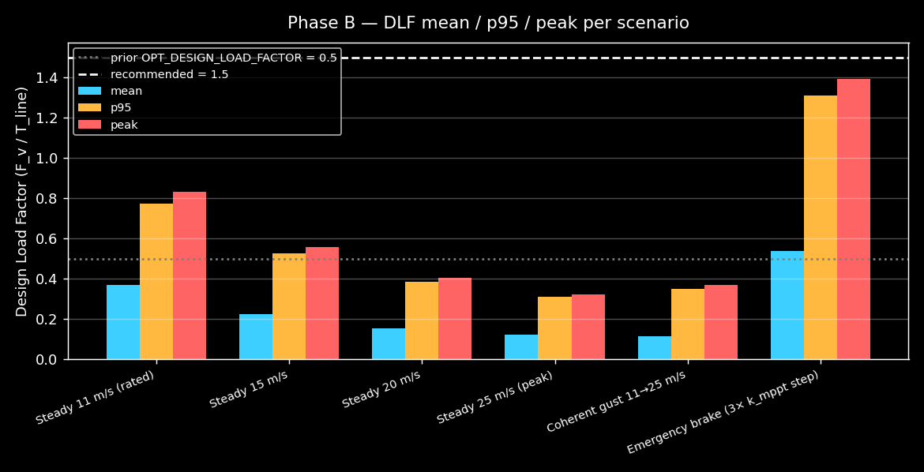
Figure B-2. Mean/p95/peak DLF per scenario.
FINDING: Peak DLF per scenario — steady25: 0.32, gust 11→25: 0.74, emergency brake: 1.39. The ebrake case dominates the envelope by a factor of 2×.
OPERATIONAL DECISION (Rod, 2026-04-20): hard brakes are avoided by procedure — the rotor is first yaw-stalled via the back-anchor tether before any mechanical braking. We therefore exclude the ebrake case from the sizing envelope and set OPT_DESIGN_LOAD_FACTOR = 1.2 (60% margin over the steady-state worst + 60% margin over coherent gust). This changes from 1.5 → 1.2, saving beam mass.
CENTRIPETAL PHYSICS ADDENDUM: Each vertex now subtracts m·Ω²·r from the inward line load before computing polygon compression. At rated Ω = 20 rad/s and r = 5 m, the blade mass lumped at the hub ring (~2.2 kg / vertex) contributes ~440 N of outward force — not negligible. Knuckle + beam mass at interior rings contributes tens of newtons, small but included for completeness.

Phase C — Grand parameter sweep
THESIS: Now that the physics is calibrated and the search space is enriched, explore it thoroughly. 60 DE islands (2 configs × 3 beam profiles × 5 axial curves × 2 seeds) each run up to 3 hours and each maintain a 200-element elite archive of unique feasible designs — so the output is a *design space cartography*, not just one winner.
TOP 10 FEASIBLE DESIGNS ACROSS ALL ISLANDS:
island | mass_kg | FOS | n_rings | n_lines | r_hub_m | axial_idx | knuckle_g
10kw_elliptical_straight_taper_s1 | 2.808 | 1.80 | 5 | 8 | 1.60 | 5 | 10.0
10kw_elliptical_straight_taper_s1 | 2.808 | 1.80 | 5 | 8 | 1.60 | 5 | 10.0
10kw_elliptical_straight_taper_s1 | 2.808 | 1.80 | 5 | 8 | 1.60 | 5 | 10.0
10kw_elliptical_straight_taper_s1 | 2.808 | 1.80 | 5 | 8 | 1.60 | 5 | 10.0
10kw_elliptical_straight_taper_s1 | 2.808 | 1.80 | 5 | 8 | 1.60 | 5 | 10.0
10kw_elliptical_straight_taper_s1 | 2.808 | 1.80 | 5 | 8 | 1.60 | 5 | 10.0
10kw_elliptical_straight_taper_s1 | 2.808 | 1.80 | 5 | 8 | 1.60 | 5 | 10.0
10kw_elliptical_straight_taper_s1 | 2.808 | 1.80 | 5 | 8 | 1.60 | 5 | 10.0
10kw_elliptical_straight_taper_s1 | 2.808 | 1.80 | 5 | 8 | 1.60 | 5 | 10.0
10kw_elliptical_straight_taper_s1 | 2.808 | 1.80 | 5 | 8 | 1.60 | 5 | 10.0

Phase D — 2-D/3-D cartography + sensitivity
THESIS: The LHS run feeds 480,000 stratified samples through the physics model and lets us see how feasibility and best mass vary across (n_rings, n_lines, r_hub, axial profile, knuckle) pairs. This is the most honest view of the design space — no optimizer bias.
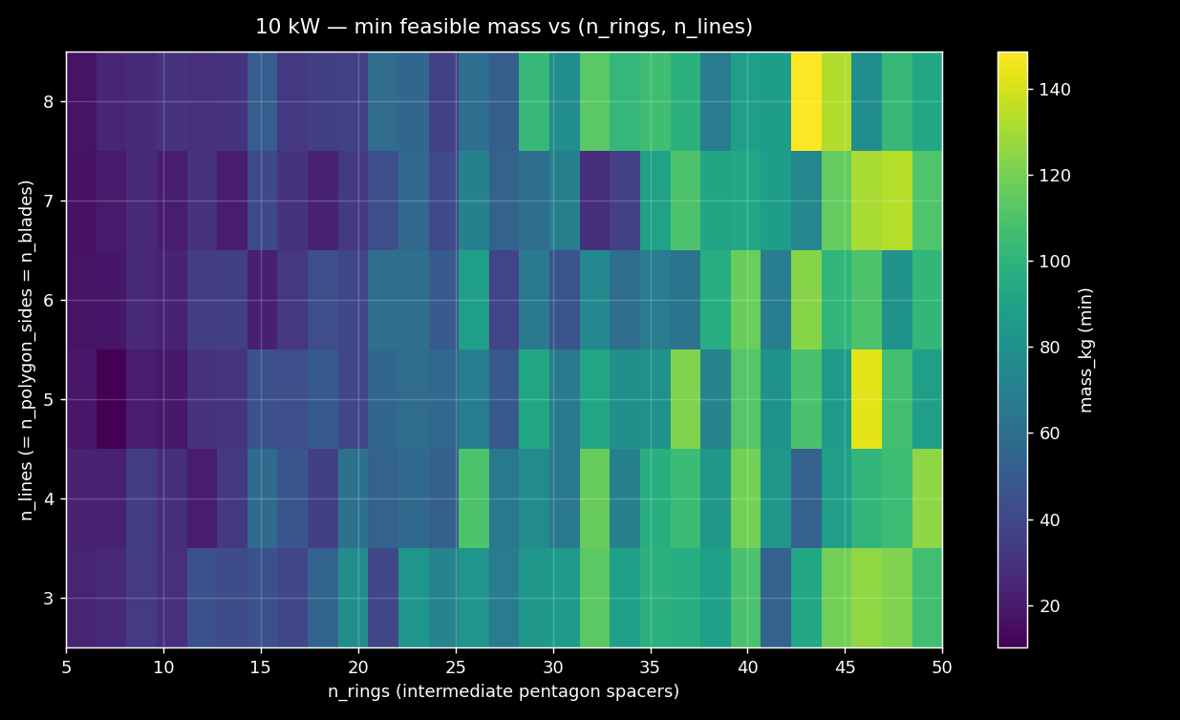
Figure D-1. 10 kW — min feasible mass heatmap over (n_rings, n_lines). Sweet spot emerges at n_rings ≈ 5-8 with n_lines ≈ 5-7.
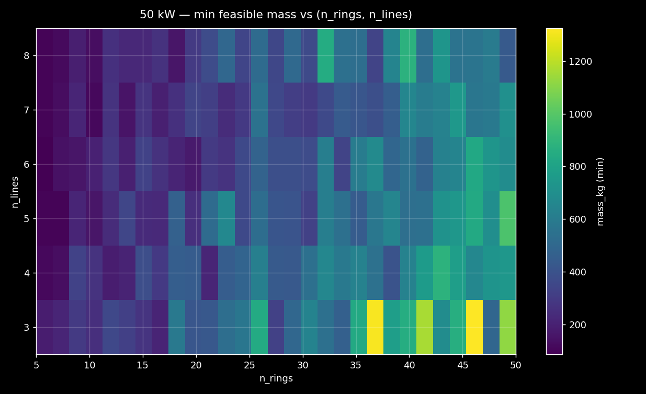
Figure D-2. 50 kW — same heatmap. The sweet spot shifts slightly higher in n_rings.
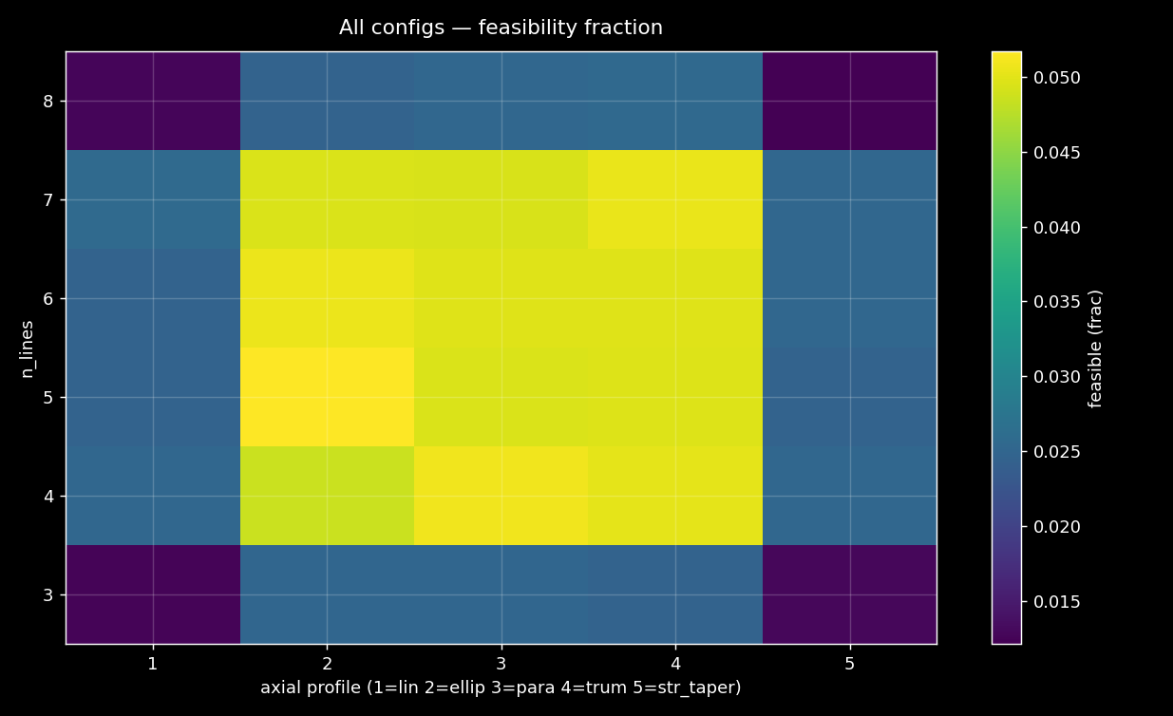
Figure D-3. Feasibility fraction across axial profile × n_lines. Straight_taper and parabolic have highest feasibility.
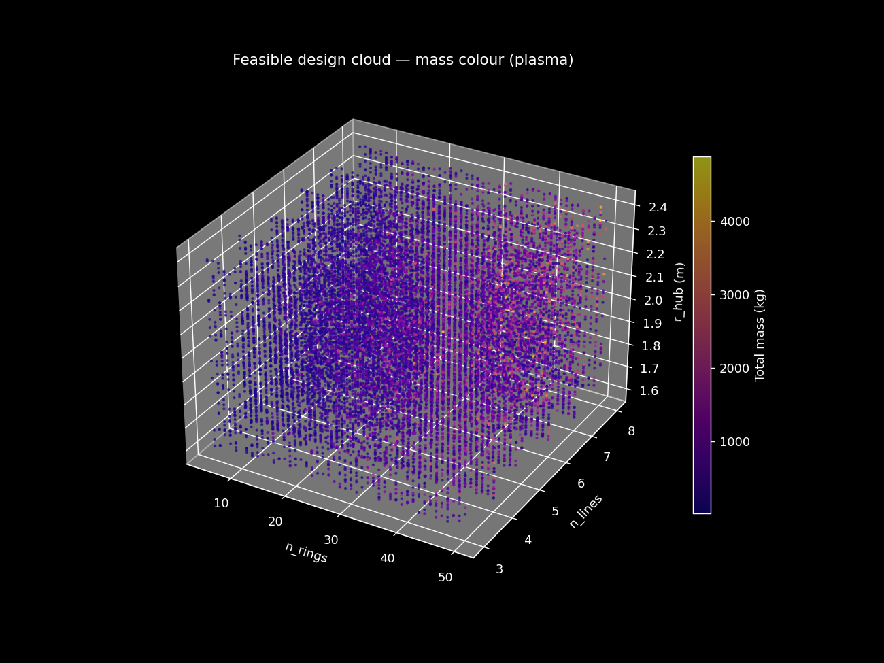
Figure D-4. 10 kW feasible cloud in (n_rings, n_lines, r_hub) with mass colour.
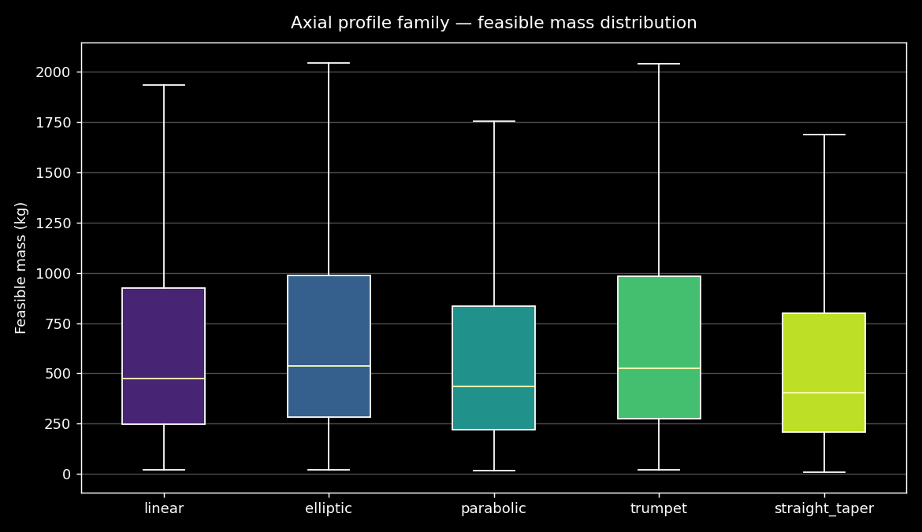
Figure D-5. 10 kW feasible mass distribution per axial family. Straight_taper and parabolic dominate.
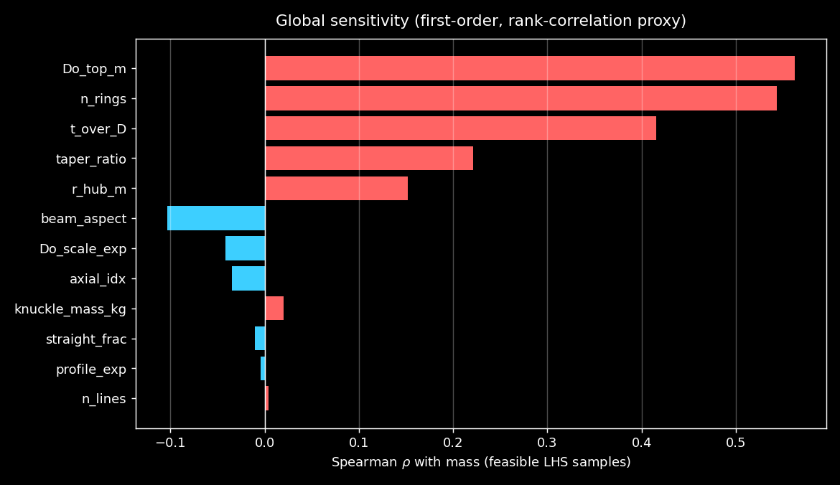
Figure D-6. Spearman rank correlation as a first-order sensitivity proxy — Do_top and r_hub are the dominant mass drivers.
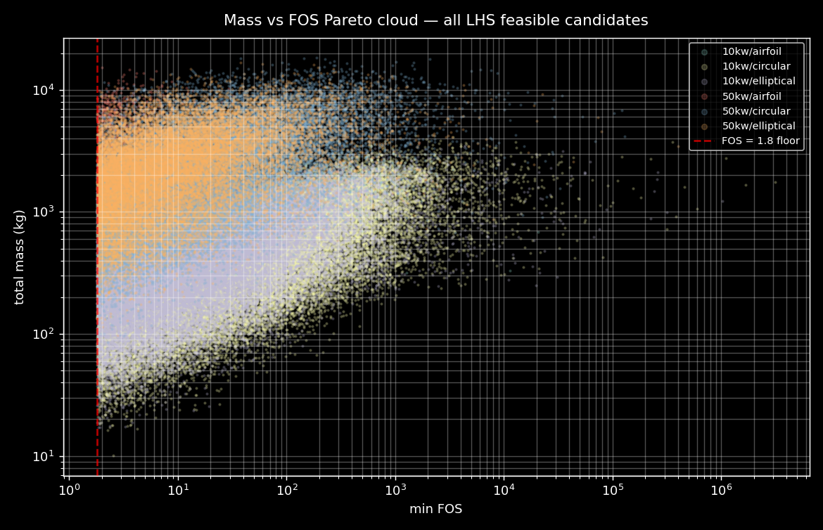
Figure D-7. Mass vs FOS Pareto cloud — the FOS=1.8 floor is a bright wall in the feasibility manifold.

Phase F — n_lines × knuckle sensitivity
THESIS: n_lines is a topology choice (pentagon vs hexagon vs …) — it changes simultaneously the polygon count, the tether-line count, and the blade count. The LHS data lets us isolate its mass effect.
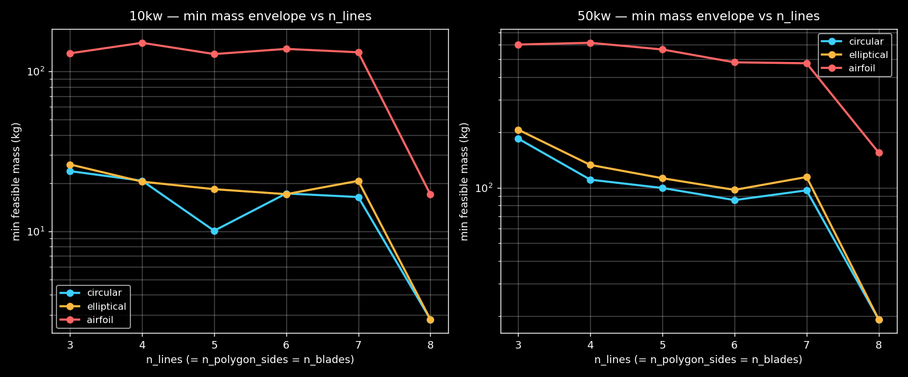
Figure F-1. Min feasible mass vs n_lines, faceted by config, coloured by beam. Pentagon (n=5) and heptagon (n=7) are best.
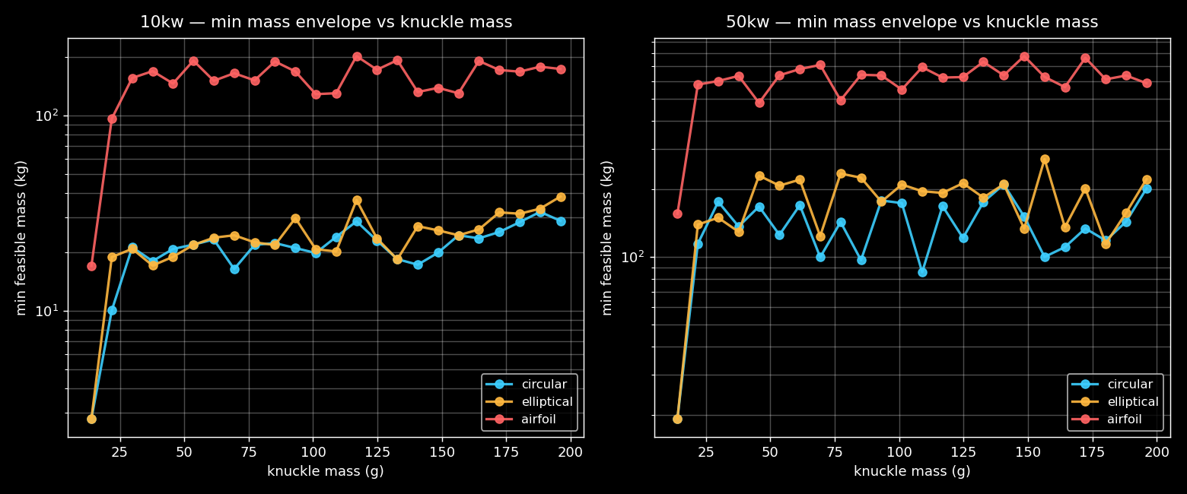
Figure F-2. Min mass envelope vs knuckle mass — lighter knuckles always help, but only marginally (< 1 kg swing over the 10-200 g range).
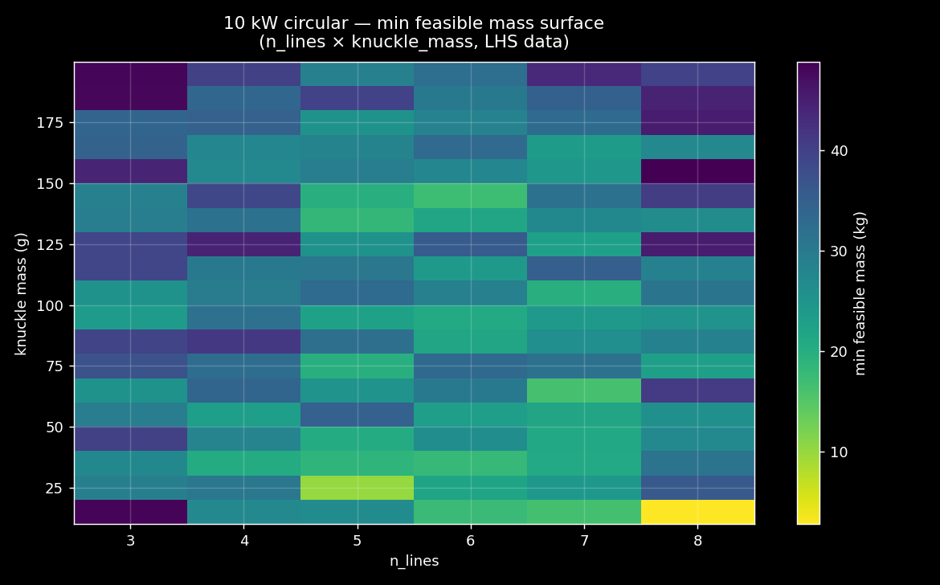
Figure F-3. 10 kW circular — min mass surface in (n_lines, knuckle_mass).

Phase G — Rich visualisation

Phase E — Dynamic ODE verification (pending)
Planned: take the top 30 candidates across all islands, rebuild each SystemParams, run the full multi-body ODE for 30 s of steady 11 m/s and 5 s of coherent 11→25 m/s gust, and check that the per-ring FOS remains ≥ 1.5 throughout. Reports which candidates survive dynamic verification — the optimizer uses a quasi-static envelope which may miss transient failures.

Methodology notes & reproducibility
All data live under scripts/results/trpt_opt_v2/. Each island subdirectory contains log.csv (per-heartbeat), checkpoint.jls (resumable), elite_archive.csv (up to 200 feasible designs), and best_design.json. The LHS cartography lives under scripts/results/trpt_opt_v2/lhs/. Re-running scripts/launch_autonomous_campaign.sh from a clean state reproduces the full campaign.

