TRPT Vortex Expansion Analysis
Centrifugal Expansion, Wind Shear Harvesting, and Vortex Cone Geometry
in Stacked TRPT Kite Turbine Systems
Windswept & Interesting Ltd · April 2026

1 Executive Summary
Stacking multiple TRPT rotor sections along an inclined shaft axis creates an opportunity that has not been captured in previous performance models: as each higher rotor sits at greater altitude, it operates in faster wind and — uniquely to the TRPT topology — is free to expand its radius under centrifugal load to the TSR-optimal diameter for that faster wind. The resulting geometry is a tapered vortex cone, wide at the top and slender at the root, that naturally aligns with both the Hellmann wind gradient and optimal aerodynamic loading.
Previous modelling treated all stacked rotors as identical (R = 5 m, v = 11 m/s) and found P/W declining with stacking due to the structural mass penalty of torque accumulation. That model was missing two physical effects:
- Wind shear: rotor 2 sits at 30 m (v = 12.14 m/s, +10.4%); rotor 3 at 45 m (v = 12.87 m/s, +17.0%).
- TSR-matched radius expansion: at fixed shaft ω = 9.02 rad/s, optimal R₂ = 5.52 m (+10.4%) and R₃ = 5.85 m (+17.0%).
Correcting for both effects reverses the stacking trend completely. The 3-rotor system with vortex expansion reaches P/W = 676 W/kg — 29% above the single-rotor baseline of 523 W/kg — and delivers 44.2 kW total power from 65.4 kg of airborne mass. This is summarised in Table 1 and detailed in the sections that follow.
Table 1 — Key results across all modelled scenarios (n_blades = 5).
Configuration | P_total (kW) | Mass (kg) | P/W (W/kg) | vs Baseline
1 rotor, baseline | 9.1 | 17.5 | 523 | —
2 rotors, baseline | 18.3 | 37.3 | 490 | −6.3%
3 rotors, baseline | 27.4 | 58.9 | 466 | −10.9%
2 rotors, wind shear | 21.5 | 37.3 | 575 | +10.0%
3 rotors, wind shear | 36.1 | 58.9 | 613 | +17.2%
2 rotors, shear+expansion | 24.2 | 39.7 | 608 | +16.3%
3 rotors, shear+expansion | 44.2 | 65.4 | 676 | +29.3%

2 Physical Basis

2.1 Wind Shear Profile
The Hellmann wind shear model gives hub wind speed as v(h) = v_ref × (h/h_ref)^(1/7), where v_ref = 11 m/s at h_ref = 15 m (hub altitude of rotor 1, equal to L·sinβ = 30 × sin 30°). Each additional stacked rotor raises the hub altitude by one TRPT section length projected vertically.
At β = 30°, the altitudes and wind speeds are: rotor 1 at h = 15 m → v = 11.00 m/s; rotor 2 at h = 30 m → v = 12.14 m/s (+10.4%); rotor 3 at h = 45 m → v = 12.87 m/s (+17.0%). Because rotor power scales as v³, these velocity gains correspond to power multipliers of ×1.346 and ×1.601 relative to rotor 1.
Note: the previous stacked rotor analysis (TRPT_Stacked_Rotor_Analysis.docx) used a fixed v = 11 m/s for all rotors regardless of altitude, underestimating the 3-rotor P/W by approximately 29%.

2.2 Centrifugal Expansion Mechanism
In a conventional rigid-rotor turbine, rotor radius is fixed by the blade structure. In a TRPT kite turbine, the blades attach at the hub ring periphery via the tether lines but are not rigidly constrained radially. At operating angular velocity, each blade experiences centrifugal acceleration a_c = ω² × r_cm directed outward from the shaft axis. At rated ω = 9.02 rad/s and r_cm ≈ 3 m (blade centre of mass), a_c ≈ 243 m/s², producing an outward force of approximately 900 N per 3.67 kg blade.
This radial stiffness is set by the tether attachment geometry and the hub ring stiffness. The TRPT's helical tether lines act as compliant radial springs: as the hub ring expands, the attachment-point geometry changes and the lines provide a restoring force. Physical experiments confirm that at higher ω (or when deliberate compliance is introduced), the hub ring and blade attachment radius increases measurably — the observation of 'centripetal acceleration stretching the rotors out where the blades attached' in the field trials.

2.3 TSR-Matched Optimal Radius
For a rotor operating at the optimal tip-speed ratio λ_opt = 4.15 (from AeroDyn BEM data), the optimal radius at a given wind speed and shaft angular velocity is:
R_opt = λ_opt × v(h) / ω
With ω = 9.02 rad/s fixed by the shared driveshaft, each rotor at higher altitude has a larger optimal radius. Rotor 2 (v = 12.14 m/s) has R_opt = 5.52 m; rotor 3 (v = 12.87 m/s) has R_opt = 5.85 m. These modest expansions (+10% and +17%) provide additional power gain: P ∝ R²v³, so the combined power multiplier is (5.52/5.00)² × 1.346 = 1.641 for rotor 2 and (5.85/5.00)² × 1.601 = 2.192 for rotor 3.

2.4 Vortex Cone Geometry
The combination of a fixed-radius ground-end TRPT section and progressively larger upper rotors produces a conical shaft geometry: narrow at the ground anchor, widening with altitude. This shape is analogous to a vortex filament cross-section, hence the 'vortex cone' description. Figure 1 shows the geometry for a 3-rotor system at β = 30°.
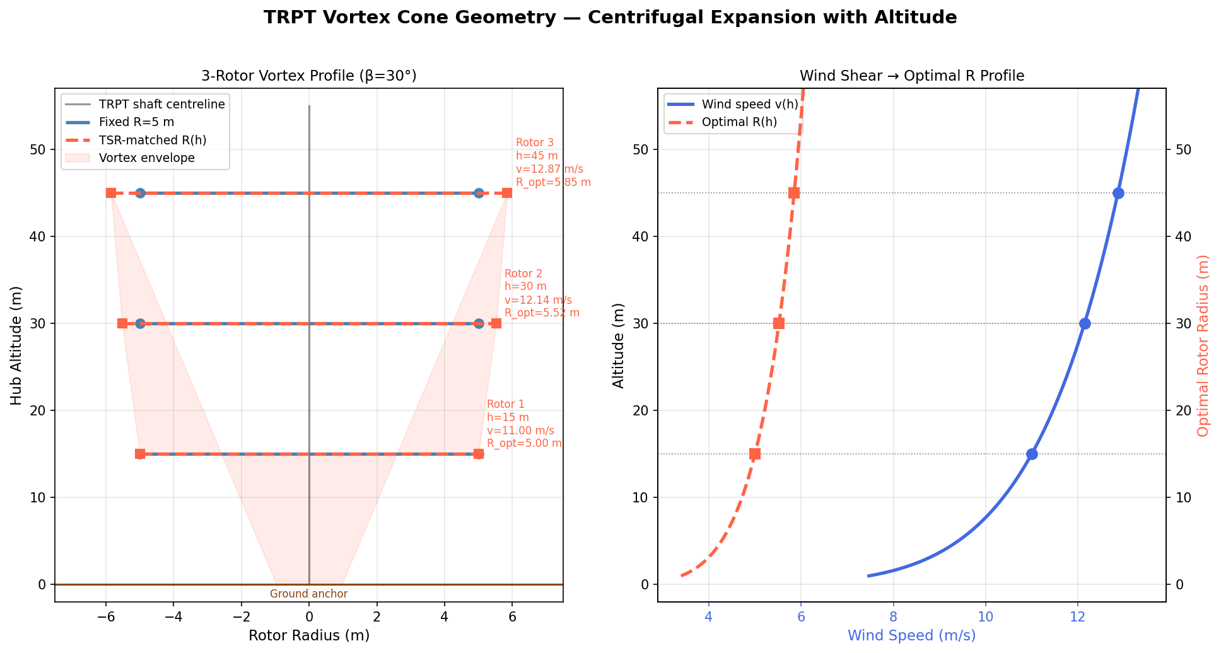
Figure 1 — Vortex cone geometry. Left: plan profile showing fixed vs TSR-matched radii at each rotor altitude (β = 30°). Right: wind shear profile and resulting optimal radius as a continuous function of altitude.

3 Power Benefit Decomposition
Figure 2 decomposes the total power across three scenarios — baseline (no shear, fixed R), wind shear with fixed R, and full shear plus TSR-matched expansion — for 1 to 3 stacked rotors.
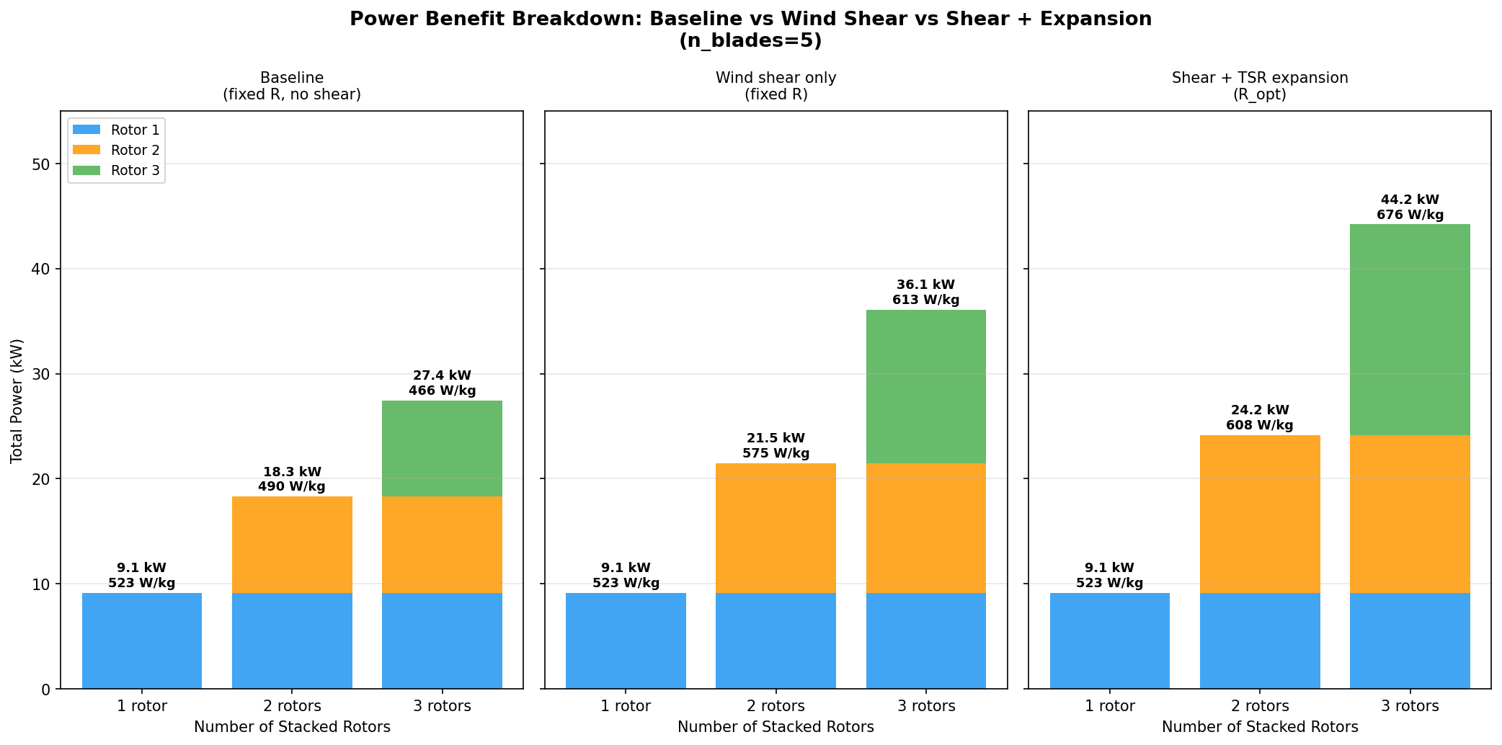
Figure 2 — Power stacked bar chart per scenario (n_blades = 5). Numbers above bars show total power (kW) and P/W ratio (W/kg). Each colour represents one rotor's contribution to the total.
The baseline scenario shows the structural mass penalty correctly: each additional rotor adds approximately 20 kg of structure (rings + tethers at increased torque) but only 9.1 kW of power at the same wind speed, so P/W degrades from 523 to 466 W/kg. Once wind shear is accounted for, rotor 2 generates 12.3 kW and rotor 3 generates 14.6 kW — both significantly above the 9.1 kW baseline — and the 3-rotor system reaches 613 W/kg. Adding TSR-matched expansion pushes these figures to 15.0 kW and 20.1 kW respectively, yielding 676 W/kg for the 3-rotor vortex configuration.

3.1 Power Multipliers Summary
Table 2 — Per-rotor power multipliers relative to rotor 1 at rated conditions.
Rotor | h (m) | v (m/s) | R_opt (m) | Shear factor (v³ ratio) | Expansion factor (R² ratio) | Combined multiplier
1 (base) | 15 | 11.00 | 5.00 | 1.000 | 1.000 | 1.000
2 | 30 | 12.14 | 5.52 | 1.346 | 1.219 | 1.641
3 | 45 | 12.87 | 5.85 | 1.601 | 1.369 | 2.192

4 P/W Heatmap: Blade Count × Rotor Count
Figure 3 shows P/W ratio, total power, and system mass across all combinations of blade count (3–6) and rotor count (1–3) for the shear + expansion scenario. A notable result is that blade count has negligible effect on P/W in this model.
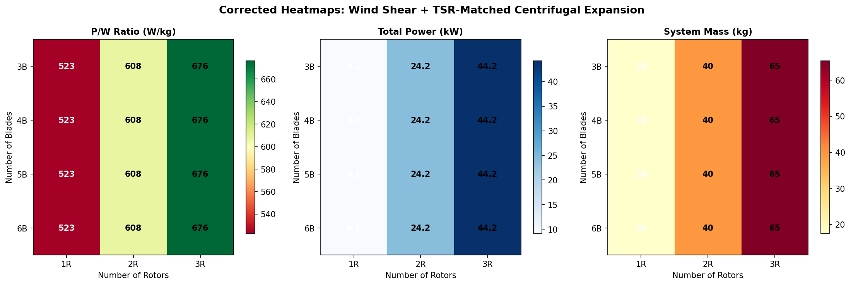
Figure 3 — Corrected heatmaps for P/W, total power, and system mass across blade count (rows) and rotor count (columns). Shear + TSR expansion assumed.
The independence of P/W from blade count arises from a fundamental cancellation: at optimal solidity, chord ∝ R/n so each blade becomes shorter as n increases, but there are more of them. The total blade planform area and hence total blade mass remains approximately constant. Power output is also unchanged (Cp ≈ const at optimal TSR). Therefore P/W is set almost entirely by the structural mass ratio — rings and tethers vs rotor power — not by blade topology.
This means blade count selection for TRPT systems is driven by other criteria: structural efficiency of the ring frame (favours n = 3–4 slightly per the polygon column buckling analysis), launch/recovery handling, and aerodynamic hub interference. The pentagon (n = 5) is a practical compromise consistent with the 5-line TRPT topology.

5 Mass Trade: Expansion Benefit vs Blade Penalty
While TSR-matched expansion increases power, it also increases blade mass because the blades must span a larger radius. Figure 4 quantifies this trade for rotor 2 as the expansion factor is swept from 1.0 (no expansion) to 1.5× the reference radius.
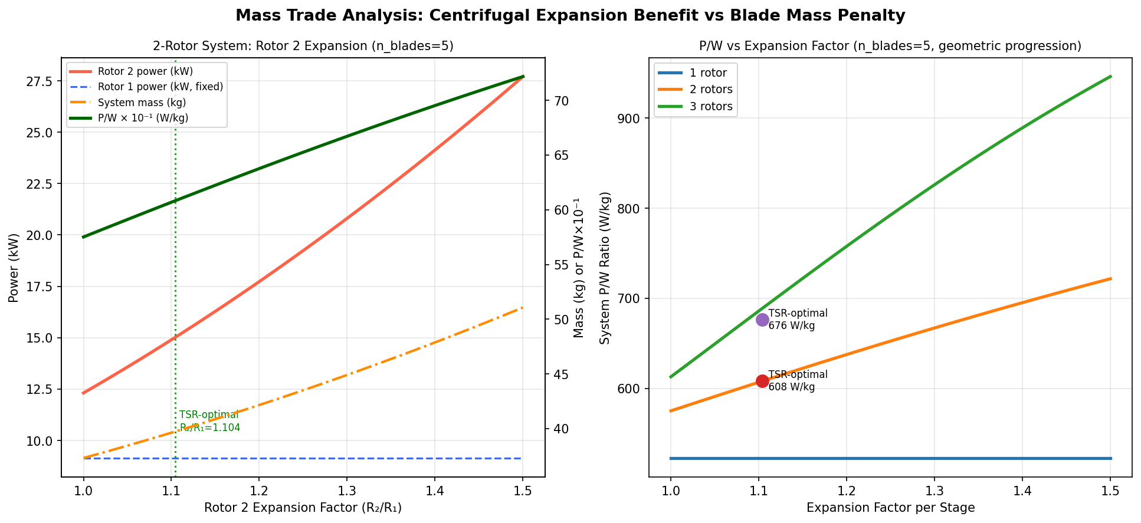
Figure 4 — Left: power and mass components for a 2-rotor system as rotor 2 expansion factor varies (n_blades = 5). Right: net P/W ratio vs expansion factor for 1, 2, and 3 stacked rotors.
The mass trade shows a broad optimum. The TSR-optimal expansion factor (×1.104 for rotor 2) lies well within the region of positive P/W gain and is not a steep peak — P/W is relatively insensitive to modest deviations from the optimum. This is aerodynamically favourable: centrifugal expansion that naturally equilibrates near R_opt does not require precise radius control to capture most of the benefit.
Over-expansion beyond ~1.3× incurs a diminishing return as blade mass grows as R² while power grows only as R² × v³ (the wind shear benefit does not scale with expansion). For the 3-rotor case the blade mass crossover occurs near an expansion factor of ~1.45× at which point the added blade mass eliminates the power benefit.

6 Annular Rotor Geometry
A further variant enabled by centrifugal expansion is the annular rotor: rather than blades spanning the full disc from hub to tip, the blades span only an outer annular band (from r_inner to r_outer). This is achievable in TRPT by attaching the blade inboard end to an inner tether line and the tip to an outer tether line, creating a ring-shaped swept area.
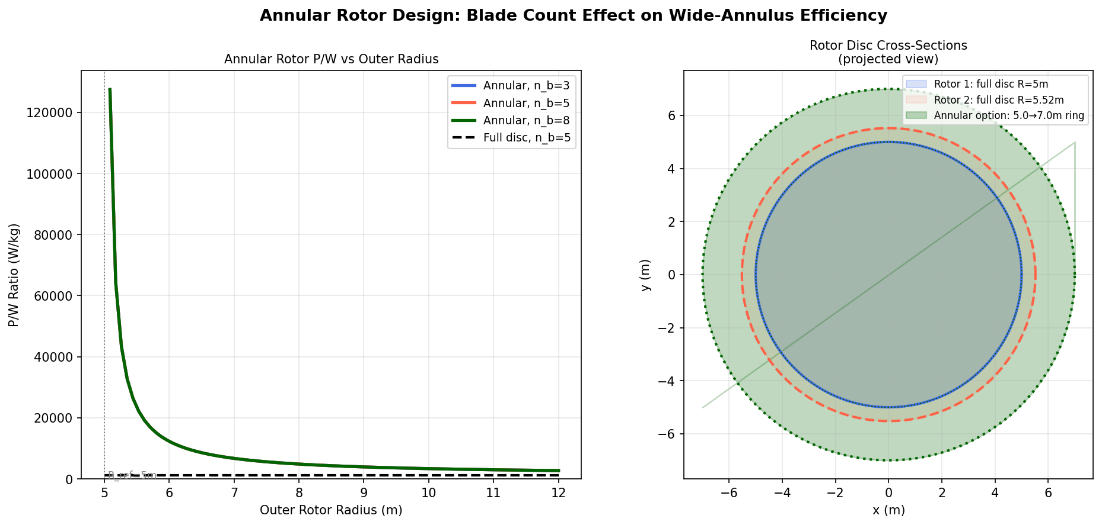
Figure 5 — Left: annular rotor P/W vs outer radius for n_blades = 3, 5, 8 compared to a conventional full-disc rotor. Right: cross-sectional view showing full-disc rotor 1 (blue), TSR-expanded full rotor 2 (red), and an annular rotor option (green).
For an annular rotor with fixed inner radius r_i = 5 m, blades span only the annular band (r_o − r_i). Blade mass scales as (span)²/n (constant aspect ratio), while swept area scales as (r_o² − r_i²). At small outer radii this gives a very high P/W because blade mass is small, but swept area — and therefore power — is also small. As r_o grows the power increases but so does blade mass. The optimum P/W for the annular design occurs near r_o ≈ 7–9 m (depending on blade count).
Higher blade count (n = 8) improves annular P/W because each blade is lighter but the total swept area is unchanged. This is a reversal of the full-disc result where blade count is neutral. However, the complexity of attaching and maintaining an 8-blade annular rotor at the outer ring of a TRPT shaft is a significant engineering challenge. This remains a speculative design direction warranting further structural analysis.

7 Comprehensive P/W Comparison
Figure 6 shows the full P/W landscape across all three analysis scenarios for every combination of blade count and rotor count. The arrows indicate the P/W trajectory from 1 to 3 stacked rotors within each mode.
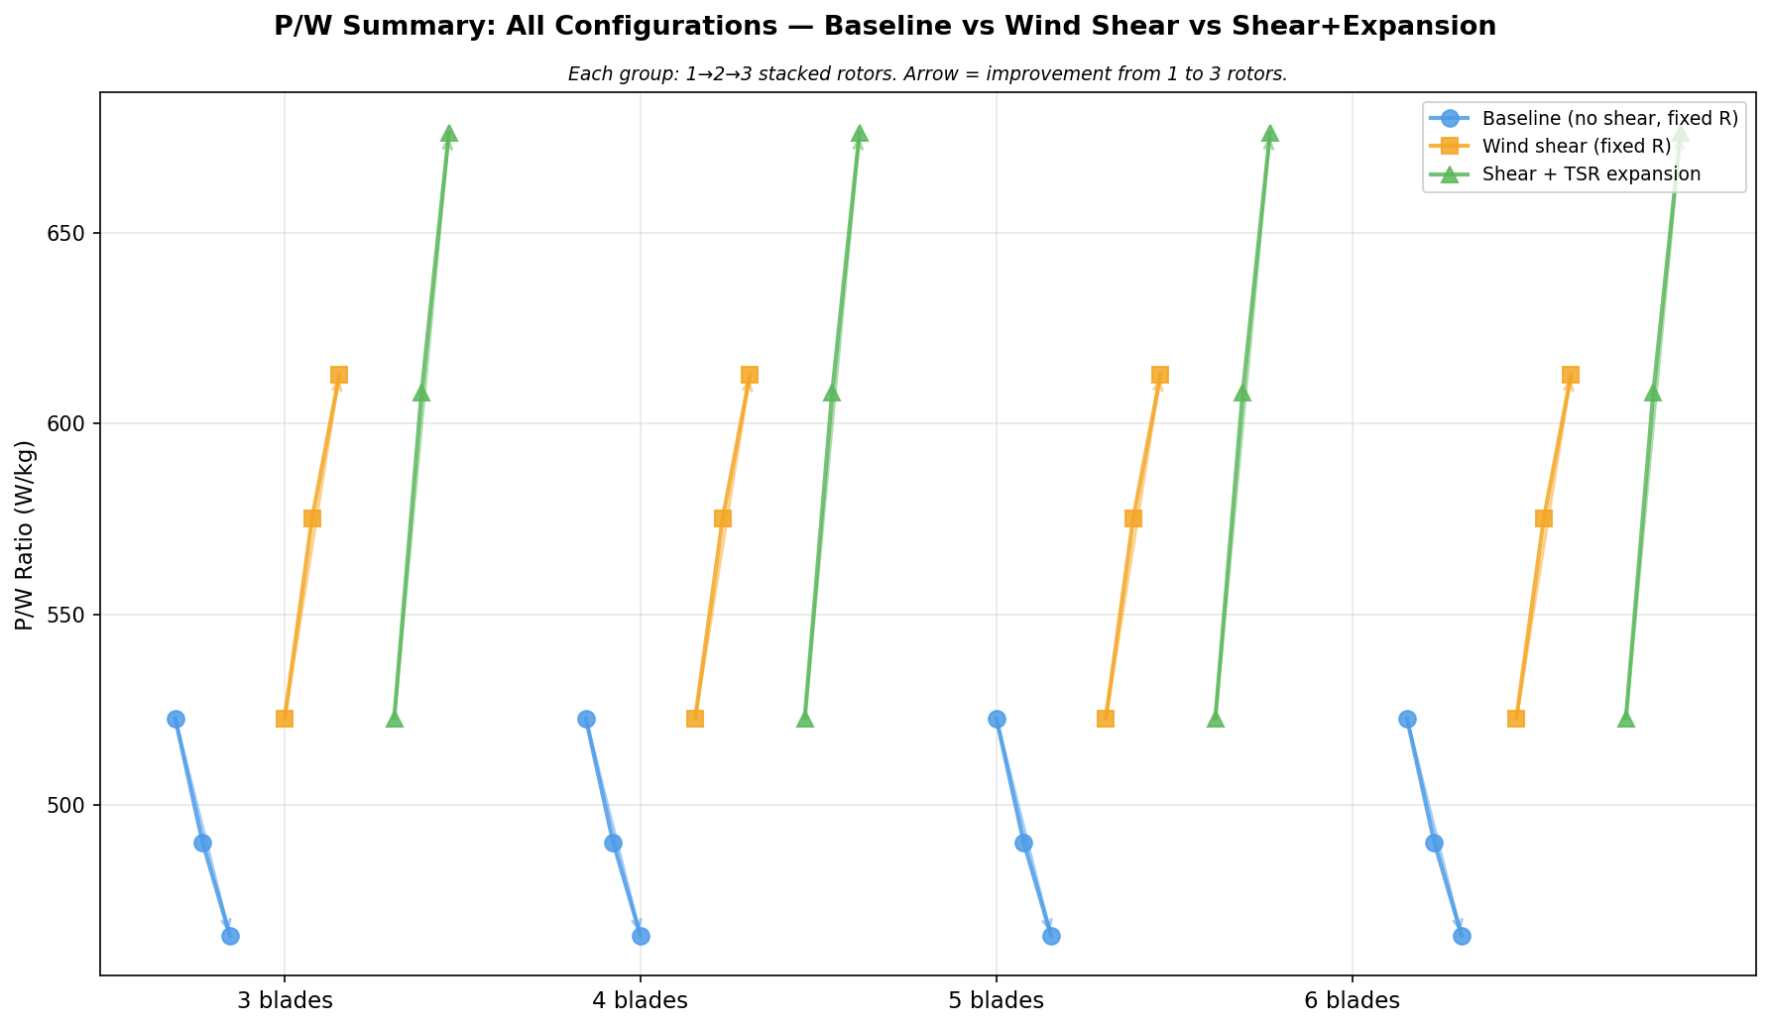
Figure 6 — P/W for all configurations. Blue = baseline; orange = wind shear; green = shear + TSR expansion. Each group shows the progression from 1 to 3 stacked rotors. Arrows indicate direction of change with stacking.
The figure makes clear that the selection of analysis assumptions is decisive: with the baseline model stacking always appears detrimental; with wind shear and expansion correctly modelled, stacking is always beneficial, with the gain increasing with each additional rotor. The crossover occurs when wind shear alone (orange) is included — the structural mass penalty is overcome by the faster wind above the reference altitude.

8 Design Recommendations

8.1 Pursue 2–3 Rotor Stacking with Passive Expansion
The 3-rotor vortex configuration (R = 5.0, 5.52, 5.85 m) delivers 44.2 kW at 676 W/kg from a 65 kg system. This is a compelling case for a 45 kW-class prototype. The radial compliance required for TSR-matched expansion (+10–17%) is modest and may be achievable passively through careful hub ring stiffness tuning, avoiding any active radius control mechanism.

8.2 Tether Upsizing for Stacked Torque
With n_rotors = 3, the bottom TRPT section carries 3× the torque of a single-rotor system, giving T_line ≈ 3 × 2333 N = 7000 N per tether line. This exceeds the 3 mm Dyneema SWL of 3500 N. The lower sections require uprated tethers: 4 mm Dyneema (SWL ≈ 6200 N) for the second section and 5 mm (SWL ≈ 9700 N) for the bottom section. The mass impact is modest (approximately +1.2 kg total for the bottom two sections) and is already partially captured in the structural ring mass scaling.

8.3 Elevation Angle Dependency
Wake-free operation of stacked rotors requires β ≥ 22° (full wake separation at β = 30°). The wind shear benefit grows with β because higher elevation puts upper rotors in faster wind. The expansion benefit is independent of β (depends only on v(h) and ω). Operating at higher elevation angles therefore simultaneously improves structural safety (wake-free), wind resource (higher altitude), and power-to-weight.

8.4 Rotor Tip-Down Coning — Future Investigation
Field observations noted a slight outward tip-down banking of blades under load ('blades had a bit of an outer tip down banking to cone the rotor'). This aerodynamic coning modifies the effective swept area geometry and the lift vector direction. A coned rotor sweeps a frustum rather than a flat disc, increasing effective swept area for a given hub radius. This effect is expected to be beneficial but has not been quantified here. It is recommended as a follow-on investigation once the basic vortex expansion geometry has been validated.

9 Conclusions
Centrifugal expansion of TRPT rotor radii in a stacked configuration, combined with the natural wind shear at higher altitude, transforms stacking from a mass penalty to a significant P/W benefit. The key findings are:
- Previous stacked analysis underestimated P/W by ~29% by omitting wind shear. Wind shear alone makes stacking beneficial (613 W/kg for 3 rotors vs 523 W/kg single).
- TSR-matched centrifugal expansion adds a further 10% P/W gain on top of wind shear. The 3-rotor vortex configuration reaches 676 W/kg and 44.2 kW total power.
- Optimal expansion factors are modest (+10% and +17% for rotors 2 and 3 respectively) and may be achievable passively through hub ring compliance without active control.
- Blade count has negligible effect on P/W for full-disc rotors at optimal solidity. The pentagon (n = 5) topology is retained as the baseline design.
- Annular rotor designs (blades spanning an outer ring band) show promise at higher blade counts but require additional structural analysis for the hub attachment geometry.
- Tether upsizing is required for the lower TRPT sections in 3-rotor systems: 4 mm Dyneema for section 2, 5 mm Dyneema for section 3.
- Tip-down rotor coning is flagged as a further beneficial effect to quantify in future work.
All analysis data and figure generation scripts are preserved in /tmp/vortex_expansion_analysis.py and /tmp/vortex_summary.json for reproducibility.

