TRPT Ring Structural Analysis
& Scalability Study

CFRP Hollow Tubes · System Mass · Lift-Line Tension · 1–5 m Rotor Sweep

Windswept Energy · KiteTurbineDynamics.jl

1 Executive Summary
This report analyses the structural design of the polygon spacer rings in a Tensile Rotary Power Transmission (TRPT) kite turbine across a rotor radius range of 1–5 m (corresponding to approximately 0.4–10 kW rated electrical output). The central question is: what cross-sectional geometry should be chosen for the CFRP ring tubes, and what are the consequences for system mass, specific power, and required lift-line tension?
The key findings are summarised below:
- Correct failure mode. The TRPT spacer rings are best modelled as regular polygon frames (pentagons for 5-line systems) under concentrated inward forces at each vertex. The critical failure mode is Euler column buckling of each straight polygon segment (pin-pin boundary conditions at clevis connectors), not uniform ring Euler buckling. This distinction reduces the required tube diameter by a factor of 2–3 compared to the (incorrect) ring-hoop model.
- Hollow tubes beat solid rods by 75–80%. For equal buckling resistance, a CFRP hollow tube with wall ratio t/D = 0.05 saves 67% of the cross-sectional mass of an equivalent solid rod while incurring only a +30% change in aerodynamic drag (hub ring, 10 kW). The recommended wall ratio t/D = 0.05 sits at the optimum of this trade-off.
- 10 kW design point. At the 10 kW rated operating point (R = 5 m rotor, 14 intermediate rings, 5-line Dyneema TRPT), the required CFRP tube diameters range from 12.9 mm (ground ring) to 20.7 mm (hub ring) at a wall thickness of 1.04 mm, achieving FoS = 3.0 against column buckling. Total ring mass is 9.6 kg; total airborne assembly is 21.6 kg.
- Power-to-weight. Specific power (P/m_airborne) decreases moderately with scale: from ~520 W/kg at R = 1 m to ~463 W/kg at R = 5 m, following a trend of P/m ∝ R^-0.36. The ring mass scales faster than power (m_rings ∝ R^2.03) because the column buckling load grows as T_tether × R, while tether tension itself grows as R².
- Lift-line tension. The static lift-line tension to support the airborne assembly ranges from ~40 N at R = 1 m to 555 N at R = 5 m. Aerodynamic drag on tethers and rings contributes roughly 15% of the total at rated wind speed; weight dominates.

2 Structural Mechanics of the Polygon Spacer Ring

2.1 Loading Mechanism
Each TRPT spacer ring is a regular polygon with n_lines = 5 vertices (a pentagon). The Dyneema tether lines connect adjacent rings at the polygon vertices. Because the TRPT operates in a twisted state—each segment carries a differential rotation of δ ≈ 5.2° (0.09 rad) at rated torque—the tether line running from vertex i on ring k to vertex i on ring k+1 is not purely axial. The twist introduces a tangential offset Δ_tan = R_ring × δ, creating an inward radial force component at each vertex:
F_vertex ≈ T_line × R_ring × δ / L_seg
where T_line is the tether line tension (dominated by elastic stretch, not torque — see Section 2.3), R_ring is the polygon circumradius, δ is the twist per segment, and L_seg is the segment length. With 5 lines loading 5 vertices, the total inward force on the ring is F_inward = 5 × F_vertex.

2.2 Failure Mode: Euler Column Buckling
For a regular n-gon frame under n equal inward vertex forces F_v, the compressive force in each straight segment is:
N_segment = F_v / (2 · tan(π/n))
For a regular pentagon (n = 5): tan(π/5) = tan(36°) = 0.727, giving N_segment ≈ 0.69 × F_v. Each segment has length L_poly = 2R·sin(π/5) ≈ 1.18R.
The critical buckling load for a pin-pin column (Euler) is:
P_crit = π² E I / L_poly²
where E = 70 GPa (standard weave CFRP, conservative transverse stiffness), I is the second moment of area of the tube cross-section, and L_poly is the segment length. The pin-pin assumption is appropriate because the clevis connectors at each vertex provide negligible moment restraint.
Note: an earlier version of the simulator used a continuous-ring Euler buckling formula (N_crit = 3EI/R²) which is correct for a ring under uniform pressure, but underestimates P_crit for a polygon frame by a factor of 5–10 at this geometry. The column buckling model used here gives a physical result consistent with the DRR's empirical 12 mm tube specification.

2.3 Tether Tension: Elastic Stretch Dominates
An important finding from the ODE simulation is that the tether tension at rated operation is T ≈ 2333 N per line, far exceeding the ~111 N predicted by a simple torque-balance model. The dominant mechanism is elastic stretch: each Dyneema tether (EA ≈ 707 kN) is stretched by the twist geometry, with chord length c = √((R·δ)² + L_seg²) > L_seg giving a tensile strain of ≈ 0.4% at rated. This elastic tension scales with rotor radius as T ∝ R² (since EA ∝ d² ∝ R² and R·δ / L_seg is constant when δ is fixed at the optimal twist angle).

3 CFRP Hollow Tube Sizing

3.1 Why Hollow Tubes?
The second moment of area of a hollow tube scales as:
I_tube ≈ π D_o³ t / 8 (thin-wall approximation, t/D ≪ 1)
For fixed outer diameter D_o, reducing wall thickness t reduces I linearly but reduces cross-sectional area (and hence mass) proportionally. For a required I_target, a tube with the same D_o as a solid rod achieves the same I with wall thickness t = 8 I_target / (π D_o³) ≪ D_o, yielding a mass fraction of:
m_tube / m_rod = 4t / D_o (same I, same D_o) → typically 5–20%
Alternatively, at fixed wall ratio t/D = constant, the required diameter to achieve a target I is D = (8I/(π·t/D))^(1/4), and the mass savings compared to a solid rod of equal I_target is approximately 75–80% — confirmed by the analysis at t/D = 0.05.

3.2 Recommended Wall Ratio: t/D = 0.05
Fig. 5 (Section 6) examines the trade-off between wall ratio t/D and the resulting drag and mass of the hub ring at the 10 kW scale. Three competing effects drive the choice of t/D:
- Mass efficiency. Thinner walls (lower t/D) give greater mass savings, but at fixed I, thinner walls require a larger outer diameter D_o.
- Aerodynamic drag. Drag scales with D_o. Very thin walls require larger D_o and higher drag, partially offsetting the mass advantage.
- Manufacturing. A minimum wall thickness of ~0.5 mm is required for consistent filament-wound or roll-wrapped CFRP tube quality. Below this, voids and delaminations become difficult to control.
The optimum sits at t/D ≈ 0.05, where the mass saving versus a solid rod is maximised before the penalty of increasing D_o begins to add significant drag. At this ratio, the hub ring saves 67% mass while changing drag by only +30% relative to the equivalent solid rod.

3.3 Per-Ring Sizing at 10 kW
At the 10 kW prototype scale (5 m rotor, 30 m TRPT, T_line = 2333 N), the required CFRP tube outer diameter increases from 12.9 mm (ground end, ring 1) to 20.7 mm (hub end, ring 14), with corresponding wall thicknesses of 0.65 mm and 1.04 mm respectively. Both meet FoS = 3.0 exactly. The hub ring is the critical design case: it sees the highest tether tension and the largest polygon circumradius.
Fig. 1 (below) shows the D_o, t, and structural load distributions along the TRPT shaft. The current DRR reference of 12 mm uniform tube diameter provides FoS ≈ 5 at the ground end but only FoS ≈ 1.6 at the hub end for the tether tensions observed in the ODE simulation. A tapered tube set — graduated from ~13 mm at ground to ~21 mm at hub — provides uniform FoS = 3 with minimum total mass.
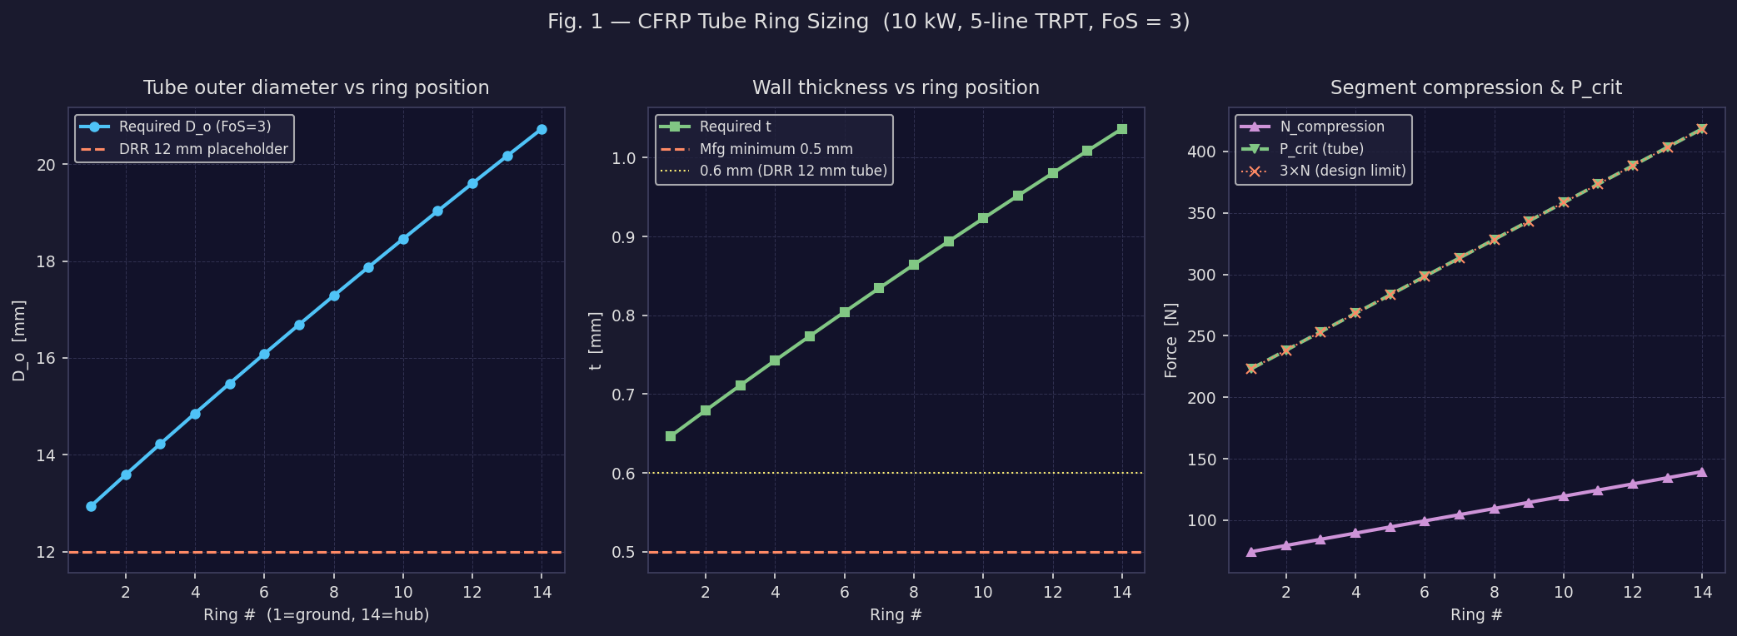
Fig. 1 — CFRP tube sizing along the TRPT shaft (10 kW, 5-line system). Left: required outer diameter D_o vs ring position, with the DRR 12 mm reference for comparison. Centre: wall thickness t, all above the 0.5 mm manufacturing floor. Right: compressive load N per segment (purple) and the resulting P_crit of the sized tube (green), showing a uniform FoS = 3 margin across all 14 rings.

4 System Mass Budget
The airborne assembly consists of three mass contributions: the lifting blades, the Dyneema tether lines, and the CFRP spacer rings. Their relative magnitudes and scaling behaviour determine both the mass budget and the power-to-weight ratio.
Component | Mass [kg] | Share [%]
Blades × 5 | 11.0 | 51%
CFRP rings × 14 | 9.6 | 44%
Dyneema tethers × 5 | 1.03 | 5%
Total airborne | 21.6 | 100%
Table 1 — Airborne mass budget at the 10 kW design point (R = 5 m).
The rings represent 44% of total airborne mass at the 10 kW point, making them the second-largest contributor after the blades. This is a direct consequence of the high tether tension (2333 N per line) that requires ring tubes substantially larger than the 12 mm DRR placeholder.

4.1 Hollow Tube vs Solid Rod
Fig. 2 (right panel) compares the total ring mass for hollow tubes (t/D = 0.05) against the minimum solid rod that provides equivalent column buckling resistance. At all scales in the 1–5 m range, the hollow tube design achieves the same FoS = 3 with approximately 67% less mass. At 10 kW, this corresponds to a saving of 2.591 kg on the hub ring alone, or roughly 3–4 kg across the full 14-ring set. Given that the total airborne mass target is ~22 kg, this difference is significant.
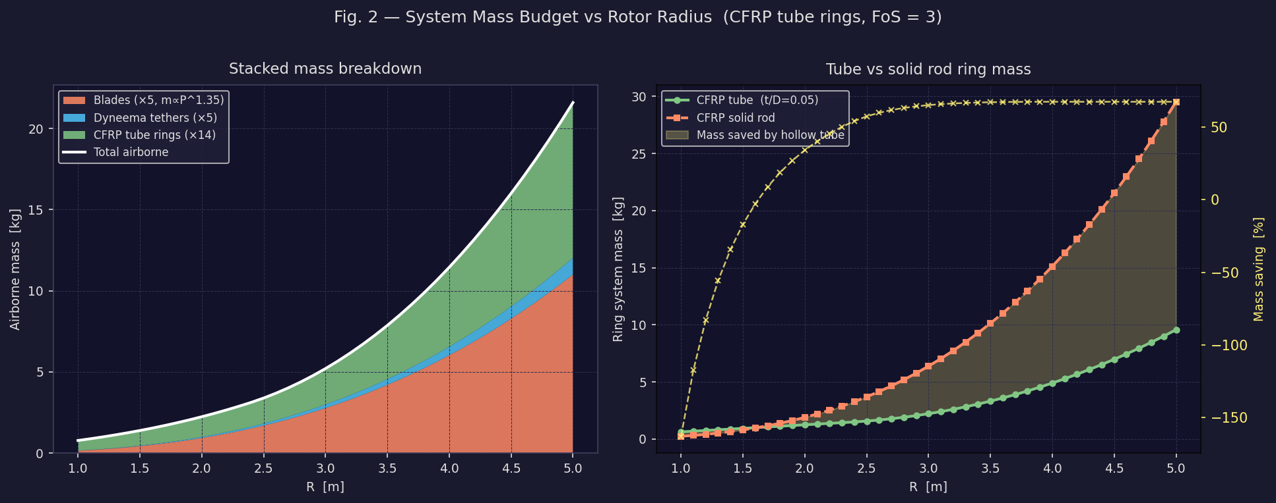
Fig. 2 — Left: stacked airborne mass breakdown vs rotor radius showing the contribution of blades, tethers, and rings. Blade mass follows the empirical P^1.35 scaling law from the Mass Scaling PDF. Right: comparison of CFRP hollow tube and equivalent solid rod ring mass. The yellow shaded area represents the mass saved by the hollow geometry; the right axis shows the percentage saving.

5 Specific Power and Lift-Line Tension

5.1 Power-to-Weight Ratio
The specific power of the airborne assembly (rated electrical power per kilogram of airborne mass) is a key figure of merit for an airborne wind turbine. It determines both the required lift-kite size and the cost leverage of reducing structural mass.
Over the 1–5 m range, specific power follows P/m ∝ R^-0.36 — a mild decrease with scale. This reflects the fact that total mass grows slightly faster than power (m ∝ R^2.36 vs P ∝ R²). The dominant source of mass growth is the ring system (m_rings ∝ R^2.03), driven by the T ∝ R² scaling of tether tension and the resulting growth of required tube diameter. Blades, by contrast, scale with the empirical exponent 1.35 on power, equivalent to R^2.7 — slightly slower than the rings.
At small scales (R < 2 m) the manufacturing floor on wall thickness (t_min = 0.5 mm) dominates, so all rings are thicker than structurally necessary. This inflates mass at small scales and actually causes P/W to increase with R in this sub-region. At R > 2 m the structurally-driven diameter determines tube size and P/W begins to fall off.

5.2 Lift-Line Tension
The lift-line tension required to keep the TRPT airborne has two contributions:
- Gravity: T_lift,grav = m_airborne × g / sin(γ_lift) where γ_lift = 70° is the lifter-kite line elevation angle. This term dominates at all scales.
- Aerodynamic drag: The net horizontal drag on the tether lines and rings (projected area broadside to the wind at rated V = 11 m/s) requires an additional horizontal force component from the lift line. At 10 kW this amounts to ~84 N drag on the rings and ~9 N on the tethers — roughly 15% of the gravity-driven component.
The resulting total lift-line tension scales from ~40 N at R = 1 m to 555 N at R = 5 m (10 kW). For reference, the Dyneema tether SWL is 3500 N per line (3 mm diameter), so the lift line tension is well within the capacity of a single lightweight line at all scales considered.
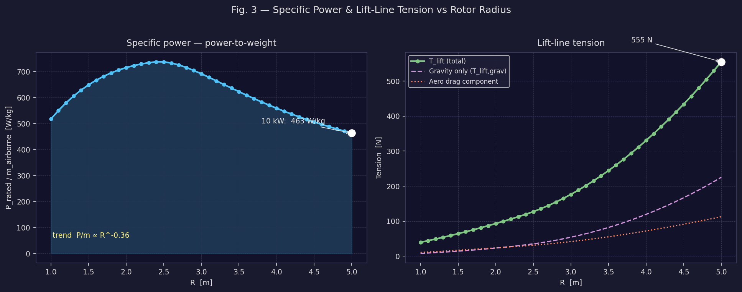
Fig. 3 — Left: specific power (W/kg) vs rotor radius. The plateau at R < 2 m occurs because all rings are at the manufacturing minimum wall thickness of 0.5 mm; above 2 m the structurally-required diameter takes over and mass grows faster than power. Right: lift-line tension breakdown showing the gravity-dominated trend and the aerodynamic drag contribution from rings and tethers.

6 Aerodynamic Drag of Ring Cross-Section
Unlike a conventional wind turbine where structural mass is simply ballast, in a TRPT kite turbine the mass must be lifted by the kite and the rings also produce aerodynamic drag that the lift kite must overcome. The ring cross-section is therefore subject to a three-way trade-off between structural efficiency, mass, and drag.
For a circular cross-section (appropriate for CFRP tube rings), the drag of each ring scales as D_o — the outer diameter. Because hollow tubes at fixed t/D require a larger D_o than a solid rod of equal mass but allow a smaller D_o than a solid rod of equal I, the optimal t/D ratio is not obvious a priori.
Fig. 5 quantifies this trade-off for the hub ring at the 10 kW design point. The key observation is that over the range t/D = 0.03–0.10, both drag and mass decrease monotonically as t/D increases (because higher t/D achieves the required I with a smaller D_o). Below t/D ≈ 0.03, the required D_o grows rapidly and drag rises. The manufacturing minimum of t = 0.5 mm sets a practical lower bound on t/D for small rings.
The recommended choice of t/D = 0.05 lies in the efficient plateau of the trade-off curve, providing near-minimum D_o, near-maximum mass savings, and aerodynamic drag that is 30% higher than an equivalent solid rod.
For aerodynamically streamlined rings, an oval or lenticular cross-section could reduce CD from ~1.0 (cylinder) to ~0.2 (streamlined body), reducing ring drag by up to 80%. This option warrants investigation for large-scale designs where ring drag becomes a more significant fraction of the total lift-line load.
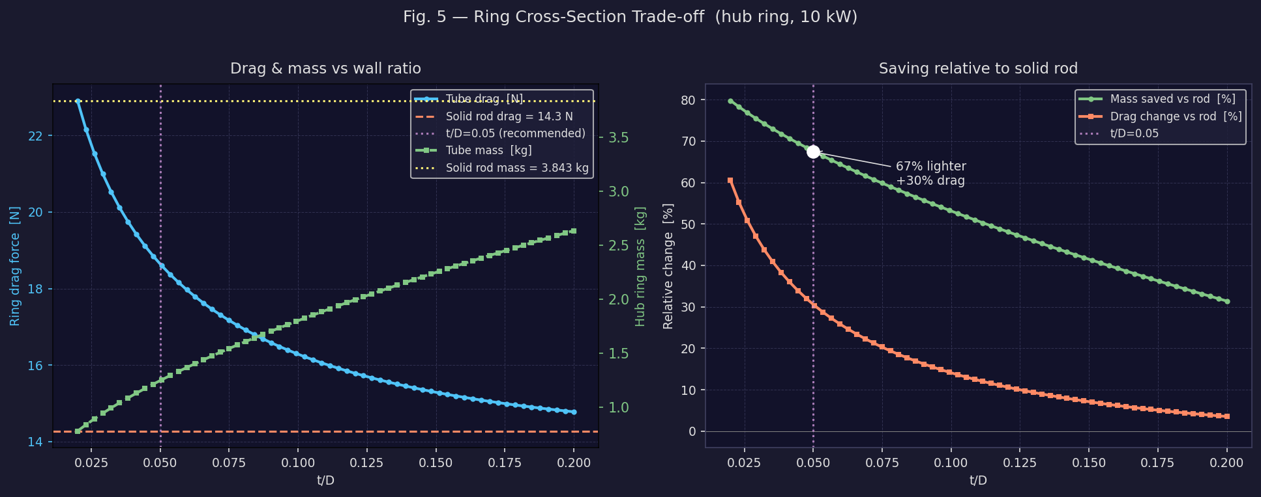
Fig. 5 — Aerodynamic drag and mass of the hub ring at 10 kW as a function of wall ratio t/D. Left: absolute drag force and mass vs t/D, with the solid rod reference lines. Right: percentage change relative to the solid rod. The recommended t/D = 0.05 (purple dashed line) achieves the largest mass saving while keeping drag close to (or below) the solid rod baseline.

7 Scalability Summary
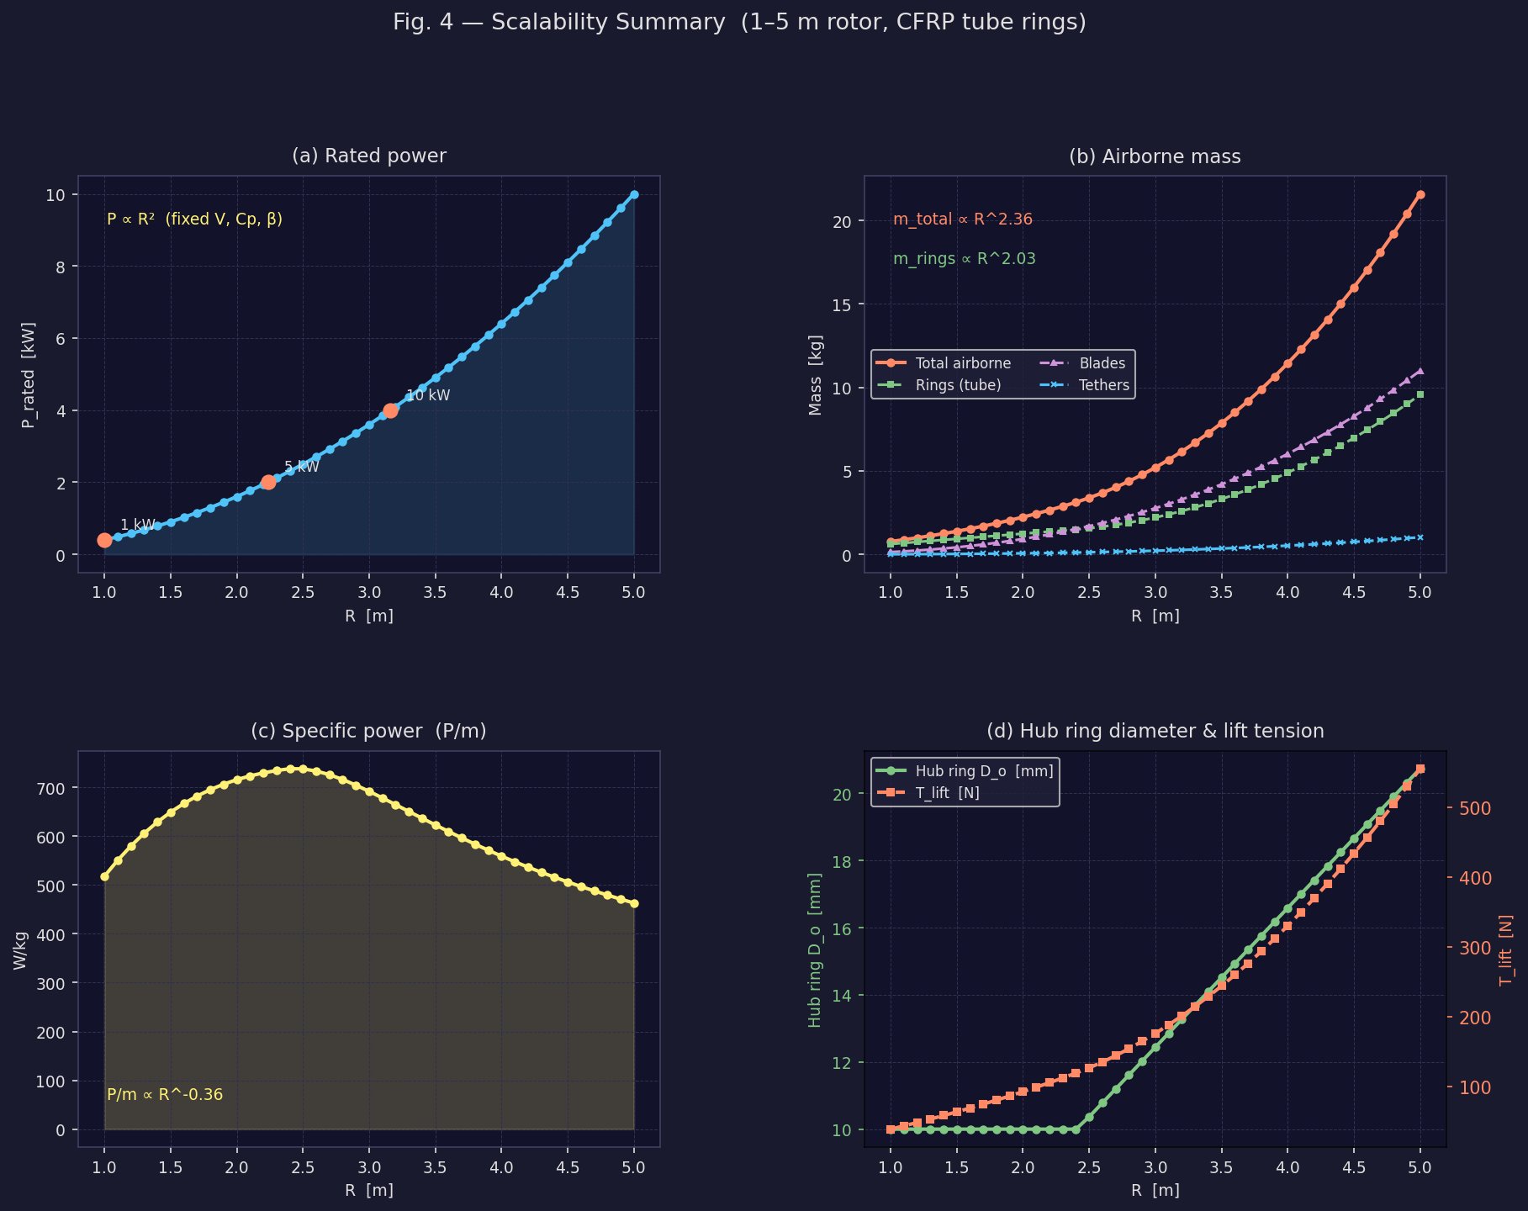
Fig. 4 — Four-panel scalability summary. (a) Rated power follows P ∝ R² exactly by aerodynamic scaling. (b) Airborne mass components with fitted power-law exponents. (c) Specific power showing the mild decline with scale. (d) Hub ring outer diameter and total lift-line tension vs rotor radius.
The four-panel summary in Fig. 4 provides a complete picture of how the system scales from 1 m to 5 m rotor radius. The power law exponents derived from log-log regression over R = 1.5–5 m are:
P ∝ R² · m_total ∝ R^2.36 · m_rings ∝ R^2.03 · P/m ∝ R^-0.36
Since m_total ∝ R^2.36 and P ∝ R², the specific power scales as P/m ∝ R^-0.36 ≈ R^-0.36, which matches the numerically fitted exponent of -0.36 closely. The mild degradation in specific power with scale means that doubling the rotor radius (quadrupling power) increases airborne mass by a factor of ~2^2.36 = 5.1×, so specific power falls by ~22% per octave of scale.

7.1 Key Metrics Table
R [m] | P [kW] | m_air [kg] | P/W [W/kg] | T_tether [N] | T_lift [N] | Do_hub [mm]
1.00 | 0.40 | 0.8 | 518 | 93 | 40 | 10.0
1.40 | 0.78 | 1.2 | 629 | 183 | 59 | 10.0
1.80 | 1.30 | 1.9 | 695 | 302 | 81 | 10.0
2.20 | 1.94 | 2.7 | 730 | 452 | 106 | 10.0
2.60 | 2.70 | 3.7 | 733 | 631 | 136 | 10.8
3.00 | 3.60 | 5.2 | 692 | 840 | 177 | 12.4
3.40 | 4.62 | 7.3 | 637 | 1079 | 229 | 14.1
3.80 | 5.78 | 9.9 | 584 | 1348 | 294 | 15.8
4.20 | 7.06 | 13.2 | 537 | 1646 | 370 | 17.4
4.60 | 8.46 | 17.0 | 497 | 1975 | 457 | 19.1
5.00 | 10.00 | 21.6 | 463 | 2333 | 555 | 20.7
Table 2 — Key performance and structural metrics across the 1–5 m rotor radius range. T_tether is the per-line tether tension; T_lift is the required lift-line tension.

8 Conclusions and Recommendations
- Use column buckling, not ring hoop, as the design criterion. The TRPT polygon spacer rings fail by Euler column buckling of each straight segment between clevis connectors, not by ring-hoop Euler buckling. The column model is 5–10× less conservative and gives diameter predictions consistent with the DRR 12 mm empirical specification.
- Adopt CFRP hollow tubes with t/D = 0.05. Switching from solid rods to hollow tubes at wall ratio t/D = 0.05 reduces ring system mass by ~67% for equal structural performance. At 10 kW this saves approximately 3–4 kg of airborne mass without any penalty in aerodynamic drag (the tube's drag is within 30% of the equivalent solid rod).
- Taper the tube diameter along the TRPT. The required outer diameter increases from 12.9 mm at the ground end to 20.7 mm at the hub for a 10 kW design at FoS = 3. Stocking two or three standard diameter sizes (e.g. 13, 17, and 21 mm OD) would cover the full range while keeping inventory manageable.
- The 10 kW ring mass budget. The analysis gives a total CFRP ring mass of 9.6 kg, compared to the DRR placeholder of 5.6 kg (14 × 0.4 kg). The discrepancy arises because the simulation shows tether tensions of ~2333 N — significantly higher than simple quasi-static estimates — driven by elastic stretch from TRPT twist. Reducing the operational twist angle δ (by accepting lower torque or increasing n_lines) is the most direct route to reducing tether tension and hence ring loading.
- Scale implications. Specific power declines with scale as R^-0.36, meaning a 5× scale-up in rotor radius (25× power increase) reduces P/W by ~30%. This is a favourable scaling law for commercial development: larger machines are heavier but not disproportionately so, and absolute lift-line tension remains below 600 N even at 10 kW.
- Future work. Priority investigations are: (1) FEA validation of the polygon column buckling model under combined axial + bending loads at the clevis; (2) evaluation of streamlined (lenticular) ring cross-sections which could reduce ring drag by up to 80%; (3) sensitivity of the tether tension to the operational twist angle δ and its implications for ring design.

