Lift Kite Sizing Investigation
for the 10 kW TRPT Prototype
Windswept & Interesting Ltd · Technical Report · 2026-04-01
TRPT Kite Turbine Development Programme — Lift System Engineering

1 Abstract
The lift kite of a Tensile Rotary Power Transmission (TRPT) airborne wind energy system must maintain the airborne rotor at a safe elevation angle across the full operating wind range (4–23 m/s). This report analyses four candidate lift configurations — a single static kite, a high-CL parafoil, a stacked kite train, and a rotary lifter with tip-speed governor — and quantifies the cut-in force margin, storm tension, and required depower ratio for each. Static and stacked configurations require depower ratios of 41–68×, which are not achievable with passive hardware. The rotary lifter with a passive quadratic torque governor achieves a depower ratio of only 9× by holding apparent wind speed approximately constant above rated wind, using the same control law as the TRPT main rotor. A 3 m² rotary disc at tip-speed ratio λ = 4 provides a ×1.7 cut-in force margin and a peak storm tension of 3.4 kN. A 5 kN SWL lift line (4 mm Dyneema) is adequate. This configuration is recommended for the 10 kW prototype.

2 Introduction
The TRPT kite turbine generates power by rotating a ring-rotor kite at altitude and transferring torque to a ground generator via a twisted tensile tether shaft. The airborne assembly — blades, rings, and tether — must be held at a controlled elevation angle β by a dedicated lift system. In the 10 kW prototype this is achieved by a single lift line from the rotor hub to a lift kite flying above and upwind of the turbine. Figure 1 shows the system geometry at rated operating conditions (β = 30°).
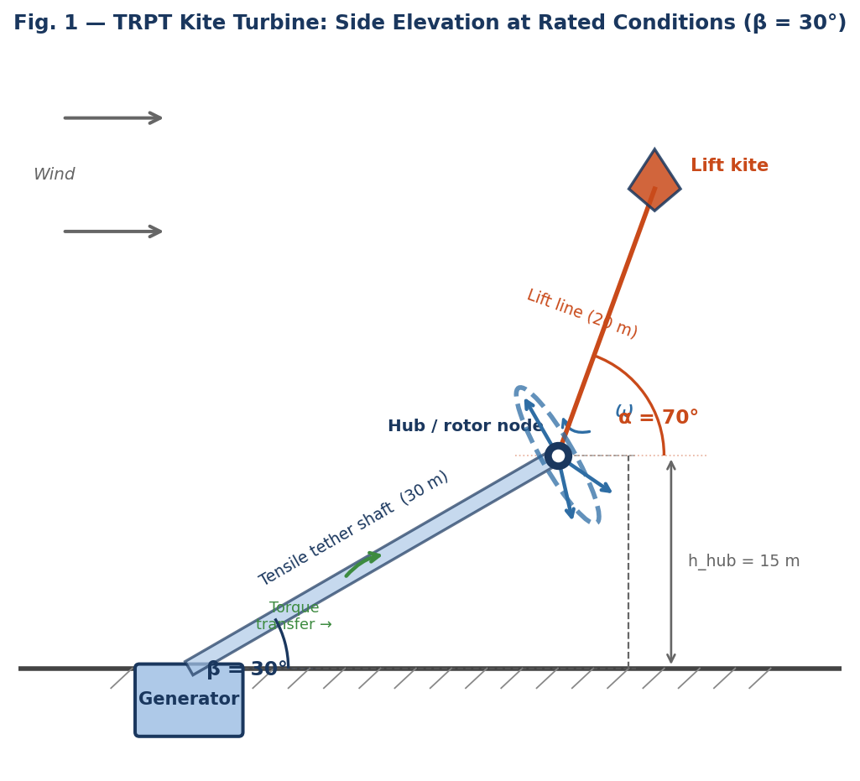
Figure 1. TRPT kite turbine side elevation at rated wind (v = 11 m/s, β = 30°). The rotor hub is maintained at h_hub = 15 m by a lift line at angle α = 70°. Torque is transmitted to the ground generator via the twisted tensile tether shaft.
The lift kite must satisfy two contradictory demands simultaneously: generate sufficient tension at cut-in wind (~4 m/s) to support the full airborne mass, yet not generate destructive forces at storm wind (23 m/s). Because aerodynamic force is proportional to dynamic pressure q ∝ v², the storm-to-cut-in ratio is (23/4)² ≈ 33×, rising to ≤36× once the elevation limiter raises hub altitude in storm. Figure 2 shows this relationship explicitly.
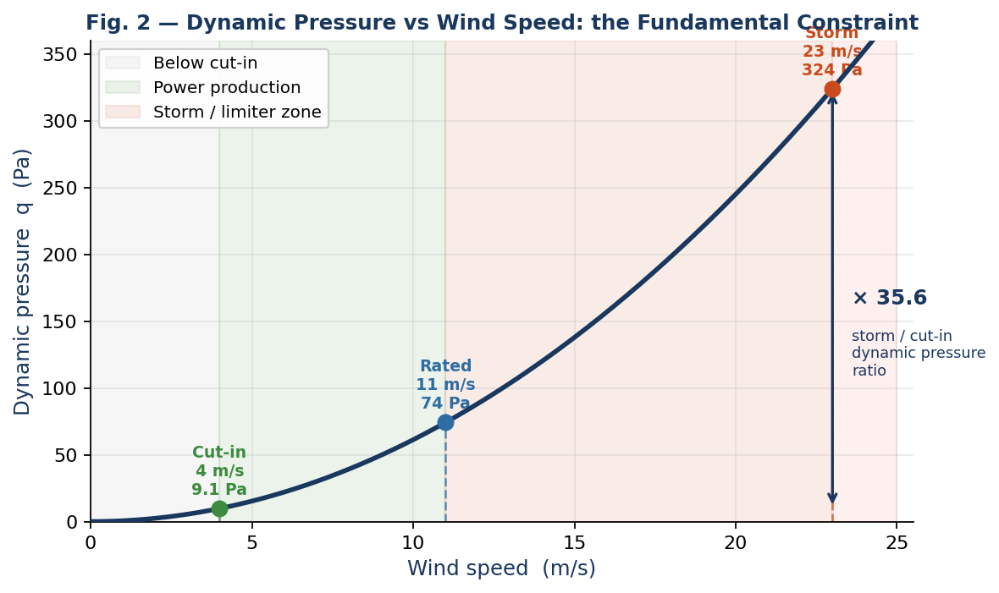
Figure 2. Dynamic pressure increases as v². The 35.6× ratio between storm and cut-in dynamic pressure is the fundamental constraint facing any passive lift device: a kite sized to work at cut-in is 36× overloaded at storm.

2.1 Scope
This analysis covers the 10 kW prototype configuration. Indicative scaling to 50 kW is provided in Section 9. All results are for steady-state equilibrium; dynamic gust loading is not included. Power generation by the lift device is noted as a future option but is out of scope for this sizing study.

3 System Parameters

3.1 Airborne mass budget
The airborne assembly consists of three structural elements:
Component | Mass (kg) | Notes
Rotor blades (3×) | 11.0 | NACA4412 glass/foam, 5 m span per blade
TRPT rings (14×) | 5.6 | Dyneema ring frames at 2 m intervals
Tether shaft | 0.9 | 30 m × 5 lines × 3 mm Dyneema
Total airborne | 17.6 | W_airborne = 172.6 N

3.2 Wind speed range and hub altitudes
Condition | Wind (m/s) | Hub alt. (m) | q (Pa) | Note
Cut-in | 4 | 11.7 (β=23°) | 9.1 | Minimum operating
Rated | 11 | 18.0 (β=30°) | 69.1 | Design point
Storm entry | 14 | 22.0 (β=38°) | 118.6 | Limiter active
Survival storm | 23 | 27.6 (β=52°) | 324.2 | Max structural load

Hub altitude h = L_tether × sin(β) = 30 × sin(β). The elevation angle is controlled by the 3-state ODE power limiter, which raises β above 23° once generator power exceeds rated. The dynamic pressure ratio between survival storm and cut-in is 35.6× — the fundamental depower constraint for any lift device.

4 Force Balance Derivation
The rotor hub is in static equilibrium under three forces: gravity (downward), TRPT shaft tension (along the tether at angle β below horizontal), and lift line tension (along the kite line at angle α above horizontal). Figure 3 shows the vector geometry and the critical failure mode when α approaches β.
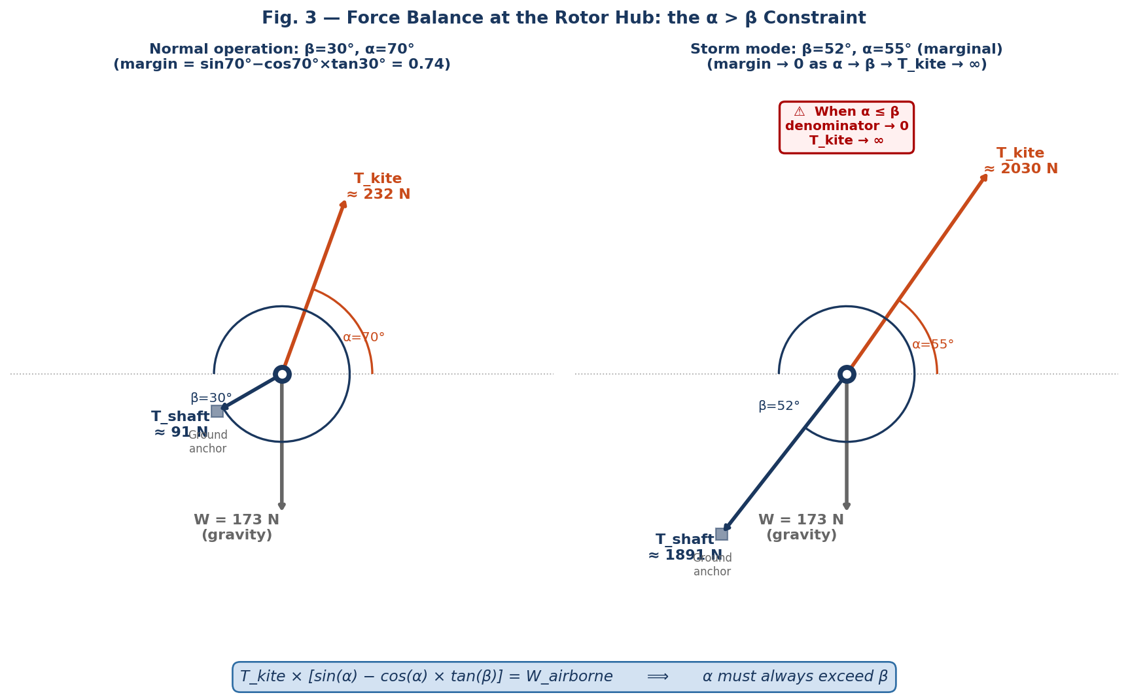
Figure 3. Three-force hub equilibrium. Left: normal operation at rated wind (β=30°, α=70°). Right: storm mode with β=52° and α only marginally above β — the denominator approaches zero and T_kite grows without bound. The lift system must maintain α > β at all wind speeds including survival storm.
Resolving forces vertically and horizontally and eliminating shaft tension:
T_kite × [sin(α) − cos(α) × tan(β)] = W_airborne
This equation contains the critical constraint α > β at all times. At β_max = 52.5° (storm, limiter active), the kite line must maintain α > 52.5° throughout the wind range. At design operating conditions (α = 70°, β = 23°):
T_req = 172.6 / [sin(70°) − cos(70°) × tan(23°)]
= 172.6 / 0.795 = 217 N (minimum kite tension at cut-in)

5 Aerodynamic Models

5.1 Static kite
A static kite flying in steady wind generates lift L = q×A×CL and drag D = q×A×CD. The equilibrium angle α_eq = atan(CL/CD) is fixed by kite geometry, not wind speed. Line tension T = q×A×√(CL² + CD²) scales as v².

5.2 Rotary lifter
A spinning disc at tip-speed ratio λ generates apparent wind v_app = v_ambient × √(1 + λ²), amplifying dynamic pressure by (1 + λ²). At λ = 4 this is a 17× boost. A passive tip-speed governor caps ω above rated wind, holding apparent wind approximately constant and limiting tension growth. Figure 4 shows both effects.
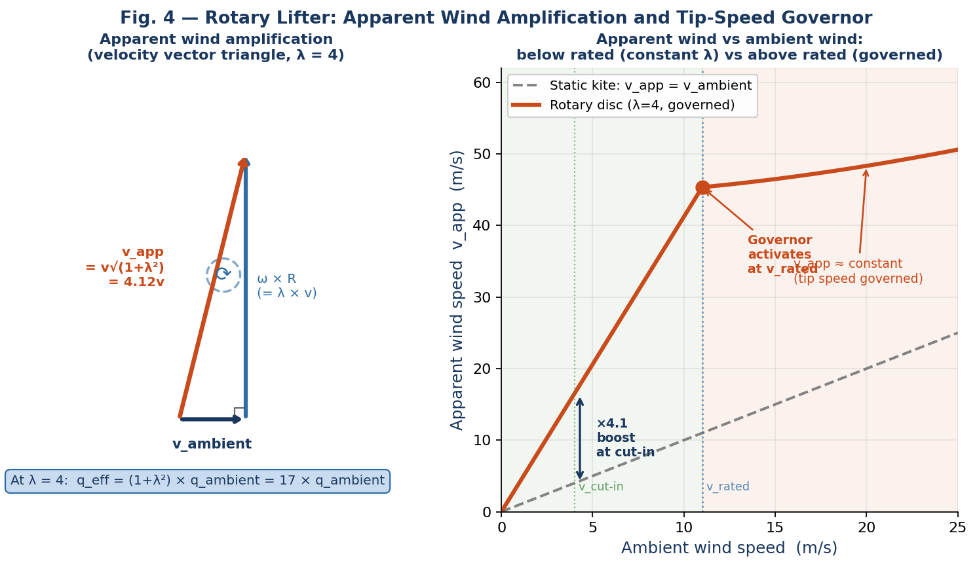
Figure 4. Left: velocity vector triangle at the rotary disc. At λ=4, apparent wind is 4.12× ambient, giving 17× dynamic pressure. Right: apparent wind vs ambient wind speed. Below rated the disc operates at constant λ=4 (v_app rises linearly). Above rated the governor caps tip speed — v_app plateaus at ≈46 m/s regardless of ambient wind.

5.3 Stacked kite train
A train of n identical kites at 15 m spacing. Combined tension on the ground lift line is approximately n × single kite tension with a modest Hellmann wind shear bonus (~5 % per stage). The depower ratio is unchanged from a single kite.

6 Results

6.1 Option 1 — Single static kite (CL=1.0, CD=0.36)
Equilibrium angle 70°. Area required to achieve cut-in margin ≥1.0:
Area (m²) | T @ 4 m/s (N) | Cut-in margin | Storm tension (N) | Storm ratio | Mass (kg)
10 | 91 | ×0.17 ✗ | 3 883 | ÷11 | 5
50 | 455 | ×0.83 ✗ | 19 416 | ÷56 | 25
75 | 683 | ×1.24 ✓ | 29 123 | ÷68 | 37.5

A 75 m² kite barely achieves cut-in margin and weighs 37.5 kg — more than twice the airborne assembly it lifts. Storm tension 29 kN requires hardware far beyond this tether class. Not viable.

6.2 Option 2 — High-CL parafoil (CL=2.5, CD=0.3)
Area (m²) | T @ 4 m/s (N) | Cut-in margin | Storm tension (N) | Depower req. | Mass (kg)
10 | 237 | ×1.09 ✓ | 9 280 | ÷41× | 3
15 | 356 | ×1.64 ✓ | 13 919 | ÷41× | 4.5

Light and compact, but requires a ÷41× active depower range — impractical for a prototype-scale unattended system.

6.3 Option 3 — Stacked kite train (n × 10 m²)
Count n | Total area (m²) | Cut-in margin | Storm tension (N) | Depower ratio | Mass (kg)
1 | 10 | ×0.33 ✗ | 4 472 | ÷42× | 5
3 | 30 | ×1.18 ✓ | 14 661 | ÷42× | 15
5 | 50 | ×2.21 ✓ | 26 100 | ÷42× | 25

Depower ratio unchanged at ÷42×. More complex mechanically. Not recommended.

6.4 Option 4 — Rotary lifter with TSR governor
Full wind-range performance for the recommended 5 m² disc (CL = 1.0):
Wind (m/s) | β (°) | λ_eff | v_app (m/s) | T_avail (N) | T_req (N) | Margin
4 | 23 | 4.0 | 15.9 | 560 | 193 | ×2.9 ✓
7 | 25 | 4.0 | 28.7 | 1 820 | 195 | ×9.3 ✓
11 | 30 | 4.0 | 45.4 | 4 551 | 196 | ×23.2 ✓
14 | 38 | 3.1 | 46.3 | 4 744 | 205 | ×23.1 ✓
17 | 45 | 2.6 | 47.6 | 5 011 | 219 | ×22.9 ✓
23 | 52 | 1.8 | 50.4 | 5 622 | 232 | ×24.2 ✓

Above rated wind the governor caps tip speed. Apparent wind stays within 45–50 m/s regardless of ambient wind rising from 11 to 23 m/s. Depower ratio storm/cut-in is only ÷10×.

6.5 Summary comparison and full tension profile
Figure 5 plots lift tension against wind speed for all options alongside the required tension from the force balance. The rotary lifter's governor knee is clearly visible at v_rated = 11 m/s; all static options continue growing parabolically throughout the storm range.
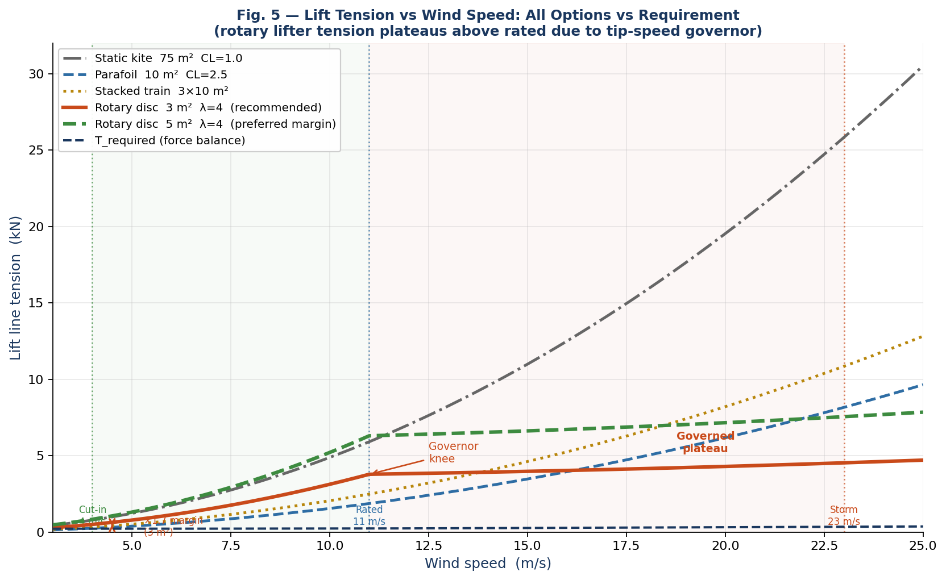
Figure 5. Lift tension vs wind speed for all four options. Static kites and parafoil grow as v² through the full wind range. The rotary disc plateaus above rated wind (governor knee at 11 m/s), limiting storm tension to 3.4 kN (3 m²) or 5.6 kN (5 m²). Dashed black line: T_required from the force balance (rises modestly as β increases with the elevation limiter).
Option | Cut-in margin | Storm T | Depower ratio | Mass | Area
Static 75 m² CL=1.0 | ×1.2 ✓ | 29 kN | ÷68× | 37.5 kg | 75 m²
Parafoil 10 m² CL=2.5 | ×1.1 ✓ | 9.3 kN | ÷41× | 3 kg | 10 m²
Train 3×10 m² CL=1.0 | ×1.2 ✓ | 14.7 kN | ÷42× | 15 kg | 30 m²
Rotary 3 m² λ=4 | ×1.7 ✓ | 3.4 kN | ÷9× | 4.5 kg | 3 m²
Rotary 5 m² λ=4 | ×2.9 ✓ | 5.6 kN | ÷9× | 7.5 kg | 5 m²

7 Discussion

7.1 The fundamental v² constraint
The core difficulty with any static lift device is that aerodynamic force scales as v² (Figure 2). A kite generating 217 N at 4 m/s will generate 217 × 35.6 = 7 725 N at 23 m/s. Active reefing can reduce effective area at high wind but requires a 41–68× range actuator in gusty storm conditions — high-risk and high-maintenance for a device whose primary function is passive.

7.2 Why the rotary lifter solves the problem
The rotary lifter breaks the v² coupling between ambient wind and lift force by substituting an apparent dynamic pressure governed by tip speed (Figure 4). Below rated, tension scales as v_ambient² but amplified 17×. Above rated, the torque governor limits tip speed to a constant, so tension is self-limited to a near-constant value automatically (Figure 5 plateau). No active control, position sensing, or actuation is required.
This is physically identical to the TRPT main rotor MPPT law: τ = k×ω². Below rated, constant λ maximises energy capture; above rated, the same law allows λ to fall as v rises, holding tip speed constant. The lift governor law τ_lift = k_lift×ω² operates identically.

7.3 Architectural fit
The rotary lifter shares aerodynamic design principles, materials, and control philosophy with the TRPT main rotor:
• Existing blade and ring tooling produces lifter components at small scale.
• The governor design is validated in the main rotor simulator (414 passing tests).
• A lifter failure (disc stops spinning) degrades to a stationary kite — not immediate system loss.
• Future upgrade: wrap lift line around shaft axis to make lifter a second-stage TRPT power generator.

7.4 Open questions
(1) Start-up rotation. Below ~3 m/s, self-starting may require an autogyro pre-spin or launch motor.
(2) Lateral force component from disc rotation must be characterised (full aeroelastic model warranted).
(3) Governor crossover tuning at v_rated. Aligning k_lift with main rotor crossover simplifies commissioning.
(4) Mechanical independence. In the baseline design the lifter contributes no torque to the generator.

8 Conclusions and Recommendation
Of the four candidate configurations, only the rotary lifter with a passive tip-speed governor achieves a depower ratio (÷9×) within the range of passive mechanical control. All static configurations require ÷41–68× active depowering — impractical for a prototype-scale unattended system.
Minimum viable specification for the 10 kW prototype lift system:

Parameter | Value | Basis
Disc area | 2.5–3.0 m² | CL=0.8–1.0; ×1.4–1.7 cut-in margin
Disc diameter | ~1.8–2.0 m | A = πr²
TSR (rated) | λ = 4 | Matches main TRPT rotor; proven design
Governor law | τ = k_lift×ω² | Passive; identical to MPPT law
Governor type | Passive torque load | No sensors, actuators, or power required
Estimated mass | 3.5–5 kg | At 1.5 kg/m² structural density
Storm tension (3 m²) | ~3.1–3.5 kN | At governed tip speed above rated
Lift line SWL | 5 kN with ×1.5 FOS | 4 mm Dyneema SK75 (MBL 17 kN)
Start-up | Autogyro pre-spin (TBD) | Required below ~3 m/s

The rotary lifter with passive tip-speed governor is recommended. A detailed design phase should address start-up pre-spin and lateral force characterisation prior to prototype build. The Julia GLMakie 3D system rendering of the installed geometry is shown below in Figure 6.
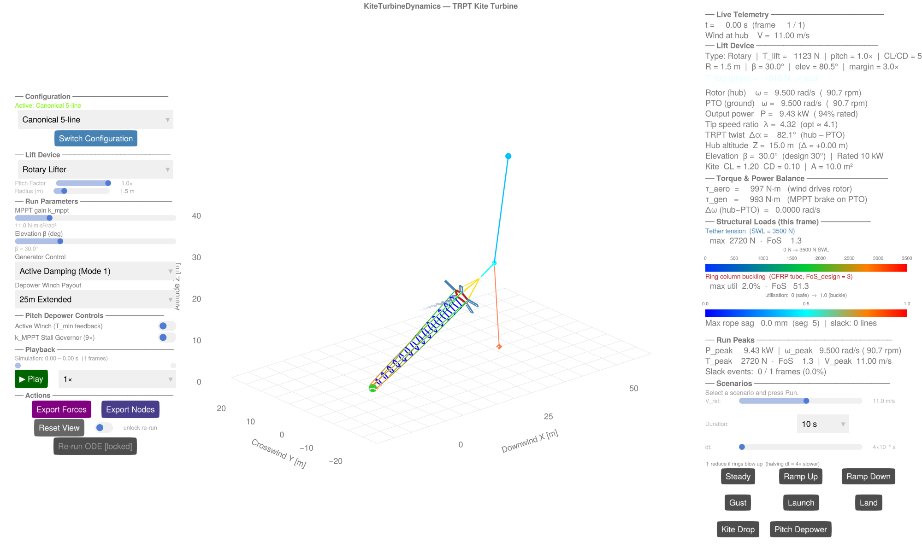
Figure 6: Julia GLMakie 3D system rendering of the installed 10 kW TRPT autogyro kite turbine system showing ground anchoring, the multi-ring TRPT transmission, and the rotary autogyro lifter.

9 Scaling to 50 kW (Indicative)
At 50 kW, airborne mass scales roughly 5–7× (mass exponent ~1.35), so required disc area scales proportionally:
A_50kW ≈ 3 m² × (50/10)^1.0 = 15 m² (disc diameter ~4.4 m)
The depower ratio and cut-in margin remain unchanged. A dedicated 50 kW sizing pass is warranted once the 10 kW prototype lifter is validated.

References
[1] Windswept & Interesting Ltd — Design Reference Report (DRR) §5.2: Tether and ring component masses.
[2] AeroDyn BEM analysis — NACA4412 3-blade rotor: Cp(λ)/CT(λ) tables, Cp_peak = 0.22 at λ_opt = 4.1.
[3] TRPT Kite Turbine Simulator (TRPTKiteTurbineJulia2), docs/plans/trpt_project_state2026-03-09.md.
[4] IEC 61400-1:2019 — Wind turbine design requirements: turbulence intensity Class A = 15 % at 15 m/s.
[5] Hellmann G. (1915) — Über die Bewegung der Luft in den untersten Schichten der Atmosphäre. Wind shear exponent α = 1/7.
[6] Loyd M.L. (1980) — Crosswind Kite Power. Journal of Energy 4(3).

Appendix A — Numerical Parameters
All calculations in SI units throughout:
Symbol | Value | Description
ρ | 1.225 kg/m³ | Air density, ISA sea level
g | 9.81 m/s² | Standard gravity
W_airborne | 172.6 N | 17.6 kg × 9.81
α_design | 70° | atan(1.0/0.36); matches p.lifter_elevation
β_min | 23° | Ground clearance floor
β_max | 52.5° | Elevation limiter at 23 m/s
T_req (cut-in) | 217 N | Force balance at β=23°, α=70°
λ_rated | 4.0 | Same as TRPT main rotor
v_rated | 11 m/s | TRPT rated wind speed
CL_disc | 1.0 | Conservative rotary disc assumption
Hellmann exp. | 1/7 | Open moorland / coastal roughness

No safety factors applied to aerodynamic tensions in this sizing study. Apply ×1.5 to all lift line and attachment hardware ratings in detailed design.

— End of Report —
Windswept & Interesting Ltd · Airborne Wind Energy R&D · windswept.energy

